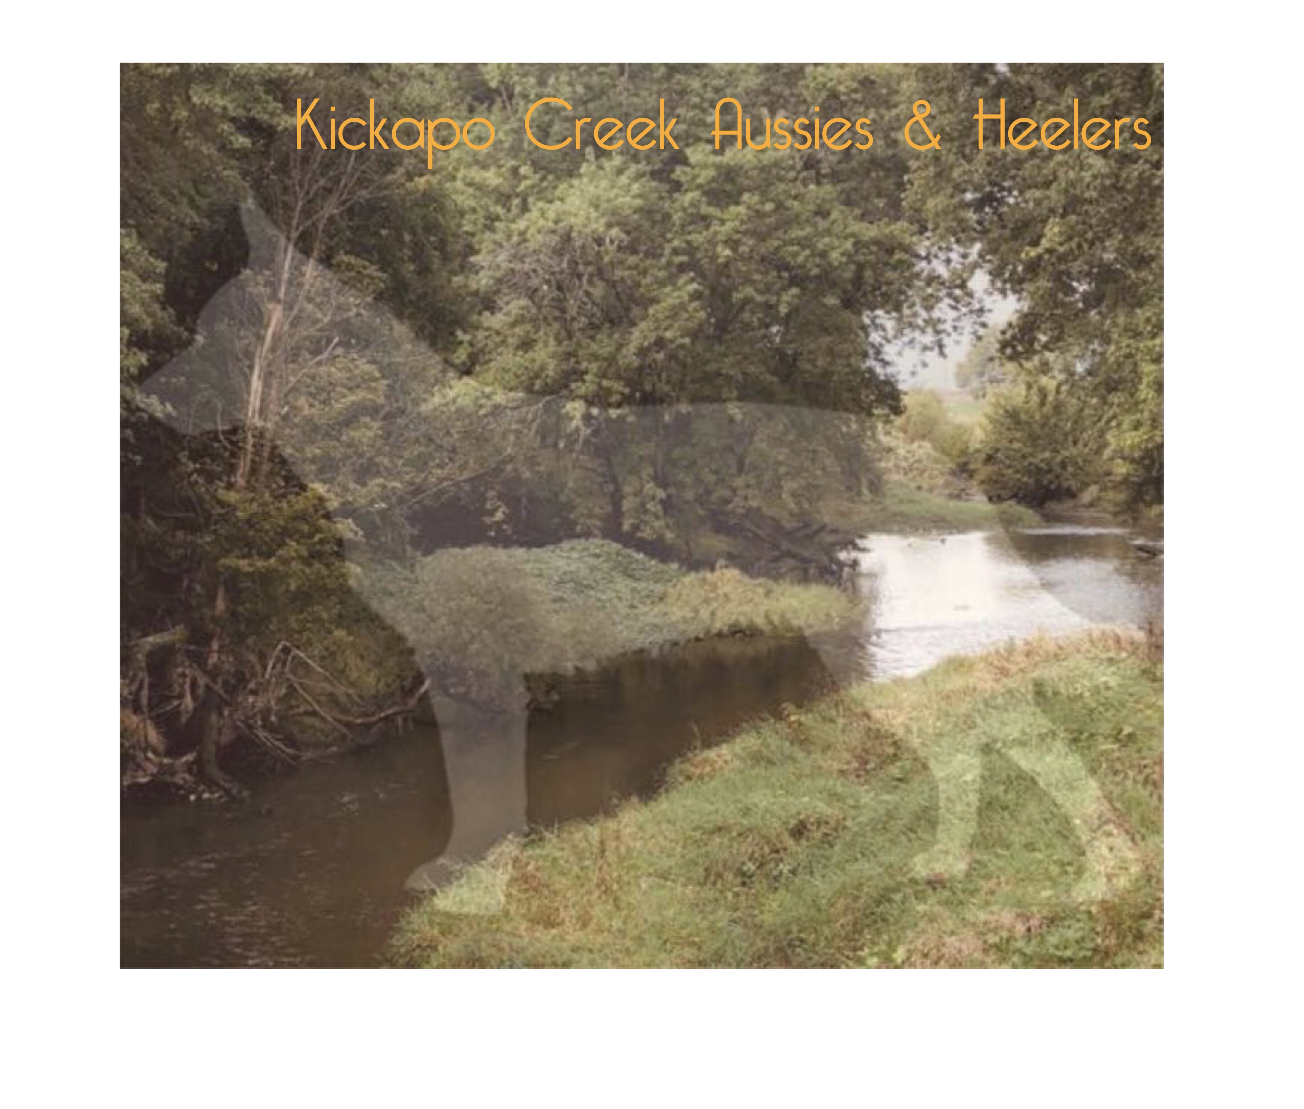
Puppy Warranty and Purchase Agreement

Seller ( Niki McGrew ) and Buyer ( _____________ ) agree to enter into this contract under the following binding agreement: Puppy being sold is (description) ___________ Sex______Male __Female
Whelped: _____ Sire_____ ___________________________ Dam_______ __________

Seller and Buyer agree that the above described puppy is a purebred Teacup/Toy/Miniature Australian Shepherd and is being sold as pet/companion quality. Registered ASDR name must begin with Kickapoo Creek.

Purchase Price: Buyer agrees to the total payment of $_____ in purchasing the puppy described above. Sellers will accept a $500 nonrefundable* deposit to hold puppy in Buyer's name until full payment is received. The puppy needs to be paid for by 6 weeks of age and will not be delivered until full payment is received and puppy is at least 8 weeks of age. Payment may be made by cash, check, money order or by credit card via PayPal (if paying by PayPal, an additional 3% will be added to cover fees).

*Order deposits are received determines order of buyer's choice, first deposit receives first choice, etc..

Shipping: Seller will ship through United Airlines on temp controlled cargo out of Peoria, IL for domestic flights and out of Chicago, IL for international flights. Price is $350 including flight, crate and health certificate. Prices can vary depending on size of crate and weight of puppy on date of flight. Seller will personally ground ship when possible. Convenience fee of $50 will apply and rate is $.30 per mile.

Health Guarantee: Seller warranties that the puppy to be free of communicable diseases, in good health, and of stable temperament having been well socialized. Puppy will have received its first set of vaccinations and been de-wormed at least 3 times. Buyer has 72 hours to have the puppy/dog examined by a licensed veterinarian for general health from date of delivery: __________ (excluding weekends and/or holidays). Failure to do so will result in any and all warranties being canceled. Seller accepts no liability for any communicable diseases after 72 hours from when the puppy/dog leaves the possession of the Seller. If puppy/dog does not pass a general health exam, Buyer agrees to notify breeder within 72 hours and provide a copy of the original signed licensed veterinary statement of health. Minor, treatable problems such as diarrhea, coccidiosis, parasites, etc. are common problems in puppies especially under stress of new circumstances, and will not be covered by this warranty although every effort is made to prevent this. Buyer acknowledges that Seller is not responsible for Buyer’s veterinary expenses at any time or under any circumstance.

Seller also warranties this puppy free from “genetic defects”, such as, deafness, serious eye defect, that would prevent the puppy from being a companion animal, until the puppy reaches one year of age. If this puppy is found to have a genetic defect of this kind, this must be verified by a licensed certified veterinarian. In case of a genetic eye deformity, written notification must come to the Seller from a Board Certified Veterinary Ophthalmologist. If one of the above listed “genetic disorder” is found, Seller will then replace the puppy with one of the same sex and coat color from the first available litter (puppy to be determined by the Seller). The puppy/dog shall be returned to the Seller at the Buyer’s expense, If Buyer wants to keep the puppy, it must be neutered or spayed at Buyer's expense and they will be able to purchase another puppy, of their choice, from the Sellers and will be given a price discount of an amount equal to 50% of the purchase price of the original puppy. Under no circumstances will money be refunded.

This contract is between the Seller and Buyer(s) signed below. If this puppy/dog is sold to a third party, this contract is void.

Purchase agreement: It is the Seller's sincere intention that none of their dogs are ever taken to a shelter. If at any point in the future, the Buyer cannot keep this puppy/dog, the Seller agrees to assist in finding this animal a new home.

Puppy is warranted only for the purpose of being a pet/companion animal. Although it could be
capable/suitable of performing other functions, such as show or breeding quality, no warranty is being
given that purpose. If used for breeding, the Seller ask that the Buyers do so responsibly, and
recommend that males must be at least one year of age before used for breeding and females at
least 18 months of age and had at least one prior heat cycle before being bred.

Seller cannot guarantee adult size or conformation of the puppy/dog. Buyer hereby releases breeder
and agrees to hold harmless for any liability, injuries or damages to persons or property caused by this
puppy/dog, whether this form is signed or not. Buyer shall assume full responsibility for the health, temperament, and appearance of the puppy/dog upon when the puppy/dog leaves the premise of the Seller.

Also, the buyer must follow the regular vaccine, de-worming, and heartworm schedule for the first year
of the puppy’s/dog’s life. Failure to do so causes this contract to become null and void. Puppy/dog will
be up to date on all vaccinations and de-wormings when it leaves premise of Seller, and those records
will be provided to Buyer.

Buyer’s Printed Name _____________________________________________________________________

Buyer’s Signature ____________________________________________ Date______/_____/____________

Buyer’s Full Address ________________________________________________________________

Buyer's email address _____________________________________ Phone____________________

Sellers Printed Name: Niki McGrew

Sellers Signature ______________________________________________ Date______/________/_____

Sellers Address: 957 N 1075 East Rd McLean, IL 61754

Sellers email address: kickapoocreekaussies@gmail.com

Phone number: 309.531.5007

****************************End of Warranty/Contract****************************

