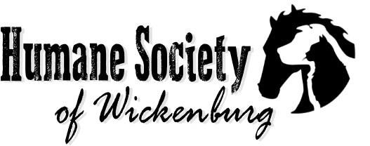

**ADOPTION CONTRACT**

Humane Society of Wickenburg

4000 Industrial Rd. Wickenburg, AZ 85390

928-684-8801 www.wickenburghumane.com

|  |  |  |  |  |  |  |  |  |  |  |  |  |  |  |  |  |
| --- | --- | --- | --- | --- | --- | --- | --- | --- | --- | --- | --- | --- | --- | --- | --- | --- |
| |  |  | | --- | --- | | Adopter’s Name(s): | Email: | | Address: | Phone:  Other Phone: | | Pet Name: | Species: Dog / Cat Gender: Male / Female | | Medical Needs for Dog | Medical Needs for Cat | | DHPP: | FVRCP: | | Bordetella: | Rabies: | | Rabies: | FELV/FIV Test: | | I verify that I have read and agree to provide the above medical needs to this animal. **Initial:** | Other: |   Pre-adoption Agreement:  I understand that some risk always exists with any anesthesia and/or surgery. I agree to indemnify and hold harmless the Humane Society of Wickenburg and the attending veterinarian from and against all liability arising out of the performance of all procedures done before animal is taken from this shelter. I would be entitled to a full refund of my preadoption fee.  Pre-adopter’s Signature: ___________________ Date: _____________________ |

As an adopter, I understand that I am committed to this animal for his/her life and I agree to abide by these adoption conditions:

Provide the animal with adequate food, water and shelter at all times and safe interaction with my other animals, if any.

Attend to all needed medical care, including dental care, annual vaccinations and preventative medications as specified in Medical Needs above.

Allow an HSW representative to call, email or visit my premises after adoption.

I agree to notify HSW if for any reason I can no longer provide this animal with a good home. I will give HSW the option of taking back the animal. I agree not to surrender this animal to another shelter before talking with an HSW representative.

I understand that while HSW makes every effort to disclose any known medical conditions of any animal adopted from this shelter, HSW cannot guarantee nor can it be assumed that the animal I am adopting is currently vaccinated completely against communicable diseases and is without need of veterinary care. I release HSW from any responsibility for any medical expenses incurred by this animal and liability of any sort regarding this animal.

I accept this animal as is, and from this day forward, assume all risks and responsibilities for any damages to property, person or other animals that it may cause.

I fully release, indemnify and hold harmless the Humane Society of Wickenburg, its directors, officers, volunteers and agents from any claim, cause of action or liability of any sort regarding this animal.

I understand that if I violate the conditions of this Adoption Contract or have provided false/inaccurate, HSW has the right to retake the animal. I further agree that in the event the animal is retaken because of violation of this contract, any expenses including court and/or legal fees that may occur are my responsibility.

**Adopter’s Signature:** Date:

HSW Signature: Adoption Fee:

(non-refundable)  **Initial**