Massage Intake Form

Name:_____________________________ Occupation:_________________________
Phone:_(_____)______-_______________ Email:______________________________
Referred By:_________________________
Have you ever had a professional massage before? YES / NO
What kind of pressure do you prefer? LIGHT MEDIUM FIRM DEEP
Please list any surgeries or medical conditions: _____________________________________________________________________________________
_____________________________________________________________________________________
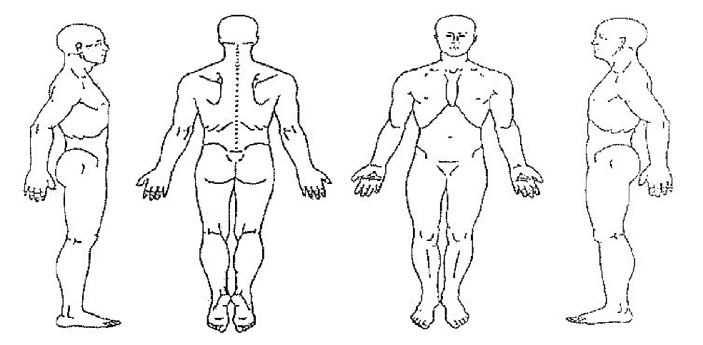

Please indicate areas in which you would like me to focus on using an O
and a X on areas in which to avoid during the service.

I have been trained in Swedish, Deep Tissue, Lomi Lomi, Trigger Point, Chair, Sports, Hot Stones, Cupping Therapy, Graston Techique. These styles are for relaxation, relief of muscle pain, breaking up toxins, and promotion of circulation. If at any time you feel uncomfortable for any reason, you may ask me to cease the massage, and I will do so. As therapist, I also reserve the right to terminate the session in the event of any sort of abusive behavior from the client.

I have stated all conditions that I am aware of and this information is true and accurate to the best of my knowledge. I understand that massage/bodywork I receive is for the purpose of stress reduction and the relief from muscular tension, spasm or pain and to increase circulation. If I experience any pain or discomfort, I will immediately inform my massage therapist so that the pressure and/or methods can be adjusted to my comfort level. I understand that my massage therapist does not diagnose illness or disease, nor perform any spinal manipulations. Sexual advances, request for sexual favors, and other verbal or physical conduct of a sexual nature will constitute as sexual harassment and will not be tolerated. I understand that I am receiving massage therapy at my own risk. In the event that I become injured either directly or indirectly as a result, in whole or in part, of the aforesaid massage therapy I hereby hold harmless and indemnify the therapist and their principals from all claims and liability whatsoever.

Client Signature: _______________________________ Date:_____________
Therapist Signature:_____________________________ Date:_____________

