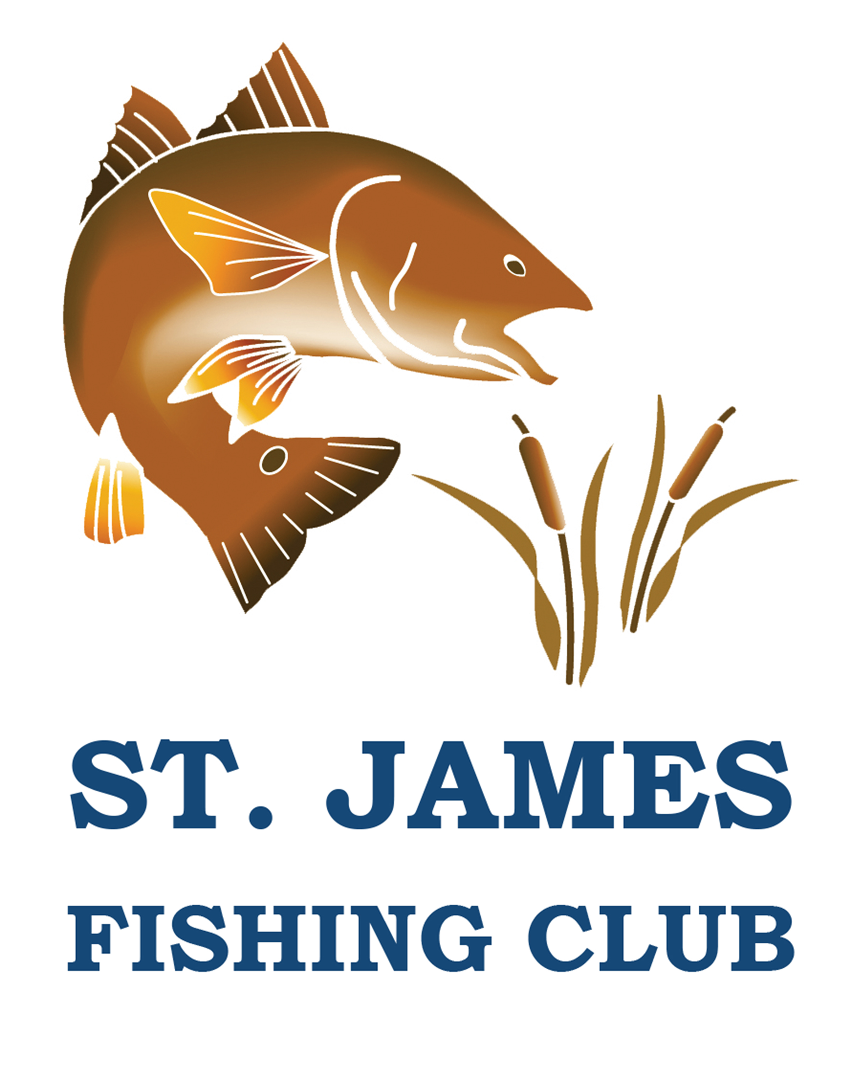

ST. JAMES FISHING CLUB DERBY RULES

**Eligibility**: All members of the club when fishing from land or a boat.

**Duration:** Jan. 1, 2025 - December 30, 2025

**Location:** To be eligible for the derby, boats must depart and return from a marina or boat ramp locatedbetween Southport harbor on the north and Little River inlet on the south. Entries from the Shore* or Piers* within this geography are also included. Departure and fishing out of Baldhead Island and Oak Island are accepted.

*All freshwater fish entries must be caught in the ponds of St James Plantation.

*Inshore Angler fish entries must be caught inside the inlets

**Entries:** All entries must be sent to the Derby Coordinator (Nick Colatosti, [stjfishgroup@gmail.com)](mailto:stjfishgroup@gmail.com)) within twoweeks. Entries must include a full pixel jpeg photo of the catch on a measurement device, angler’s name, Captain’s Name or landed location, date of catch, fishlength rounded to the nearest inch or half inch based on required measurement point (**TL**, **FL, CFL**) for the fish on the Derby list (Appendix B) of fish.

Fish may be entered that were caught while using a guide, a non-members boat or on a charter. The angler gets credit. The guide/ charter is viewed as the captain thus will be listed as “Guide”. Member Captains will get a credit for being Captains for a Non-Member if the nonmembers fish is larger than the current posted fish. This larger fish will not displace the existing Members catch in the Derby. Fish caught onboard Kayak, Canoe or any other floating vessel; the operator of the vessel will get the credit as the captain.

**Regulations:** Fish must be within the **regulation size limits imposed by NCDMF.** Fish maybe caught out of season, (Cobia, Flounder, Red Snapper etc.) but must be safely released. Angler must hold a required Fishing license for appropriate species. Please see the list of qualified species by following the link below.

[NC Citation Fish Species](http://portal.ncdenr.org/web/mf/n.c.-saltwater-fishing-tournament)

**Special Additional Species**: Members may submit the following fish to the derby.All fish in this category areeligible for recognition and included for angler and Captain of the year: Big Eye Tuna, Bluefin Tuna, Yellowfin Tuna, Tarpon, Striped Bass, Blue Marlin, White Marlin, Jack Crevalle, Red Snapper, African Pompano, Tilefish (all species) Florida Pompano, Snappers (others), Sailfish, Mako Shark, Tautog, Triple Tail, Spot, Atlantic Bonito, Spade Fish and Hog Fish. These fish are in addition to the ones listed in appendix B. All billfish caught will receive awards, but the fish must be brought to the boat (leader touched) and a picture must accompany entry.

**Recognition:** Recognition will be presented for the longest fish (using the proper measurement) for each species on the leader board at the end of theDerby.

**Length Measurement:**

**Total length** (TL) is measured from tip of snout with mouth closed to top of compressed tail.

**Fork length (FL)** is measured from tip of snout to middle of fork in tail. Lower jaw fork length (LJFL) ismeasured from lower jaw to middle of fork at the tail.

**Curved fork length (CFL)** is the measurement of the length taken in a line tracing the contour of the bodyfrom the tip of the upper jaw to the fork of the tail.

See Appendix A for clarification

**Anglers of the Year:** Three club members will be awarded Angler of the year. The club member who has thelargest number of fish, for each category, on the leader board at the close of the derby year, will be Angler of the Year. The Categories are: Fresh Water, Inshore Salt Water, and Salt Water.

**Captain of the Year:** The captain(s) whose boat has the most entries posted at the close of the derby year, will becaptain of the year.

**Vacation catches:** The purpose of the derby is to recognize club members and the angling that is done in ourlocal area. The club also wishes to encourage members with boats to take out members without boats so that everyone can get a chance to fish. It is understood by the club that many of member’s fish while on vacation in other areas. If a member makes an exceptional catch while on vacation they can submit their catch to the derby director for possible special recognition at the end of the year. Vacation catches do not count for angler of the year.

Leader board will be displayed in the Marina office window and posted on the Club website.

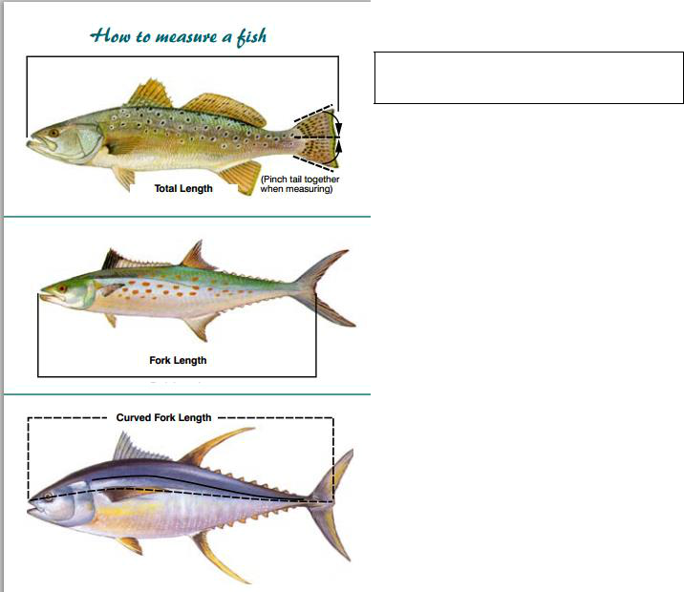Appendix: A

Use this method for all fish except for those listed below

Use this method for:

Amberjack, Barracuda, King Mackerel, Spanish Mackerel, Florida /African Pompano and Wahoo

Use this method for: False Albacore and all Tuna

|  |  |  |  |  |  |  |  |  |  |
| --- | --- | --- | --- | --- | --- | --- | --- | --- | --- |
|  |  |  | **ST. JAMES FISHING CLUB DERBY** | | | | |  |  |
|  |  | **2025 Saltwater Derby Species List Appendix "B"** | | | | | |  |  |
|  | **MEASURE** |  | **Past Leader** |  |  | **Current Leader** |  |  |  |
| **FISH** | **METHOD** |  |  |  |  |  |  |
|  |  |  |  |  |  |  |  |
|  |  | **ANGLER** | **LENGTH** (INCHES) | **CAPTAIN** | **ANGLER** | **LENGTH** (INCHES) | **CAPTAIN** | **DATE CAUGHT** |  |
|  |  |  |  |  |  |  |  |  |  |
| Albacore, False | CFL | Bill Smith | 40.0" | Mary Smith | **Joe Johnson** | 45.0" | Guide | 1/4/19 |  |
| Albacore, False | CFL |  |  |  | Non-Member | 46.5" | **Mary Johnson** | 1/6/19 |  |
| Amberjack | FL | Jack McFarlin | 31.0" | Mike Carney | Chuck Jackson | 35.0" | Hirioki Tomo | 1/5/19 |  |
| Barracuda | FL |  |  |  |  |  |  |  |  |
| Bluefish | TL |  |  |  |  |  |  |  |  |
| Cobia | TL |  |  |  |  |  |  |  |  |
| Croaker | TL |  |  |  |  |  |  |  |  |
| Dolphin | TL |  |  |  |  |  |  |  |  |
| Drum, Black | TL |  |  |  |  |  |  |  |  |
| Drum, Red Slot | TL |  |  |  |  |  |  |  |  |
| Drum, Red Release | TL |  |  |  |  |  |  |  |  |
| Flounder | TL |  |  |  |  |  |  |  |  |
| Grouper | TL |  |  |  |  |  |  |  |  |
| Grunt | TL |  |  |  |  |  |  |  |  |
| Mackerel, King | FL |  |  |  |  |  |  |  |  |
| Mackerel, Spanish | FL |  |  |  |  |  |  |  |  |
| Mullet, Sea/Whiting | TL |  |  |  |  |  |  |  |  |
| Pompano, Florida | FL |  |  |  |  |  |  |  |  |
| Porgy, Red | TL |  |  |  |  |  |  |  |  |
| Porgy, Other | TL |  |  |  |  |  |  |  |  |
| Sea Bass, Black | TL |  |  |  |  |  |  |  |  |
| Sheepshead | TL |  |  |  |  |  |  |  |  |
| Snapper, Vermilion | TL |  |  |  |  |  |  |  |  |
|  |  |  |  |  |  |  |  |  |  |
| Tilefish | TL |  |  |  |  |  |  |  |  |
| Triggerfish | TL |  |  |  |  |  |  |  |  |
| Trout, Gray | TL |  |  |  |  |  |  |  |  |
| Trout, Speckled | TL |  |  |  |  |  |  |  |  |
|  |  |  |  |  |  |  |  |  |  |
| Tuna, Blackfin | CFL |  |  |  |  |  |  |  |  |
| Wahoo | FL |  |  |  |  |  |  |  |  |
| BLUEGILL | TL |  |  |  |  |  |  |  |  |
| CATFISH | TL |  |  |  |  |  |  |  |  |
| LARGEMOUTH BASS | TL |  |  |  |  |  |  |  |  |
|  |  |  |  |  |  |  |  |  |  |
| **Captain of the Year** | **Salt Water** | |  |  |  |  |  |  |  |
| **Captain of the Year** | **Inshore Salt Water** | |  |  |  |  |  |  |  |
| **Angler of the Year** | **Salt Water** | |  |  |  |  |  |  |  |
| **Angler of the Year** | **Inshore Salt Water** | |  |  |  |  |  |  |  |
| **Angler of the Year** | **Fresh Water** | |  |  |  |  |  |  |  |



**Please submit entries to** Nick Colatosti, [stjfishgroup@gmail.com)](mailto:stjfishgroup@gmail.com))

**Additional Species,** Jack Crevalle, Red Snapper, African Pompano, Sailfish, Mako Shark, Tautog, Triple Tail, Spot, Atlantic Bonito, Spade Fish and Hog Fish.These fish are in addition to the ones listed in appendix B.**:** All billfish caught will receive awards, but the fish must be brought to the boat (leader touched), and a picture must accompany entry.

|  |  |  |  |  |  |  |  |  |  |
| --- | --- | --- | --- | --- | --- | --- | --- | --- | --- |
|  |  |  | **ST. JAMES FISHING CLUB DERBY** | | | | |  |  |
|  |  | **2025 Inshore Saltwater Derby Species List** | | | | | |  |  |
|  | **MEASURE** |  | **Past Leader** |  |  | **Current Leader** |  |  |  |
| **FISH** | **METHOD** |  |  |  |  |  |  |
|  |  |  |  |  |  |  |  |
|  |  | **ANGLER** | **LENGTH** (INCHES) | **CAPTAIN** | **ANGLER** | **LENGTH** (INCHES) | **CAPTAIN** | **DATE CAUGHT** |  |
|  |  |  |  |  |  |  |  |  |  |
| Bluefish | TL |  |  |  |  |  |  |  |  |
| Croaker | TL |  |  |  |  |  |  |  |  |
| Drum, Black | TL |  |  |  |  |  |  |  |  |
| Drum, Red Slot | TL |  |  |  |  |  |  |  |  |
| Drum, Red Release | TL |  |  |  |  |  |  |  |  |
| Flounder | TL |  |  |  |  |  |  |  |  |
| Grunt | TL |  |  |  |  |  |  |  |  |
| Mackerel, King | FL |  |  |  |  |  |  |  |  |
| Mackerel, Spanish | FL |  |  |  |  |  |  |  |  |
| Mullet, Sea/Whiting | TL |  |  |  |  |  |  |  |  |
| Sea Bass, Black | TL |  |  |  |  |  |  |  |  |
| Sheepshead | TL |  |  |  |  |  |  |  |  |
| Tarpon | FL |  |  |  |  |  |  |  |  |
| Trout, Gray | TL |  |  |  |  |  |  |  |  |
| Trout, Speckled | TL |  |  |  |  |  |  |  |  |
|  |  |  |  |  |  |  |  |  |  |
|  |  |  |  |  |  |  |  |  |  |
| **Captain of the Year** | **Salt Water** | |  |  |  |  |  |  |  |
| **Captain of the Year** | **Inshore Salt Water** | |  |  |  |  |  |  |  |
| **Angler of the Year** | **Salt Water** | |  |  |  |  |  |  |  |
| **Angler of the Year** | **Inshore Salt Water** | |  |  |  |  |  |  |  |
| **Angler of the Year** | **Fresh Water** | |  |  |  |  |  |  |  |



**Please submit entries to** Nick Colatosti, [stjfishgroup@gmail.com)](mailto:stjfishgroup@gmail.com))

**Additional Species,** Jack Crevalle, Red Snapper, African Pompano, Sailfish, Mako Shark, Tautog, Triple Tail, Spot, Atlantic Bonito, Spade Fish and Hog Fish.These fish are in addition to the ones listed in appendix B.**:** All billfish caught will receive awards, but the fish must be brought to the boat (leader touched) and a picture must accompany entry.