Optomap
NEW! Wider Images

✔ Fast, easy, and comfortable (no dilation)
✔ 215-degree view of the retina vs 45-degree view through the microscope
✔ Provides a permanent record for annual review
A comprehensive examination of your eyes is crucial to ensuring their health, and utilizing the Optomap is the most effective method available. This advanced imaging system captures up to 82% of your retina in a single image, significantly reducing examination time and minimizing risks. These images facilitate the physician’s assessment of ocular health and allow for the detection of various conditions such as macular degeneration, glaucoma, and retinal detachments with confidence.
These problems can threaten vision without warning or symptoms.
“I would never do an eye exam on a friend or family member without retinal images.” ~Dr. David Anderson

The cost of the Optomap is $39 (it is typically not covered by vision insurance but we will check for you).
 | I would like this procedure. |  | No, thank you.*
____________________________________ Patient Signature Date
* If opting out of imaging, it may be necessary to schedule an appointment for dilation at a later time.
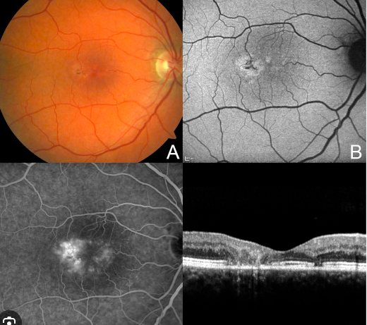
More information: We are proud to introduce the latest Optomap camera, featuring auto-fluorescence retinal imaging technology that is quick, painless, and free from the residual effects of dilation.

With digital imaging, we can identify early changes linked to glaucoma, cataracts, and macular degeneration. This technology can be used with or without dilation and will be included in your medical records. It is important to understand that once vision symptoms appear, it is often too late to prevent permanent damage. We are dedicated to actively monitoring your eye health, and the Optomap is the most effective means to achieve this.

