**CHAPTER 22**

**SUBDIVISION AND LAND DEVELOPMENT**

**Part 4**

**Construction and Design Standards**

**§401. General Standards.** The standards outlined in this Part shall be applied by the Township in evaluating plans for proposed subdivisions or land developments. The standards outlined herein shall be considered minimum standards for the protection of the public welfare and the Township may require more restrictive standards where special circumstances warrant. Whenever municipal or other applicable regulations impose more restrictive standards, such other regulations shall control.

**§402. Hazardous Areas.** Land deemed by the Township to be uninhabitable because of hazards to life, health, or property such as flooding, excessive slope, soil instability, inadequate soil bearing strength, or inadequate access shall not be subdivided or developed for building purposes unless:

(1) The hazard has been eliminated, or

(2) The plans show adequate safeguards to reduce the impact of the hazardous condition.

**§403. Conformity with Zoning and Comprehensive Plans.** The location of the subdivision shall conform to the township comprehensive plan, and the use of land in the subdivision shall conform to any applicable zoning ordinance.

**§404. Streets.**

(1) Street System General Arrangement. The following criteria shall be considered in the design of streets in the Township:

(a) The arrangement of streets shall be in a manner that minimizes congestion, avoids hazardous intersections, provides convenient and safe access to the property and shall conform to the circulation plan of the Township comprehensive plans, to official maps, and to such County, Municipal, and State road and highway plans as have been duly adopted.

(b) Proposed streets shall be coordinated with existing or proposed streets on adjacent properties and shall be planned and designed for the continuation of existing streets in adjoining areas, the proper projection of streets into adjoining undeveloped or unplatted areas and the continuation of proposed streets to the boundaries of the tract being developed.

(c) Streets shall be laid out to be harmonious with the existing and proposed site characteristics including, but not limited to, slope, best use, parcel layout, runoff, soil capacity, water table, floodplain, sight distance, traffic volume and safety, pedestrian use, traffic control, and parking.

(d) Curvilinear streets should be utilized only where their use will be consistent with adjoining development patterns, topography, and natural features of the site.

(e) Curvilinear streets shall not be used immediately adjacent to an existing grid street system without providing a transition that continues and projects the historic grid.

(f) Streets shall be laid out to preserve the integrity of their design.

(g) Streets shall be laid out to conform as much as possible to the topography in order to permit efficient drainage and utility systems, to require the minimum number of streets necessary to provide for convenient and safe access, and to result in usable lots and satisfactory street grades.

(h) Streets which provide ingress and egress to residential areas of single and multiple family dwellings shall be laid out to discourage and minimize their use by through traffic and to discourage excessive speeds; however, street connectivity into and from adjacent areas is encouraged and will generally be required.

(i) If lots resulting from a subdivision or land development, including the residual tract, are large enough for re-subdivision, adequate street right-of-way to permit further subdivision and land development shall be provided as necessary.

(j) Where a subdivision or land development abuts a collector or arterial street the Township may require an internal street system, marginal access street, rear service street, reverse frontage lots, shared driveways, or such other treatment as will provide protection for abutting properties, reduction in the number of intersections and driveways with the collector or arterial street, and to separate local and through traffic.

(k) Adequate vehicular and pedestrian access shall be provided to all lots abutting the street.

(l) Where streets continue into adjacent municipalities the applicant shall coordinate the design of the street with the Township and the adjacent municipalities in order to ensure uniform cartway widths, pavement cross sections, and other public improvements.

(m) All proposed connections to existing streets shall be approved by the jurisdiction in which the existing streets are situate. No proposed connection to an existing street will be approved if (1) existing intersections affected by the proposed development having an existing Level of Service of “A”, “B”, or “C” may be reduced to a Level of Service of less than “C” as a result of the maximum build out of the proposed development or (2) any existing intersection affected by the proposed development has an existing Level of Service of “D”, “E” or “F”. Provided however that said connection shall be permitted if the developer/owner/applicant makes arrangements satisfactory to the Township to assure that the Level of Services of the said existing intersections is an “A”, “B”, or “C”. Said arrangement to be in writing. The Level of Service of said intersections both the current level and the level at build out shall be included in the required Traffic Study and shall be identified based upon Pennsylvania Department of Transportation standards and regulations as amended from time to time.

(n) Streets shall be designed with drainage grates that are safe for crossing by bicycles and horse drawn vehicles.

(o) All streets must meet the Pennsylvania Department of Transportation (Penn DOT) requirements for liquid fuel allocation.

(p) Additional infrastructure may be required where design standards warrant further improvements based on traffic impact studies.

(q) Where a subdivision or land development abuts or contains an existing street right-of-way of improper width or alignment, the Township may require the reservation of additional land sufficient to widen the street or correct the alignment.

(r) The Township shall determine the classification of roadway and street systems. This determination, if necessary, should be obtained prior to the design process.

(2) Traffic Engineering Report.

(a) The applicant developer shall prepare a Traffic Impact Study (TIS) where any of the following conditions are met. All calculations shall be based on the Institute of Transportation Engineers, or its successor’s, most recent manual and shall be based on full, complete build out of project regardless of the number of stages or phases.

(1) The site is expected to generate 100 or more vehicle trips entering or exiting the development during any one hour time period of any day of the week.

(2) When any subdivision or land development will result in the creation of 25 or more lots, or 25 or more residential living units.

(3) If the entire site, upon final build out, is expected to generate 3,000 or more average daily trips or 1,500 average vehicles per day.

(4) Existing development sites that are expanded or redeveloped and the expanded or redeveloped site is expected to generate 100 or more additional trips entering or exiting the site during any one hour period of any day of the week.

(5) The elimination of a street or road resulting in redistribution of traffic onto the existing roadway network.

(6) The Township may require a Traffic Impact Study when its Engineer determines that the development is expected to have significant impact on its existing highway, street and/or road system regarding safety or traffic flows even if none of the conditions above are met.

(b) The Township and/or Pennsylvania Department of Transportation may require a Transportation Impact Assessment (TIA) for a proposed development or redevelopment even if the conditions set forth above are not met. Factors in determining if a TIA may be necessary include but are not limited to location of the proposed access and site configuration, existing or potential congestion and delay on surrounding roadway network, and/or safety concerns. The purpose of a TIA is to assess the impact of the development on specific intersections or elements of the state or local transportation system. A TIA shall be prepared in the same manner as a TIS as applicable and may be incorporated as part of a TIS.

(c) The said TIS and TIA shall be prepared by a person who possesses a current Professional Engineer’s license issued by the Commonwealth of Pennsylvania, shall be prepared in compliance with the applicable Pennsylvania Department of Transportation’s most recent policies and procedures for preparation of said report or study and the Engineer shall affix his/her seal and signature to the report.

(d) Prior to the commencement of a TIS and/or a TIA, the applicant developer’s engineer shall submit a scope of the study to the Township and the Township Engineer for review and approval.

(e) The Township may elect to have the studies and supporting documents reviewed by a qualified engineer for completeness, accuracy and consistency with the applicable policies, practices, and procedures and report their findings as recommendations or comments to the Township for consideration of acceptance of the study. All costs associated with the reviews shall be the responsibility of the applicant developer.

(Ordinance No. 38, adopted September 27, 2011)

## (3) Required Right-Of-Way and Cartways.

(a) Right-of-way and cartway widths contained in this Part are the minimum required for streets based upon the need to provide efficient movement of vehicles, serve utilities, accommodate ponding runoff, storage of plowed snow, emergency parking, temporary roadway adjustments during maintenance and accidents, and to accommodate future improvements.

(b) The applicant shall certify that title to any street right- of-way is free and clear of all liens and encumbrances and that no prior right-of-way has been granted to any utility or any other person or if so granted shall be clearly identified.

(c) Right-of-way and cartway widths should not be less than that required for all elements of the design cross sections, utility accommodation, and appropriate border areas, such as in cul-de-sacs, and by the Penn DOT Liquid Fuels Regulations. All plans shall be designed to provide for the entire right-of-way and cartway widths. Refer to Table 4-1 of this Ordinance for the minimum requirements.

(d) The Township may require a right-of-way width greater than PennDOT specifications and the standards set forth in Table 4-1 of this Part for reasons of public safety and convenience, for acceleration and deceleration lanes into parking lots, streets, or high density developments, or to provide for future service roads.

(e) The right of way and cartway width of a new street that is a continuation of an existing street shall in no case be continued at a width less than the existing street. Where the right-of-way and cartway width of the new street is greater than the existing street, a transition area shall be provided, the design of which is subject to Township approval.

(f) All of the right-of-way shall be graded similar to the street grade. The slope of banks along street centerlines shall be no steeper than the following:

(1) One (1) foot of vertical measurement for three (3) feet of horizontal measurement for fills.

(2) One (1) foot of vertical measurement for two (2) feet of horizontal measurement for cuts.

Where a cut or fill abuts a sidewalk there shall be a two (2) foot level area adjacent to the sidewalk and the fill slope shall not exceed three to one (3:1) slope.

(g) Where a subdivision or land development adjoins undeveloped acreage, new streets or reserved right of ways shall be provided to the boundary lines of the development.

## (4) Street Design Standards. The following design criteria shall be considered the minimum standards in the design of streets:

(a) Streets shall be designed for a twenty (20)-year service life. If a street is to be utilized prior to completion of construction of buildings on land abutting the street, the utilized portion must be structurally designed to support all anticipated loading without significant loss of the designed service life of the street.

(b) Special consideration for future bus and truck routes must be taken into consideration in the design of streets for pavement thickness and width, sight distances and curb radii.

(c) Streets located in floodplain or flood prone areas shall be designed and constructed to meet the requirements of the applicable statutes, laws, ordinances, rules and regulations.

(d) Traffic calming techniques should be considered with projects that result in high vehicular or pedestrian traffic areas of commercial development and transition areas between commercial and residential development. Techniques shall be employed based on Penn DOT regulations.

(e) Design Speed. The maximum design speeds and operating speeds shall be as shown in Table 4-1.

(f) Vertical Alignment.

(1) Vertical curves shall be used in changes of grade exceeding one percent. In order to provide proper sight distances, the minimum length (in feet) of vertical curves shall be as computed in accordance with the Penn DOT regulations.

(2) The minimum grade on all local streets shall be one half (0.5) percent. The maximum grade on any street shall not exceed twelve (12) percent; however, grades not more than sixteen (16) percent may be used for limited distances less than 300 feet and shall be subject to the approval of the Township prior to design. Refer to Table 4-1.

(3) Grades at intersections shall be as flat as possible. The grade of the approach shall not exceed four (4) percent grade change for forty (40) feet or greater depending on the stacking length of the vehicles caused by high traffic volume areas. Refer to Table 4-2 for further design requirements.

(g) Horizontal Alignment.

(1) Alignment between control points should conform to topography following closely the natural contours, consistent with the design speed, the traffic volumes to be served, the right-of-way and construction cost.

(2) Horizontal curves shall be designed in accordance with Table 4-1.

(h) Intersections.

(1) Streets shall intersect as nearly as possible at right angles, and no street shall intersect another at an angle of less than seventy-five (75) degrees, or more than one-hundred and five (105) degrees.

(2) No more than two (2) streets shall intersect at the same point.

(3) Street intersections shall be designed with a minimum of fifteen (15) foot radii, but should at all times be designed to safely accommodate the intended vehicular traffic such as combination trucks and buses. Refer to Table 4-2 for additional minimum curb radii.

(4) The corner sight distances or clear sight triangle for each design speed shall be as specified in the Township Zoning Ordinance. The clear sight triangle shall be maintained as open space with no visual obstructions (Refer to Figure 4-1).

(5) Sight distances for all intersection, horizontal alignments, or vertical alignments shall be designed to achieve the required minimum safe sight distances and safe stopping distances as specified in accordance with PennDOT regulations.

(6) Any street intersecting with another street shall not be located closer than the distances specified in Table 4-2. Distances shall be measured from the centerline of the two intersecting streets along the centerlines.

(7) Where a subdivision or land development is provided access by a single street, the Township may, in its sole and absolute discretion, require a boulevard-type entrance that would consist of two streets having a width of 20 feet each separated by an island having a width of 10 feet within a right- of-way having a width of 70 feet.

(8) All signalized intersections shall be equipped with preemption devices acceptable to the fire company primarily responsible for the area of the Township in which the intersection is situated.

(9) Any subdivision or land development, which can be expected to generate more than 200 vehicle trips per day shall provide any or all of the following facilities as may be required to provide safe and efficient operation at any proposed driveway or street:

(a) Acceleration or deceleration lanes;

(b) Concrete median or median barriers;

(c) Left-turn lanes;

(d) Traffic signals;

(e) Lane markers; and

(f) Other such traffic control devices as may be necessary.

(10) Turning lanes, medians, acceleration and deceleration lanes, traffic signals, lane markers and other such traffic control devices required shall be designed in accordance with PennDOT regulations.

(i) Roadway Cross Sections. Minimum widths of roadway surface and shoulders shall be in accordance with Table 4-1 and Figure 4-2. All roadways shoulders and berms shall be constructed in accordance with Penn DOT specifications and standards as established from time to time.

Any conflict in the provision of this Ordinance and Penn DOT specifications and standards shall be resolved in favor of the stricter standards.

(j) Structures.

(1) Bridges, culverts, walls, tunnels and other structures should be designed in accordance with the current AASHTO publication “Standard Specifications for Highway Bridges” and Penn DOT regulations.

(2) The design of all structures is subject to the review and approval of the Township Engineer.

(3) For new construction projects required bridge widths and design load structural capacities shall be designed using Penn DOT regulations.

(4) A 14’-0’’ minimum vertical clearance plus an allowance of six (6) inches to accommodate future resurfacing shall be provided for all new and reconstructed facilities on or over collector and local road facilities.

(5) A 16’-0” minimum vertical clearance plus an allowance of six (6) inches to accommodate future resurfacing shall be provided for all new and reconstructed facilities on or over Interstate, limited access, and arterial facilities.

(6) For additional vertical clearance requirements refer to PennDOT regulations.

(7) The minimum width criteria and minimum design load structural capacities shall be as indicated in the applicable PennDOT regulations.

(8) All laterals, pipes, conduit, tunnels or similar structures intended to provide utility services, storm water drainage or other similar use to a lot or parcel of land abutting a street or road shall be installed at the time the road or street is constructed. Said installation shall be subject to such reasonable requirements as the Township may impose to prevent settling around the same.

(k) Special Streets.

(1) Cul-de-Sacs.

(a) A cul-de-sac will not be permitted when a through street is feasible. The feasibility of a through street will be based on the physical features of the tract proposed for development, the potential for extension of the street to adjoining lands, restrictions imposed by other government regulations, and the ability to design to meet all other requirements of this Ordinance. When cul-de-sacs are proposed, a written analysis of the merits of the design and the reasons that a through street would not be feasible shall be submitted. Approval of cul-de-sac streets shall be at the sole discretion of the Township.

(b) Cul-de-sacs shall not be used immediately adjacent to an existing grid street system without providing a transition that continues and projects the historic grid.

(c) Cul-de-sacs shall be prohibited where it is possible to provide loop streets that provide better access for emergency vehicles, fewer restrictions on snow removal, and improved pedestrian access.

(d) Permanently designed as such cul-de-sac streets shall not exceed such length as the fire department servicing the portion of the Township in which the street is situate determines to be the maximum length it can service with its then current equipment the same not to exceed 1,000 feet in length. The length shall be measured from the intersection of the centerline of the said street with the centerline of the street that intersects to the center point of the cul-de-sac turnaround.

(e) Permanent cul-de-sac streets shall have a paved, circular turnaround with a minimum radius to the curb line of forty-five (45) feet and the minimum radius to the right-of-way lines shall be fifty (50) feet. Refer to Figure 4-3 for minimum geometrical requirements.

(f) An interior island may be permitted in the cul-de-sac turnaround at the discretion of the Township.

(g) The centerline grade on a cul-de-sac street shall not exceed ten (10) percent and the grade of the diameter of the turnaround shall not exceed four (4) percent.

(h) Temporary cul-de-sacs shall be permitted at the sole and absolute discretion of the Township and only when the street is intended to be extended. Temporary cul-de-sacs shall be constructed to the same standards and designs as permanent cul-de-sacs. When the street is extended the improved area outside the street cartway and berm shall be placed in the same condition as the land adjacent to the berm and all required grades and storm water drainage systems shall be installed. At the time the temporary cul-de-sac is approved the Applicant shall execute an agreement with the Township guaranteeing the work to be done in removing the temporary cul-de-sac as well as the costs to vacate or revoke an easement for that portion of the cul-de-sac to be removed when the street is extended. Financial security satisfactory to the Township shall be pledged with the said agreement.

(i) Unless future extension is clearly impractical or undesirable and it is clearly demonstrated by the applicant to the Township, the turnaround right-of-way shall be placed adjacent to the tract boundary with sufficient additional width provided along the boundary line to permit extension of the street at full width.

(j) The mail and newspaper boxes servicing structures erected upon lands abutting cul-de-sac shall be placed in a cluster at either the beginning or end of the radius of the cul-de-sac, the same to be in accordance with the United States Postal regulations. No mail box shall be erected or maintained upon or along the radius of any cul-de-sac. The location of the mail boxes as provided herein shall be set forth on the subdivision plan in which the cul-de-sac is located.

(k) There shall be no more than 3 driveways accessing a cul-de-sac. In the case of driveways accessing a single lot the width of the driveway within the street right-of-way shall not exceed 10 feet in width. The driveways shall be at least 15 feet from the side lot lines measured at the point of the intersection of the said lot line and the right-of-way line of the street. Driveways in no case shall be closer than 5 feet from any lot line beyond the right-of-way

Where there are more than 3 lots abutting a cul-de-sac common driveways shall be utilized to service 2 or more lots. Said common driveways will be placed at the location of the common boundary lot line with one half of the driveway on each lot. The width of common driveways shall not exceed 20 feet. Where common driveways are to be utilized the developer shall provide the Township with a written agreement as to the maintenance of the said driveway, a copy of said agreement shall be recorded in Union County.

(2) Dead End Streets. Dead end streets are prohibited unless designed as cul-de-sac streets or designed for future access to adjoining lands.

(3) Half or Partial Streets. New half or partial streets are prohibited except as otherwise permitted herein.

(4) Alleys. Alleys may be permitted only in Commercial or Industrial land developments, with the concurrence of the Township and shall comply with the following standards:

(a) Alleys may not be used as the only means of access to a lot.

(b) Alleys shall have a minimum right-of-way width of 24 feet and a minimum cartway width of 16 feet. Where necessary, corners shall have a radius adequate to accommodate any large vehicles that may be expected to use the alley.

(c) Dead end alleys shall not be permitted.

(d) Alleys should be designed and constructed in accordance with the local street standards in this Ordinance.

(e) Alleys should be sized to accommodate emergency vehicles and the vehicular turning movements desired.

(5) Private Streets.

(a) The private street system shall be designed and built to accommodate the type and volume of traffic anticipated to be generated and shall be constructed in accordance with the standards and criteria established in this Part for public streets.

(b) Private streets shall be approved at the sole discretion of the Township.

(c) Private streets i.e those not accepted for dedication shall be prohibited unless design objectives of the development warrant private ownership, the Township will not approve private street, if at all, until the following conditions are met:

(1) A private right-of-way agreement shall be properly executed by the landowner granting the access to all lots and tracts abutting and adjoining said private street and shall run with the land and be available for the use of all owners, present and future. This agreement is subject to the approval of the Township;

(2) The adjoining landowners or an association of property owners agree that the street(s) shall not be dedicated but shall be maintained by the adjoining landowners or association of property owners;

(3) The adjoining landowners or association of property owners agree to the maintenance of the private street in a mud-free condition and agree that the adjoining lot owners or an association of property owners agree to provide for repair, snow removal, and any other necessary maintenance;

(4) The agreement is entered into by the adjoining landowners or an association of property owners and shall be recorded with the Union County Recorder of Deeds as part of the Final Plan and subsequently reflected in the deeds of all future lot owners. This agreement shall establish the conditions under which the street will be constructed and maintained as well as conditions controlling the offer of dedication and provisions for funds sufficient to restore the private street to the standards required for public streets should dedication occur.

(d) A notation shall be included on the final plan and reflected in the deeds of conveyed lots identifying the street right-of-way as “Private” and identifying the entity responsible for maintenance.

(e) All gates on private streets shall be located a minimum of thirty (30) feet from the public right-of-way and shall not open outward. Emergency personnel shall have ready access to locking mechanisms on any gate restricting access.

(f) Private streets shall be considered a required improvement and must be constructed prior to Final Plan approval or, in lieu of completion of improvements, the applicant must provide an acceptable guarantee to be approved by the Township.

# (5) Street Construction Standards.

# (a) At a minimum all street construction activities shall be performed in strict accordance with Penn DOT regulations including all references, supplements, and revisions, Table 4-3 of this Ordinance, and to applicable Township ordinances and requirements in order to ensure proper serviceability.

(b) Liquid Fuels Requirement.Any street or part thereof offered for dedication or intended to be offered for dedication to the Township for inclusion into the road system, shall comply with the minimum requirements of Penn DOT covering the allocation of liquid fuel tax receipts and the standards outlined in this Ordinance.

(c) All streets and related facilities shall be staked-out during construction by an individual qualified in the construction, engineering, or surveying field to ensure that infrastructure is constructed in accordance with the approved design drawings.

(d) The applicant shall be responsible for implementing all necessary plans to control, mitigate, and eliminate any forms of pollution, disturbance, or destruction resulting from noise, odor, stormwater, and/or excessive loads or repetitions of loads that may occur during construction.

(e) The applicant shall furnish the necessary guards, watchmen, warning lights and similar items necessary to maintain state highway and other street traffic in accordance with Penn DOT regulations. In general, the applicant shall not be permitted to interrupt traffic without specific arrangements for detouring traffic in accordance with PennDOT requirements. When traffic cannot be detoured, a minimum of ½ the roadway width shall be open at all times with traffic control.

(6) Street Improvements.

(a) Curbs and Gutter.

(1) Curbing may be required by the Township for:

(a) Stormwater management;

(b) Road stabilization;

(c) To delineate parking areas;

(d) Ten feet on each side of drainage inlets;

(e) At intersections;

(f) At corners; and

(g) At tight radii.

(2) Curbs shall be required on streets in subdivisions and land developments having lots 80 feet or less in width.

(3) Curbs shall be constructed in accordance with PennDOT specifications as from time to time amended and /or replaced.

(4) Concrete curb shall be eighteen (18) inches high, eight (8) inches wide, and have an exposed face of eight (8) inches. Refer to Figure 4-4. Alternative types of concrete curb can be approved at the Township’s discretion.

(5) Terminal concrete curbs or terminal radii shall be provided at the start or cut-off locations as needed for streets to transition from one pavement section to another.

(6) Curbing shall be designed to provide a ramp for bicycles and/or wheelchair access at each intersection, at the principal entrances to buildings which front on parking lots, and at all crosswalks.

(b) Shoulders.

(1) Paved shoulders and drainage swales shall be used instead of curbs when:

(a) Shoulders are required by law;

(b) Soil or topographic conditions make the use of shoulders and drainage swales preferable; or

(c) It is in the best interest of the community to preserve its rural character.

(2) Shoulders shall be required on streets where curbing is not required. Refer to Figure 4-2.

(3) The depth of shoulders shall be the combined depth of the surface and base courses. Refer to Figure 4-2 for the roadway pavement depths.

(c) Sidewalks and Pathways.

(1) Sidewalks shall be required for streets where any of the following are met:

(a) Distance to the nearest school is within State limits, which requires students to walk rather than be transported;

(b) To continue existing sidewalks from adjoining subdivisions or land developments; and

(c) Within planned business, commercial, and industrial developments, apartment complexes, townhouses, condominiums, and mixed-use developments.

(2) Pedestrian way easements ten (10) feet wide may be required by the Township through the center of blocks more than six hundred (600) feet long to provide circulation or access to schools, playgrounds, shopping, or other community facilities.

(3) Sidewalks, where provided, shall be located within and be parallel with the street right-of-way; however, alternative locations will be considered to preserve topographic features and to provide visual interest provided the applicant shows that an alternative system maintains safe and convenient pedestrian circulation to the satisfaction of the Township.

(4) The minimum width of all sidewalks and pathways shall be four (4) feet. Wider widths may be necessary near major pedestrian generators and employment centers.

(5) There shall be a minimum four (4) foot planting strip of grass between the curb or shoulder and the sidewalk. This planting strip may be used for the location of underground utilities, streetlights, and street signs but shall not be used for the planting of street trees.

(6) The grades and paving of the sidewalks shall be continuous across driveways except in non-residential and high-density developments and in certain other cases where heavy traffic volume dictates special treatment.

(7) The sidewalk shall be constructed of at least four (4) inches of Class AA concrete and a six (6) inch depth at intersections and handicap and curb cut ramps. All curbs and sidewalks shall be underlain by four (4) inches of compacted crushed stone or gravel. Where sidewalks cross streets serving commercial and industrial uses the Township may impose additional requirements.

(8) Pathways may be constructed of other materials including pervious materials provided that the proposed materials and construction are appropriate to the surrounding land use, expected volume of pedestrian traffic, and are approved by the Township Engineer.

(9) Sidewalks and pathways shall be laterally pitched at a slope toward the street not less than one eighth (1/8) inch per foot to provide for adequate surface drainage.

(10) At corners and pedestrian street-crossing points, sidewalks shall be extended to the curb line with an adequate apron area for anticipated pedestrian traffic and curb cuts and ramps designed in accordance with federal Americans with Disabilities Act (ADA) accessibility requirements.

(11) Sidewalks and pathways shall not exceed a seven (7) percent grade. All sidewalks and ramps, e.g. slopes greater than five (5) percent, shall be designed in accordance with federal ADA accessibility requirements.

(12) Minimum construction standards for sidewalks shall be in accordance with Penn DOT regulations.

(d) Street Lighting.

(1) Street lighting shall be provided in accordance with an illumination plan designed in conformance with the standards of the local electric utility company and coordinated with the Township.

(2) Street lighting shall be provided by the applicant and shown on subdivision and land development plans as follows:

(a) All new intersections in commercial and industrial areas;

(b) All new intersections on existing arterial or collector streets;

(c) At the driveway, access, or entrance of any new residential development with ten lots or more or which enters onto an arterial road.

(3) A lighting plan shall be provided.

(4) Street lighting shall be provided as needed for public safety and convenience.

(5) The placement, height, and shielding of lighting standards shall provide adequate lighting without hazard to drivers or nuisance to nearby residents and the design of the lighting standard shall be of an appropriate type to the development and the Township.

(6) Lighting types and levels shall be designed based on recommended intensities specific to the area being lighted.

(7) All light fixtures, standards, and foundations shall be approved by the Township and all lighting plans shall be prepared by a person qualified in the design field.

(e) Street Signs.

(1) Design and placement of traffic control and street signs shall be provided by the applicant as needed and shall follow the requirements specified in Penn DOT regulations.

(2) At least two street name signs shall be placed at each four-way street intersection and one at each “T” intersection. Signs shall be installed under light standards (where applicable) and be free from visual obstruction.

(3) The design and placement of street signs shall be consistent, of style, color, and material and erected in accordance with Township standards or Pennsylvania Department of Transportation standards.

(4) The owner/developer/applicant shall be responsible to obtain, purchase and install all necessary Traffic control signs, street name signs and mounting apparatus in accordance with the materials and workmanship prescribed in Township and/or Pennsylvania Department of Transportation regulations for public and private streets, roads or lanes.

**§405. Lot Access and Driveways.**

(1) Lot Access. Access to any lot, tract, parcel, subdivision or development shall be provided in a manner that promotes a safe and efficient ingress and egress to a street, limits the number of driveways, and promotes common points of ingress and egress that are adequate for existing and future growth, and in accordance with the following:

(a) The Township may disapprove any point of ingress or egress to any lot, tract, parcel, or development from any street or highway when the proposed ingress or egress would create unsafe conditions, reduce the capacity of the adjoining street or highway, or result in substandard circulation and impaired vehicle movement.

(b) The Township may require the applicant to provide ingress and egress to a particular lot or tract through the remainder of his/her/its property or other properties over which the applicant has control. Recorded written easement shall be required in such cases.

(c) In approving ingress and egress from any State road or highway, the Township can only approve those access points that are not in conflict with safety standards of the Pennsylvania Department of Transportation. A Highway Occupancy Permit is required for each access point onto a State highway.

(d) The receipt of a Highway Occupancy Permit does not assume approval of the Township. The Township may require the applicant to reapply for a permit if the location of the Penn DOT approved access is in conflict with any provision of any Ordinance or if the Township feels the location of the access will hinder the safe and efficient movement on any State road or highway or the proper development of the site.

(2) Driveways. Proposed driveways shall conform to standards set forth in Township Ordinances and regulations. Additionally, all driveways shall, at a minimum, be designed in accordance with the following:

(a) All proposed lots shall be situated in such a fashion that safe and efficient driveway access can be provided onto a public or private street in accordance with this Section in order to facilitate the design of common points of ingress and egress that are adequate for existing and future growth.

(b) Driveways shall not interfere with the normal traffic movement on public or private streets nor be inconsistent with the design, maintenance, and drainage of the street.

(c) The Township may require the joint or shared use of driveways to provide ingress and egress when such design would increase traffic safety by decreasing the potential for vehicular conflicts. In such cases a shared driveway maintenance and use agreement acceptable to the Township, shall be entered into by the respective property owners and recorded.

(d) Driveway Classifications. For the purposes of this Section driveways are separated into the following four classifications:

(1) Minimum Use Driveway. A driveway normally used by not more than 25-vehicles per day (See Figures 4-7 & 4-8), such as:

(a) Single family dwellings, duplexes; or

(b) Apartments with five units or less.

(2) Low Volume Driveway. A driveway normally used by more than 25 vehicles per day but less than 750 vehicles per day (see Figure 4-9), such as:

(a) Office buildings;

(b) Schools; or

(c) Car washes.

(3) Medium Volume Driveway. A driveway normally used by more than 750 vehicles per day but less than 1,500 vehicles per day, which does not normally require traffic signalization (See Figure 4-10), such as:

(a) Motels;

(b) Fast food restaurants; or

(c) Service stations and small shopping centers or plazas.

(4) High Volume Driveway. A driveway normally used by more than 1,500 vehicles per day, which often requires traffic signalization (See Figure 4-11), such as:

(a) Large shopping centers; or

(b) Multi-building apartment or office complexes.

(5) Driveway Design Standards. Driveways shall be designed in accordance with all applicable geometric designs set forth in this Part and in the absence of design standards the latest version of Penn-Dot standards shall apply. In addition, the following shall apply:

(a) Driveways shall have a throat width and curb return radii based on the volume of traffic use of the intersection in accordance with Figures 4-7 through 4-11.

(b) Lots with less than 400 feet of street frontage shall only have 1 curb cut (drive access).

(c) Lots with more than 400 feet of street frontage may have 2 curb cuts.

(d) Double front lots may have 1 curb cut per street front.

(e) No driveway shall be placed within 5 feet from any side or rear lot line, or within 15 feet of any street or road right-of-way except as otherwise provided herein.

(f) All driveways shall meet the minimum sight distances as set forth in the most recent Penn-Dot standards.

(6) Driveways shall be located at a point within the property frontage that provides at least the minimum sight distance as prescribed below.

(a) Sight distances shall be in accordance with the Township Ordinances and Regulations but in no case shall the sight distances be less than the minimum Safe Stopping Sight Distance as computed in accordance with Penn DOT regulations.

(b) If sight distance requirements specified in this Section cannot be met, the Township may:

(1) Prohibit left turns by exiting vehicles;

(2) Restrict turning movements to right turns in and out of a driveway;

(3) Require installation of a right turn acceleration or deceleration lane;

(4) Require installation of a separate left turn standby lane;

(5) Alter the horizontal or vertical geometry of the roadway; or

(6) Deny access to the highway.

(7) Driveway shall not be placed at such locations as would interfere with the placement and proper functioning and maintenance of street signs, signals, detectors, lighting or other devices that affect or regulate traffic control.

(8) Where a lot abuts two or more streets access to the lot may be restricted to the street which can more safely accommodate ingress or egress to and from the lot.

(9) The Township may require the driveway to be locate directly across a street from a street or other driveway on the opposite side of the street if it determines that left turns from the lot serviced by the driveway or access from the street or driveway across the street will create a safety hazard.

(10) The number and location of driveways will be determined by the Township based upon usage, interior and exterior traffic patterns and current design standards. Normally 1 driveway will be permitted for residential use and no more than 2 driveways will be permitted for non-residential uses. Lots with unusually large street frontages may have additional driveways in the sole discretion of the Township.

(11) The location and angle of the driveway in relation to the street shall be such that a vehicle entering or leaving the driveway may do so in a safe manner and with minimum interferences with traffic.

(12) The design of the driveway shall be such as to accommodate the anticipated use of the lot.

(13) Driveways used for two way traffic shall be positioned at a right angle (90º) to the street or as near thereto as site conditions permit. Where 2 driveways are located on the same lot and used for one way traffic each driveway may be placed at an angle of less than a right angle but not less than a 45º angle.

(14) Driveways accessing a street shall be located at least 50 feet from the paved portion of a street intersecting the street being accessed.

(15) Multiple driveways accessing a single lot shall be separated by at least 10 feet measured along the shoulder, ditch line or curb. When the distance separating the said multiple driveway is 50 feet or less the driveways and area between the driveways shall be curbed.

(16) Application for driveways to be utilized for drive-in or drive-thru services shall, when requested, include information relative to the storage provided between the drive-in or drive-through facility and the street right-of-way line, the number of service operations during peak hours and the hours and days of operation.

(17) Curbing may be required when the Township determines that it is needed to control access, drainage of storm water, and/or parking. The location and extent of the curbing shall be determined by the Township.

(18) Except for common driveways servicing more than one lot or except as otherwise permitted herein driveways shall not be located in side or rear yards as defined in the Township Zoning Ordinance.

§406. Inspections.

(1) All streets, roads and alleys as well as related storm water systems and utilities (Improvements) whether intended to be public or private, shall be subject to inspection during construction to assure that the same are in compliance with the provisions of this Ordinance and all applicable statutes, laws, ordinances, rules and regulations.

(2) Prior to the commencement of construction the developer shall submit to the Township a written schedule for the said construction setting forth the anticipated commencement date and completion date for the various stages of construction. Developer shall, within 48 hours, communicate to Township, in writing, any deviation from the said schedule.

(3) Township shall cause inspections to be made of the construction at such times as it deems appropriate and/or necessary. The minimum inspections are as follows:

(a) Inspection of the placement of utilities within the right- of-way of said street, road and/or alley. Said inspection shall determine the materials used, the placement of components and structures in accordance with an approved plan, the compaction of back fill as well as any other matter deemed relevant by the Township. This inspection shall occur prior to the installation of the sub base.

(b) Inspection of sub base material and the compaction of the same. This inspection shall occur prior to the application of the base course.

(c) Inspection of the base course and compaction of the same. This inspection shall occur prior to the application of the wearing course.

(d) Inspection of the wearing course and compaction of the same.

(4) Developer shall provide Township with any information requested by it relative to the construction and its inspection including certifications from contractors, engineers and material suppliers. The same shall be provided promptly upon request and the information shall be in writing.

(5) Developer shall be responsible for the costs of said inspections and shall pay Township for the same within 15 days of the receipt of any invoice for said costs. The said costs to be in accordance with the Township’s fee schedule and in the case of engineers and/or consultants the actual cost charged for the service.

(6) The said inspections shall be made by those persons or firms designated by the Township the same to include Township employees and officials and others retained by the Township for such purposes.

(7) Upon the completion of an inspection a written report shall be prepared for Township use and a copy of the same will be provided to developer.

(8) In the event the said inspections reveal a failure to comply with the provisions of this Ordnance, with the approved plans or with applicable ordinance, laws, statutes, rules and regulations developer shall be notified of the same and shall take immediate steps to bring the work into compliance. Should developer fail to bring the work into compliance the Township shall issue a cease and desist order and proceed according to law.

# §407. Dedication.

(1) Township is under no obligation to accept any street, road, alley or related improvements.

(2) No street, road, alley and/or related stormwater systems will be accepted by Township unless the same are constructed in compliance with all applicable statutes, laws, ordinances, regulations and rules.

(3) No street, road, alley and/or related stormwater systems will be accepted for dedication without first having been inspected as provided by Township ordinances and regulations and all fees of said inspections having been paid.

(4) No street, road and/or alley offered for dedication shall be accepted by the Township as a public street, road or alley until (1) 100% of the lots abutting the same have been developed and structures have been erected thereon, and (2) all utilities and stormwater drainage facilities required to be installed within the right-of-way of said street, road or alley have been installed in accordance with all applicable laws, statutes, ordinances, regulations and rules and the approved plans for the same.

(5) Where the Board of Supervisors of the Township, in their sole discretion, determines that it is in the best interests of the Township exceptions to the provisions of this Ordinance dealing with dedication of streets, roads, alleys and related stormwater drainage systems may be authorized.

(6) At the time of the offer of dedication the person or entity offering the said street, road, alley and related stormwater drainage facility for dedication shall provide the Township with the following:

(a) Properly executed and recordable deed.

(b) A plan or drawing of the area proposed for dedication.

(c) Fees as established from time to time by the Board of Supervisors.

(d) A maintenance bond as provided for in the Pennsylvania Municipalities Planning Code.

**§408. Utilities.** The placement of utilities within a subdivision or land development shall be in conformity with all Township ordinances, resolutions and regulations as adopted and amended from time to time, as well as the following:

(1) All above ground structures, used singularly or in combination, for purposes of providing utility service shall be set back at least 5 feet from the edge of the public or private cartway. Where the right-of-way is of sufficient width or where the Township anticipates widening the cartway in the future the said setback may, in the sole discretion of the Township, be greater than 5 feet.

(2) No overhead utility lines may be suspended over a public or private cartway, except where the utility line crosses the cartway for the purpose of providing service to a parcel of land, to change the direction of the utility line or when additional support is needed for the utility line or structure. Approval for the installation of utility lines over cartways shall be given only when there is no other practical alternative. Commercial impractbility shall not be a suitable reason. When a utility line crosses a cartway it shall be at least 16 feet above the surface of the cartway.

(3) Co-location of utility lines shall be required where existing utility structures are in place. It shall be the responsibility of the Applicant to demonstrate to the Township’s satisfaction that co-location is impossible. Commercial impractibility shall not be a suitable reason. Utilities owning existing utility structures within the rights-of-way shall be reasonable in dealing with requests for co-location.

(4) Utility lines and structures installed in the rights-of-way of public or private streets shall be installed outside the existing and anticipated cartway, shoulders, storm water and drainage facilities. Where it is impossible to install the said lines and structures outside the cartways and shoulders the same may be installed within the shoulders or drainage facility but as far from the cartway as possible. Commercial impractibilities shall not be considered a valid reason for installing utility lines and structures in the shoulder and drainage facility. It shall be the responsibility of the Applicant to demonstrate that it is impossible to install the said lines and structures outside the cartway, shoulder and storm water drainage facilities and if placed in a storm water drainage area facility an engineer shall certify that the same does not cause a disturbance of the design of the storm water facility. The location of the said lines and structures shall be subject to the approval of the Township.

(5) All man hole covers, inspection ports, curb boxes, gates and other access structures or control devices shall be installed and maintained at elevations approved by the Township and shall have covers, tops, lids or other devices installed which shall clearly identify the same.

(6) No utility structure shall be installed where it creates a safety hazard for vehicular or pedestrian traffic or to property. All utility structures shall be properly maintained and where they, in the opinion of the Township, create a safety hazard they shall be replaced, repaired or moved.

(7) Upon the completion of the installation all materials excavated in the installation of utility lines and structures shall be graded in accordance with the subdivision or land development plan. Excavation permits shall be obtained under applicable Township ordinance and regulations and state and federal statutes, laws and regulations.

(8) Applicant shall notify all appropriate agencies, authorities, firms or persons of the work to be done.

(9) Applicant shall, at all times, provide traffic controls in accordance with the then applicable Pennsylvania Department of Transportation regulations when necessary. Minimum traffic controls shall include posting flag persons to direct and control traffic, warning signs, cones and/or flags in both directions of the work site.

(10) Applicant shall contact Pennsylvania Call One or its successors and all other appropriate agencies or authority to locate or certify existing utility lines and structures within the area of proposed work prior to starting any excavation, digging, boring or similar work.

(11) All work shall be in compliance with the then most recent standards and practices of engineers, utility regulators and other appropriate agencies and authorities including but not limited to Pennsylvania Department of Transportation regulations and the national electric safety code, subject however to the approval of the Township.

§409. Covenants and Restrictions.

(1) Developer/applicant shall submit Covenants and Restrictions Running With The Land with its application for Subdivision and/or Land Development plan approval. The said Covenants and Restrictions shall provide, inter alia, that:

(a) All lots within the subdivision or land development shall have a right of way over and along all streets, alleys, sidewalks and paths within the subdivision/land development.

(b) That the maintenance of the streets, alleys, and storm water drainage systems shall be the responsibility of the lot owners and shall set forth the manner in which the said maintenance shall be provided and the cost of the same paid.

The Covenants and Restrictions shall be recorded in the Office of the Recorder of Deeds in and for Union County, Pennsylvania, contemporaneously with the recording of the subdivision or land development plan.

The Covenants and Restrictions as well as the proposed method of maintenance shall be subject to the approval of the Township.

(2) A notation shall be placed on the plan and any deeds conveying any of the land that the Township is not obligated to accept dedication of any of the improvements and that the lot owners are responsible for the improvements.

(3) No street, alley or other improvements will be accepted for dedication, if at all, until (1) 100% of the lots abutting the same have been developed and structures have been erected thereon. (2) all utilities and storm water drainage facilities required to be installed within the right of way of said street or alley have been installed, (3) Township has inspected the said street, alley or improvements and the same has been found to be in accordance with all applicable ordinances, regulations and statutes, and (4) the costs of said inspections have been paid by applicant.

(4) At the time of the offer of dedication applicant shall provide the Township with the following:

(a) Properly executed and recordable deed of dedication.

(b) A plot or drawing of the area proposed for dedication.

(c) Fees as established from time to time by the Board of Supervisors.

(d) Maintenance bond as provided for in the Pennsylvania Municipalities Planning Code.

**§410. Blocks.** Blocks shall be a maximum of 1,600 feet in length, although the Township may grant a waiver to this requirement in the event of unusual topographic conditions.

**§411. Monuments.** Monuments shall be solid steel, aluminum, copper, or brass bars at least 30” long x ½” diameter and shall be set at all newly established points where lines or lines and curves intersect. Survey caps and underground magnetic markers may also be utilized in conjunction with bars used for monuments.

In subdivisions of 10 lots or greater, a minimum of two permanent reference monuments shall be established in the external boundary of the subdivision with the bar set in concrete at least 6” x 6” x30”.

**§ 412. Easements.**

(1) Utility easements will be located at such place as causes the least intrusion and still provide the utilities needed for the development or subdivision of the land. The size of the utility easement shall be the least area necessary to provide said services but in no event less than 20 feet in width and where necessary additional width shall be provided for maintenance of the said easement. The location, width and construction of the utility easement shall be in compliance with all local, state and federal ordinances, statutes, laws, rules and regulations. Upon cause shown the minimum width may be reduced by the Board of Supervisors.

(2) Where a subdivision or land development is traversed by a water course, drainage way, channel, or stream, there shall be provided a drainage easement conforming substantially with the line of such water course, drainage way, channel or stream and of such width as will be adequate to preserve the unimpeded flow of natural drainage without damaging adjacent property. Drainage easements shall also be provided for the maintenance and protection of storm sewers and other storm water management facilities. Easements shall permit necessary public or private channel maintenance or improvement work and access of equipment and shall prohibit buildings or other permanent structures. Maintenance responsibilities for private easements shall be provided in accord with the provisions of this Ordinance and applicable ordinances, laws, statutes, rules and regulations.

§413. Sewage Facilities.

(1) The Subdivisions shall be connected to a public sewer system in accord with the requirements of the Municipal Authority and the Pennsylvania Department of Environmental Protection unless connection is not feasible. The Township may permit the following alternatives listed in order of preference:

(a) Connection to a private sewer system designed and constructed by the developer in accord with the requirements of the Pennsylvania Department of Environmental Protection.

(b) Utilization of on lot sewage disposal facilities in accord with the requirements of the Pennsylvania Department of Environmental Protection.

(2) The developer shall submit documentation with the subdivision, land development or subdivision/land development plan application that verifies Municipal Authority or Township Sewage Enforcement Officer approval of the proposed sewage disposal method. Additional documentation shall be provided that verifies Pennsylvania Department of Environmental Protection approval.

(a) Lots Utilizing On-Lot Facilities. All lots utilizing on lot sewage facilities shall provide an approved sewage planning module in accordance with the most recent provisions of the applicable state, federal or local regulation.

(b) Lots Utilizing Private Sewer System, or Sewer Extension of a Public Sewer System. A copy of the approved Pennsylvania Department of Environmental Protection Planning Module for a Revision or Supplement shall be provided.

(c) Subdivision Not Approved For On-Lot Sewer Disposal. The Township may elect to grant subdivision approval without approved on- lot sewage facilities provided the following notation is prominently affixed to the plan:

“Lot #.....~ is not approved for on—lot sewage disposal. Subdivision plan approval does not guarantee that a permit for on-lot disposal can be obtained. No building or zoning permit for a structure or use requiring sewage facilities shall be issued by the Township for this lot until an on-lot sewage disposal permit has been obtained.”

**§414. Water Supply.**

(1) Public Water Supply. The subdivision or land development shall be connected to a public water supply company unless the developer provides documentation that such a connection is not feasible. The Township may require that the developer provide a cost feasibility study prepared by a licensed professional engineer as part of the documentation.

(2) On-Lot Water Supply. In the event that the water supply to a proposed subdivision or land development is proposed via individual on—lot wells, and where known groundwater problems exist, the Township may require that the developer provide a feasibility study by a licensed professional engineer or hydrogeologist to evaluate the adequacy of water quality and quantity for the proposed development. Prior to subdivision or land development plan approval the developer shall demonstrate that adequate, safe, and reliable water supply exists for the proposed development in accord with the standards of the applicable ordinances, statutes, laws, rules and regulations.

(3) Documentation of Available Water Supply. If water is to be provided by means other than private wells owned and maintained by the individual owners of lots within the subdivision or development, applicants shall present evidence to the Township that the subdivision or development is to be supplied by a certificated public utility, a bona fide cooperative association of lot owners, or by a municipal corporation, authority or utility. A copy of a certificate of public Convenience from the Pennsylvania Public Utility Commission or an application for such certificate, a cooperative agreement, or a commitment or agreement to serve the area in question, whichever is appropriate, shall be acceptable evidence.

**§415. STORM WATER MANAGEMENT.**

**§415.1. Storm Water Management.** Provisions for the management of storm water within a subdivision or land development shall be in conformity with Township Ordinances, resolutions and regulations as adopted and enacted from time to time.

(1) Applicability. This section shall apply to all subdivision and land development in areas within the Township for which a stormwater study plan is required.

(2) General Requirements.

(a) The management of storm water on the site, both during and upon the completion of construction, shall be accomplished in accord with this section. The design of any temporary or permanent facilities or structures and the utilization of a natural drainage system shall be in full compliance with this section and with the interpretations of the Township.

(b) Developers are urged to consider alternative solutions for storm water management and to select the most appropriate and economical system for their development project. Applicants are urged to consult with the Township Engineer and the Pennsylvania Stormwater Best Management Practices Manual for guidance in preparing the storm water management plan.

(c) All storm water management facilities including detention basins, sewers, and culverts shall be designed by a professional engineer licensed by The Commonwealth of Pennsylvania.

(d) The anticipated peak rate of storm water runoff from the site during and after full development shall not exceed the peak rate of runoff from the site prior to development activities, measured in accordance with the standards and criteria of this section. This rule may be waived for locations where in the opinion of the Township Engineer retention of storm water would be harmful to the overall control of storm water.

(e) Storm sewers, swales, culverts, bridges, and related facilities shall be provided to:

(1) Permit the unimpeded flow of natural water courses; and

(2) Insure the drainage of all points along streets; and

(3) Intercept stormwater runoff along streets at reasonable intervals related to the extent and grade of the area drained, and to prevent the flooding of intersections and the undue concentration of storm water; and

(4) Provide storm water drainage of all points along streets; and

(5) Insure unrestricted flow of storm water under driveways, and all natural watercourses or drainage swales.

(f) The following criteria shall be utilized for computing runoff:

(1) The U.S. Department of Agriculture Soil-Cover Complex Method shall be utilized to compute runoff for the design of storm water runoff rate reduction facilities. The peak runoff rates and volumes shall be determined by using Chapter 2 of the Engineering Field Manual, August 1989 Edition, USDA, SCS, and by using Technical Release No. 55, Urban Hydrology for Small Watersheds, USDA, SCS, June 1986, as supplemented, amended and changed from time to time.

To compute design flows for the sizing of storm sewers, inlets, and swales, the Rational Method may be used in lieu of the Soil Cover Complex Method. The Township may also permit the use of the Rational Method for calculation of runoff from sites of ten (10) acres or less. Any method approved by the Pennsylvania Department of Transportation or the Pennsylvania Department of Environmental Resources may be used to design the waterway areas of bridges.

(2) Where farm fields or disturbed earth is the existing natural condition, meadowland shall be used as the starting base for calculations instead of the natural condition.

(3) Storm frequencies for 2, 10, and 100 year storm events shall be evaluated and no greater runoff rate shall be permitted after development than what existed prior to development for any of these events.

(g) When existing storm sewers or drainage swales are accessible, the Developer may connect his storm water drainage system to the existing facilities provided the Township approves the connection.

(3) Design Considerations.

(a) All storm sewers shall be constructed using PennDOT Form 408 specifications, as amended, unless otherwise directed by the Township.

(b) Storm water roof drains shall not discharge into any municipal sanitary sewer line or over a sidewalk.

(c) The minimum pipe size shall have a waterway opening of 1.23 square feet (15” diameter or equivalent arch pipe).

(d) Inlets shall be placed at the curb line where a curbed section is installed. Inlets required for parallel or cross drainage without a curbed section shall be set at the centerline of the ditch.

(e) Structures shall be PennDOT Type M pre-cast concrete or cast-in-place Class A concrete. Brick or block structures shall be incorporated into a structure only for grade adjustment of the casting.

(f) Bridges and culverts shall have ample waterway opening to carry expected flows, based on a minimum storm frequency of twenty- five (25) years. Bridge and culvert construction shall be in accordance with the Pennsylvania Department of Transportation specifications and shall meet the requirements of the Pennsylvania Department of Environmental Protection.

(g) Detention Basins for storm water peak discharge storage shall comply with the following criteria:

(1) Basins shall be installed prior to any earthmoving or land disturbance which they will serve. The phasing of their construction shall be noted in a narrative and on the Drainage Plan.

(2) Whenever a basin will be located in an area underlain by limestone, geologic evaluation of the proposed location may be required to determine susceptibility to sinkhole formations. The design of all facilities over limestone formations shall include measures to prevent ground water contamination and, where necessary, sinkhole formation.

(3) Soils used for the construction of basins shall have low erodability factors (“K factors”).

(4) The minimum storage capacity for a detention basin shall be determined by routing the projected post-development 25 year-24 hour storm through the basin and releasing it at a rate not to exceed the before development 10 year-24 hour discharge.

(5) Energy dissipators and/or level spreaders shall be installed at points where pipes or drainage ways discharge to or from basins. Discharge from basins shall be into a natural waterway or drainage way.

(6) Exterior slopes of compacted soil shall not exceed one foot (1’) vertical in three feet (3’) horizontal and may be further reduced if the soil has unstable characteristics.

(7) Interior slopes of the basin shall not exceed one foot (1’) vertical in three feet (3’) horizontal except with the approval of the Township Engineer. Where concrete, stone, or brick walls are used for steeper interior slopes, the basin shall be fenced with a permanent wire fence at least forty-two inches (42”) in height and a ramp of durable, non-slip materials for maintenance vehicles shall be provided for basin access.

(8) Outlet structures with basins which will control peak discharge flows and distribute the flows by pipes to discharge areas shall be constructed of concrete, polymer-coated steel or aluminum and shall have childproof, non-clogging trash racks over all design openings exceeding twelve (12”) inches in diameter, except those openings used to carry perennial stream flows. Small outlet structures may be constructed of Schedule 40 PVC. Where spillways will be used to control peak discharges in excess of the ten (10) year storm, the control weirs shall be constructed of concrete of sufficient mass and structural stability to withstand the pressures of impounded waters and outlet velocities. Concrete outlet aprons shall be designed as level spreaders and shall extend at a minimum to the toe of the basin slope. The incorporation of any large stone found on the site into the concrete apron to provide a more natural appearance is suggested. Construction shall comply with PennDOT Form 408 specifications.

(9) Inlet and outlet structures shall be located at maximum distance from each other. The Township may require a rock filter berm of rock-filled gabions between inlet and outlet areas when the distance is deemed insufficient for sediment trappings.

(10) Temporary and permanent grasses or stabilization measures shall be established on the sides of all earthen basins within fifteen (15) days of initial construction.

(4) Other Provisions. In the event there is a conflict between any of the provision in this section the provision which, in the opinion of the Township Engineer, will produce the best overall stormwater management result shall be applicable.

**§415.2. Stormwater Management – Watersheds Subject to Plans.**

(1) General Requirements.

(a) All subdivisions and land development in an area of the Township for which a Plan has been completed, and which do not fall under the exemption criteria in this Section, shall submit a Drainage Plan consistent with the Plan for the watershed in which the area is located to the Township for its review. These provisions shall apply to the total proposed development even if development is to take place in stages. Impervious cover shall include, but not be limited to, any roof, parking or driveway areas, and any new streets and sidewalks. Any areas designed to initially be gravel or crushed stone shall be assumed to be impervious for the purposes of comparison to the exemption criteria.

(b) Stormwater drainage systems shall be provided in order to permit unimpeded flow along natural watercourses, except as modified by stormwater management facilities or open channels consistent with this Section.

(c) The existing points of concentrated drainage that discharge onto adjacent property shall not be altered without permission of the affected property owner(s) and shall be subject to any applicable discharge criteria specified in this Section or in other ordinances, laws, statutes and regulations.

(d) Areas of existing diffused drainage discharge shall be subject to any applicable discharge criteria in the general direction of existing discharge, whether proposed to be concentrated or Maintained as diffused drainage areas, except as otherwise provided by this Section or in other ordinances, laws, statutes or regulations. If diffused flow is proposed to be concentrated and discharged onto adjacent property, the developer must document that adequate downstream conveyance facilities exist to safely transport the concentrated discharge, or otherwise prove that no erosion, sedimentation, flooding, or other harm will result from the concentrated discharge.

(e) Where watercourses traverse a development site, drainage easements shall be provided conforming to the line of such watercourses. The terms of the easement shall prohibit excavation; the placing of fill or structures; and any alterations, including the growth of stiff or woody vegetation, that may adversely affect the flow of stormwater within any portion of the easement.

(f) When it can be shown that, due to topographic conditions, natural drainage ways on the site cannot adequately provide for drainage, open channels may be constructed conforming substantially to the line and grade of such natural drainage ways. Work within natural drainage ways shall be subject to approval by DEP and the appropriate permits shall be obtained where required.

(g) Any stormwater management facilities regulated by this Section that would be located in or adjacent to waters of the Commonwealth or wetlands shall be subject to approval by DEP and the United States Army Corps of Engineers and the appropriate permits shall be obtained. When there is a question whether wetlands may be involved, it is the responsibility of the Developer or his agent to show that the land in question cannot be classified as wetlands, otherwise approval to work in the area must be obtained from DEP and the United States Army Corps of Engineers.

(h) Minimization of impervious surfaces and infiltration of runoff through seepage beds, infiltration trenches, etc. are encouraged, where soil conditions permit, to reduce the size or eliminate the need for detention facilities.

(i) Roof drains must not be connected to streets, sanitary or storm sewers, or roadside ditches.

(j) Developers are encouraged to incorporate designs to take advantage of the stormwater credits presented in the Plans for the various watersheds.

(2) Water Quality Requirements.

(a) In addition to the performance standards and design criteria requirements of this Section, the Developer SHALL comply with the following water quality requirements of this Section unless otherwise exempted by provisions of this Section.

For water quality, the objective is to provide adequate storage to capture and treat the runoff from 90% of the average annual rainfall. P90 represents the depth of rain associated with 90% of the total rainfall events over 0.11-inches.

(1) The size of the water quality facility shall be based upon the following equation:

WQv = (P90) (Rv)(A) P90 = 1.2 inches of

rainfall

Where: WQv = water quality volume (in ac-ft)

Rv = 0.05 + 0.009(I) where I = the impervious area expressed as a percentage (i.e. 50% = 50)

A = area in acres

(2) Treatment of the WQv shall be provided at all developments where stormwater management is required. A minimum WQv of 0.2-inches per acre shall be met at sites or in drainage areas that have less than 15% impervious cover.

(3) Drainage areas having no impervious cover and no proposed disturbance during development may be excluded from the WQv calculations. Designers are encouraged to use these areas as non-structural BMPs for WQv treatment.

(4) The design of the facility shall consider and minimize the chances of clogging and sedimentation potential. Orifices smaller than 3-inches in diameter are not recommended. However, if the Developer can provide proof that the smaller orifices are protected from clogging by use of trash racks, etc., smaller orifices may be permitted.

(b) To accomplish A. above, the Developer MAY submit original and innovative designs to the Township Engineer for review and approval. Such designs may achieve the water quality objectives through a combination of BMPs.

(c) In selecting the appropriate BMPs or combinations thereof, the Developer SHALL consider the following:

(1) Total contributing area

(2) Permeability and infiltration rate of the site soils

(3) Slope and depth to bedrock

(4) Seasonal high water table

(5) Proximity to building foundations and well heads

(6) Erodibility of soils

(7) Land availability and configuration of the topography

(d) The following additional factors SHOULD be considered when evaluating the suitability of BMPs used to control water quality at a given development site:

(1) Peak discharge and required volume control

(2) Stream bank erosion

(3) Efficiency of the BMPs to mitigate potential water quality problems

(4) The volume of runoff that will be effectively treated

(5) The nature of the pollutant being removed

(6) Maintenance requirements

(3) Ground Water Recharge (Infiltration/Recharge/Retention).

(a) General. The ability to retain and maximize the ground water recharge capacity of the area being developed is encouraged. Design of the infiltration/recharge stormwater management facilities shall give consideration to providing ground water recharge to compensate for the reduction in the percolation that occurs when the ground surface is paved and roofed over. These measures are encouraged, particularly in hydrologic soil groups A and B and shall be utilized wherever feasible. Soils used for the construction of basins shall have low-erodibility factors (“K” factors).

The criteria for maintaining recharge is based on the USDA average annual recharge volume per soil type divided by the annual rainfall in Union County (40-inches per year) and multiplied by 90%. This keeps the recharge calculation consistent with the WQv methodology. Thus, an annual recharge volume requirement shall be specified for a site as follows:

(1) Percent Volume Method

Rev = [(S)(Rv)(A)]/12

where: Rev = Groundwater Recharge Volume

Rv = 0.05 + 0.009(I) where I is percent impervious cover

A = site area in acres

S = Soil Specific Recharge Factor

#### (2) Percent Area Method

Rev = (S)(Ai)

where: Ai = the measured impervious cover

Hydrologic Soil Group Soil Specific Recharge Factor(S)

A 0.40

B 0.27

C 0.14

D 0.07

The recharge volume is considered part of the total WQv that must be provided at a site and can be achieved either by a structural practice (e.g., infiltration, bioretention), a non-structural BMP as shown in the appropriate Plan, or a combination of both.

Drainage areas having no impervious cover and no proposed disturbance during development may be excluded from the Rev calculations. Designers are encouraged to use these areas as non-structural BMPs for Rev treatment.

**Note**: Rev and WQv are inclusive. When treated separately, the Rev may be subtracted from the WQv when sizing the water quality BMP.

(b) Basis for Determining Recharge Volume.

(1) If more than one HSG is present at a site, a composite soil specific recharge factor shall be computed based on the proportion of total site area within each HSG. **The recharge volume provided at the site shall be directed to the most permeable HSG available.**

(2) **The “percent volume” method is used to determine the Rev treatment requirement when structural practices are used to provide recharge.** These practices must provide seepage into the ground and may include infiltration and exfiltration structures (e.g., infiltration, bioretention, dry swales, or sand filters with storage below the under drain). Structures that require impermeable liners, intercept groundwater, or are designed for trapping sediment (e.g., forbays) may not be used. In this method, the volume of runoff treated by structural practices shall meet or exceed the computed recharge volume.

(3) **The “percent area” method is used to determine the Rev treatment requirements when non-structural BMPs are used.** Under this method, the recharge requirements are evaluated by mapping the percent of impervious area that is effectively treated by an acceptable non-structural practice and comparing it to the minimum recharge requirements.

(4) Acceptable non-structural BMPs as determined by the Township Engineer.

(5) The recharge volume criterion does not apply to any portion of a site designated as a stormwater hotspot or any project considered as redevelopment. In addition, the Township Engineer may alter or eliminate the recharge volume requirement if the site is situated on unsuitable soils (e.g., marine clays, karst, or in an urban redevelopment area). In this situation, non-structural BMPs (percent area method) shall be implemented to the maximum extent practicable and the remaining or untreated Rev included in the WQv treatment.

(6) If Rev is treated by structural or non-structural BMPs, separate and upstream of the WQv treatment, the WQv is adjusted accordingly.

(c) Soils Evaluation.

(1) **A detailed soils evaluation of the project site shall be performed to determine the suitability of recharge facilities.** The evaluation shall be performed by a qualified professional, and at a minimum, address soil permeability, depth to bedrock, susceptibility to sinkhole formation, and subgrade stability. Advanced testing methods such as the double ring test are encouraged. The Township Engineer may require an additional soils evaluation when it is believed that test results are not reasonable.

(2) **Extreme caution shall be exercised where infiltration is proposed in geologically susceptible areas such as strip mine or limestone areas.** Extreme caution shall also be exercised where salt or chloride would be a pollutant since soils do little to filter this pollutant and it may contaminate the groundwater. It is also extremely important that the design professional evaluates the possibility of groundwater contamination from the proposed infiltration/recharge facility and recommend a hydrogeologic justification study be performed if necessary. Whenever a basin will be located in an area underlain by limestone, a geological evaluation of the proposed location shall be conducted to determine susceptibility to sinkhole formations. The design of all facilities over limestone formations shall include measures to prevent ground water contamination and, where necessary, sinkhole formation.

(a) The Township may require the installation of an impermeable liner in detention basins. A detailed hydrogeologic investigation may be required by the Township. The Township may require the Developer to provide safeguards against groundwater contamination for uses, which may cause groundwater contamination, should there be a mishap or spill.

(b) It shall be the developer’s responsibility to verify if the site is underlain by limestone. The following note shall be attached to all Drainage Plans and signed and sealed by the Developer’s engineer/surveyor/landscape architect/geologist:

##### I, ____________________________________, certify that the proposed detention basin (circle one) is/is not underlain by limestone.

(3) Where pervious pavement is permitted for parking lots, recreational facilities, non-dedicated streets, or other areas, pavement construction specifications shall be noted on the plan.

(4) Recharge/infiltration facilities may be used in conjunction with other innovative or traditional BMPs, stormwater control facilities, and non-structural BMPs.

(5) All recharge/infiltration facilities shall be designed to completely drain within 72-hours of reaching maximum capacity.

(4) Stream Bank Protection Requirements.

(a) Stream bank protection shall be considered in implementing performance standards pursuant to this Section. If a stormwater storage facility needs to be constructed, then, to protect channels from erosion, the outflow structure shall be designed to provide the **24-hour extended detention of the one-year, 24-hour storm event**. The method for determining the Cpv requirement is detailed in Appendix D of the Plan (Susquehanna River).

For discharges to streams having verified naturally reproducing wild trout or that is stocked with trout, only 12-hours of extended detention shall be provided. The rationale for this criterion is that runoff will be stored and released in such a gradual manner that critical erosive velocities during bankfull and near-bankfull events will seldom be exceeded in downstream channels.

(b) Basis for Determining Channel Protection Storage Volume.

(1) The models HEC-HMS, TR-55, and TR-20 (or an equivalent approved by the Township Engineer) shall be used for determining peak discharge rates.

(2) Rainfall depth for the one-year, 24-hour storm event in Union County is 2.2-inches.

(3) Off-site areas shall be modeled as present land use in good condition for the one-year storm event.

(4) The length of overland flow used in time of concentration (tc) calculations is limited to no more than 150- feet.

(5) Cpv is not required at sites where the one-year post development peak discharge (qi) is less than or equal to 2.0-cfs. A Cpv orifice diameter (do) of less than 3.0-inches is subject to approval by the Township Engineer and is not recommended unless an internal control for orifice protection is used.

(6) Cpv shall be addressed for the entire site. If a site consists of multiple drainage areas, Cpv may be distributed proportionately to each drainage area.

(7) Extended detention storage provided for the Cpv does not meet the WQv requirement (i.e., Cpv and WQv shall be treated separately).

(8) The stormwater storage needed for the Cpv may be provided above the WQv storage in stormwater ponds and wetlands; thereby meeting all storage criteria except Rev in a single facility with appropriate hydraulic control structures for each storage requirement.

(9) Infiltration is not recommended for Cpv control because of large storage requirements.

(5) Release Rate Requirements.

(a) The watersheds for which plans have been prepared have been divided into subwatersheds (stormwater management districts) as identified in the Plans.

In addition to the requirements specified below, the Erosion & Sedimentation Control Requirements, Water Quality, Ground Water Recharge, and Stream Bank Protection, as provided herein, shall be implemented.

All controls designed to meet the requirements of this Section shall apply the release rate as specified in the appropriate tables for the said subwatersheds for the two (2-) year, ten (10-) year, twenty-five (25-) year, and one hundred (100-) year return period storms.

(b) For sites that discharge directly to the Susquehanna River the requirements of Section 4.15.2.6 may be waived. However, safe conveyance of runoff must be demonstrated for the 2-, 10-, 25- and 100-year storms. The Township reserves the right to require that Section 4.15.2.6 be met.

(6) Stormwater Management District Implementation Provisions (Performance Standards).

(a) To utilize the appropriate release rate for a particular site in a watershed the Developer shall follow the following general sequence of actions:

(1) Compute the pre-development and post-development runoff for the specific site using an approved method for the 2- , 10-, 25-, and 100-year storms, using no stormwater management techniques. If the post-development peak rate is less than or equal to the pre-development rate and time to peak of post and pre-development rates are identical, the requirements of this Section, Act 167 and the Plan have been met. If the post- development runoff rate exceeds the pre-development rate, proceed to Step 2.

(2) Apply on-site stormwater management techniques to provide for WQv, Rev, and Cpv. Recompute the post-development runoff rate for the 2-, 10-, 25-, and 100-year storms; and if the resulting post-development peak runoff rate is less than or equal to the pre-development peak runoff rate, the requirements of the Plan have been met. Otherwise additional stormwater management measures, possibly detention or retention, will be required and the developer should proceed to Step 3.

(3) Design the necessary facilities to meet the pre- development peak runoff rate.

It should be noted that stormwater storage can be provided on or off-site. The possibility for regional or off-site facilities is an option, which can be considered as a means to more efficiently provide the needed facilities, in terms of both cost and land requirement considerations. In many areas, the best solution may be for several development sites to share a joint facility.

Municipalities may also benefit from this approach. They may maximize development in prime development areas by providing regional or distributed storage through the use of natural or artificial lakes, floodplains, and steep sloped valleys, which are unsuitable for development. However, where off-site storage is to be used, the Developer must ensure that no flooding or harm will be caused by runoff between the new development and the off-site storage area. This may require the protection of the stream channel or the construction of a storm sewer to convey runoff to the storage site.

(b) District Boundaries. The boundaries of the Stormwater Management Districts are shown on maps that are available for inspections at the Township office. The exact location of the Stormwater Management District boundaries as they apply to a given development site shall be determined by mapping the boundaries using the topographic contours (or most accurate data required) provided as part of the Drainage Plan.

(c) Off-Site Areas. Off-site areas that drain through a proposed development site are not subject to release rate criteria when determining allowable peak runoff rates. However, on-site drainage facilities shall be designed to safely convey off-site flows through the development site.

(d) Site Areas. Where the site area to be impacted by a proposed development activity differs significantly from the total site area, only the proposed impact area utilizing stormwater management measures shall be subject to the Management District Criteria. In other words, unimpacted areas bypassing the stormwater management facilities would not be subject to the Management District Criteria.

(e) “No Harm” Option. For any proposed development, the Developer has the option of using a less restrictive runoff control including no detention) if the Developer can prove that “no harm” would be caused by discharging at a higher runoff rate than that specified by the Plan. The “no harm” option is used when a Developer can prove that the post-development hydrographs can match pre- development hydrographs, or if it can be proved that the post- development conditions will not cause increases in peaks at all points downstream. Proof of “no harm” would have to be shown based upon the following “Downstream Impact Evaluation” which shall include a “downstream hydraulic capacity analysis” consistent with this Section to determine if adequate hydraulic capacity exists. The Developer shall submit to the Township this evaluation of the impacts due to increased downstream stormwater flows in the watershed.

(1) The “Downstream Impact Evaluation” shall include hydrologic and hydraulic calculations necessary to determine the impact of hydrograph timing modifications due to the proposed development upon a dam, highway, structure, natural point of restricted streamflow, or any stream channel section, established with the concurrence of the Township.

(2) The evaluation shall continue downstream until the increase in flow diminishes due to additional flow from tributaries and/or stream attenuation.

(3) The peak flow values to be used for downstream areas for the design return period storms (1-, 2-, 5-, 10-, 25-, 50-, and 100-year) shall be the values from the calibrated model for the appropriate watershed. These flow values can be obtained from the Plans where applicable. In all other cases the values utilized shall be subject to the approval of the Township Engineer.

(4) Developer proposed runoff controls which would generate increased peak flow rates at storm drainage problem areas would, by definition, be precluded from successful attempts to prove “no-harm,” except in conjunction with proposed capacity improvements for the problem areas consistent with this Section.

(5) A financial distress shall not constitute grounds for granting a “no-harm” exemption.

(6) Capacity improvements may be provided as necessary to implement the “no harm” option, which proposes specific capacity improvements to provide that a less stringent discharge control would not create any harm downstream.

(7) Any “no harm” justifications shall be submitted by the Developer as part of the Drainage Plan submission.

(f) “Downstream Hydraulic Capacity Analysis”. Any downstream capacity hydraulic analysis conducted in accordance with this Section shall use the following criteria for determining adequacy for accepting increased peak flow rates:

(1) Natural or man-made channels or swales must be able to convey the increased runoff associated with a 2-year return period event within their banks at velocities consistent with protection of the channels from erosion. Acceptable velocities shall be based upon criteria included in the DEP *Erosion and Sediment Pollution Control Program Manual*.

(2) Natural or man-made channels or swales must be able to convey increased 25-year return period runoff without creating any hazard to persons or property.

(3) Culverts, bridges, storm sewers, or any other facilities which must pass or convey flows from the tributary area must be designed in accordance with DEP regulations (if applicable) and, at a minimum, pass the increased 25-year return period runoff.

(g) Regional Detention Alternatives. For certain areas within the study area, it may be more cost-effective to provide one control facility for more than one development site than to provide an individual control facility for each development site. The initiative and funding for any regional runoff control alternatives are the responsibility of prospective developers. The design of any regional control basins must incorporate reasonable development of the entire upstream watershed. The peak outflow of a regional basin would be determined on a case-by-case basis using the hydrologic model of the watershed consistent with protection of the downstream watershed areas. “Hydrologic model” refers to the calibrated model as developed for the Plans. For those areas not part of the Plans, the methods applied to determine peak outflow are subject to the approval of the Township Engineer.

(h) Hardship Option. The development of the Plans and their standards and criteria was designed to maintain existing peak flows throughout a watershed as the watershed becomes developed. The same is true for the provisions of this Section affecting areas not part of the said watershed. There may be certain instances, however, where the standards and criteria established are too restrictive for a particular landowner or developer. The existing drainage network in some areas may be capable of safely transporting slight increases in flows without causing a problem or increasing flows elsewhere. If a developer or landowner is not be able to meet the stormwater standards due to lot conditions or if conformance would become a hardship to an owner, this hardship option may be applied. The landowner shall present his/her case to the Township Supervisors with the final determination being made by the Township Supervisors. Any landowner presenting the “hardship option” will assume all liabilities that may arise due to exercising this option, economic hardship alone will not be sufficient to warrant the application of this hardship option.

**§415.3. Design Criteria for Stormwater Management Facilities.**

(1) Any stormwater facility located on State highway rights-of-way shall be subject to approval by the Pennsylvania Department of Transportation (PENNDOT).

(2) Any stormwater management facility (i.e., detention basin) designed to store runoff and requiring a berm or earthen embankment required or regulated by this Section shall be designed to provide an emergency spillway to handle flow up to and including the 100-year post-development conditions. The height of embankment must be set as to provide a minimum 1.0-foot of freeboard above the height of the emergency spillway routing. Should any stormwater management facility require a dam safety permit under DEP regulations, the facility shall be designed in accordance with and meet the said regulations.

(3) Any facilities that constitute water obstructions (e.g., culverts, bridges, outfalls, or stream enclosures), and any work involving wetlands as directed in DEP regulations (as amended or replaced from time to time by DEP and the United States Army Corps of Engineers), shall be designed in accordance with said regulations and all required permits shall be obtained. Any other water obstruction that does not fall under said regulations must be able to convey, without damage to the drainage structure or roadway, runoff from the 25-year design storm with a minimum. Any facility that constitutes a dam as defined in DEP and the United States Army Corps of Engineers regulations may require a permit under dam safety regulations. Any facility located within PENNDOT rights-of-way must meet PENNDOT minimum design standards and permit submission requirements.

(4) Storm sewers and manmade channels (i.e. swales) must be able to convey post-development runoff from a 10-year design storm without surcharging inlets, where appropriate. When connecting to an existing stormsewer system the applicant must demonstrate that the proposed system will not exacerbate any existing stormwater problems.

(5) Adequate erosion protection shall be provided along all open channels, and at all points of discharge.

(6) The design of all stormwater management facilities shall incorporate sound engineering principles and practices. The Township shall disapprove any design that would result in the occupancy or continuation of an adverse hydrologic or hydraulic condition within the watershed.

**§415.4. Calculation Methodology.** Stormwater runoff from all development sites shall be calculated using either the rational method or a soil-cover-complex methodology.

(1) Any stormwater runoff calculations shall use a generally accepted calculation technique that is based on the NRCS soil cover complex method. Table 411.4 summarizes acceptable computation methods. It is assumed that all methods will be selected by the design professional based on the individual limitations and suitability of each method for a particular site. The Township may allow the use of the Rational Method to estimate **peak discharges** from drainage areas that contain 200-acres or less. However, the rational method shall not be used to generate **pseudo-hydrographs** for drainage areas greater than 10-acres.

(2) All calculations consistent with this Section using the soil cover complex method shall use the appropriate design rainfall depths for the various return period storms according to the region for which they are located as presented in the Plans, if applicable. If a hydrologic computer model such as PSRM or HEC-HMS is used for stormwater runoff calculations, then the duration of rainfall shall be 24-hours. The SCS ‘S’ curve shown in Figure B-1, Appendix B of the Plan (Susquehanna River) shall be used for the rainfall distribution.

(3) For the purposes of pre-development flow rate determination, undeveloped land shall be considered as “meadow” in good condition, unless the natural ground cover generates a lower Curve Number or Rational ‘C’ value (i.e., forest), as determined by the Township Engineer.

(4) All calculations using the Rational Method shall use rainfall intensities consistent with appropriate times of concentration for overland flow and return periods from the Design Storm Curves from Department of Transportation Design Rainfall Curves (1986). Times of concentration for overland flow shall be calculated using the methodology presented in Chapter 3 of Urban Hydrology for Small Watersheds, NRCS, TR-55 (as amended or replaced from time to time by NRCS). Times of concentration for channel and pipe flow shall be computed using Manning’s equation.

(5) Runoff Curve Numbers (CN) for both existing and proposed conditions to be used in the soil cover complex method shall be obtained from the Plans or determined by the Township Engineer.

(6) Runoff coefficients (C) for both existing and proposed conditions for use in the Rational method shall be obtained from the Township Engineer.

(7) Where uniform flow is anticipated, the Manning’s equation shall be used for hydraulic computations, and to determine the capacity of open channels, pipes, and storm sewers. Manning’s equation should not be used for analysis of pipes under pressure flow or for analysis of culverts. Values for Manning’s roughness coefficient (n) shall be obtained from the Township Engineer.

Outlet structures for stormwater management facilities shall be designed to meet the performance standards of this Section using any generally accepted hydraulic analysis technique or method.

(8) The design of any stormwater detention facilities intended to meet the performance standards of this Section shall be verified by routing the design storm hydrograph through these facilities using the Storage-Indication Method. For drainage areas greater than 200-acres in size, the design storm hydrograph shall be computed using a calculation method that produces a full hydrograph. The Township may approve the use of any generally accepted full hydrograph approximation technique that shall use a total runoff volume that is consistent with the volume from a method that produces a full hydrograph.

**§415.5. Erosion and Sedimentation Requirements.**

(1) Whenever the vegetation and topography are to be disturbed, such activity must be in conformance with applicable state, federal and local ordinances, laws, statutes, rules and regulations and in accordance with the Union County Conservation District.

(2) Additional erosion and sedimentation control design standards

and criteria that must be applied where infiltration BMPs are proposed shall include the following:

(a) Areas proposed for infiltration BMPs shall be protected from sedimentation and compaction during the construction phase, so as to maintain their maximum infiltration capacity.

(b) Constructed infiltration BMPs shall be protected from

receiving sediment-laden runoff.

**§415.6. Drainage Plan Requirements.**

(1) General Reguirements. No subdivision or land development may be approved until the property owner or developer or his/her agent has received written approval of a Drainage Plan from the Township.

(2) Exemptions.

(a) Any regulated activity on lands within the Township may be granted a waiver of the Section of this Part dealing with Release Rate Requirement and Storm Water Management District Implementation Provisions when the impervious area resulting from the regulated activity plus the existing impervious area on the said land is less than 5,000 square feet. In those cases where the land upon which the impervious area is to be placed was, on the date of the adoption of the Storm Water Ordinance, part of a larger tract of land, the land to be considered in determining the total impervious area shall be the said larger tract of land. Exemption shall be at the discretion of the Township Board of Supervisors consistent with the findings of the Township Engineer upon review of site conditions, typography, soils and other factors as deemed appropriate.

(Ordinance No. 56, adopted October 24, 2017)

(b) Prior to the granting of a waiver, the Applicant must provide documentation that the increased flow(s) from the site leaves the site in the same manner as the pre-development condition, and that there will be no adverse effects to properties along the path of flow(s), or that the increased flow(s) will reach a natural watercourse or an existing stormwater management structure before adversely affecting any property along the path of the flow(s). This documentation must include a signed statement under oath by the landowner indicating the total impervious area constructed since the date of adoption of this Section.

(3) Drainage Plan Contents. The Drainage Plan shall consist of all applicable calculations, maps, and plans. A note on the maps shall refer to the associated computations and erosion and sedimentation control plan by title and date. The cover sheet of the computations and erosion and sedimentation control plan shall refer to the associated maps by title and date. All Drainage Plan materials shall be submitted to the Township in a format that is clear, concise, legible, neat, and well organized; otherwise, the Drainage Plan shall be disapproved and returned to the Applicant. The following items shall be included in the Drainage Plan:

(a) General.

(1) General description of project.

(2) General description of permanent stormwater management techniques, including construction specifications of the materials to be used for stormwater management facilities.

(3) Complete hydrologic, hydraulic, and structural computations for all stormwater management facilities.

(b) Map(s) of the project area shall be submitted on 24-inch x 36-inch sheets and shall be prepared in a form that meets the requirements for recording at the offices of the Recorder of Deeds of Union County which shall include a statement signed by the owner of the land attesting to the ownership of the land, the same to be acknowledged by a notary public or other person authorized by law to take acknowledgements. The contents of the maps(s) shall include, but not be limited to:

(1) The location of the project relative to highways, Municipalities, or other identifiable landmarks.

(2) Existing contours at intervals of no greater than two foot. In areas of steep slopes (greater than 15-percent), five- foot contour intervals may be used.

(3) Existing streams, lakes, ponds, field delineated wetlands, or other bodies of water within the project area.

(4) Other physical features including flood hazard boundaries, sinkholes, streams, existing drainage courses, areas of natural vegetation to be preserved, and the total extent of the upstream area draining through the site.

(5) The locations of all existing and proposed utilities, sanitary sewers, and water lines within 50-feet of property lines.

(6) An overlay showing soil names and boundaries.

(7) Proposed changes to the land surface and vegetative cover, including the type and amount of impervious area that would be added.

(8) Proposed structures, roads, paved areas, and buildings.

(9) Final contours at intervals no greater than two foot. In areas of steep slopes (greater than 15- percent), five-foot contour intervals may be used.

(10) The name of the development, the name and address of the owner of the property, and the name of the individual or firm preparing the plan who shall be a professional engineer or architect licensed by the Commonwealth of Pennsylvania and who shall affix his or her seal and signature to the plan.

(11) The date of submission.

(12) A graphic and written scale of one (1-) inch equals no more than fifty (50-) feet; for tracts of twenty (20-) acres or more, the scale shall be one (1-) inch equals no more than one hundred (100-) feet.

(13) A North arrow.

(14) The total tract boundary and size with distances marked to the nearest foot and bearings to the nearest degree.

(15) Existing and proposed land use(s).

(16) A key map showing all existing man-made features beyond the property boundary that would be affected by the project.

(17) Horizontal and vertical profiles of all open channels, including hydraulic capacity.

(18) Overland drainage paths.

(19) A minimum twenty feet wide access easement around and to all stormwater management facilities that would provide ingress to and egress from a public right-of-way. The twenty feet shall extend from the top of bank of any channel or berm of any basin. The said easement shall remain unobstructed at all times.

(20) A note on the plan indicating the location and responsibility for maintenance of stormwater management facilities that would be located off-site. All off-site facilities shall meet the performance standards and design criteria specified in this Ordinance.

(21) A construction detail of any improvements made to sinkholes.

(22) Design details for stormwater infiltration, water quality, and detention/retention facilities including operation and maintenance requirements.

(23) A statement, signed by the landowner, acknowledging the stormwater management system to be a permanent fixture that can be altered or removed only after Township approval of a revised plan.

(24) The location of all erosion and sedimentation control facilities.

(25) Signature blocks for approval by the Township Board of Supervisors, reviewed by the Township Planning Commission and the County Planning Commission.

(c) Supplemental Information.

(1) A written description of the following information shall be submitted:

(a) The overall stormwater management concept for the project.

(b) Stormwater runoff computations as specified in this Ordinance.

(c) Existing and proposed drainage area maps.

(d) Stormwater management techniques to be applied both during and after development.

(e) Expected project time schedule.

(2) A soil erosion and sedimentation control plan, where applicable, including all reviews and approvals, as required by DEP.

(3) A geologic assessment of the effects of runoff on sinkholes as specified in this Ordinance.

(4) The effect of the project (in terms of runoff volumes and peak flows) on adjacent properties and on any existing Township stormwater collection system that may receive runoff from the project site.

(5) A Declaration of Adequacy and Highway Occupancy Permit from the PENNDOT District Office when utilization of a PENNDOT storm drainage system is proposed.

(d) Stormwater Management Facilities.

(1) All stormwater management facilities must be located on a plan and described in detail.

(2) When groundwater recharge methods such as seepage pits, beds, or trenches are used, the locations of existing and proposed septic tank infiltration areas and wells must be shown.

(3) All calculations, assumptions, and criteria used in the design of the stormwater management facilities must be shown.

**§415.7. Plan Submission.** For all subdivisions and land developments, the steps below shall be followed for submission. For any activities that require a permit under applicable state or federal laws, statutes or regulations, the proof of application for said permit(s) shall be part of the plan. The plan shall be coordinated with the state and federal permit process.

(1) The Drainage Plan shall be submitted by the developer as part of the Preliminary and Final Plan submission for the subdivision s and/or land development.

(2) The number of plans required with the submission of a subdivision or land development plan shall be as required by this Chapter.

(3) Distribution of the Drainage Plan will be as follows:

1. One (1) copy for the Township Engineer.
2. One (1) copy for the County Conservation District.
3. One copy for the Union County Planning Department.
4. The remaining copies shall be for the Townships approval and review process accompanied by the requisite Township Review Fee. The Township shall retain three (3) copies for their file and the remaining copies shall be returned to the applicant.

**§415.8. Drainage Plan Review.**

(1) The Township Engineer or other designated person shall review the Drainage Plan for consistency with the adopted Plan or as otherwise provided in this Section. The Township shall require receipt of a complete plan, as specified in this Chapter.

(2) For activities regulated by this Chapter, the Township Engineer shall notify the Township in writing, within 15-calendar days, whether the Drainage Plan is consistent with this Section. Should the Drainage Plan be determined to be consistent with this Section, the Township Engineer will forward a letter recommending approval to the Township Planning Director.

(3) Should the Drainage Plan be determined to be inconsistent with this Section, the Township Engineer will forward a letter recommending disapproval to the Township Planning Director citing the reason(s) for the disapproval.

(4) For subdivisions and/or land developments, the Township Planning Director shall notify the Township Building Code and Township Zoning Officers in writing, within a time frame consistent with the Township Building Codes and Zoning Section and/or this Section, whether the Drainage Plan is consistent with this Section and forward a copy of the approval/disapproval letter to the Developer.

(5) For subdivision and/or land developments requiring a DEP permit, the Township Planning Director shall notify DEP whether the Drainage Plan is consistent with this Section and forward a copy of the review letter to the Developer.

(6) The Township shall not approve any subdivision or land development if the Drainage Plan has been found to be inconsistent with this Section, as determined by the Township. All required permits must be obtained prior to approval of any subdivision or land development.

(7) The Township Building Codes and Township Zoning Officers shall not issue building and/or zoning permits if the Drainage Plan has been found to be inconsistent with this Section, as determined by the Township Engineer. All required permits from DEP must be obtained prior to issuance of a Building Permit or Zoning Permit.

(8) The Developer shall be responsible for completing record drawings (as built drawings) of all stormwater management facilities included in the approved Drainage Plan. The record drawings and an explanation of any discrepancies with the design plans shall be submitted to the Township for review by the Township Engineer or other designated person for final approval. In no case shall the Township approve the record drawings until the Township receives a copy all applicable permits.

(9) The Township’s approval of a Drainage Plan shall be valid for a period not to exceed five (5) years. This 5-year time period shall commence on the date that the Township signs the approved Drainage Plan. If stormwater management facilities included in the approved Drainage Plan have not been constructed, or if constructed, and record drawings of these facilities have not been approved within this 5-year time period, then the Township may consider the Drainage Plan disapproved and may revoke any and all permits. Drainage Plans that are considered disapproved by the Township shall be resubmitted in accordance with this Section.

(10) Approval of the Drainage Plan on behalf of the Township shall by the Board of Supervisors.

**§415.9. Modification of Plans.** A modification to a submitted Drainage Plan for a development site that involves a change in stormwater management facilities or techniques, or that involves the relocation or re-design of stormwater management facilities, or that is necessary because soil or other conditions are not as stated on the Drainage Plan as determined by the Township Engineer, shall require a resubmission of the modified Drainage Plan consistent with this Section and be subject to review as specified in this Section.

A modification to an already approved or disapproved Drainage Plan shall be submitted to the Township, accompanied by the applicable Township Review Fee. Modification to a Drainage Plan for which a formal action has not been taken by the Township shall be submitted to the Township, accompanied by the applicable Township Review Fee.

**§415.10. Resubmission of Disapproved Drainage Plans.** A disapproved Drainage Plan may be resubmitted, with the revisions addressing the Township Engineer’s concerns documented in writing, to the Township in accordance with this Section and distributed accordingly and be subject to review as specified in this Section. The applicable Township Review Fee must accompany a resubmission of a disapproved Drainage Plan.

**§415.11. Inspections.**

(1)Schedule of Inspections.

(a) The Township Planning Director or a person designated by the Township shall inspect all phases of the installation of the permanent stormwater management facilities as deemed appropriate by the Township.

(b) During any stage of the work, if the Township Planning Director or Township designee determines that the permanent stormwater management facilities are not being installed in accordance with the approved Drainage Plan, the Township shall revoke any existing permits and issue a cease and desist stop work order until the work is brought into compliance with the approved plan or a revised Drainage Plan is submitted and approved, as specified in this Section.

**§415.12. Fees and Expenses.** Township shall, by resolution, establish an application fee and such other fees it deems appropriate. These fees shall defray the costs incurred by the Township for Administrative Services and review services provided by Township employees or officials. The fees shall be paid by the applicant at the time of submission of a plan or in the case of other fees within 10 days of receipt of an invoice. In addition, applicant shall be responsible for and shall pay within 10 days of receipt of an invoice for the same all fees incurred by the Township for engineering and other independent consultant fees, the same to be the actual fee incurred by Township.

**§415.13. Maintenance Responsibilities.**

(1) Performance Guarantee. The Applicant shall provide a financial guarantee to the Township for the timely installation and proper construction of all stormwater management controls as required by the approved stormwater plan and this Section equal to the 110% of the construction cost of the required controls in a form acceptable by the Township.

(2) Maintenance Responsibilities.

(a) The Drainage Plan for the development site shall contain an operation and maintenance plan prepared by the Developer and approved by the Township. The operation and maintenance plan shall outline required routine maintenance actions and schedules necessary to insure proper operation of the facility(ies).

(b) The Drainage Plan for the development site shall establish responsibilities for the continuing operating and maintenance of all proposed stormwater control facilities, consistent with the following principals:

(1) If a development consists of structures or lots which are to be separately owned and in which streets, sewers, and other public improvements are to be dedicated to the Township, stormwater control facilities shall also be offered for dedication to the Township (the Township is not obligated to accept ownership).

(2) If a development site is to be maintained in a single ownership or if sewers and other public improvements are to be privately owned and maintained, then the ownership and maintenance of stormwater control facilities shall be the responsibility of the owner or private management entity.

(c) The governing body, upon recommendation of the Township Engineer, and/or Township Planning Director shall make the final determination on the continuing maintenance responsibilities prior to final approval of the subdivisions and/or land development. The governing body reserves the right to accept or reject the ownership and operating responsibility for any or all of the stormwater management controls. Developer/Owner shall enter into an Agreement with the Township and acceptable to the Township providing for the maintenance, repair and modification of the said system. Said Agreement shall bind Developer/Owner his/her/it successors, assigns and heirs.

(3) Maintenance Agreement for Privately Owned Stormwater Facilities.

(a) Prior to final approval of the site’s subdivision and/or land development plan, the property owner shall sign the maintenance agreement set forth above and upon approval Developer shall record the same in the office of the Recorder of Deeds in and for Union County, Pennsylvania.

(b) Other items may be included in the agreement where determined by the Township to be necessary to guarantee the satisfactory maintenance of all facilities. The maintenance agreement shall be subject to the review and approval of the Township solicitor and governing body.

(4) Township Stormwater Maintenance Fund.

(a) Persons installing stormwater storage facilities shall be required to pay a fee to the Township Stormwater Maintenance Fund to help defray costs of periodic inspections and maintenance expenses. The amount of the deposit shall be determined as follows:

(1) If the storage facility is to be privately owned and maintained, the deposit shall cover the cost of periodic inspections performed by the Township for a period of ten (10) years, as estimated by the Township Engineer. After that period of time, inspections will be performed at the expense of the Township.

(2) If the storage facility is to be owned and maintained by the Township, the deposit shall cover the estimated costs for maintenance and inspections for ten (10) years. The Township Engineer will establish the estimated costs utilizing information submitted by the Applicant.

(b) If a storage facility is proposed that also serves as a recreation facility (e.g., ballfield, lake), the Township may reduce or waive the amount of the maintenance fund deposit based upon the value of the land for public recreation purpose.

(c) If, at some future time, a storage facility (whether publicly or privately owned) is eliminated due to the installation of storm sewers or other storage facility, the unused portion of the maintenance fund deposit will be applied to the cost of abandoning the facility and connecting to the storm sewer system or other facility. Any amount of the deposit remaining will be returned to the depositor.

**§415.14. Enforcement and Penalties.**

(1) Right-of-Entry. Upon presentation of proper credentials, duly authorized representatives of the Township may enter at reasonable times upon any property within the Township to inspect the condition of the stormwater structures and facilities in regard to any aspect regulated by this Section.

(2) Notification. In the event that a person fails to comply with the requirements of this Section or fails to conform to the requirements of any permit issued hereunder, the Township shall provide written notification of the violation. Such notification shall set forth the nature of the violation(s) and establish a time limit for correction of these violation(s). Failure to comply within the time specified shall subject such person to the penalty provisions of this Chapter. All such penalties shall be deemed cumulative. It shall be the responsibility of the Owner of the real property to comply with the terms and conditions of this Section.

(3) Enforcement. The Board of Supervisors is hereby authorized and directed to enforce all of the provisions of this Section. All inspections regarding compliance with the Drainage Plan shall be the responsibility of the Township Engineer, Township Planning Director, or other qualified persons designated by the Township.

(a) A set of design plans approved by the Township shall be on file at the site throughout the duration of the construction activity. The Township or designee may make periodic inspections during construction.

(b) It shall be unlawful for any person, firm, or corporation to subdivide or develop any property except as provided for in the approved Drainage Plan and pursuant to the requirements of this Section. It shall be unlawful to alter or remove any control structure required by the Drainage Plan pursuant to this Section or to allow the property to remain in a condition which does not conform to the approved Drainage Plan.

(c) At the completion of the project, and as a prerequisite for the release of the performance guarantee, the owner or his representatives shall:

(1) Provide a certification of completion from an engineer, architect, surveyor, or other qualified person verifying that all permanent facilities have been constructed according to the plans and specifications and approved revisions thereto.

(2) Provide a set of as-built (record) drawings.

(d) After receipt of the certification by the Township, a final inspection shall be conducted by the Township Engineer, Township Planning Director, or designated representative to certify compliance with this Section.

(e) Suspension and Revocation of Approvals.

(1) Any approval issued under this Section may be suspended or revoked by the Board of Supervisors for:

(a) Non-compliance with or failure to implement any provision of the approval.

(b) A violation of any provision of this Section or any other applicable law, ordinance, rule, or regulation relating to the project.

(c) The creation of any condition or the commission of any act during construction or development which constitutes or creates a hazard or nuisance, pollution, or which endangers the life or property of others.

(2) A suspended approval shall be reinstated by the Board of Supervisors or its designee when:

(a) The Township Engineer or Township designee has inspected and approved the corrections to the stormwater management and erosion and sediment pollution control measure(s), or the elimination of the hazard or nuisance, and/or;

(b) The Board of Supervisors is satisfied that the violation of the ordinance, law, or rule, and regulation has been corrected.

(3) An approval that has been revoked by the Board of Supervisors cannot be reinstated. The Applicant may apply for a new approval under the procedures outlined in this Section.

**§416. Soil Erosion and Sediment Control.** All land disturbance activity shall be in compliance with all local, state and federal ordinances, statutes, laws, rules and regulations, and the applicant shall submit a narrative and plan in compliance with the applicable regulations to the Township and the County, or State agency designated to review, approve and issue all necessary permits. No plan shall be approved or permit issued by the Township without receipt of compliance.

**§417. Floodplain Management.**

(1) Purpose. The purpose of this section is to comply with the requirements of the National Flood Insurance Program and the Pennsylvania Floodplain Management Act (Act 166 of 1978), and to minimize future damage from flooding the Township.

(2) Plan Requirements.

(a) All subdivision and land development plans for property located within a designated floodplain area must show the location of the 100 year Floodplain Boundary and the location of the Floodway, according to the most current National Flood Insurance Maps for the Township.

(b) Where detailed mapping indicating 100 year floodplain and floodway locations is not available, Flood Hazard Boundary Maps, or the best available elevation and floodplain information from other sources shall be used to determine the flood hazard area.

(c) Where applicable, and as required by the Pennsylvania Department of Community Affairs, a copy of a Special Permit Application shall be submitted for evaluation along with the subdivision and land development plan.

(3) Design Standards.

(a) The finished elevation of new streets shall be no more than one (1) foot below the 100 year flood elevation.

(b) New or replacement water and sanitary sewer facilities shall be located, designed, and constructed to minimize or eliminate flood damages and the infiltration of flood waters.

(c) No part of any on-site sewage system shall be located within any identified floodplain area, except in strict compliance with all state and local regulations for such system.

(d) All other utilities, such as gas, electrical, and telephone, shall be located and constructed to minimize the chance of impairment during a flood.

(e) Any new construction, development, use, activity, or proposed encroachment in the floodway which will cause an increase in flood heights shall be prohibited.

(f) In all floodplain areas, all new or substantially improved residential structures shall be elevated to or above the 100’ year flood elevation; and, all new or substantially improved non- residential structures shall be elevated to or above the 100 year flood elevation or flood proofed in accord with the flood proofing regulations of the Township (see Ordinance No. , October 23, 1979, as amended by Ordinance No. 87-1).

§418. Community Facilities. The Township may require the reservation of appropriate land for community facilities in order to serve the proposed subdivision or land development.

**§419. Public Recreation and Open Space Facilities.** The Township may require the public dedication of land suitable for recreation or other intended use; and, upon agreement with the applicant or developer, the construction of recreational facilities, the payment of fees in lieu thereof, the private reservation of the land, or a combination, for park or recreation purposes as a condition precedent to final plan approval, provided that:

(1) The maximum land area dedicated for this purpose shall not exceed 5% of the total land area of the subdivision; or

(2) The total fees shall not exceed $500 per lot or dwelling unit; and

(3) The land and/or fees shall only be used for the purpose of providing park or recreation facilities reasonable accessible to the development; and

(4) A fee collected for this purpose shall, upon receipt by the Township, be deposited in an interest-bearing account, clearly identifying the specific recreation facilities for which it was received. Interest earned on such accounts shall become funds of the account; and

(5) Upon request by any person who paid any fee for this purpose, the Township shall refund such fee, plus interest accumulated thereon from the date of payment, if the Township fails to utilize the fee paid within three years.

**§420. Single Lot Stormwater Plans.** In the event the approved Storm Water Management Plan for the subdivision and/or land development provides for individual on lot storm water management facilities to service a single lot which will not be installed until the individual lot is developed the following shall apply to the said subdivision and/or land development plan:

(1) The first, front or face sheet of the plan shall include the following statement:

The Stormwater Management Plan for this development provides for individual storm water facilities to be installed on individual lots to service the lot upon which it is to be installed. The lots upon which the said individual storm water facilities are to be installed are ___________. The Developer will not be installing the said individual facilities. The installation shall be the responsibility of the person, persons or entity developing the said lot. The person, persons or entity developing the said lots shall be required to sign an Agreement with White Deer Township assuring the proper installation and maintenance of the said facility, the same to include financial security.

(2) The developer and the developer’s heirs, executors, administrators, successors, and assigns as the case may be shall include the following statement on all documents transferring ownership of a lot upon which an individual on lot stormwater management facility is to be installed or has been installed:

Prior to the commencement of any work in furtherance of the development of the within described lands the Grantee shall enter into an Improvements Guaranty Agreement with White Deer Township assuring that the on lot stormwater management system servicing the within described lands as provided for in the subdivision and/or land development plan and related stormwater management plan shall be installed in accordance with the said plan and the said stormwater management plan. Said Improvements Guaranty Agreement shall require financial security and shall be in a form satisfactory to Township. This provision shall be a covenant running with the land and shall be binding upon the Grantee his/her, their or its heirs, executors, administrators, successors and assigns.

Township shall not issue Zoning Permit and/or Building Permits unless and until the Grantee has complied with all provisions of applicable Township Ordinances and has entered into an Improvements Guaranty with financial security in a form satisfactory to the Township.

(Ordinance No. 34, adopted August 24, 2010)

(Ordinance No. 27, adopted March 24, 2009)

(Ordinance No. 90-2, adopted October 23, 1990)

|  |  |  |  |  |
| --- | --- | --- | --- | --- |
| TABLE 4-1 - DESIGN STANDARDS | | | | |
| **CRITERIA** | **ARTERIAL** | **COLLECTOR** | **LOCAL** |  |
| ADT | >3,000 | 1,000-3,000 | 200-1,000 |  |
| DESIGN SPEED | 55 | 40 | 30 |  |
| OPERATING SPEED (MPH) | 50 | 35 | 25 |  |
| MINIMUM GRADE | 0.5% | 0.5% | 0.5% |  |
| MAXIMUM GRADE | 6% | 8% | 12%1 |  |
| RIGHT-OF-WAY WIDTH (FEET) | 70 OR GREATER | 60 | 50 |  |
| CARTWAY WIDTH (FEET) | 24 | 22 | 203 |  |
| SHOULDER WIDTH WITHCURBS (FEET)2 | 8 | 6 | 4 |  |
| SHOULDER WIDTH WITHOUT CURBS (FEET)2 | 8 | 8 | 6 |  |
| PARKING LANE WIDTH (FEET) | NO PARKING LANE PERMITTED | 10 IF PERMITTED | 8 MIN. |  |
| CARTWAY WITH PARKING AND CURB (FEET) | NO PARKING LANE PERMITTED | 36 | 34 |  |
| HORIZONTAL CURVATURE (FEET)4 | 750 | 500 | 150 |  |
| REVERSE CURVE OFFSET (FEET) | 300 | 150 | 100 |  |
| VERTICAL CURVES (FEET) | SEE (4) | SEE (4) | SEE (4) |  |

1–Greater grades may be allowed at the discretion of the Township with concurrence of the Township engineer.

2 – Shoulders in streets with curbs shall be constructed to cartway standards.

3 – All streets shall be curbed where lot widths are less than 80 feet.

4 – All sight distances shall be in accordance with the Commonwealth of Pennsylvania regulations.

|  |  |  |  |  |  |
| --- | --- | --- | --- | --- | --- |
| TABLE 4-2 – INTERSECTION DESIGN SPECIFICATIONS | | | | | |
| DESCRIPTION | INTERSECTION TYPES | | | | |
| ARTERIAL WITH COLLECTOR | ARTERIAL WITH LOCAL2 | COLLECTOR WITH COLLECTOR | COLLECTOR WITH LOCAL | LOCAL WITH LOCAL |
| MINIMUM DISTANCE BETWEEN CENTERLINES (Same Side/Opposite Side) | 800'/800' | 800'/300' | 500'/300' | 500'/300' | 300'/150' |
| ANGLE OF STREET INTERSECTIONS1 | 90 | 90 | 90 | 75 TO 105 | 75 TO 105 |
| LENGTH/GRADE CHANGE OF INTERSECTION APPROACHES | 100'/4% | 80'/4% | 80'/4% | 60'/4% | 40'/6% |
| MINIMUM CURB RADIUS | 50' | 20' | 35' | 25' | 20' |

1 – Angles should be designed to 90 degrees when possible.

2 – Where the centerlines of local streets opening onto opposite sides of an arterial street are within 150 feet of each other, they shall be made to coincide by curving the streets to form a four-way intersection whenever possible.

3 – This includes railroads. Refer to the detail for proper alignments.



# Figure 4-3

**TYPICAL CUL-DE-SAC DETAIL**



**Figure 4-4**

**CURBING DETAIL**

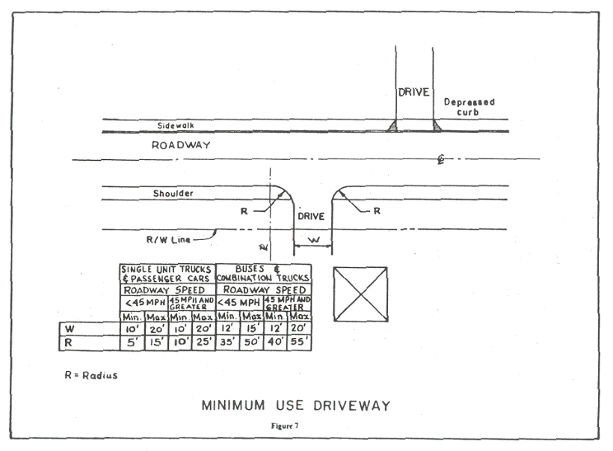

**Figure 4-7**

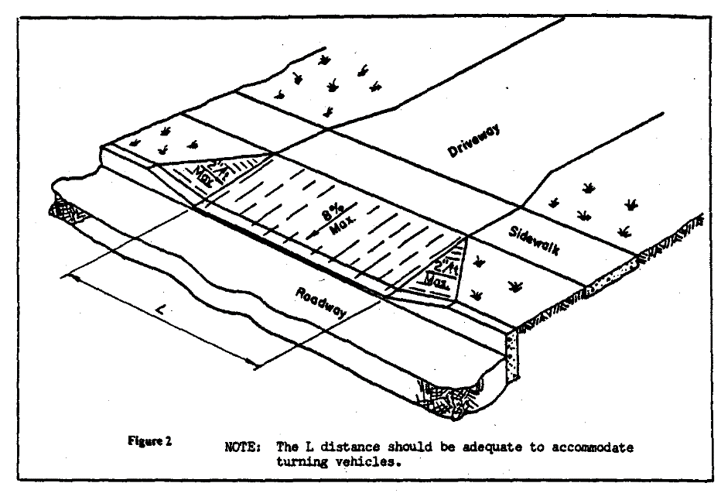

# Figure 4- 8

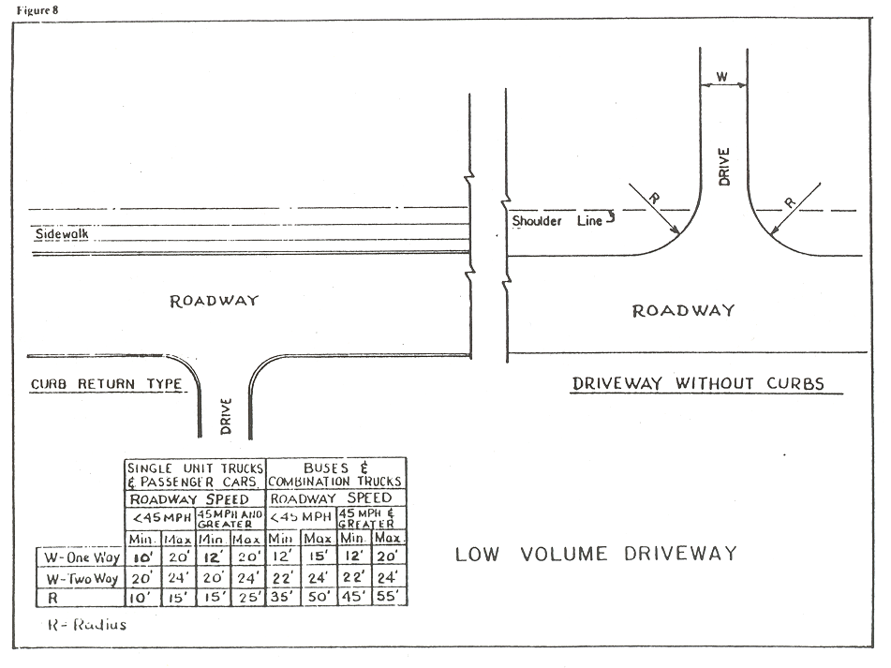

# Figure 4-9

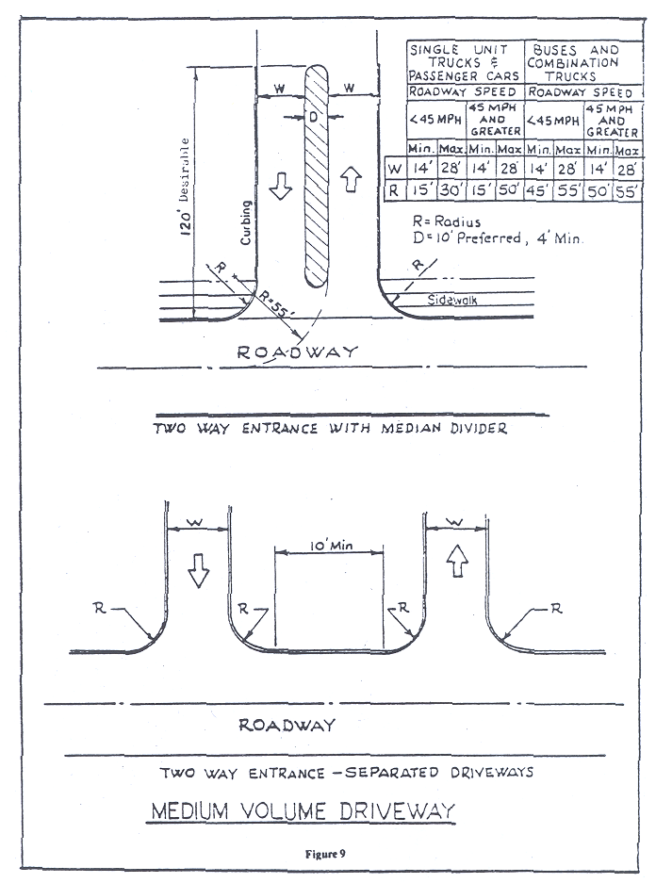

# Figure 4-10

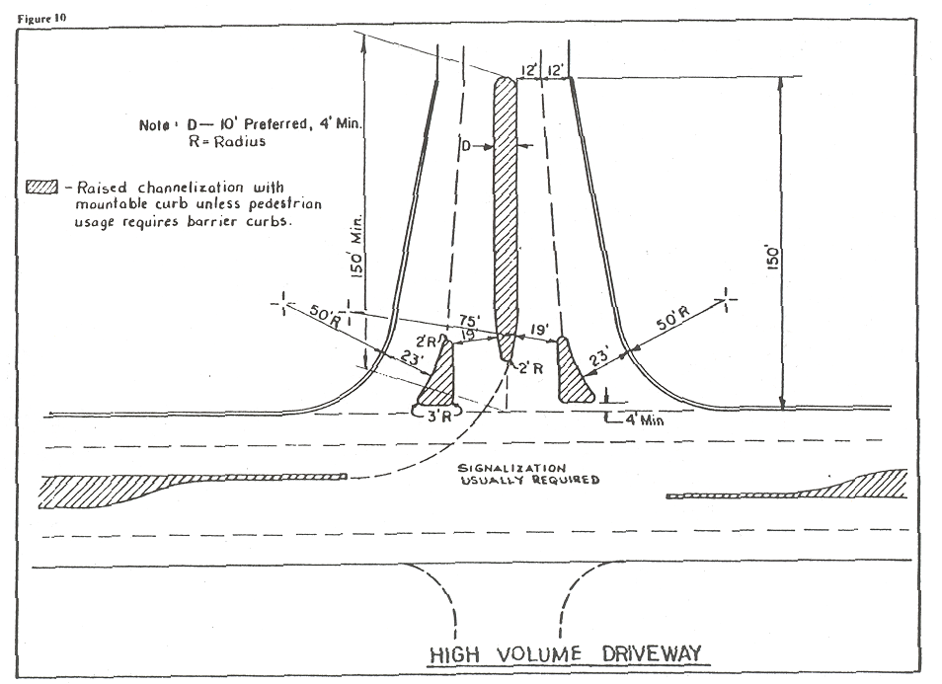

**Figure 4-11**

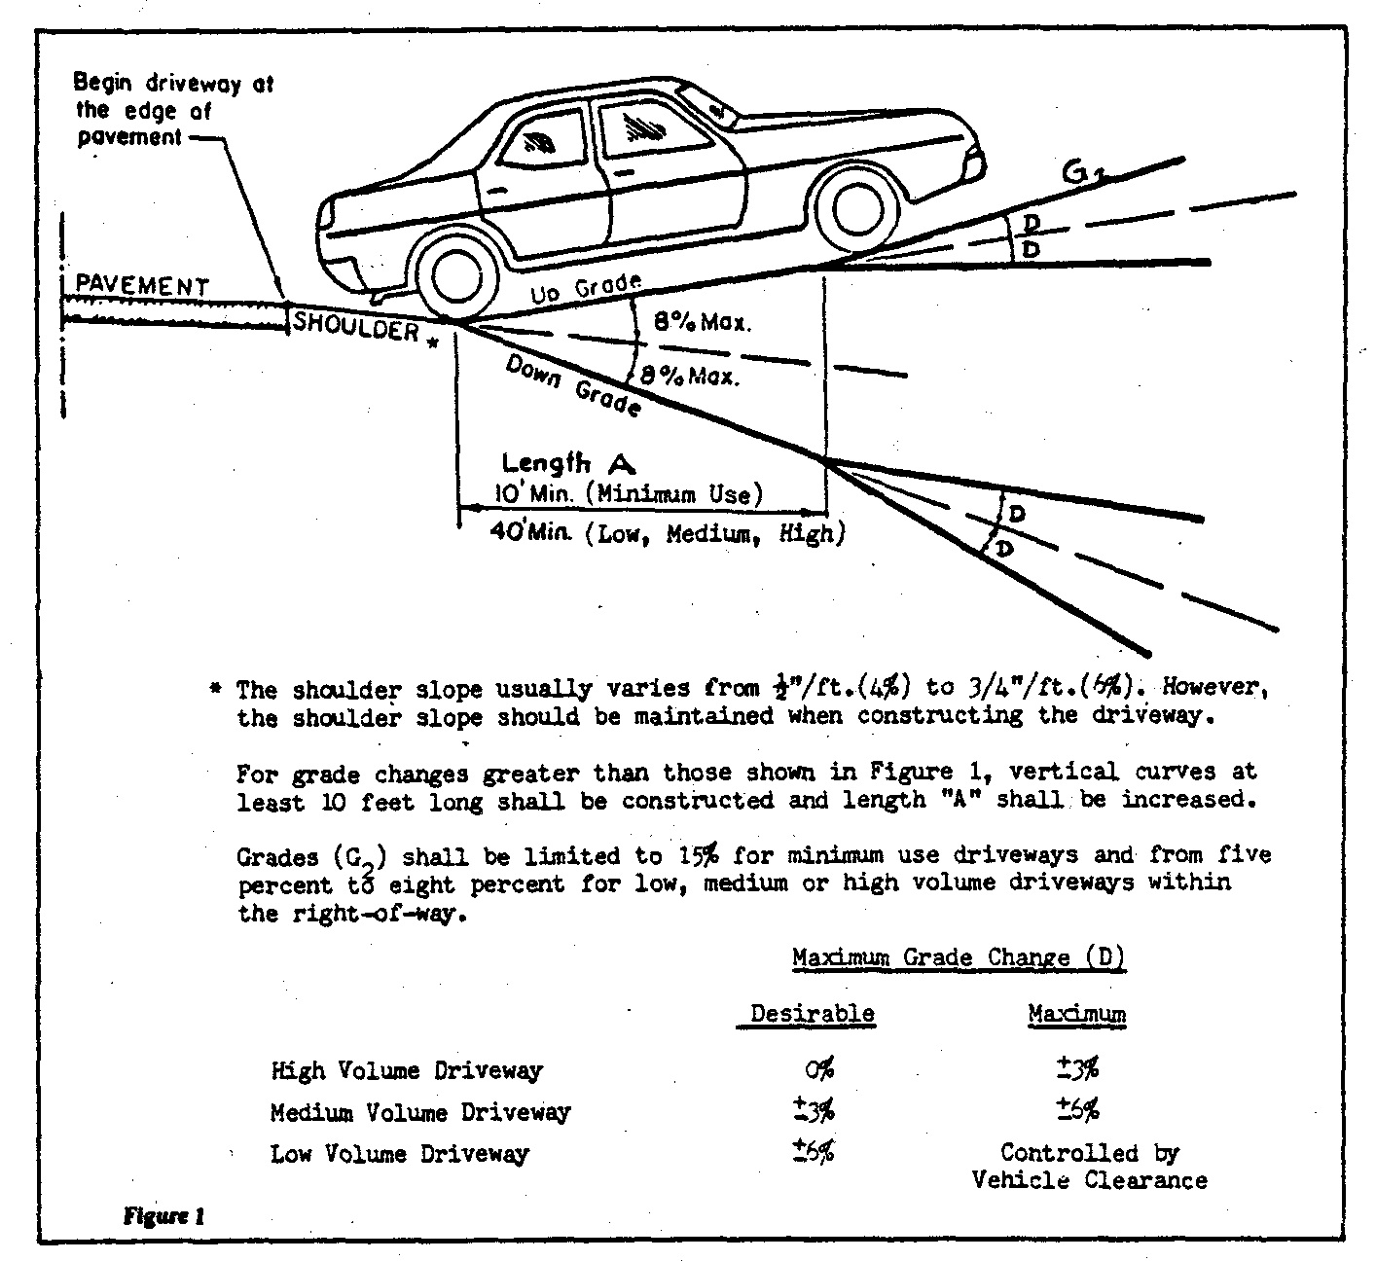

# Figure 4-12

**Table 415.2(5): West Branch Susquehanna River Release Rates**

|  |  |
| --- | --- |
| **Subwatershed** | **Release Rate (%)** |
| 3-37 | 90 |
| 3-38 | 60 |
| 5-3 | 50 |
| All other Subwatersheds | 100 |

**Table 415.2(5): White Deer Creek Watershed Release Rates**

|  |  |
| --- | --- |
| All | Release Rate |
| Subwatersheds | 100% |

Table 415.2(5).: Buffalo Creek Watershed Release Rates

|  |  |  |  |  |
| --- | --- | --- | --- | --- |
| Runoff Control Districts | A | Subareas | Post-Development  Design Storm | Pre-Development  Design Storm |
| 1-4 | 2-Year  10-Year  50-Year | 1-Year  10-Year  50-Year |
| 16 |
| 28-39 |
|  | 58-59 |
| B | 5-15 | 2-Year  10-Year  50-Year | 1-Year  5-Year  25-Year |
| 17-27 |
| 40-55 |
| 60-65 |
| 70-75 |
| C | 79-81 | 2-Year  10-Year  50-Year | 1-Year  10-Year  50-Year |
| 56-57 |
| 66-69 |
| 76-78 |
| 82-92 |

**TABLE 415.4: Acceptable Computation Methodologies For Stormwater Management Plans**

|  |  |  |
| --- | --- | --- |
| **METHOD** | **METHOD DEVELOPED BY** | **APPLICABILITY** |
| TR-20  (or commercial computer  package based on TR-20) | USDA NRCS | Applicable where use of full hydrology computer model is desirable or necessary |
| TR-55  (or commercial computer package based in TR-55 | USDA NRCS | Applicable for land development plans within limitations described in TR-55 |
| HEC-1, HEC-HMS | US Army Corps of Engineers | Applicable where use of full hydrologic computer model is desirable or necessary |
| PSRM | Penn State University | Applicable where use of a hydrologic computer model is desirable or necessary |
| Rational Method (or commercial computer package based on Rational Method) | Emil Kuichling (1889) | For sites less than 10-acres, or as approved by the Township and/or Township Engineer |
| Other Methods | Varies | Other computation methodologies approved by the Township and/or Township Engineer |