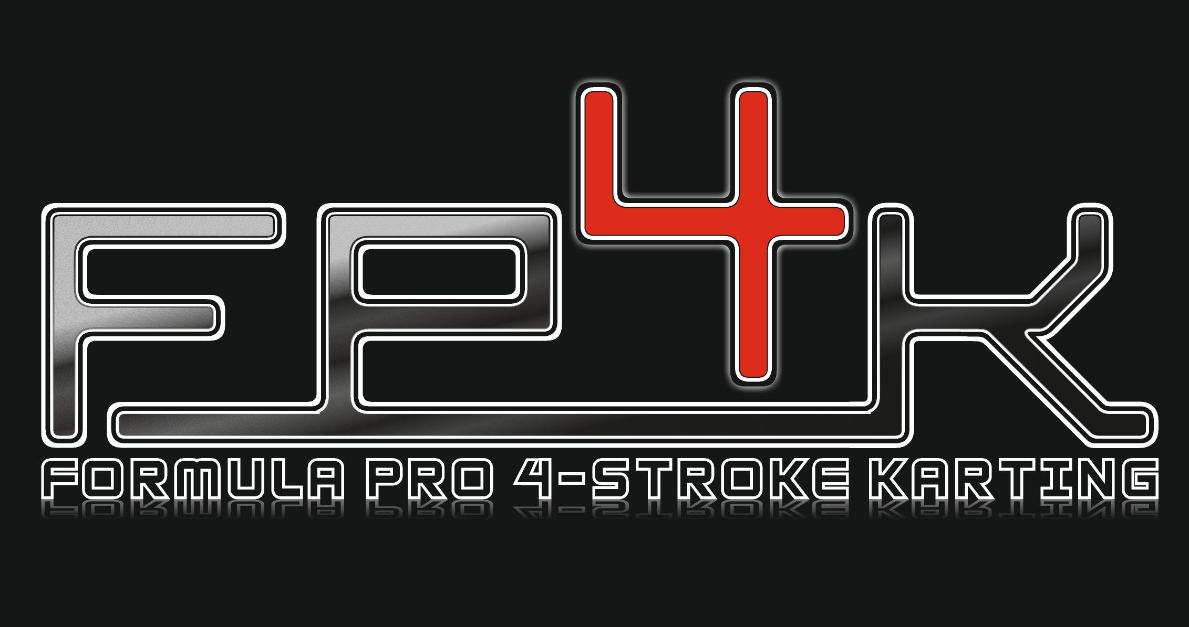
So, you want to start Karting? Or you used to race back in the day and would love to get back into it?
The first step is to come and see us at a race meeting and/or contact us via the website to see how it all works. As much knowledge that you can acquire before you buy your first kart may save you not only money but ensure that it is or can easily be made suitable for our safety and technical regulations.

The World Formula Engine
Karts must have been produced by a recognised kart 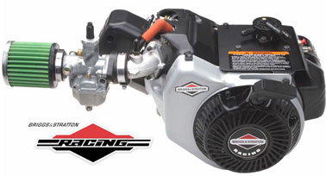manufacturer. They are powered by a single engine of 206cc produced by American manufacturer Briggs and Stratton. These engines are specifically produced for racing and as such slightly more specialised than, say, a prokart, which uses twin Honda engines. The weight restriction on these for Kart + Driver is 165Kg (179kg for the Heavyweights) to ensure that all karts are capable of the same sort of speeds, and it is the driver who makes the difference. As a guide, a modern chassis weighs around 90/95 Kgs.
One word of advice: when you buy a machine that is used it is generally the case that you get what you pay for! A kart that has been used for racing may well need some work to make it race ready. As a rule, try to get one as close to your budget limit. It will be newer, have spares readily available and most importantly had less use. A retirement sale is always a good place to start, as it sometimes comes with many useful bits in the price. But as mentioned earlier, if in doubt speak to us. It is a lot more fun learning your race craft than mending overly worn parts!
When buying a chassis, we would recommend that you make sure it is a fairly commonly used make: in our club many drivers use a TonyKart (also referred to as OTK) and there are lots of lookalike chassis such as Kosmic. This means you won’t have too much trouble sourcing spare parts. Don’t buy a kart unseen – you need to check if the chassis has been through a tough time. Check that the metalwork is not flattened underneath (caused by using kerbs when on track) or that it hasn’t needed any weld repairs. A kart chassis undergoes a large amount of hard work and an older one will possibly need to be straightened by a professional to make sure it will run in a straight line. When you sit in the seat, you need to make sure you fit – too tight a seat will be really uncomfortable or too big will mean that you will slide around resulting in a number of bruises. If in doubt, ask someone who has raced before.

Equipment & Racewear
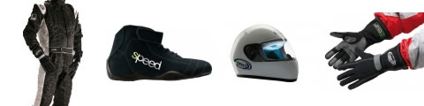

To race you are going to need some equipment and special clothing. The one thing that will make your life easier is a stand with wheels: This will help you to work on your kart at the track without lying on the ground. These are available second hand on the Internet or new from any of the kart suppliers.
You will also need a decent air compressor or pump so you can alter the tyre pressures. This can make a big difference to your lap times. A reliable stop watch will give you an idea of how well you are doing. Some drivers have a combined laptimer and rev counter on their steering wheel so they can monitor how each lap is going. These are often referred to as a MyLaps or Alfano. A Jerrycan for fuel and a current Fire Extinguisher are also necessary. As far as tools are concerned, a decent socket set, flat spanners, screwdrivers, and a soft mallet are also useful.
For your first race meeting, bring spare chains, spare cables, and a few nuts and bolts.
In addition to an MSUK race licence, you must have an Motorsport UK approved crash helmet in good condition, boots that cover your ankles, gloves and a regulation kart race suit available from all karting suppliers. If you aren’t used to driving a kart a neck protector and rib protector are good ideas.
These items will be checked when you are scrutineered, so be prepared to present them at the time. If you don’t have the necessary safety wear or equipment, you will not be able to race.
At FP4, we travel around the South of England to race at some of the most exciting tracks in the country. Our calendar tries to offer as many different types of tracks possible, from tight, twisty low speed to wide open high speed circuits. Each one offers its own particular challenge requiring a number of setup changes to your chassis and engine and many drivers make a weekend of it, so they can practise on the Saturday, ready to race on the Sunday. Most tracks offer free camping, so there is often a social event on the Saturday evening.
The club ethos has always been to offer low-cost motor racing to all ages and ability without compromising on safety or enjoyment. Many members have gone on to race at regional and national levels with great success.
Please have a look at our website www.fp4karting.co.uk

