Fourth Week: Stress and Emotion

Managing Stress:
- Stress has the ability to have some major health affects on the body such as sleep problems, overeating, exercising less, depression, and a multitude of others
- A form of helping with stress is using what we call a Gratitude Journal
- This Journal can be used for any sort of writing or reflection that can include goals, accomplishments, or reflection on a particular time period
- The journal will allow for expression for both individuals who do and do not feel comfortable sharing with others
- Before/After Bed:
- An individual should reflect on what they have accomplished or can make better from the day
- Planning ahead for the next day or time period is key for staying organized and on task
- Make sure we are eating breakfast each morning and starting the day off right
- Meditation can be key in relieving or managing stress because it allows an individual to express themselves through an activity that speaks to them
- There are many different ways to meditate such as yoga, walking, guided imagery, or even just concentration
- The key is relaxation
- Meditation can help with bodily processes and certain health aspects
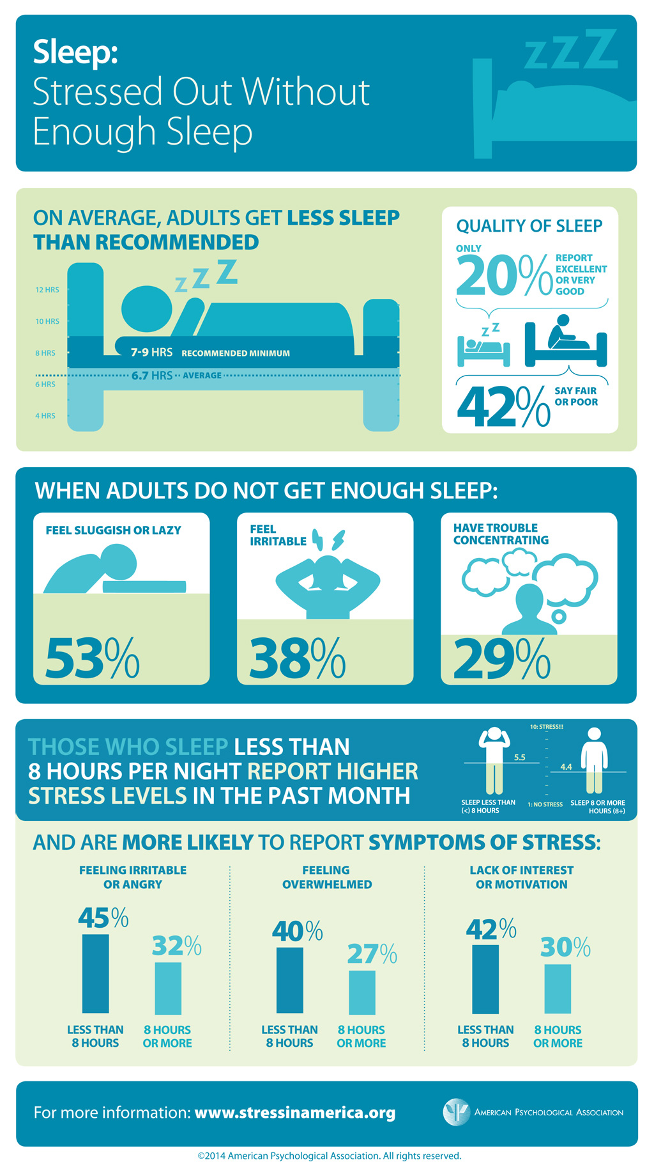
- Yoga: is a possible workout but also can be used to relax the body and mind before bed
- See attachment for activity

Are we eating smart?:
- Eating is very much about enjoyment, however we should be eating for our bodies and function
- Foods should be eaten such as fruits, vegetables, and non-fatty protein that can help us use our brains and bodies to their fullest on a daily basis
- Eating unhealthy foods such as pizza, while it tastes good, does not help us become healthier and has no nutritional affect on our body
- Allowing our bodies to perform at the highest level should be our goal and eating smart will allow that
- Emotional eating can be a bad habit that leads to an unhealthy living/eating style
- More times than not emotional eating consists of junk/unhealthy food
- Mass amounts are general eaten during these emotional outbursts
