Affidavit / Declaration of Truth

Prepared by: Michel Van Thielen, a living man, American State National, one of We the People, sui juris In care of: 55 Westland Run, Florida [RFD32132] (NON-DOMESTIC MAIL, zip code exempt; DMM 122.32, without UNITED STATES).
I am Michel Van Thielen. I am the flesh and blood living soul. I am naturalized American, also called an American State National (USC 8 section 1101 a(21). I am a Floridian. I am a man, one of We the People. I am not a legal fiction, nor a United States citizen.
Let it be known that the DRIVER LICENSE that was issued to me, Michel Van Thielen, by the STATE OF FLORIDA, has errors present on it. Please see the images of the DRIVER LICENSE below.
I am an inhabitant of Florida, domiciled on the land. I live in America, the Republic. I do not live, or “reside” in Washington DC. I am providing you the DRIVER LICENCE as an acceptable form of identification per your passport application requirements.
I am not to be mistaken as the ALL CAPITAL LETTERS NAME, “MICHEL VAN THIELEN” which appears on the DRIVER LICENSE.
I am a living, breathing man, and I am not to be mistaken for a vessel, or a corporation.
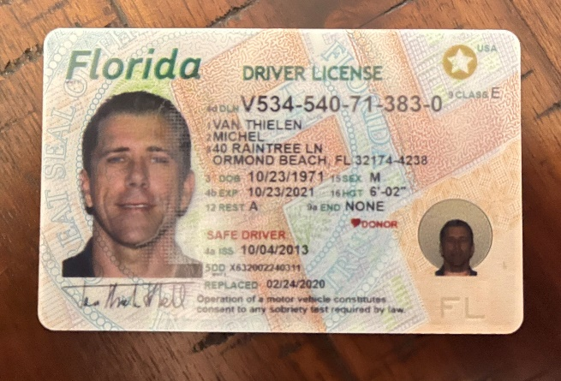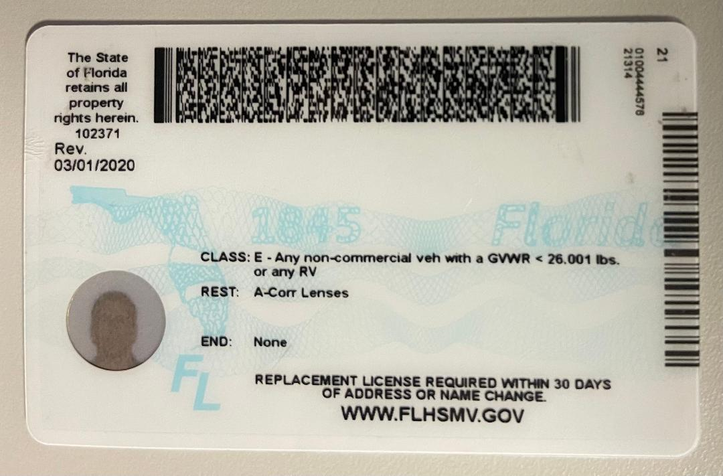

By:_____________________________________
By: Michel Van Thielen ©, a man, Living Soul,
American State National, one of We the People,
Sui juris - All Rights Reserved, without Prejudice.

Witness:________________________, Date:________________

Witness:________________________, Date:________________

Notice

Using a notary witness on this document does not constitute any adhesion, nor does it alter my status in any manner. The purpose for the notary is verification and identification only, and not for entrance into any foreign jurisdiction.

Jurat

Florida }
Volusia County }

As a Commissioned Public Notary, an officer of the court, I, hereby certify that today before me, is the living woman known to me to be Michel Van Thielen and she did present before me and after being duly put under oath, she executed the forgoing document, Affidavit/Declaration of Truth as shown, on this ____day of ______, in the year 2023, in Witness whereof I set my signature and seal:

Notary Public: _________________________________________

STATE OF_____________________COUNTY OF_________________
The foregoing instrument was acknowledged before me by means of
□ physical presence or □ online notarization, this___________ by_____________
Who is personally known to me or who has produced _________ as identification.
___________________________________________________________________
Notary Public
___________________________________________________________________
Name typed, printed, or stamped.

My Commission Expires: ___________________

