UPPER SUSITNA SHOOTERS
ASSOCIATION
P.O. Box 769
52645 Parks Hwy
Willow, Ak 99688

Standard Operating Procedure and Range Safety

Revision History
Version | Changes | Effective Date
4 | Full document edits | 04 June 2026

Approvals
Name | Title/Position | Signature | Date
Tim J.D. Newman | Chief Range Safety Officer
Mike Boll | Asst. Chief Range Safety Officer
J. Buddy Giddens | Range Ops Manager
Wes Rath | Asst. Range Ops Mgr.
J. Chad Zavorka | USSA Range QA/QC Lead
James Gustafson | USSA President
Sommer Zavorka | USSA Secretary

Table of Contents
1. Introduction 3
1.1. Purpose 3
1.2. Scope 3
1.3. Roles And Responsibilities 3
1.4. Facility and Firing Range maps 3
1.4.1. Facility Map …. 3
1.4.2. Range Area 1 25yd, 50yd, 100yd,200yd………………………………………….... 3
1.4.3. Range Area 2 1000yd…………………………………………………………..3
2. General Rules………………………………………………………………………….4
3. Range Safety Rules……….........................................................................................6
3.1. general Range Rules and firearm safety………………………………………....6
3.2. General Firing Line Commands and Procedures………………………………....7 3.3. Unique Firing Line Rules……………………………………………………………..7
4. Emergency MEDICAL RESPONSE…………………………………………………..8
5. INCIDENT PROCEDURES……………………………………………………………......9
6. Opening and Closing procedures…………………………………………….. 9
7. daily records and log book…………………………………………………… 9
8. appendix a - facility and firing range maps……………………………11
8.1. Diagram 1- USSA Facility Map………………………………………………...12
8.2. Diagram 2 - 25yd-200yd Map………………………………………………......13
8.3. Diagram 3 - 1000yd Map……………………………………………………….14
9. Appendix b - REPORT FORMS …………… 15
9.1. Appendix B(1) - Injury Report Form…………………….……………………..16
9.2. Appendix B(2) - Incident Report……………………………………………….17
10. Appendix c – witness statement 18
11. Appendix d – Opening and Closing procedures 19

Introduction

Purpose
This Range Safety Standard Operating Procedure (SOP) will act as a guide for the Range Safety Officer as he or she performs his or her duties and responsibilities. This document will also outline the steps necessary to:
- Organize
- Conduct
- Supervise
All shooting activities and range operations in a safe and orderly manner.

Scope
Safety is paramount, and will never be compromised and Range Safety Officers are always professional, friendly, helpful, understanding and honest.

Roles And Responsibilities

Role | Definition
RSO / User Group RSO | Ensures range users follow range regulations and safety policies.
CRSO | Trains RSO’s and develops range SOPs with guidance from Range Ops Mgr./Assist. Range Ops Mgr. and maintains RSO scheduling and range scheduling.
Range Ops Manager | In charge of range operations, maintenance, repairs, range upgrades.
Range QA/QC Lead | In charge of the QA/QC Team for ensuring that the range meets customer expectations and quality of standards. Reports directly to the CRSO, ACRSO, Vice Pres. And Pres. Of the USSA
Range User | A shooter, spectator, instructor or member of the shooting range.

Facility and Firing Range Maps

Facility Map: This encompasses the grounds of the Upper Susitna Shooters Association. Please See Appendix A (Diagram 1)

Range 1 Area: This encompasses the 25 yd, 50 yd, 100 yd and 200 yd ranges and the location of the RSO Conex. Please see Appendix A (Diagram 2)

Range 2 Area: This encompasses the entire 1000 yd range, from the parking area to the targets. Please see Appendix A (Diagram 3)

General Rules

2.1 Members and visitors: As members and visitors to the Upper Susitna Shooters Association Range, one of the benefits you receive is the use of the range facility. The information contained in this publication contains information to help make your visit to this range safer and more enjoyable.

2.2 Compliance to our range rules, regulations and policies is a condition of range usage.

2.3 This range currently has 5 live fire areas: 25yds, 50yds, 100yds, 200yds and 1000yds.

2.4 RANGE OPERATION HOURS:

2.4.1 Open Monday, Thursday, Friday from 1000 Hrs. (10 a.m.) to 1800 Hrs. (6 p.m.). Saturdays and Sundays from 1000 Hrs. (10 a.m.) to 2000 Hrs. (8p.m.)

2.4.2 USSA Range is closed on Tuesday and Wednesday for range maintenance. The only exception to this may be an ongoing class at the USSA admin building or any of the Clubs five ranges.

2.4.3 There may be occasional closures to facilitate construction, maintenance, competitions or training events. This will be annotated on the range calendar located on our facilities website at susitnashooters.org or you may call (907) 733-3323 during normal business hours.

2.5 When using the USSA Range Facility, you do so at your own risk. All members and non-members that participate in shooting activities are required to check in at the facility office and sign the range liability release and payment sheet. At that time, you will receive a range briefing. All individuals that are guest/observers (non-shooters) are required to sign this sheet to be admitted to the range property.

2.6 The USSA prohibits the use of all alcoholic beverages and drugs on the property, there are no exceptions to this rule. Shooters, visitors and observers may not consume alcohol or drugs before shooting or entering the range facilities. This is a severe violation of the rules and regulations which may result in loss of shooting privileges, loss of membership at the facility and the notification to the proper law enforcement authorities.

2.7 Eye/Hearing and Footwear Protection
2.7.1 Eye and Hearing protection must be worn at all times while on a hot firing line and if you are within 15 feet of the firing line. This rule is whether you are a shooter, spectator or any member of the range staff. Your sight and hearing are important to all of us.

2.7.2 All children (under the age of 17 yrs of age), will wear eye and hearing protection and be under direct supervision of their parents or adult guardian at all times.

2.7.3. No open-toes shoes, Crocs, or high heels are allowed on the range.

2.8 Slopes, Backstops and Berms are off limits to all shooters, visitors and observers at all times.

2.9 All pets are to be leashed/ controlled at the range while it is in operation.

2.10 Use of the range is prohibited when no USSA RSO is on duty.

2.11 The Range Safety Officer (RSO), Chief Range Safety Officer (CRSO) or Range Ops Manager shall have the right to close any and all ranges to firing at any time he/she believes that conditions are unsafe, or an unsafe act has been conducted.

2.12 The RSO, CRSO, or Range Ops Manager shall have the authority to issue commands at any time, temporarily suspend a shooters privilege, eject a shooter from the facility for any violation of the facility rules and regulations, failure to obey range commands, or for any unsafe condition that they may cause. The shooter shall have the right to file an appeal in writing to the Secretary of the Board of Directors and have a chance to make a personal appearance in front of the board.

2.13 Targets: Only paper, cardboard or range approved metallic targets are approved for usage on any range at the USSA. Approved metallic targets may be engaged at 10 yards for pistols and 100 yards for rifles. There is absolutely no shooting at rocks, car tires, soda cans, any bottles (plastic or glass), firewood, etc. If it is not an approved target as listed above, you cannot shoot at it. No personal steel usage is authorized at the USSA Range. Only approved steel for sponsored companies or associations is authorized.

2.14 THERE IS ABSOLUTELY NO SHOOTING AT WILDLIFE ON ANY RANGE AT THE USSA UNLESS IT IS IN DEFENSE OF LIFE. If at any time one of our many species of Alaskan wildlife are seen on a range, whether alive, wounded or deceased, an immediate cease fire is to be given and notify the RSO on duty.

2.15 All shooting may commence at 0830 Hrs. (830 a.m.) and must be complete by 2100 Hrs. (9 p.m.) There is no night time shooting at the range authorized at this time.

2.16 In the event of an emergency, call an immediate “CEASE FIRE”, call 911 and give the location of the range as 52645 Parks Hwy (Mile 94). Ensure that you inform the 911 dispatcher of the type of injury and that there is no active shooting on the range. Contact the nearest RSO on duty or call 733-3323.

2.17 All firearms must be carried cased or unloaded with actions open when exposed, with the exception of a holstered firearm.

2.18 All RSO personnel working on the firing line are required to wear the safety yellow shirt or vest while working downrange for RSO identification.

2.19 All QS/QC personnel working the range are to wear the safety red shirt or vest for QA/QC identification.

3. Range Safety Rules
This chapter covers the General Range Rules and Firearm Safety. These rules apply to the entire range and all firing lines. General firing line commands and procedures are specified in sub-section 3.2. Unique firing line rules are specified in the sub-section 3.3

  - General Range and Firearms Safety

    - Treat all firearms as if they are loaded.

    - Keep all firearms pointed in a safe direction. On all ranges the term safe
direction is defined as: The muzzle of all weapons is to be pointed at the backstop. Never allow the muzzle to point in any direction that would allow a bullet to leave the range in the event of a negligent/accidental discharge.

    - Always be certain of your target, your line of fire and what lies beyond
your target.

3.1.4 Keep your finger off the trigger until you are ready to fire.

3.1.5 Always wear appropriate eye and hearing protection when shooting and
maintaining your firearm.

3.1.6 Targets: Only paper, cardboard or range approved metallic targets are
approved for usage on any range at the USSA. Approved metallic targets may be engaged at 10 yards for pistols and 100 yards for rifles. There is absolutely no shooting at rocks, car tires, soda cans, any bottles (plastic or glass), firewood, etc. If it is not an approved target as listed above, you cannot shoot at it. No personal steel usage is authorized at the USSA Range. Only approved steel for sponsored companies or associations is authorized.

3.1.7 No fully automatic firearms or firearms with mechanically assisted rapid fire (including but not limited to: forward reset triggers, bump stocks, and binary triggers) may be fired at the USSA Range without authorization from the Admin. RSO and the RSO on duty. The 100 yd range is the only range to be used. Every person who will fire the firearm must be initially observed by the RSO to prove that they are able to do so in a safe manner. Controlled fire must be maintained. Failure to do so will result in an immediate cease fire and authorization will be revoked. This does not include Special Events.

3.1.8 Use of armor piercing (AP), incendiary, tracer rounds, fireworks,
explosives, or pyrotechnic devices are prohibited on the USSA Range.
The only exception to this is the use of tannerite targets with the permission of the CRSO/ACRSO or Range Ops Manager/Asst. Range Ops Manager.

3.1.8.A Steel core ammo may only be shot at the 100 yd range and into paper targets only.

3.1.9 All firearms must be carried cased or unloaded with actions open when
exposed, with the exception of a holstered firearm.

3.1.10 Holstered firearms may be loaded but cannot be handled unless the
shooter is on the firing line and the range is hot.

3.1.11 All shooters are responsible for cleaning up their targets and removing materials from the backboard upon completion of your range session. This includes picking up any spent brass, live rounds and other materials brought to the range. If a shooter does not intend to keep the brass, it is to be place in
the hanging buckets provided on each of the firing lines and not swept forward onto the range (this poses and safety hazard for other shooters
and training activities). All rim fire and aluminum casings must be disposed of in the trash containers provided.

3.2 General Firing Line Commands and Procedures

3.2.1 “CEASE FIRE!” may be called on each range by any person that observes an unsafe situation or at the ending of a shooting relay. All firing shall immediately cease. All firearms are to be unloaded, actions open, remove magazines or cartridges, and ground/bench your firearm and stand away during a cease fire. Firing will only commence after the appropriate call from the RSO or by all persons agreeing that it is safe to resume fire.

3.2.2 Everyone on the firing line needs to communicate and agree when it is safe to go down range. NO ONE IS PERMITTED AHEAD OF THE FIRING LINE UNLESS THE LINE IS SAFE!

3.2.3 When people go down range, DO NOT HANDLE FIREARMS FOR ANY REASON! This includes scope adjustments, taking a firearm off a bench or setting up a firearm on a bench. Remember the cease fire rule prior to going down range.

3.3 Unique Firing Line Rules

3.3.1 25 yd and 50 yd Firing Lines: No center fire rifle ammunition is to be shot on either of these ranges. All metal targets are to be placed a minimum of 10 yards away.

3.3.1.A 25 yd range is used strictly for rim fire and archery. Any exceptions to this have to be approved by the USSA Range CRSO, Operations Management or the Board of Directors.

3.3.1.B 50 yd firing line is for pistols smaller than 454 caliber and rimfire rifles only. No centerfire rifles, pistol-caliber carbines or sub-guns are allowed.

3.3.2 100 yd Firing line: The use of steel core ammunition is only allowed at paper targets. No steel is allowed on this range.

3.3.3 200 yd Firing Line: Short target stands are mandatory in front of the 50 yd berms at all times. No steel targets are authorized on this range at less than 100 yds.

3.3.4 1000yd Firing Line: There is a gate located to the right of the firing line for access down range, if this gate is open, there are personnel down range, DO NOT approach the firing line to set up any firearms or equipment.

3.3.3A At any time that personnel go down range, all shooters are to make their firearms safe and are to step away from the firing line.

3.3.3B There is a 100yd “Reconfirmation” target berm located on the 1000yd firing line. This is to be used for reconfirming zero on your rifle and only for reconfirming. There is a three (3) round maximum per shooter.

4. Emergency Medical Response
This section details appropriate staff responses in a medical emergency. The structure of this chapter should allow for quick reference and include clear, easy-to- understand steps. Remember that the RSO is the first responder in the case of any trauma. Trauma bags are located at the Range building, RSO conex and on the 1000yd Range.

4.1 When informed of a medical emergency, the RSO’s on duty are to immediately call a “CEASE FIRE” on all ranges and ensure that the Admin RSO in the Range building is aware of the medical emergency.

4.2 The RSO on the Firing Line will start to apply needed first aid, assign persons to direct medical response vehicles and personnel to the scene. Remember to ask personnel on the scene if they have any medical training. Ask all personnel on the scene to refrain from recording anything on their phones. Have all personnel not involved in assisting you to step back at least 50 feet, and ask all witnesses to remain at the range to provide witness statements.

4.3 Admin RSO is to call 911. Inform the dispatcher of the medical emergency at the USSA Range located at 52645 Parks Highway, Willow, Ak 99688 (Mile 94 on the Parks Hwy) and give phone number (907) 733-3323 and that all shooting on the range has been stopped. If the medical emergency involves a gunshot injury ask the dispatcher to inform the Alaska State Troopers. Contact the CRSO and Range Ops Manager and inform them of the medical emergency. Start filling out the Injury report form and pull blank witness statements. Injury report form and witness statements are located in the administration desk drawer. No range will be authorized to commence firing until all medical vehicles and personnel have left the facility.

4.4 Admin RSO will ensure that the Injury report form and Witness Statements are filled out correctly and turned over to the CRSO/ACRSO or Range Ops Mgr./Asst. Range Ops Mgr. and that a copy is given to the witness (s) and to the appropriate Agency.

5. Incident Procedures
This section details appropriate staff responses to any incidents that may take place at the USSA Facility. The structure of this chapter should allow for quick reference and include clear, easy-to-understand steps. Remember that the RSO is the first line of safety and enforcement of rules and regulations.

5.1 All RSO’s should know the rules and regulations of the USSA facility and be able to enforce them in a polite and non-demeaning manner. Remember that no RSO has the authority to touch any shooter or their firearms without consent or permission to do so. The only time this rule does not apply is in defense of one’s self or to stop a serious safety violation.

5.2 In the event of a safety violation, an immediate “CEASE FIRE” is to be given on the range of the incident. The RSO is to notify the shooter of said violation, instruct them of the proper procedure and ensure that they understand. One verbal warning is given.

5.3 In the event of continued violations by the same shooter, or if any shooter
commits a violation that could endanger the shooter, other shooters on the fire
line or the range, endanger the RSO or cause damage to the USSA Facility, the RSO is to advise the shooter to cease fire and report to the range office. An
incident report shall be done by the RSO.

5.4 The Senior RSO/Admin will ensure that the incident report is done and any witness statements (if needed) are complete. The CRSO and Range Ops Manager will be notified. The person that committed the said offense is to be informed that their shooting privileges are suspended and they can contact the CRSO or Range Ops Manager to find out the procedures to have their privileges re- instated. Incident Form can be found in Appendix B (2).

6. Opening and Closing Procedures
Refer to the list found in Appendix D for the minimum requirements of opening and closing the USSA Facility. There will be a separate set of instructions, not included in this manual, for the procedures pertaining to opening and closing the Clover.

7. Daily Records and Log Book

7.1 All range daily records are to be completely filled out and placed in the record tray located by the desk in the USSA facility. If copies are needed, please inform the CRSO.

7.2 The log book is to report any shooters names that violate safety, facility rules and regulations, emergency medical situations or anything that could bring about an injury or incident to anyone on the range. It is also for any important pass down information for the next working day RSO’s.

APPENDIX A

RANGE FACILITY
AND
FIRING RANGE MAPS

DIAGRAM 1
USSA FACILITY MAP

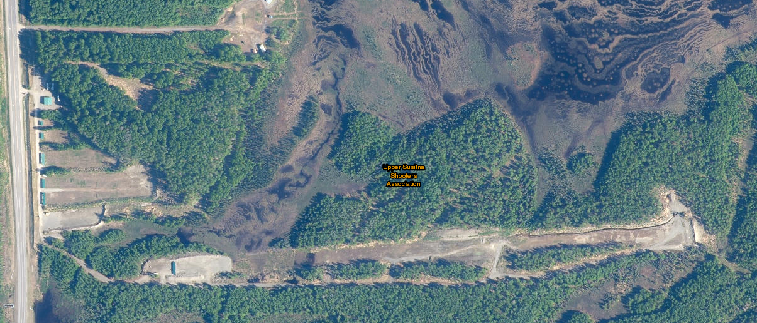

DIAGRAM 2
25 YD – 200 YD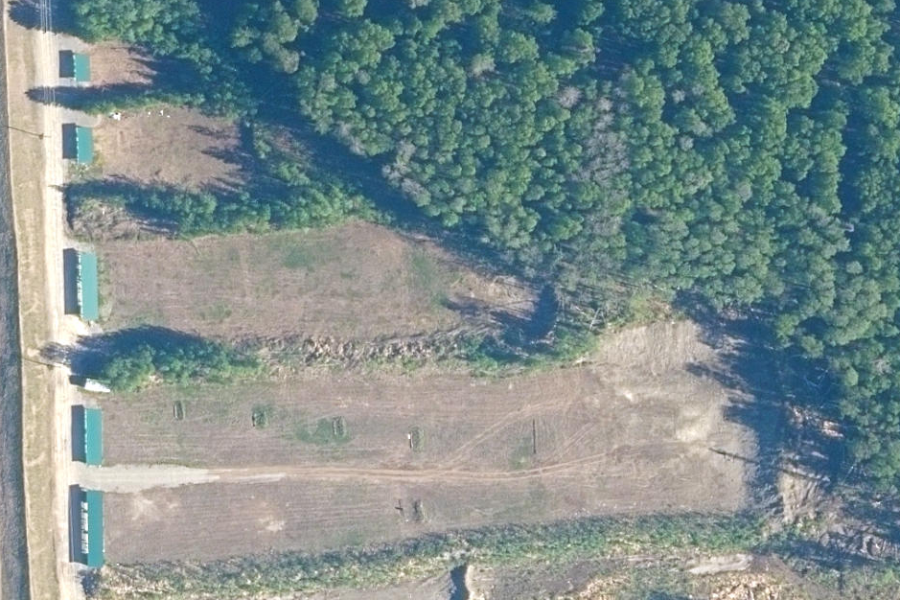

DIAGRAM 3
1000 YD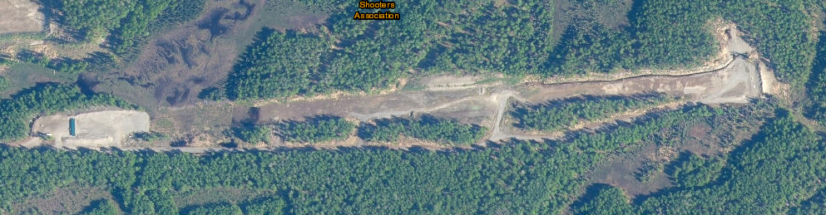

APPENDIX B
REPORT FORMS

INJURY REPORT FORM
Upper Susitna Shooter’s Assoc.

Name of Injured: _____________________ Date: _____________________

Location Injured on Facility: ____________ Time: _____________________

Home Address: ______________________________________________________

Contact Phone Numbers: __________________________

1. Description of injury: ___________________________________________________

2. How did injury occur: __________________________________________________

3. Time 911 was informed: ____________ Medical on Scene at: ______________
First Aid provided by: __________________________________________________
_____________________________________________________________________
Law Enforcement on scene at: _________________

4. Disposition (Transport time, Hospital, etc. If known): _________________________

5. Was protective equipment worn and used by all involved? YES ______ NO _______

6. Witnesses are to fill out witness statements and be interviewed separately.
All statements to include witness statement from RSO on scene are to be signed and attached to this report. Notation is to be made in log book.

Report Completed by: Name: ___________________ Title: __________________
Signature: _________________ Date: __________________
Copies are to be given to injured person/guardian and respective agency.

INCIDENT REPORT FORM
Upper Susitna Shooter’s Assoc.

Location of incident: _______________________ Date: ______________

Type of incident: __________________________ Time: ______________

Description of incident: ______________________________________________

Personnel involved: _______________________________________________________

Action Taken: ____________________________________________________________

CRSO Notified: _______ Range Ops Manager Notified: _________________

Report Completed by: Name: ___________________ Title: __________________
Signature: _________________ Date: __________________

Copies given to person/guardian involved and respective agency.

APPENDIX C

WITNESS STATEMENT
Upper Susitna Shooter’s Assoc.

Name: _______________________ Date: __________________

Address: ________________________________________________________________

Contact Phone Number(s): __________________________________________________

I, ______________________________(name), was a witness to ___________________

______________________________________________ (incident/medical emergency).

What follows is from my point of view and the facts as far as I know them.

Below please write the facts as clearly as you remember them. Try to be as detailed as possible.

Witness Signature: __________________________________________

Received By: Name: __________________________ Position: ___________________

Signature: ___________________________________

Copies to be given to Witness and respective agency.

APPENDIX D

OPENING AND CLOSING PROCEDURES

The following is a minimum guide to opening and closing of the USSA facility.

1. Controlled access gate: Open Monday, Thursday, Friday at 1000 hrs. (10 a.m.), hang open range sign. Closed at 1800 hrs. (6 p.m.), take down sign. Open Saturday and Sunday at 1000 hrs., (10 a.m.), hang open sign. Closed at 2000 hrs. (8 p.m.), take down sign. No on duty RSO is authorized to close the range prior to 1730 hrs. (530 p.m.) on week nights and 1930 hrs. (730 p.m.) on weekends without the consent of the Range Ops Mgr./Asst. Range Ops Mngr., CRSO or ACRSO.

2. Raise and lower the American Flag and Range Flag: Both up at opening and down at closing. The cotton American Flag is for clear weather and the nylon flag is for inclement weather. The red triangle flags are the range “hot” flag. The 2 red flags are to be raised and lowered, one located at the RSO Conex and the other located at the 1000 yd firing line.

3. Check all backstop areas and steel targets for any excessive damage at opening and closing. Repaint steel targets if needed.

4. Check all firing points for cleanliness and ensure all target frames/mounts are in good condition for usage.

5. Inspect all shooting benches and tables. Ensure that firing line is cleaned of all empty casings.

6. Ensure all trauma kits are accessible and located in assigned areas.

7. Range Facility Building: Front door and back door unlocked at opening. Turn two orange switches in power box on. Turn on orange water valve on water tank in kitchen. Ensure restrooms are clean and stocked. Open safe to get cash box out and turn on square, open cash drawer. Ensure all shooter sign in sheets are on clipboards and filled out by RSO’s. Make sure that radio equipment is in good order and usable. At closing you will reverse all of the above listed.

