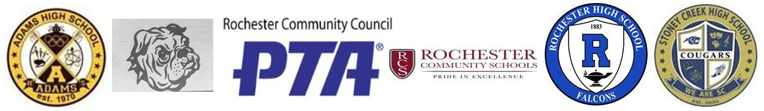
ROCHESTER COMMUNITY PTA COUNCIL
BATTLE OF THE BOOKS

We are so excited to be in our third year of our district-wide program for all the high schools in the Rochester Community Schools. BATTLE OF THE BOOKS is a competition between all the high schools, during which they read five titles nominated by the students and chosen by the RCS staff and media specialists (see 2019-2020 books below) and then get ready for a fun night of food, video-chatting authors, the Trivia Competition, and a huge raffle. This school year’s Battle Night is scheduled for Friday, February 21, 2020.
RCS students get a raffle ticket for every Battle Book they read. The Battle Night raffle is a huge draw for students to join this program and continue to read, and our hope is that each student participating in this program will leave the Battle Night with one raffle win that congratulates them on the hard work reading and studying these books. We are hoping you will donate an item for this raffle that would appeal to teens. It doesn’t have to be big – a pair of socks, a coffee mug, a bookmark, a small gift card. Or if you want to go bigger, a basket or bag of fun items. Monetary donations are also welcome so we can buy more raffle items.
In appreciation for your donation, we will add you as a sponsor with your logo and company name/contact or a family name for donating families:
- on our website – www.rcsbattleofthebooks.com
- on our Twitter -- @RCSBattleBooks
- on our Instagram – RCSBattleOfTheBooks
- on our Battle of the Books Competition Night program

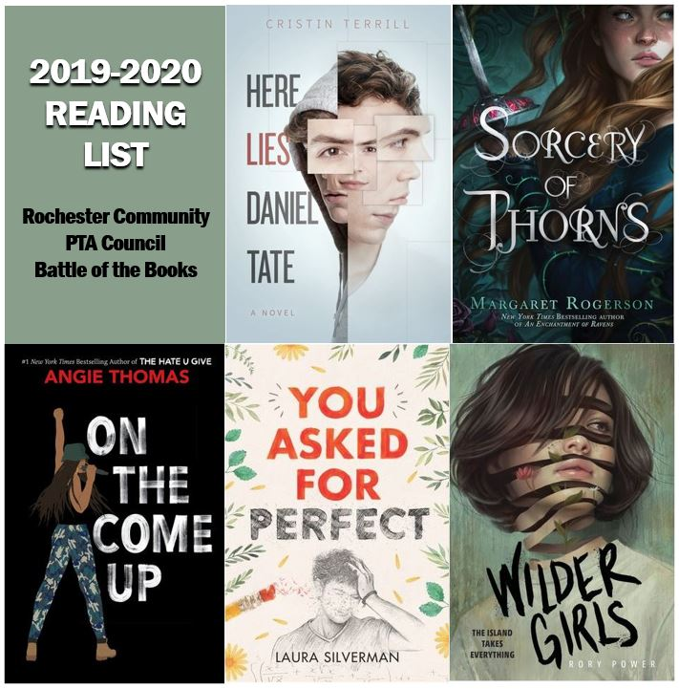
If you are interested in donating, please contact Heather Meloche, Battle of the Books coordinator, at rcsbattleofthebooks@gmail.com. Monetary donations can be made out to Rochester PTA Council and sent to: Rochester Adams High School
ATTN: Heather Meloche, Battle of the Books
3200 W. Tienken Road
Rochester Hills, MI 48306

We hope you are able to contribute, and, as always, we so appreciate the support and involvement of our community and local businesses as we continue to work to enrich the education of our RCS students.

With Best Regards,
Heather Meloche
PTA Council Battle of the Books Chair
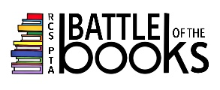
rcsbattleofthebooks@gmail.com

