A HISTORY of the ALUMNI INITIATIVE
At SOUTH HOUSTON HIGH SCHOOL (2007-2016)

- In the fall of 2007, the school – under first-year Principal Steve Fullen – held a 50th Anniversary celebration to coincide with Homecoming. An open house was held the night before the football game and was very well received with two hundred alumni or more in attendance. As part of that observance, the school sought to identify and post pictures of distinguished alumni. About 10 alumni were featured, most of them recent graduates. Alumni interest in the event demonstrated the possible benefits of additional alumni outreach.

- In 2008, alum Al Carter joined the SHHS faculty as an AP history teacher. The following year, as he was spearheading efforts for his own class’s (1970) 40th reunion, Carter began a series of discussions with Fullen about the possibility of using his networking knowledge of older alumni to take the school’s distinguished alumni efforts to another level. Fullen agreed to a wholesale expansion with Carter taking the lead on research, alumni selection and the design of a display wall in the hall adjacent to the Reinartz Center. Carter’s research and design efforts went on for more than a year, and extending into his new role as communications specialist for the Pasadena ISD, a position he took in August of 2010.
- In the spring of 2010, the first group of 54 Hall of Honor inductees was approved by Fullen and by the school’s baccalaureate committee, a faculty-based group charged with organizing the annual SHHS “Circle of Light” assembly at the end of the school year. When the “Circle of Light” event was discontinued the following year, the committee was kept intact to vote on Hall of Honor candidates.

- On March 3, 2011, the SHHS Hall of Honor was dedicated in a ceremony at the school with about 400 guests in attendance. Fifty-four alumni (a number picked to coincide with the school’s 54th anniversary) were chosen for induction. All but a handful attended the ceremony, some flying from as far away as California and Washington, D.C. At Fullen’s suggestion, a section was added to the wall display for “The Fallen” – military members who had died while on active duty in a war zone. Five of the 54 inductees were fallen service members. “The Fallen” was later expanded to include public first-responders killed in the line of duty. Preliminary plans were also made to launch a Teacher Hall of Honor section in the coming years. Link: http://www.chron.com/neighborhood/pasadena/news/article/South-Houston-High-School-Hall-of-Honor-9302531.php

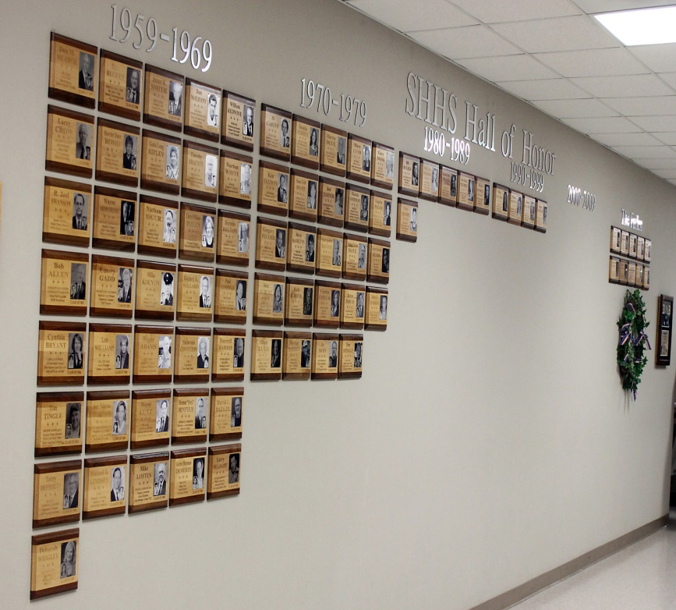

- In the fall of 2011, with the help of Facebook social media networking, about 750 alumni turned out for the Trojans’ Homecoming Game. The year before, a relatively modest effort to generate alumni attendance at the game resulted in a turnout of about 100 alums. Homecoming 2011 coincided with a Pasadena ISD Education Foundation-based initiative to create alumni associations at the four oldest district high schools and lay the groundwork for a district-wide alumni association. Carter was asked to play a central role in planning and organization. As a result, the South Houston HS Alumni Association was formed that winter and immediately went to work on various projects. Link: http://pisd.ss4.sharpschool.com/cms/One.aspx?portalId=80772&pageId=484883

- In the spring of 2012, in an effort to quickly raise money, the SHHS Alumni Association launched the “Hector’s Hundred” drive, the goal being to take $100 donations from 100 alumni, thereby raising $10,000. Several large donations had been sent to the school immediately after the first Hall of Honor induction ceremony. The association was able to meet it’s 100 x 100 goal in less than a month. Donors were honored with brass plaques in a remodeled display case placed at the entrance to the Hall of Honor.
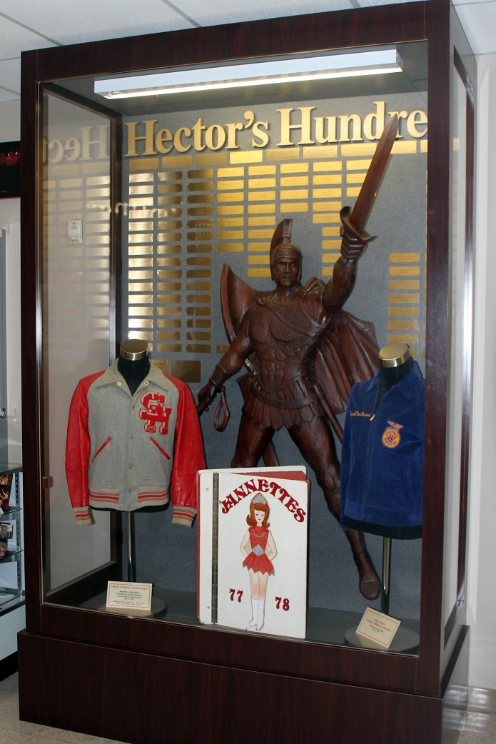

- On Oct. 12, 2012, the school hosted its first Homecoming Open House – during school hours – since 1967. The SHHS Alumni Association hosted a Homecoming Party later that night at the Marriott Hobby Hotel. Around 1,000 alumni attended at least one of the three Homecoming events: the Open House, the Homecoming Party and the Homecoming Game. Funds raised from the party, combined with Hector’s Hundred funding, went toward the purchase of a customized cargo trailer for the Trojan Band, a top priority in the district’s alumni association planning. The trailer was delivered to the school in April of 2014.
Link: http://www.chron.com/neighborhood/pasadena/news/article/Contributions-pave-way-for-trailer-for-South-9657345.php

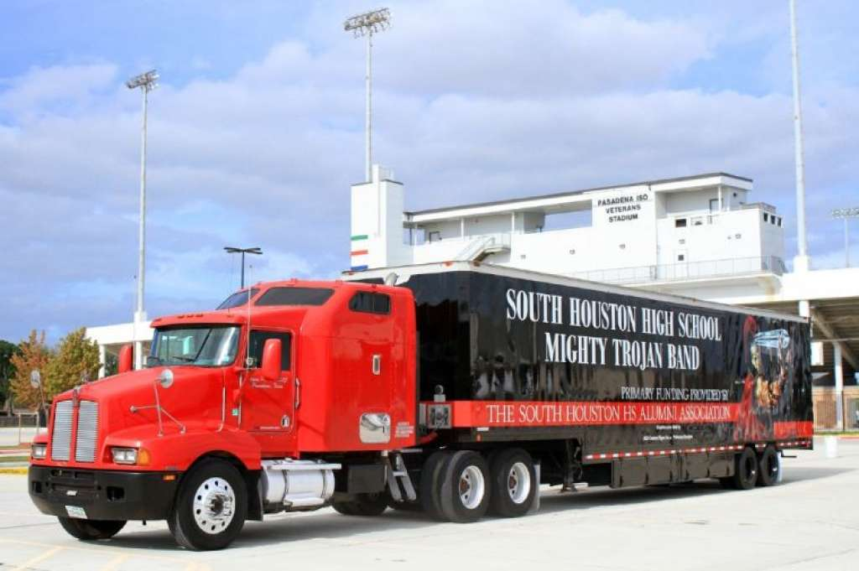

- During the 2012-13 school year, a second phase of development began in the Hall of Honor. With the financial support of the SHHS Alumni Association, the school’s collection of panorama class photos was recovered from storage, restored and remounted, by decade, in the rear of the hall. Work was completed in time for Homecoming 2013. A new class photo is hung in the hall each May.
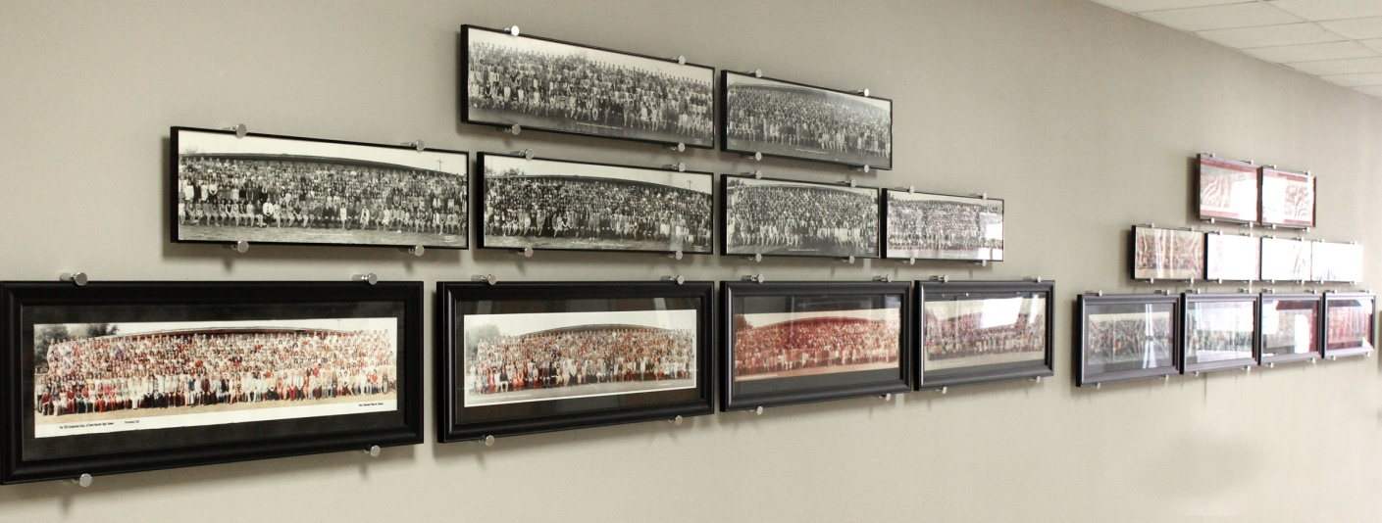

- On Tuesday, Oct. 1, 2013 – during Homecoming Week – a ceremony was held in the auditorium to formally induct the first 20 teachers into the Distinguished Faculty and Staff portion of the Hall of Honor. All nine of the living inductees attended the ceremony, including 99-year-old former school librarian Margaret Rose Lodge. This third phase of the Hall of Honor included a plaque display opposite the Alumni Hall of Honor display. Friday activities included the Open House, Homecoming Game and a Homecoming Party at La Brisa Restaurant in League City. Link: https://www1.pasadenaisd.org/news/archived_news/teacher_hall_of_honor_unveiling_launches_s_h_h_s_h/

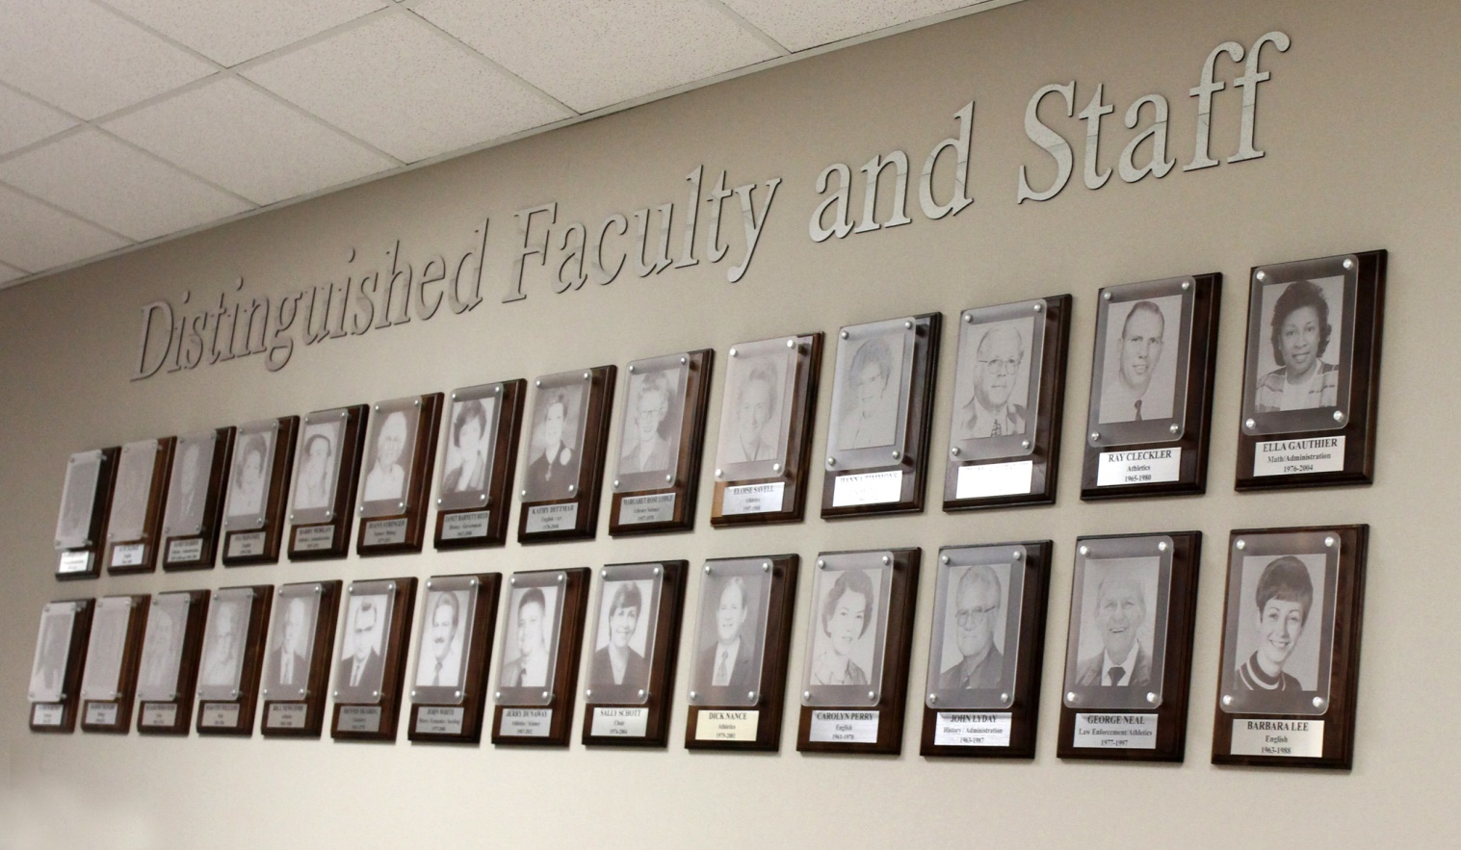

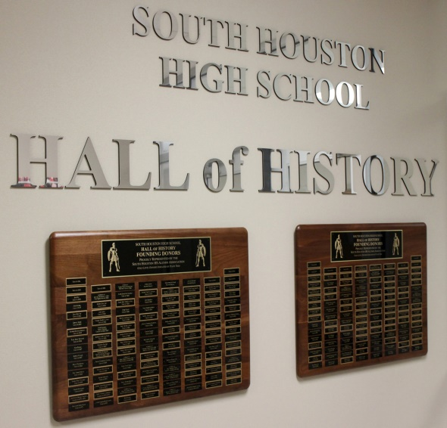
- Planning for the fourth and final phase of the Hall of Honor – the “Hall of History,” a full-scale campus museum – began during the 2013-2014 school year and continued until the museum’s ribbon-cutting at Homecoming 2015. Carter moved his office from the Administration Building to a work room that had been set aside by Fullen for the museum. After a year of planning, designing and collecting memorabilia, remodeling of the room began in the fall of 2014 with initial funding provided by alumni Bobby Allen. The SHHS Alumni Association remained actively involved with fund-raisers over this time. Funds were raised to purchase a new run-through tunnel for the football team in time for the 2015 season. Another fund drive raised about $20,000 to purchase materials needed to complete the museum. Donor’s names were listed on metal plates on two plaques place at the entrance to the Hall of History.

- The ribbon-cutting ceremony for the Hall of History was conducted during Homecoming Open House on Oct. 16, 2015. Superintendent of Schools Dr. Kirk Lewis held the ribbon and Bob Fay, a member of the Class of 1959 and the school’s first “Hector” mascot, used ceremonial scissors to slice it. About 400 alumni and guests visited the museum that day and attended Hall of Honor induction ceremonies for three additional alumni and three additional teachers. Another 500 alumni attended the Homecoming Game that night. Less than a month after the Hall of History opened, Fay died of a heart attack. A memorial plaque was place at the entrance to the museum, just a few feet from where he had cut the ribbon.
Link: http://www.chron.com/life/health/article/SHHS-Hall-of-History-Crown-Jewel-in-9645079.php#photo-11279933
Link: http://www.chron.com/neighborhood/pasadena/news/article/Museum-opening-highlights-homecoming-9829123.php

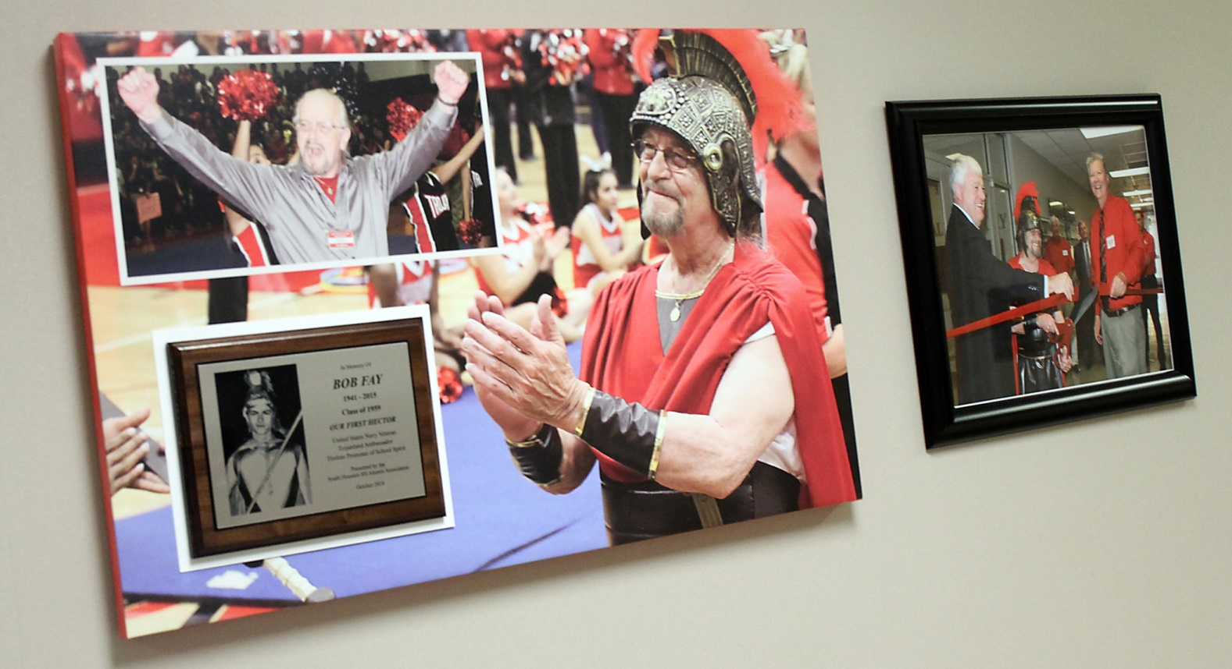

- The Hall of History was “expanded” outside the museum itself in 2016 when SHHS choir alumni unveiled a display honoring long-time choral director Sally Schott. The display, located in the Hall of History itself, focused on the musicals produced by Schott’s students during her 30 years at the school. Donor plaques were mounted to salute those alumni who contributed to the project. Link: https://www1.pasadenaisd.org/news/what_s_new/new_exhibit__alumni_choir_revue_to_honor_schott_s_

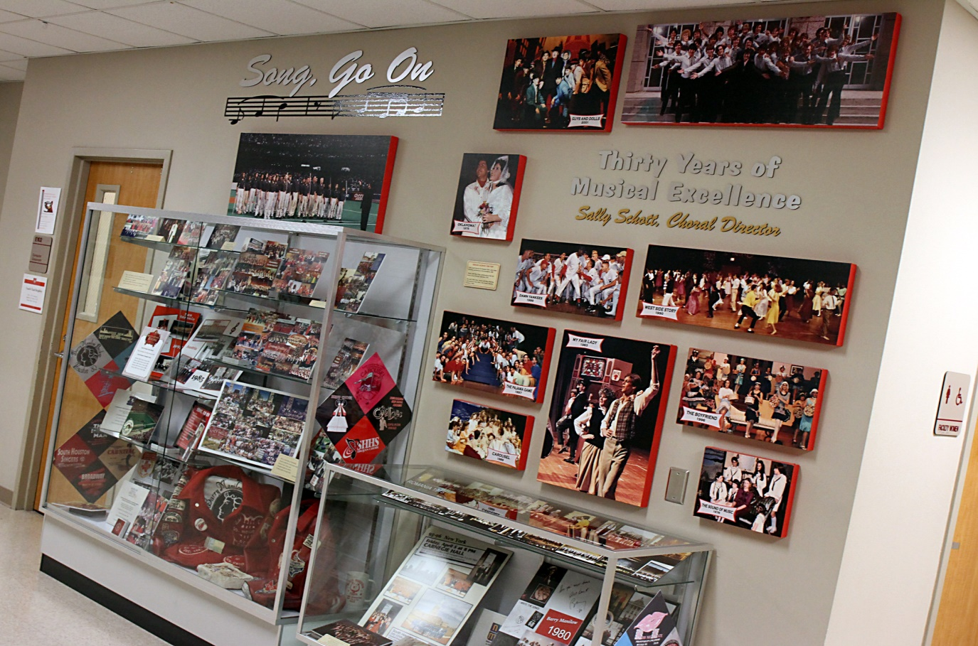

- Homecoming 2016 ceremonies featured the school’s sixth Alumni Hall of Honor induction class (raising the number of alumni inductees to 79), the fourth Teacher Hall of Honor induction class (raising the number of teacher inductees to 28) and the school’s fifth consecutive Homecoming Open House.
Link: https://www1.pasadenaisd.org/news/what_s_new/s_h_h_s_inductions__homecoming_events_attract_hund

Prepared by Al Carter
March 2017

