Go Out App - Creating a Venue
Creating a Venue with the Go Out App is simple. Just follow these steps:
- Click ‘Create New’ in the top right corner of the page to create a new venue.
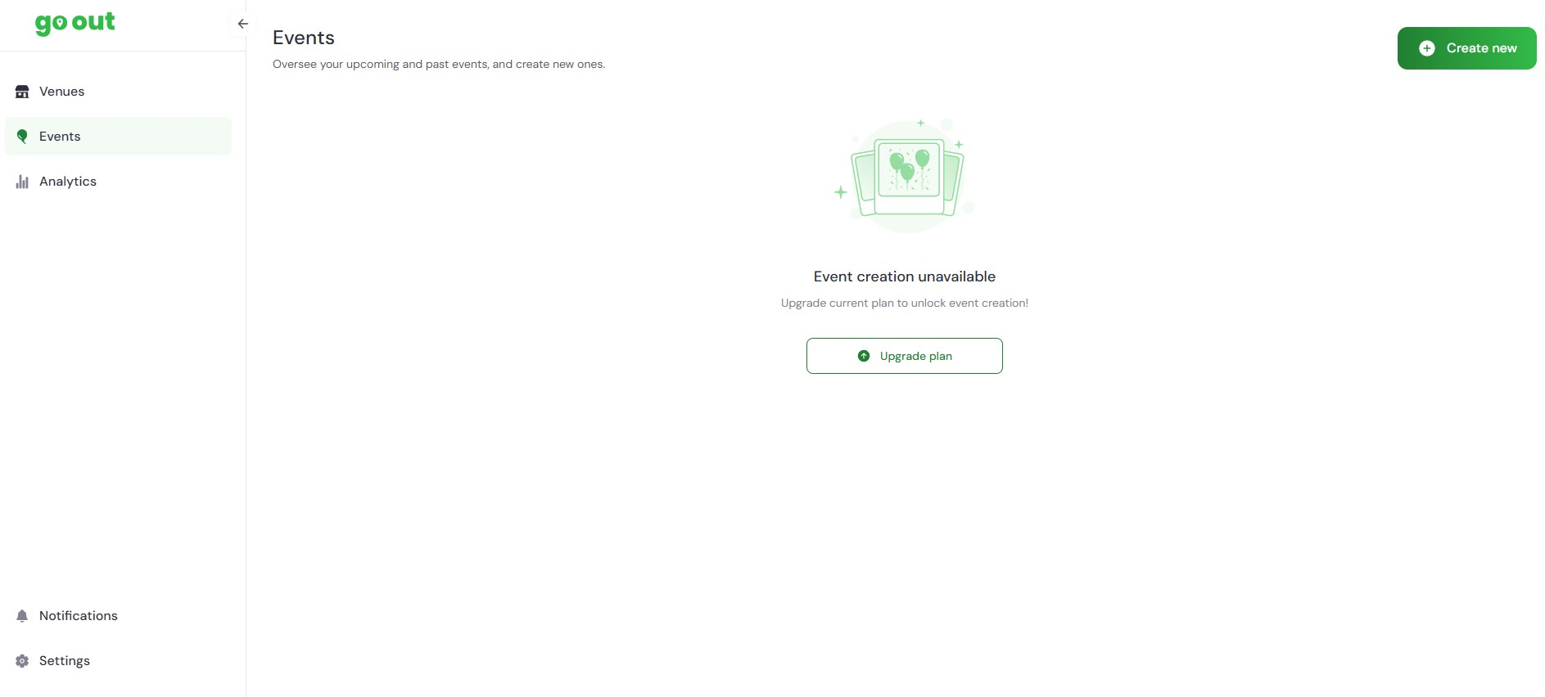
- Select the Venue Button and then select ‘Next
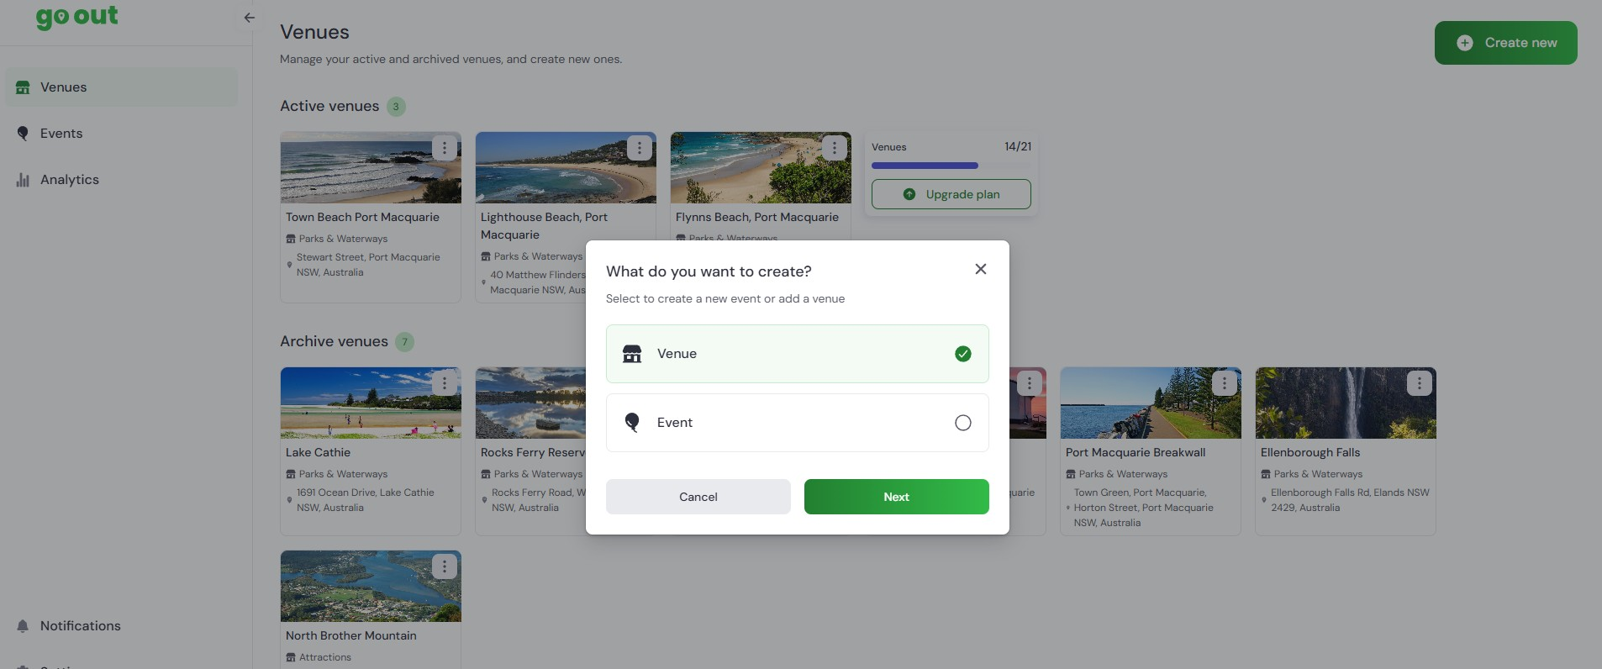
- If you’re unable to select ‘Next’ you will need to close the ‘What do you want to create?’ Window and select the ‘Upgrade plan’ button. (Instructions on purchasing and upgrading plans are available).
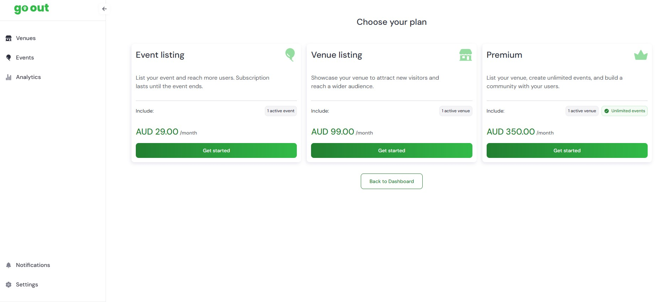
- After creating a new venue you will be returned to your homepage.
Then try step #2 again, then continue.
- Creating a new Venue:
  - Enter venue name
  - Select ‘Venue Type’ from drop down menu
  - Enter ‘Location Address’ (Begin writing address and select correct option)
  - Enter opening hours (enter in 24 Hour format EG. 08:30 - 17:00, if the venue is not open for a day enter ‘closed’, fill each day of the week).

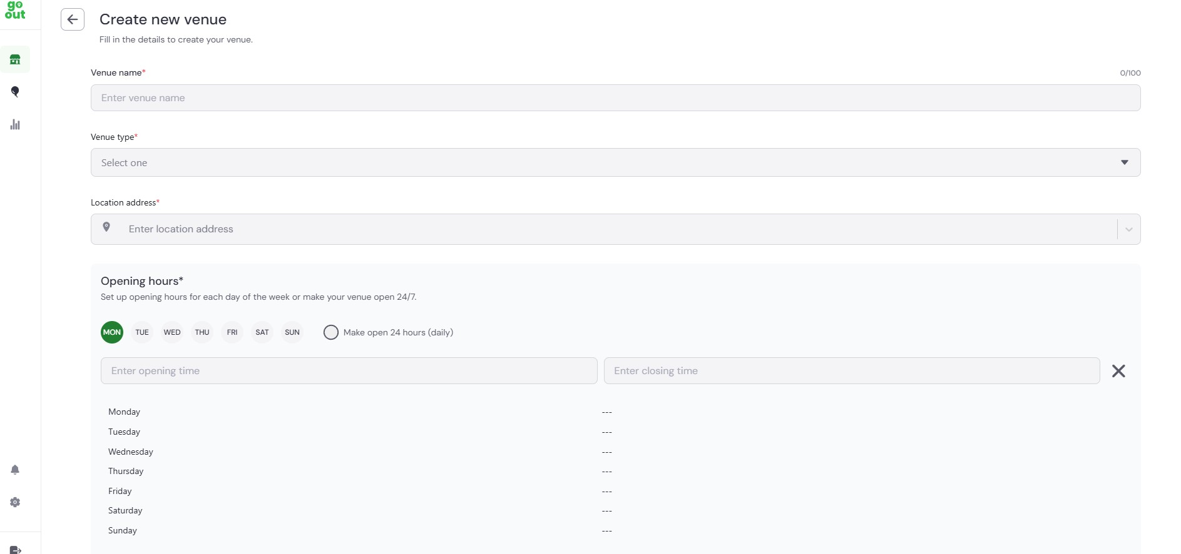
- Creating new Event continued:
  - Enter phone number - optional
  - Enter website or social link - optional
  - Enter banner/art promo (landscape smaller than 5 MB in png or jpeg format. Size - 1080 x 600 preferred)Select applicable Categories (you may select more than one)
  - Select applicable Categories (you may select more than one)
  - Add applicable keywords (words users may use to search your business)
  - Add additional information that is applicable to your venue - optional
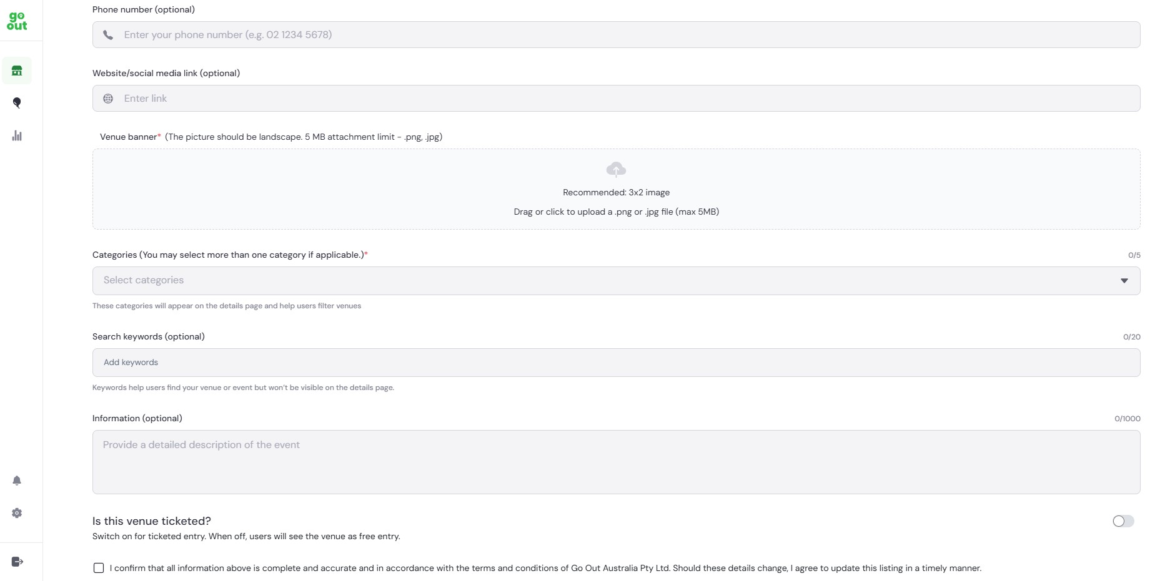
- Creating a new Event - Ticketed
  - If the venue is Ticketed, select the button on the right. Add the starting price and the booking page link.
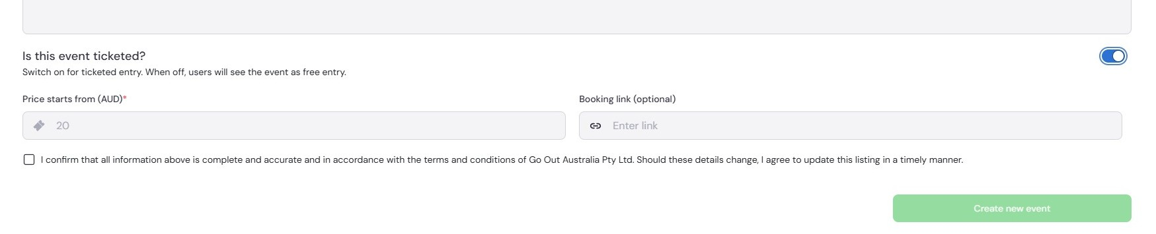
- When all applicable fields are filled, select the ‘Terms & Conditions’ box, then click ‘Create New Venue’ at the bottom of the page (If it is dark green it can be selected. If it can’t be selected there is a required incompleted field)

- A dark green box will appear ‘Venue Created’ if the event is created successfully. Your event will appear immediately on the Go Out App. As it is a new venue it may not appear on the first page, search the categories you selected to find/view your event.
Tips for successful Venue creation:
- After creating a venue, the venue creation form will begin to autofill with your previous entries. They will appear for selection.
- Upload a landscape-oriented image that’s not too large. Reduce the size of your image for best results.
- Have your webpage and socials open, cut and paste 'information' into the fields.

If you need further assistance, The Go Out Australia team is here to help! Feel free to email us or give us a call anytime.
For more details, visit gooutaustralia.com.

