Getting Started with the Go Out App - Businesses
Getting started with the Go Out App is simple. Just follow these steps:
- Click the link below to access the Business/Community sign-up page:
http://app.gooutaustralia.com/
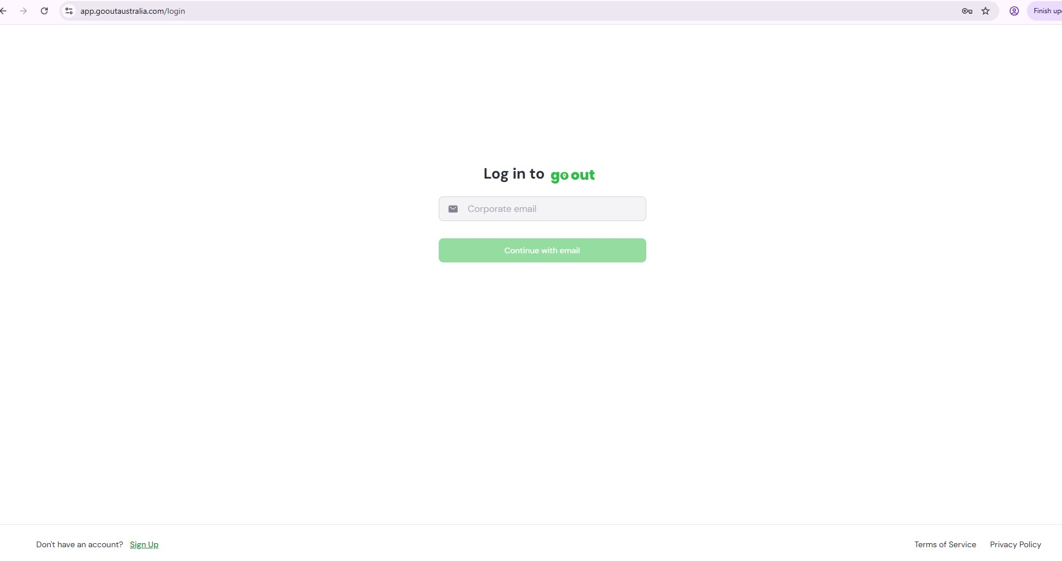
- Select ‘Sign Up’ and follow the prompts:
  - Enter your email address
  - Create a password
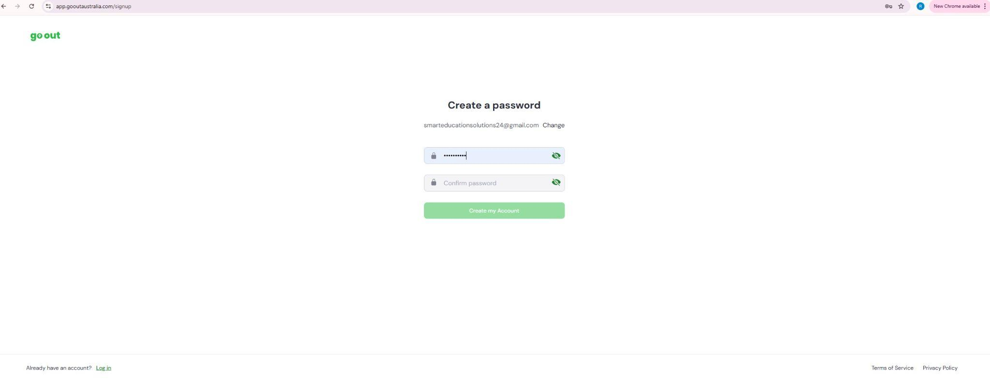
- You’ll receive an email account confirmation email from Go Out Australia.
(If not received check Spam/Junk Folder).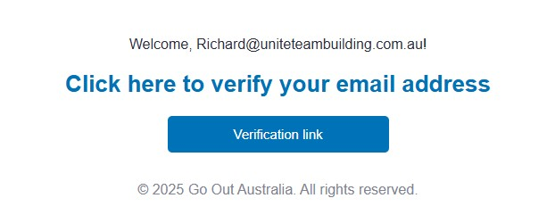
- Click the confirmation link in that email. You will then be taken to a section to create your account..
(If link doesn’t take you to the sign in page, use the http://app.gooutaustralia.com/ in a new browser window and ‘log in’ with your email and password. If you are able to ‘log in’ go to #7 and continue).

- Log in to your account and follow the prompts.
Click the link below to access the Business/Community sign-up page:
http://app.gooutaustralia.com/
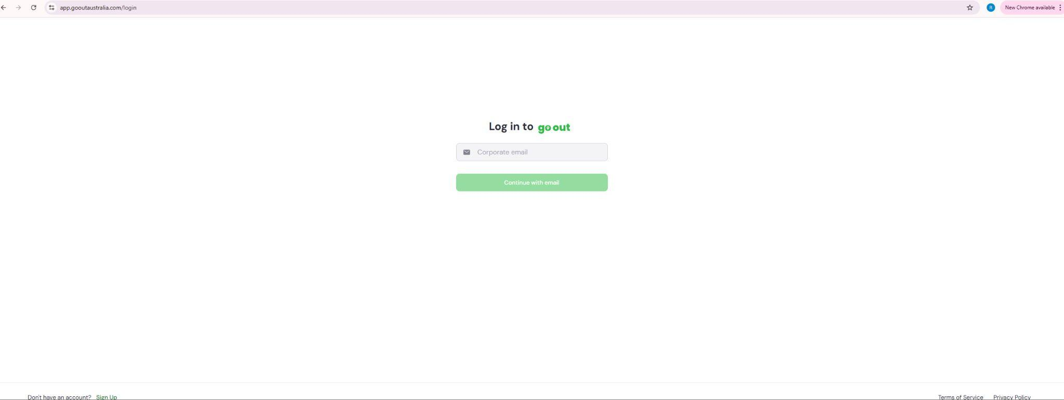

  - Select ‘Business’ as your organisation type, select ‘Next’.
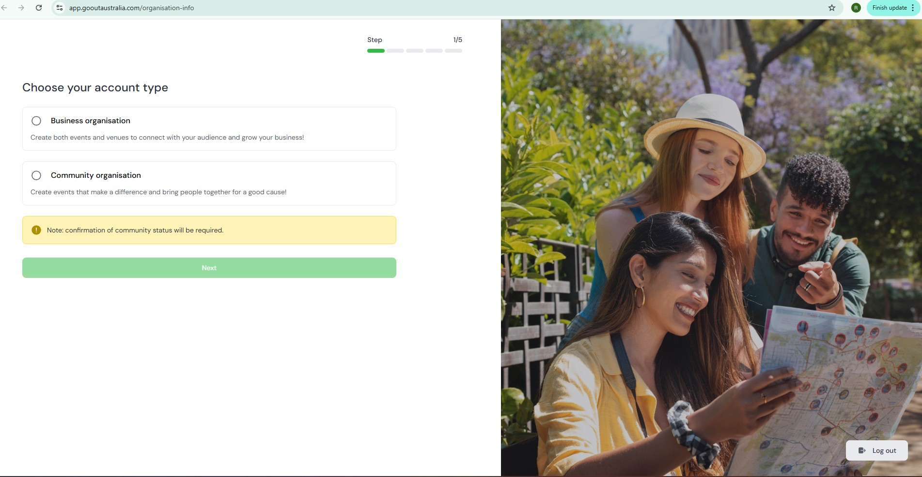
  - Enter your Business name, select ‘Next’.
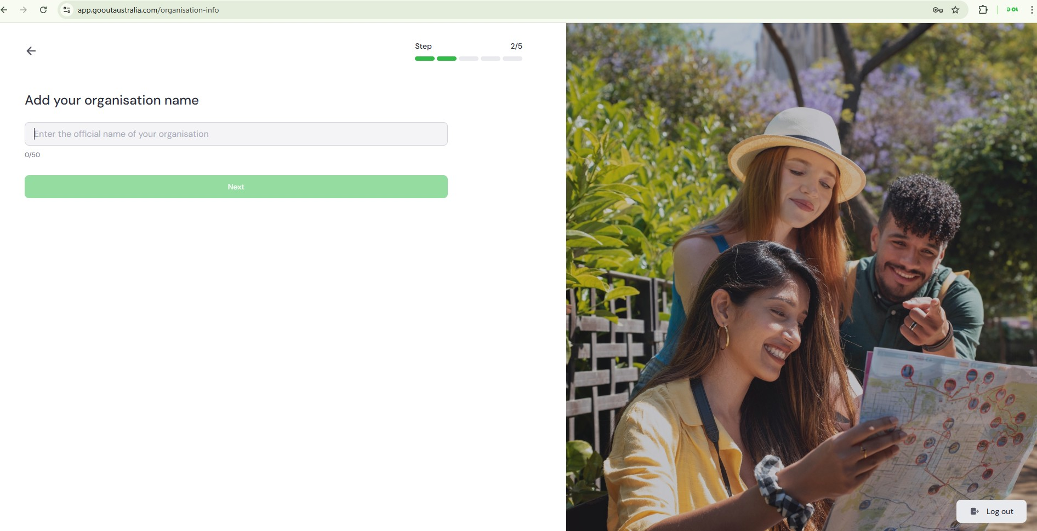
  - Add Description of your business, select ‘Next’.
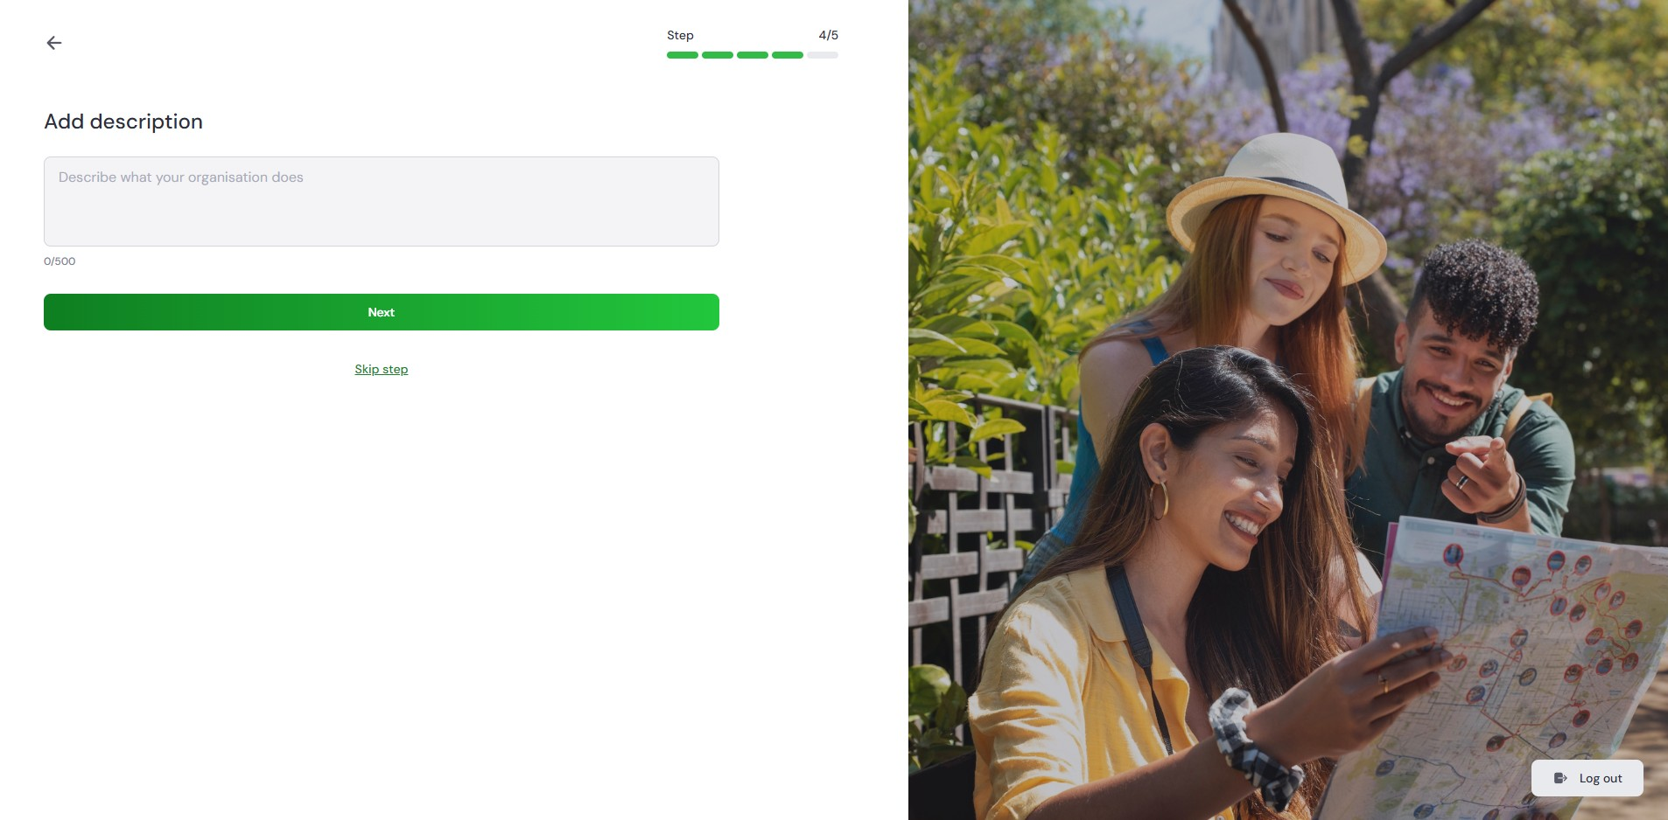

  - Upload business Logo, select ‘Next’.
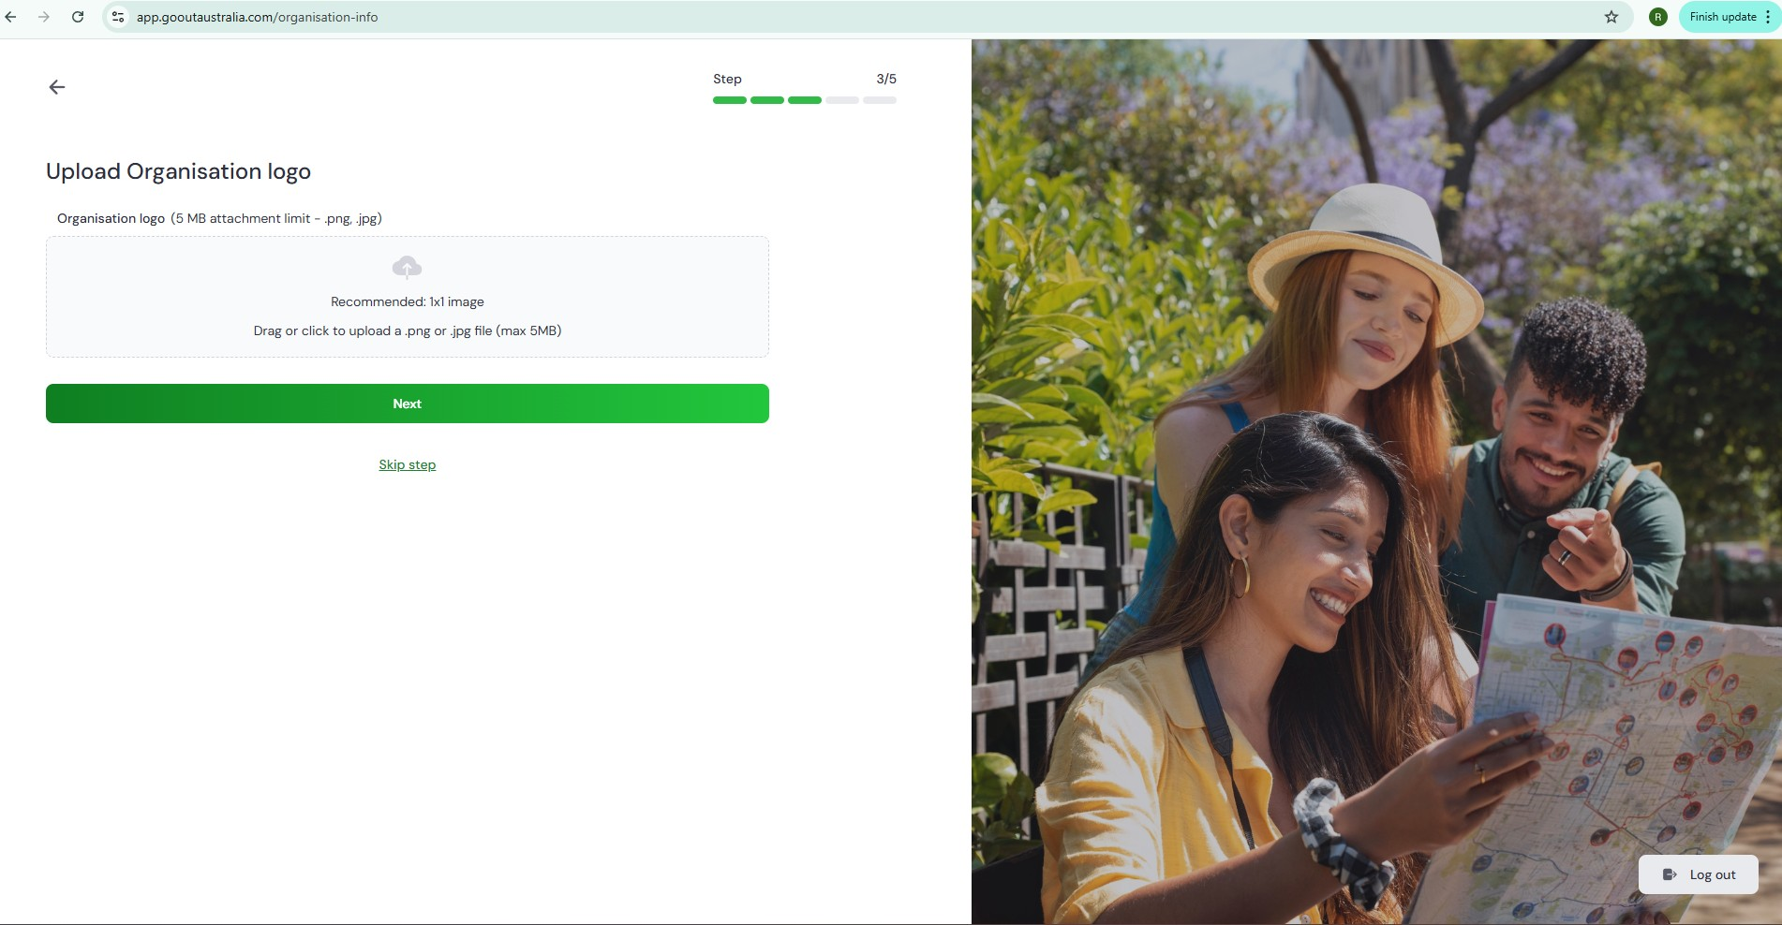
  - Organisation ID verification. Provide your ABN/ACN, select
‘Send for Approval’.
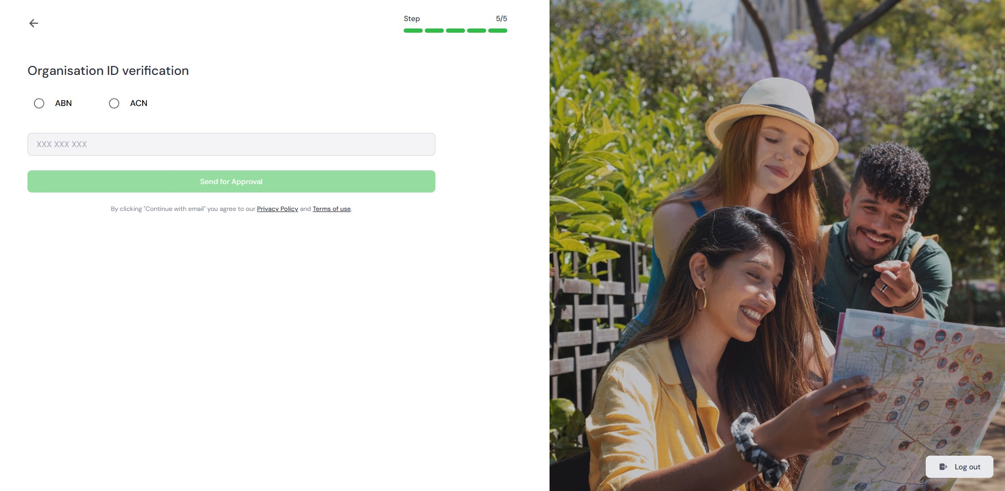
- Once completed, you’ll be taken to your organisation’s Business page, where you can manage your venue and events.
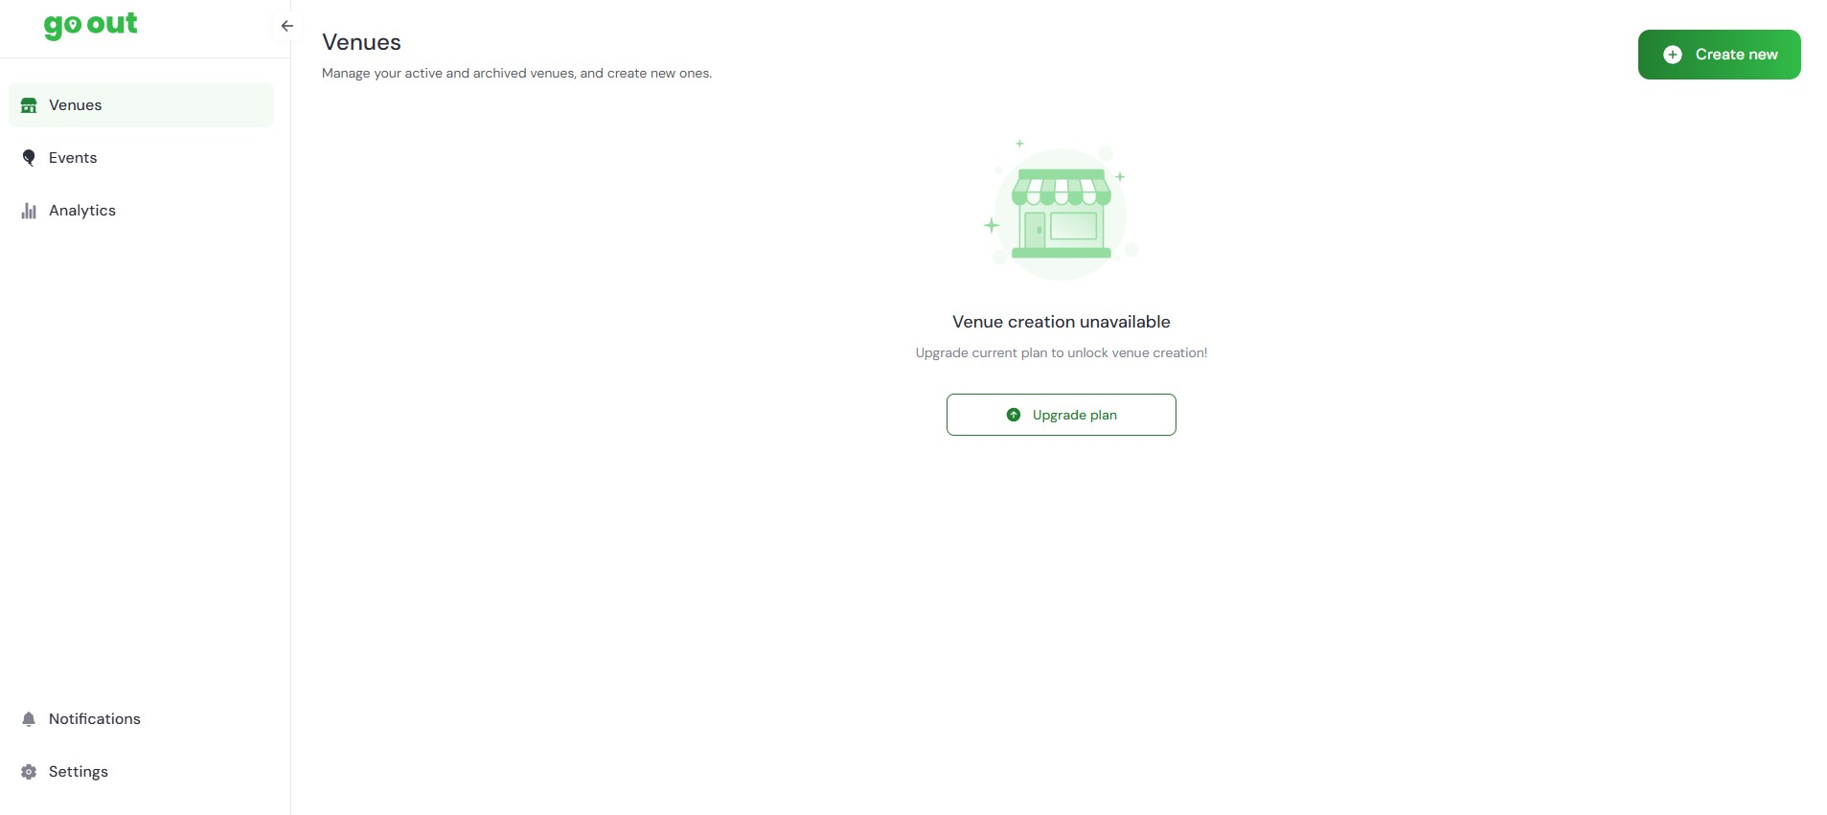

- Your request will be reviewed by the Go Out Australia Team.
(this usually happens quickly).
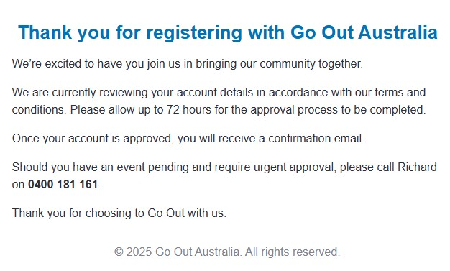
- Once approved, you’ll receive a follow-up email. Click the link below to access the Business sign-up/log in page:
http://app.gooutaustralia.com/
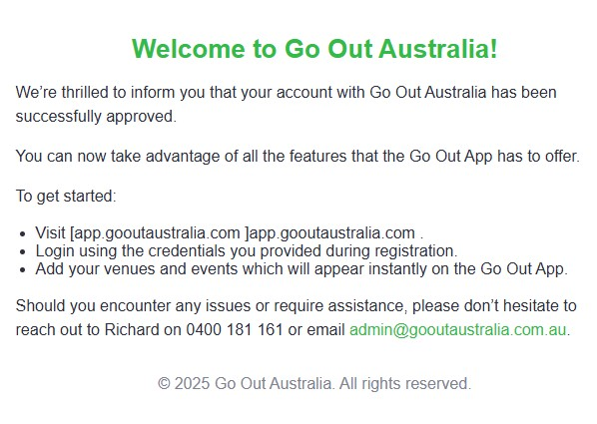

If you need further assistance, The Go Out Australia team is here to help!
Feel free to email us or give us a call anytime.
For more details, visit gooutaustralia.com.

