Go Out App - Creating an Event
Creating an Event with the Go Out App is simple. Just follow these steps:
- Click ‘Create New’ in the top right corner of the page to create a new event.
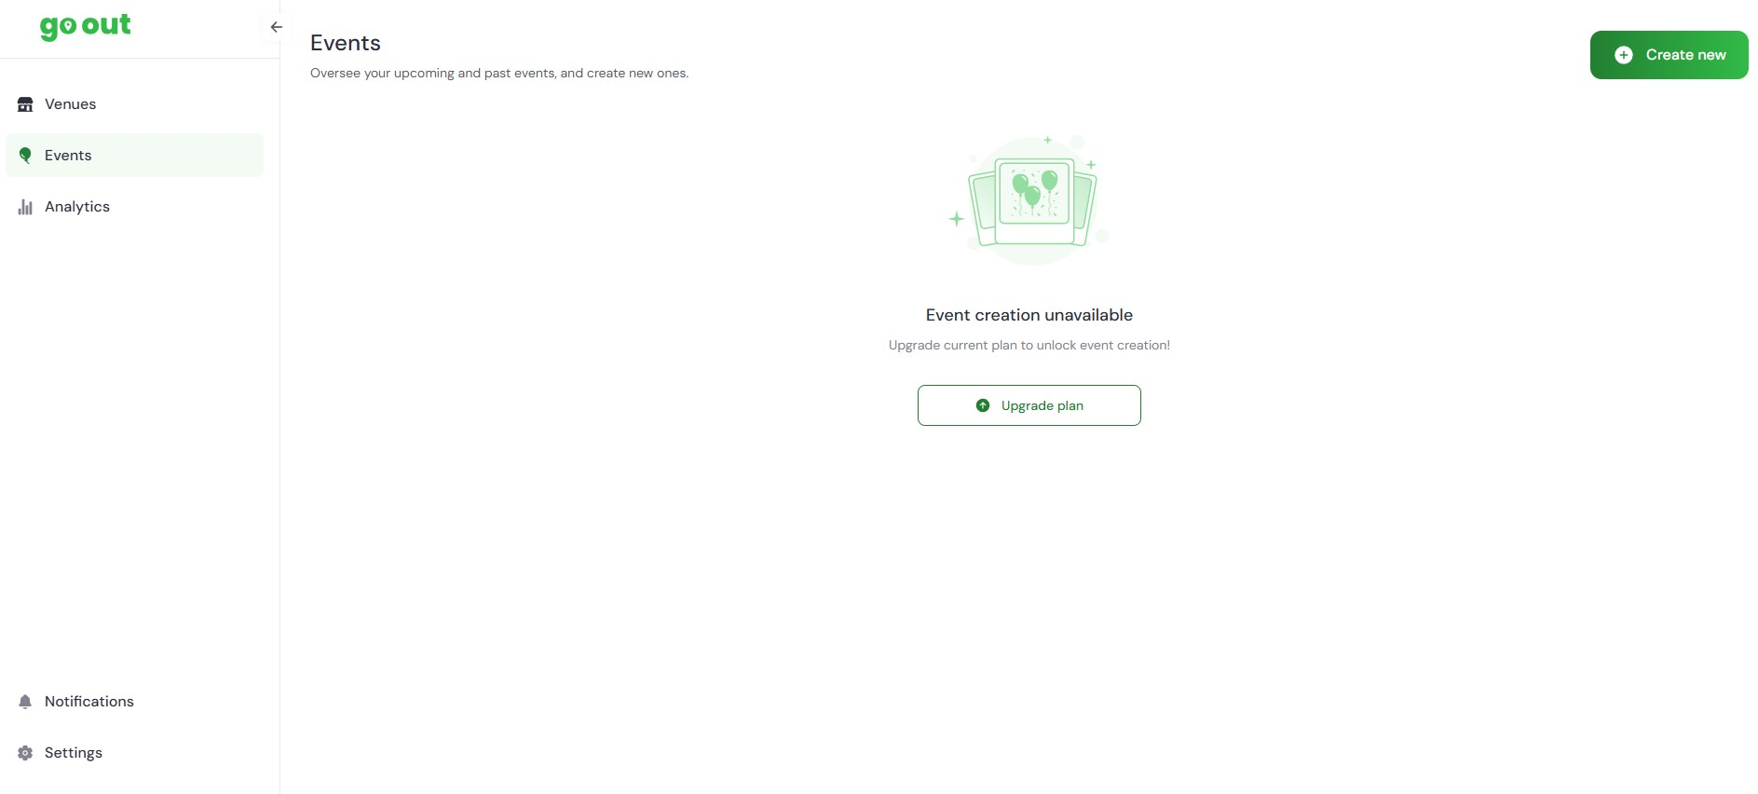
- Select the Event Button and then select ‘Next’.
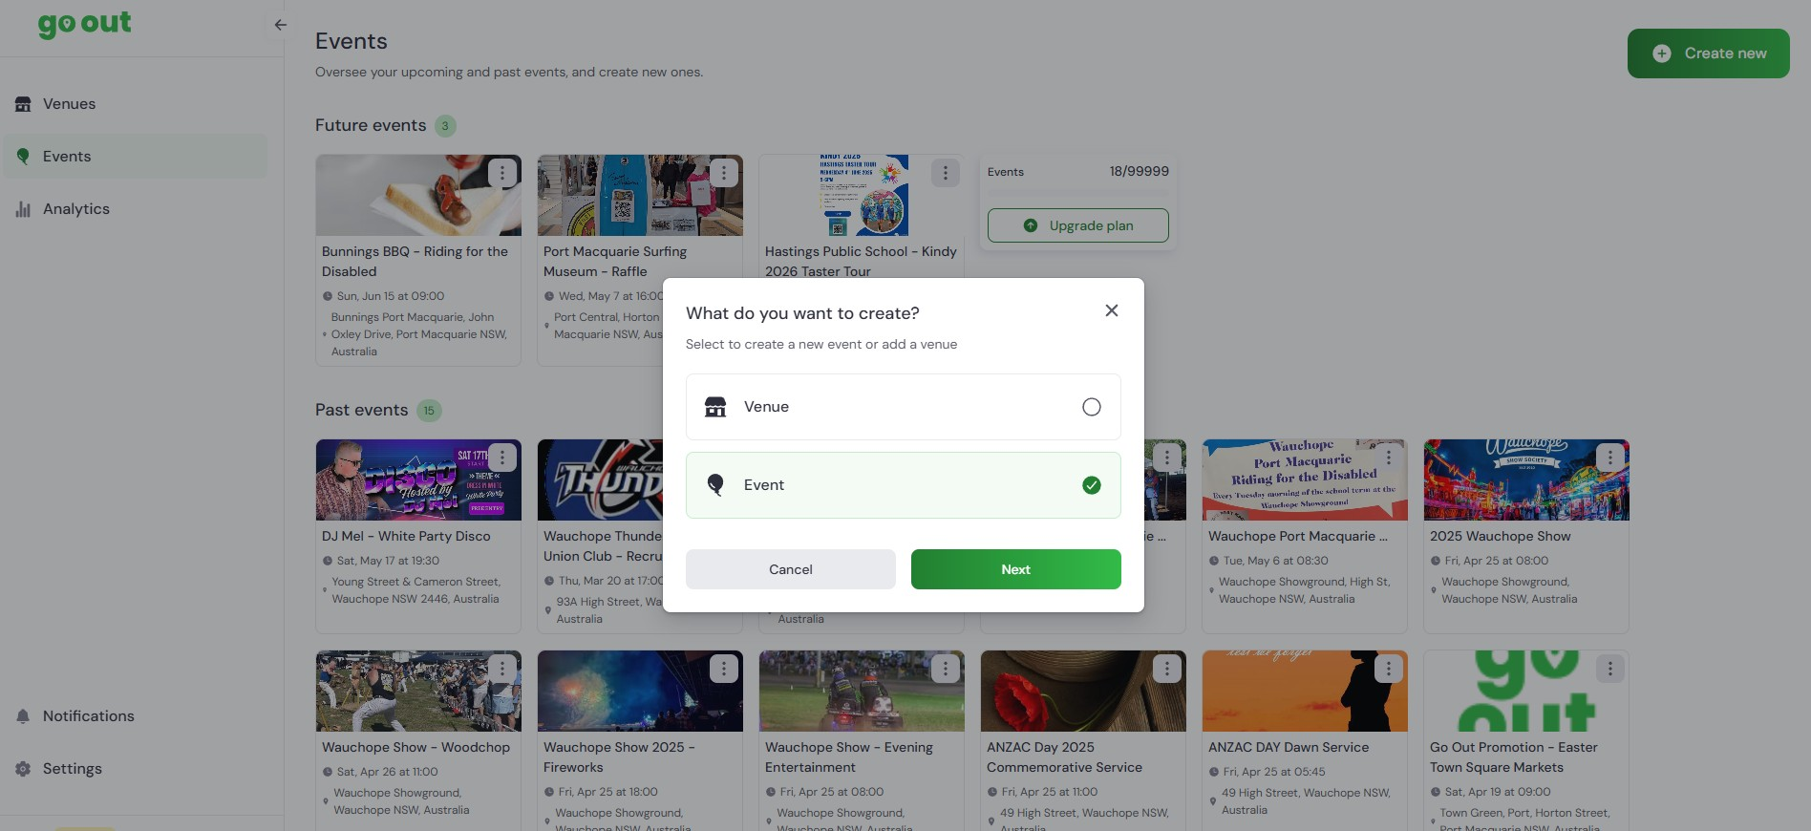
- If you’re unable to select ‘Next’ you will need to close the ‘What do you want to create?’ Window and select the ‘Upgrade plan’ button. (Instructions on purchasing and upgrading plans are available).
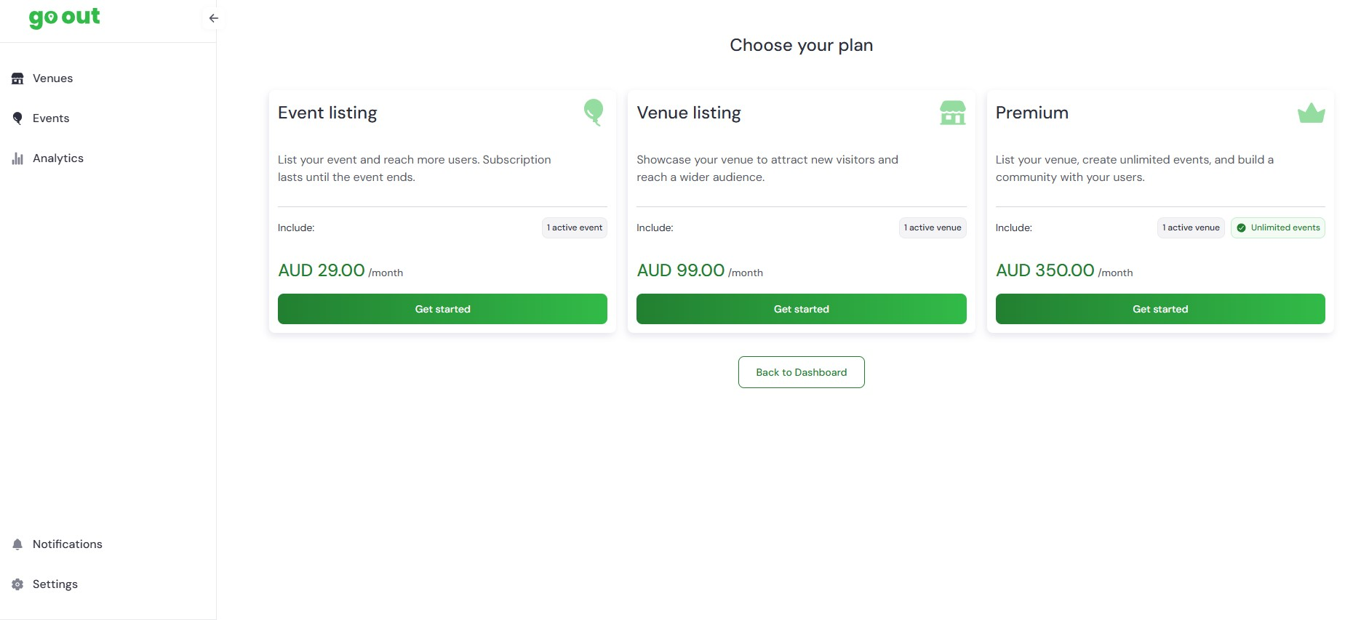
- After creating a new event you will be returned to your homepage.
Then try step #2 again, then continue.

- Creating a new Event:
  - Enter event name
  - Select ‘Event Type’ from drop down menu
  - Select date and time from calendar and time menu
  - Select recurring (if applicable)
  - Choose an existing venue or enter a new location (fill in either venue or location address field - only one is required)
  - Enter phone number - optional
  - Enter website or social link - optional
  - Enter banner/art promo (landscape format is required. Smaller than 5 MB in png or jpeg format. Size - 1080 x 600 preferred)
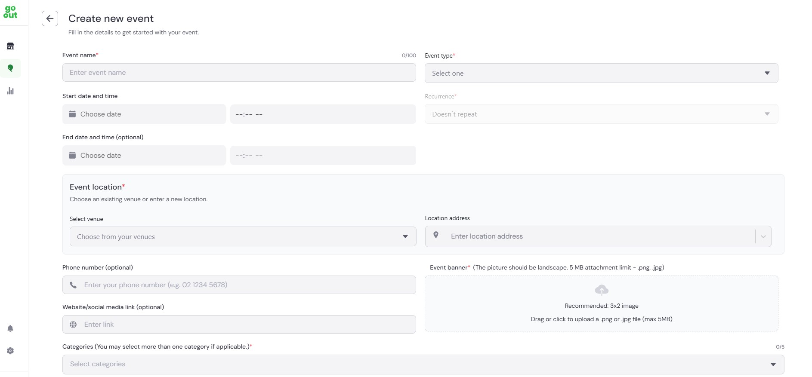
- Creating new Event continued:
  - Select applicable Categories (you may select more than one)
  - Add applicable keywords (words users may use to search your organisation)
  - Add additional information that is applicable to your event - optional
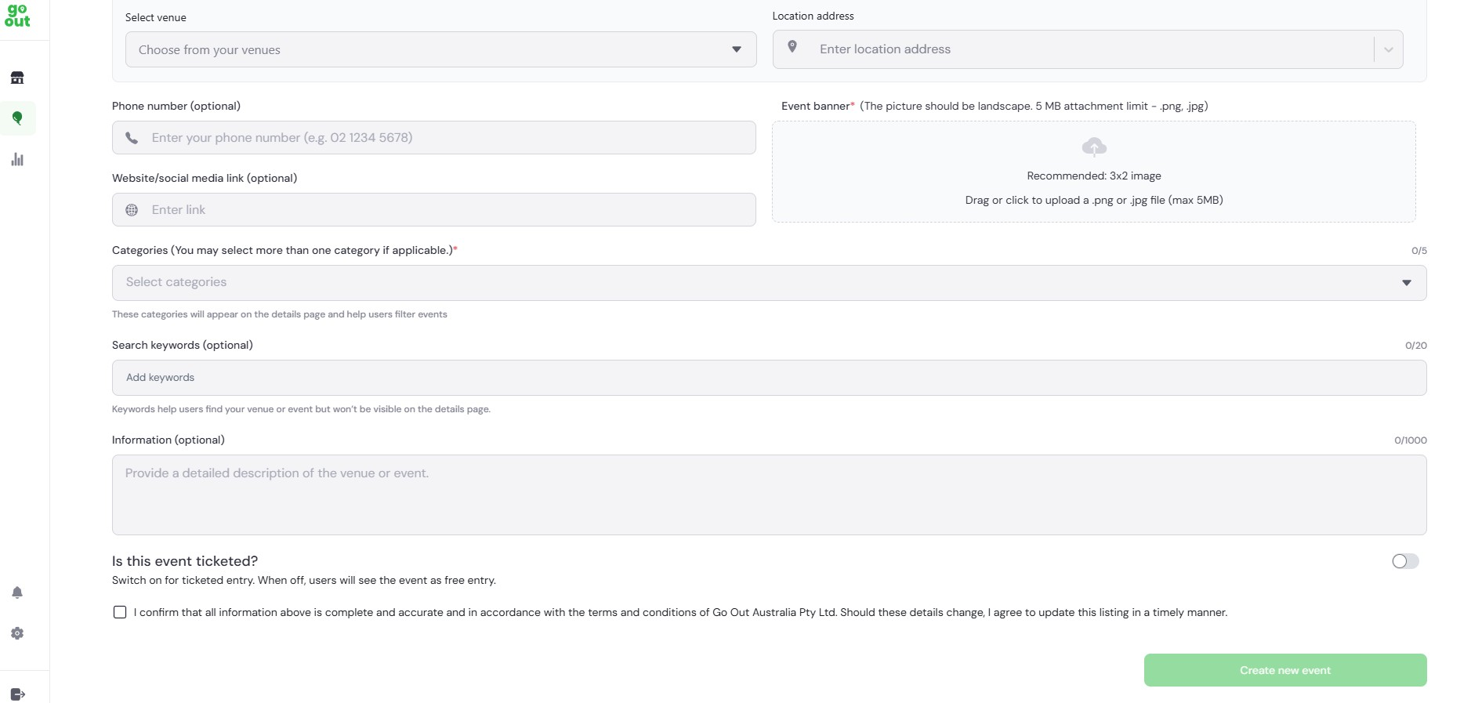
- Creating a new Event - Ticketed
  - If the event is Ticketed, select the button on the right. Add the starting price and the booking page link.
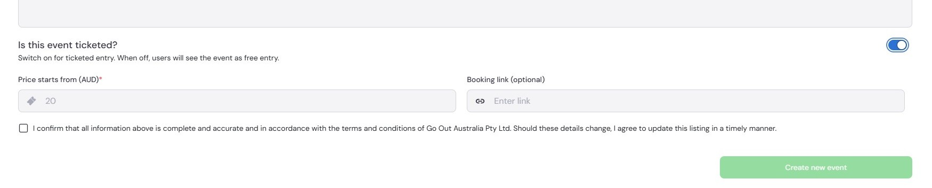
- When all applicable fields are filled, select the ‘Terms & Conditions’ box, then click ‘Create New Event’ at the bottom of the page (If it is dark green it can be selected. If it can’t be selected there is a required incompleted field)

- A dark green box will appear ‘Event Created’ if the event is created successfully. Your event will appear immediately on the Go Out App. As it is a new event it may not appear on the first page, search the categories you selected to find/view your event.
Tips for successful Event creation:
- After creating a few events, the event creation form will begin to autofill with your previous entries. They will appear for selection.
- Upload a landscape-oriented image that’s not too large. Reduce the size of your image for best results.
- Have your webpage and socials open, cut and paste 'information' into the fields.

If you need further assistance, The Go Out Australia team is here to help! Feel free to email us or give us a call anytime.
For more details, visit gooutaustralia.com.

