Go Out App - Upgrade Plan

Upgrading your plan with the Go Out App is simple. Just follow these steps:
- Click ‘Upgrade Plan’ button in the middle of the page to upgrade your current plan.
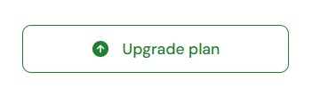

- The ‘Choose your plan’ page will open. There are three plans that can be selected.
- Event listing - this option is for individual events. They can be created as stand alone events and they will connect to any other current content you have listed. Once created this content will stay live on the Go Out App until the event has ended.
- Venue listing - this option is for a short or long term venue. Once created it will stay on the Go Out App for as long as your subscription is current.
- Premium - this option includes one ‘Venue’ and unlimited ‘Events’ per month. Once created this content will stay on the Go Out App for as long as your subscription is current.

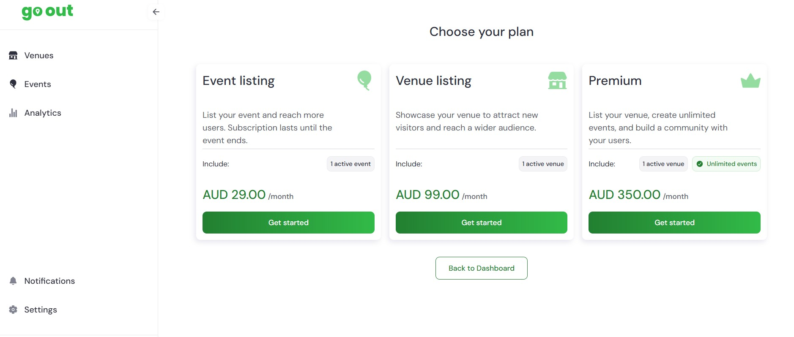

- When you have chosen your plan a new page will open associated with that plan. Eg. ‘Event’. Complete the information and payment process to purchase a plan.
(If you have a ‘Promotion code’) go to step
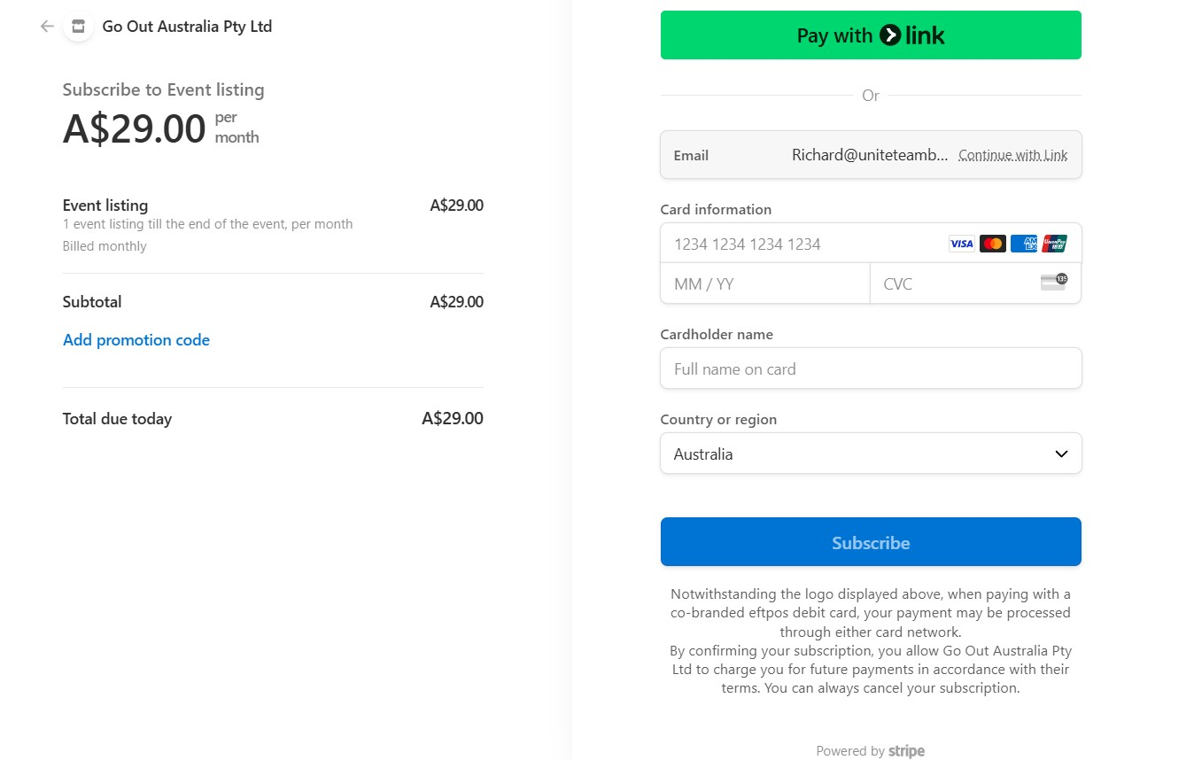
- When you have chosen your plan a new page will open associated with that plan. Eg. ‘Event’. If you have an existing STRIPE account, confirm your account to purchase a plan.
(If you have a ‘Promotion code’) go to step
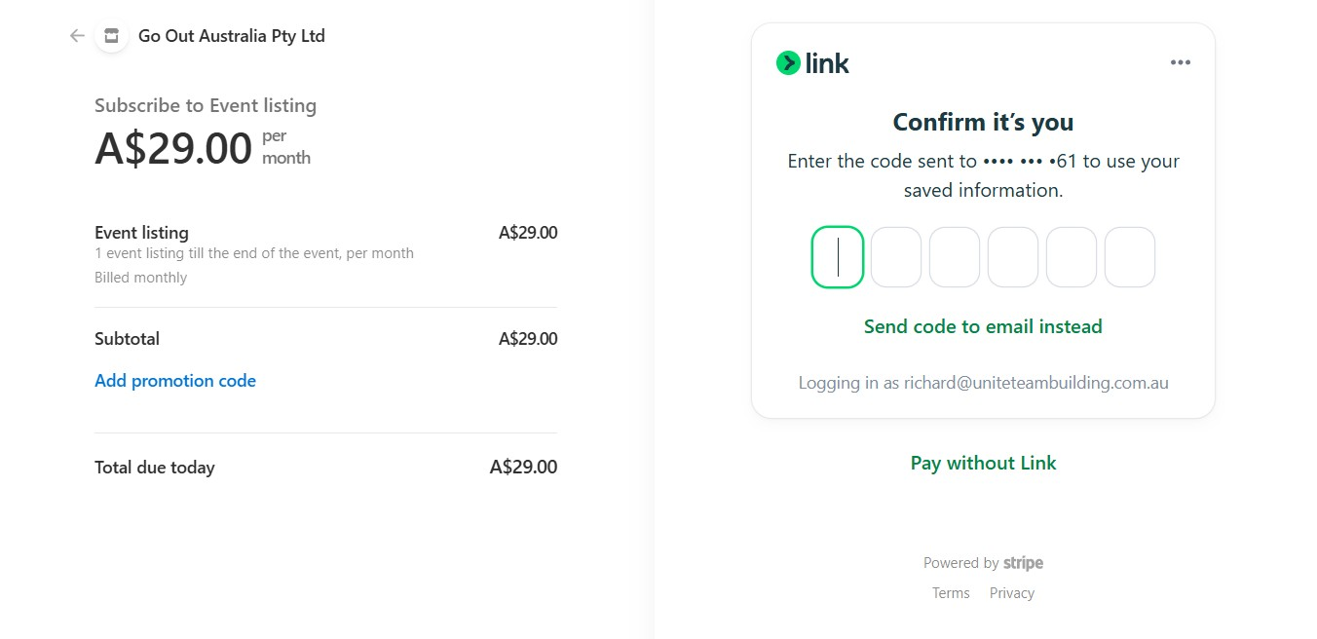
- If you have a ‘Promotion Code’ to apply:
  - Select ‘Add promotion code’
  - Enter the promotion code
  - Select apply
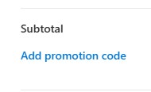
If the promotion code is valid the price of your purchase will be displayed as $0.00. To complete the process you are required to enter a credit card, no cost will be applied.
- When all fields are filled and details are correct select ‘Subscribe’. When the purchase process is completed you will return to your homepage. You will then be able to create content aligned with your purchase.

If you need further assistance, The Go Out Australia team is here to help! Feel free to email us or give us a call anytime.
For more details, visit gooutaustralia.com.

