Getting Started with the Go Out App - Community
Getting started with the Go Out App is simple. Just follow these steps:
- Click the link below to access the Business/Community sign-up page:
http://app.gooutaustralia.com/
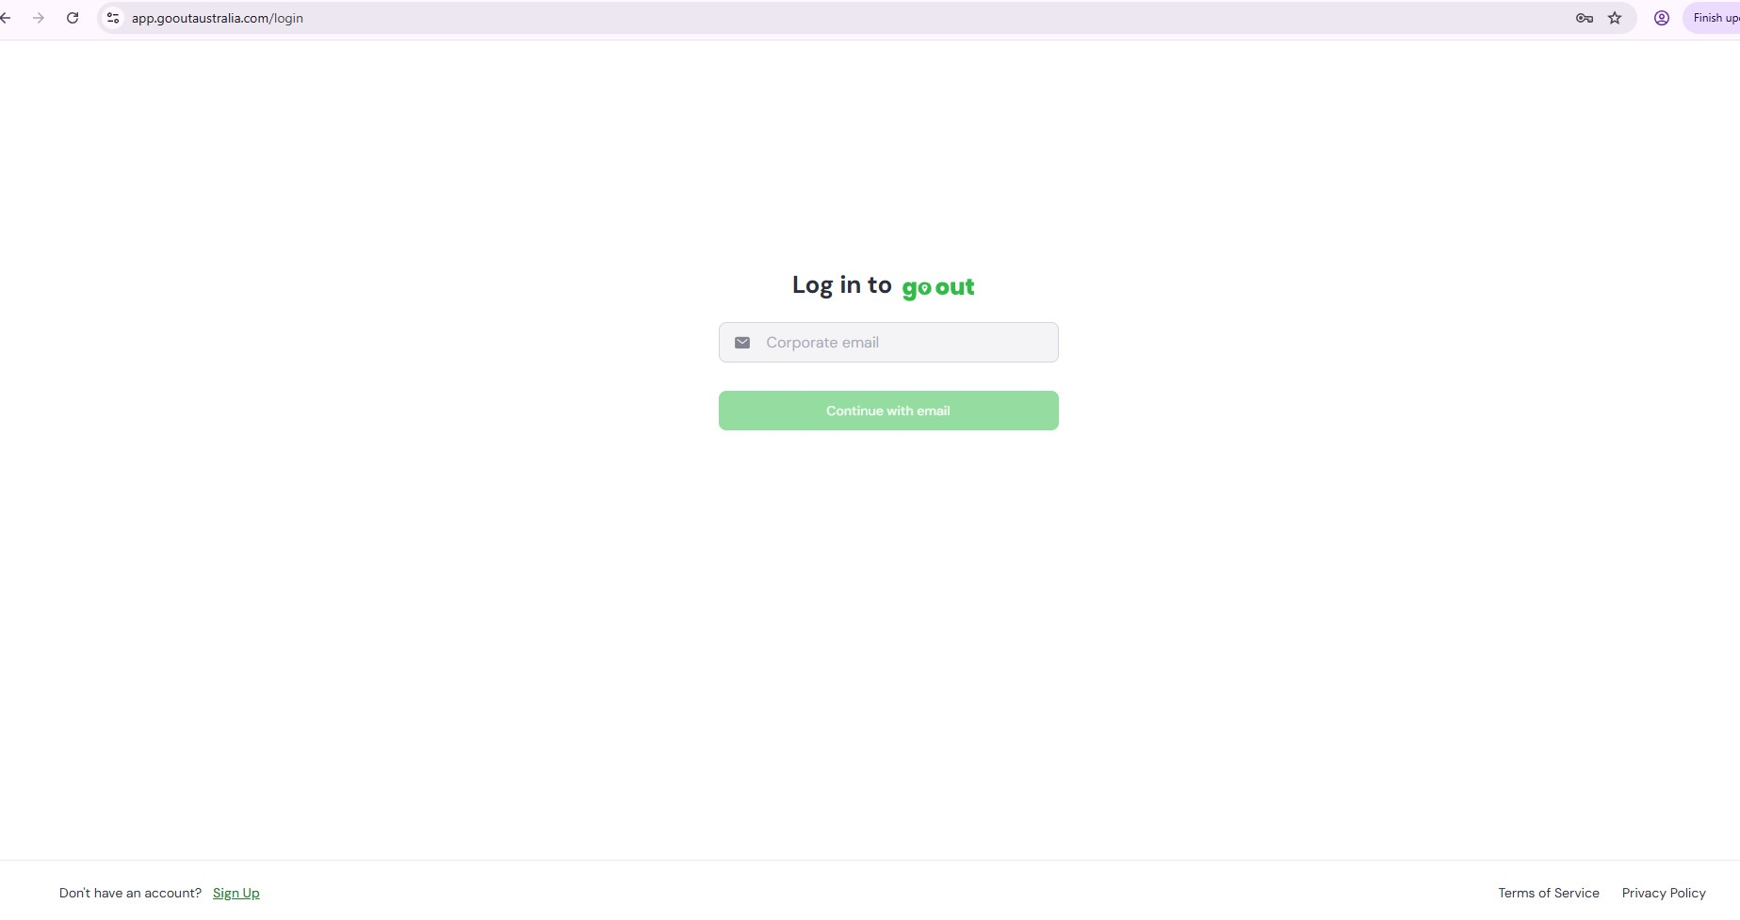
- Select ‘Sign Up’ and follow the prompts:
  - Enter your email address
  - Create a password
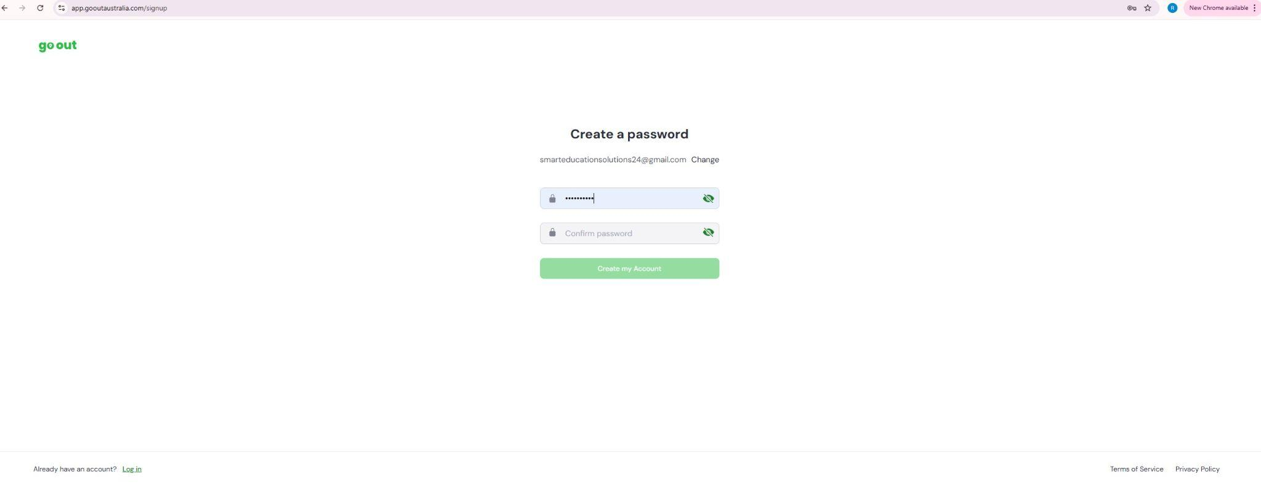
- You’ll receive an email account confirmation email from Go Out Australia.
(If not received check Spam/Junk Folder).
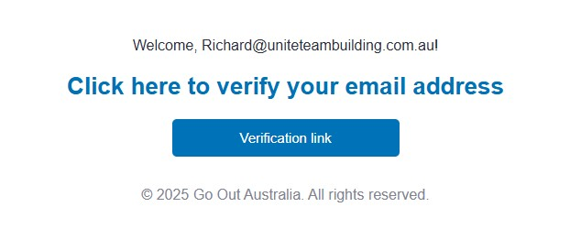
- Click the confirmation link in that email.
(If link doesn’t take you to the sign in page, use the http://app.gooutaustralia.com/ link in a new browser window).
- Your request will be reviewed by the Go Out Australia Team
(this usually happens quickly).
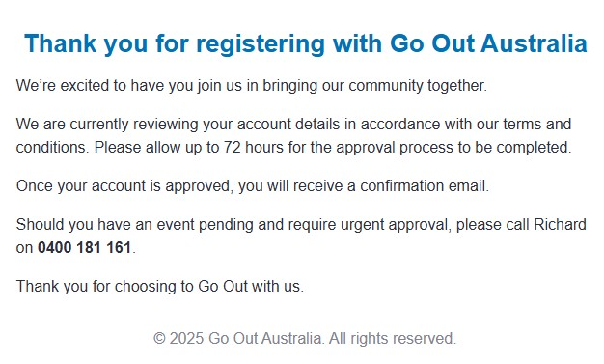
- Once approved, you’ll receive a follow-up email. Click the link below to access the Business/Community sign-up page:
http://app.gooutaustralia.com/
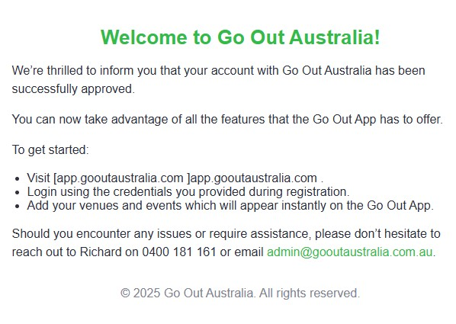

- Log in to your account and follow the set up steps.
Click the link below to access the Community sign-up/log in page:
http://app.gooutaustralia.com/
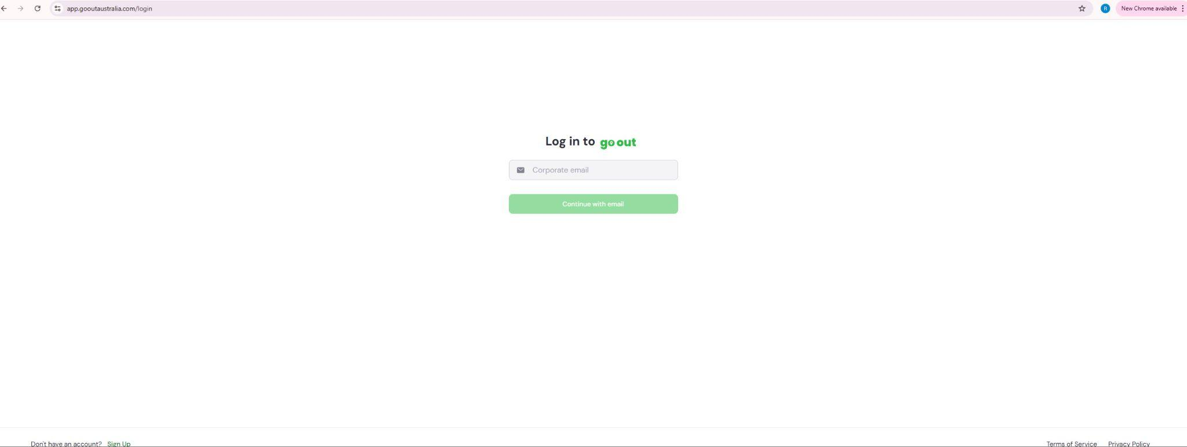
  - Select ‘Community’ as your organisation type, select ‘Next’.
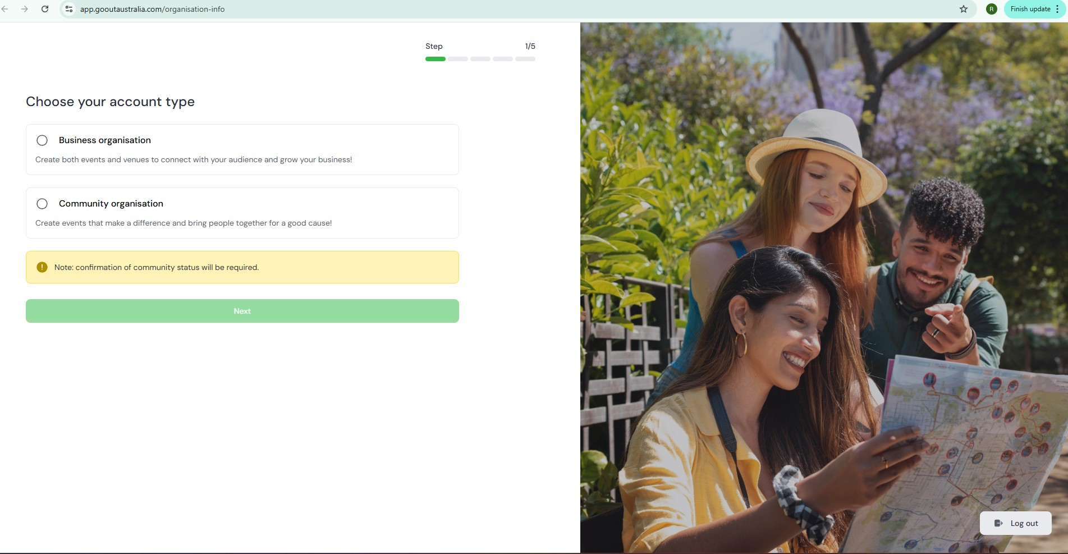
  - Enter your Organisation name, select ‘Next’.
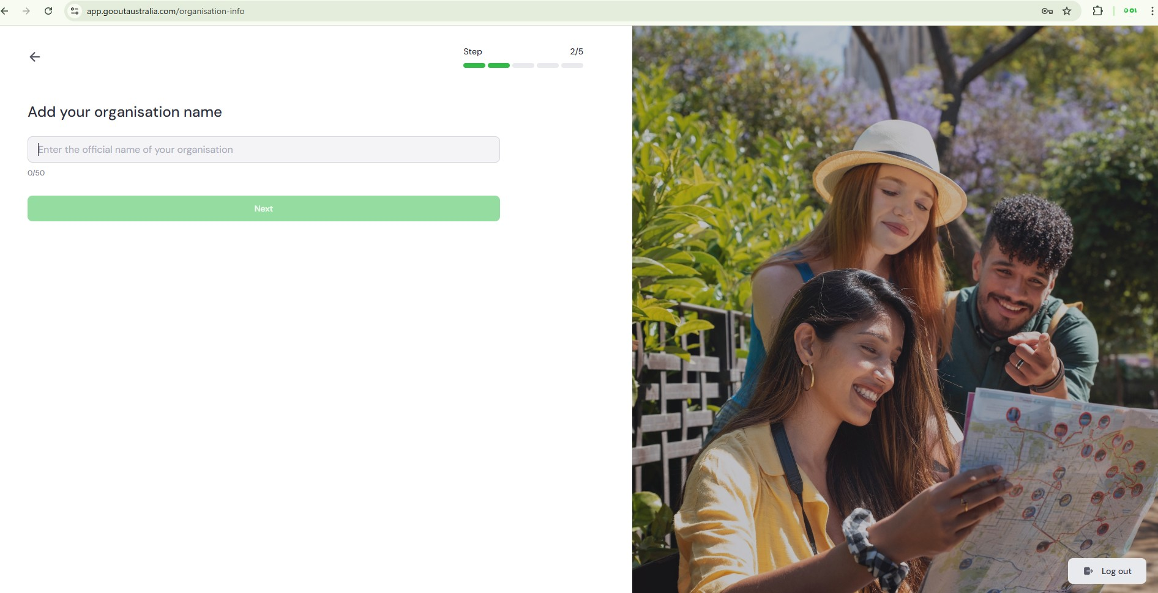

  - Add a Description of your organisation, select ‘Next’.
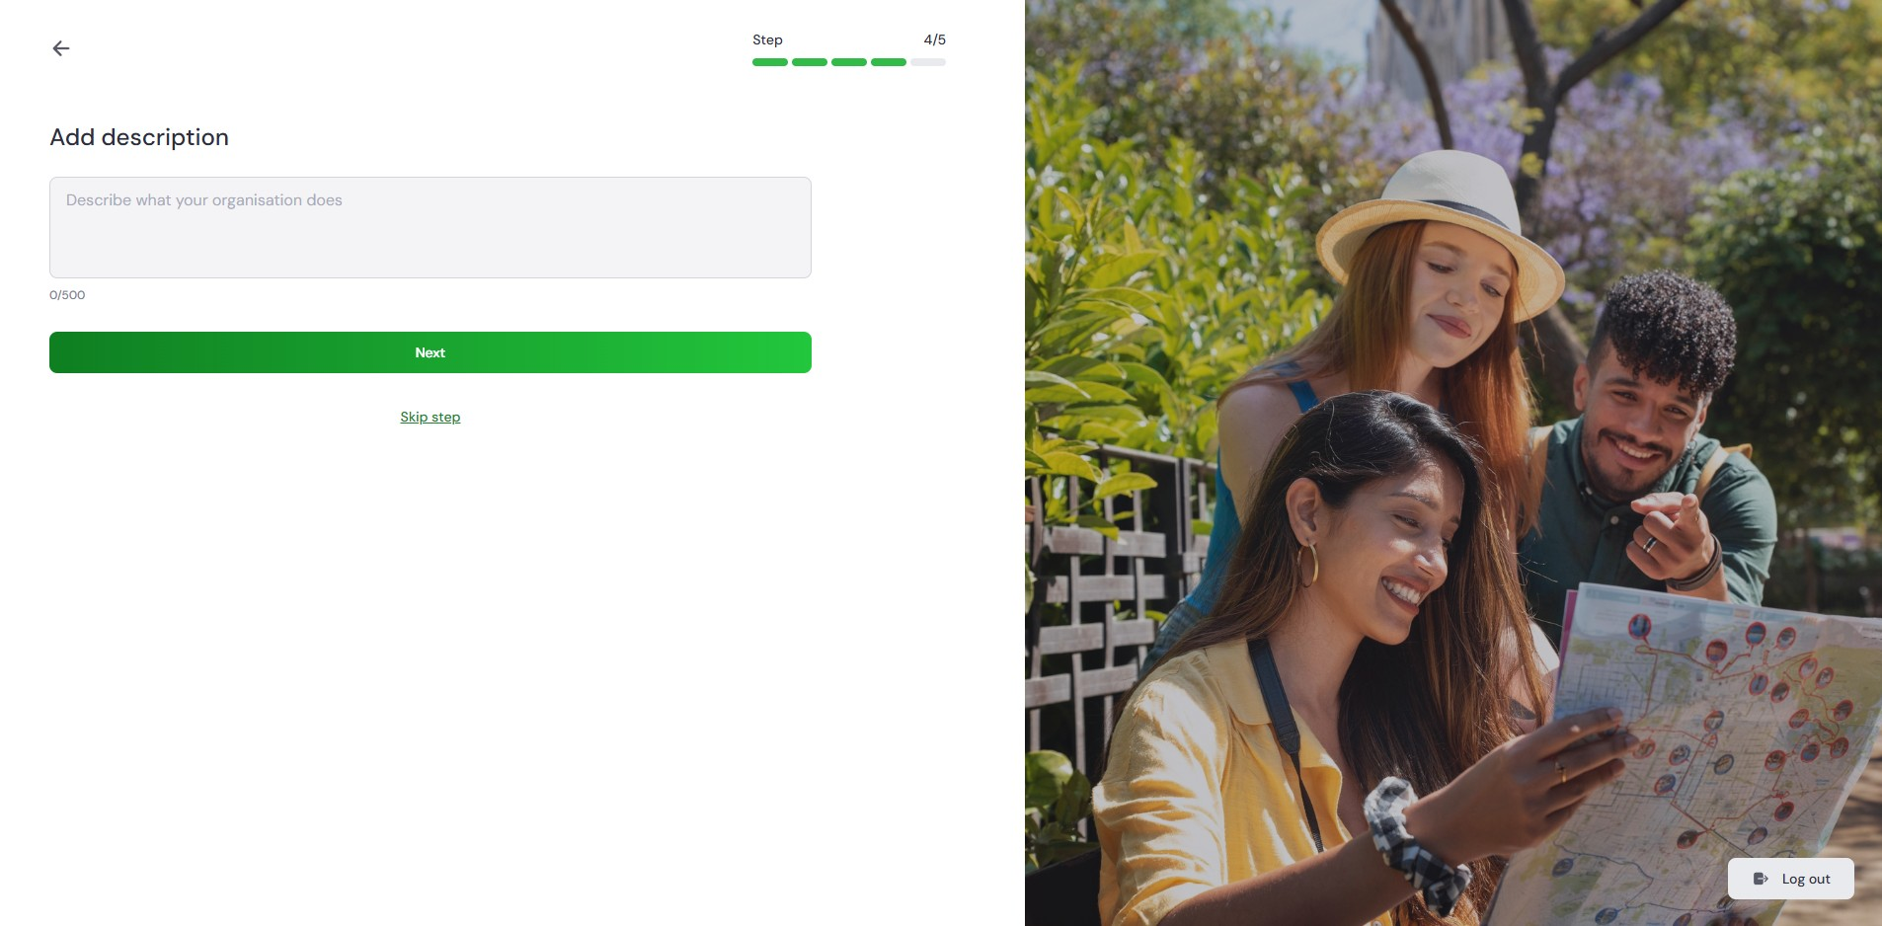

  - Upload your organisations Logo, select ‘Next’.
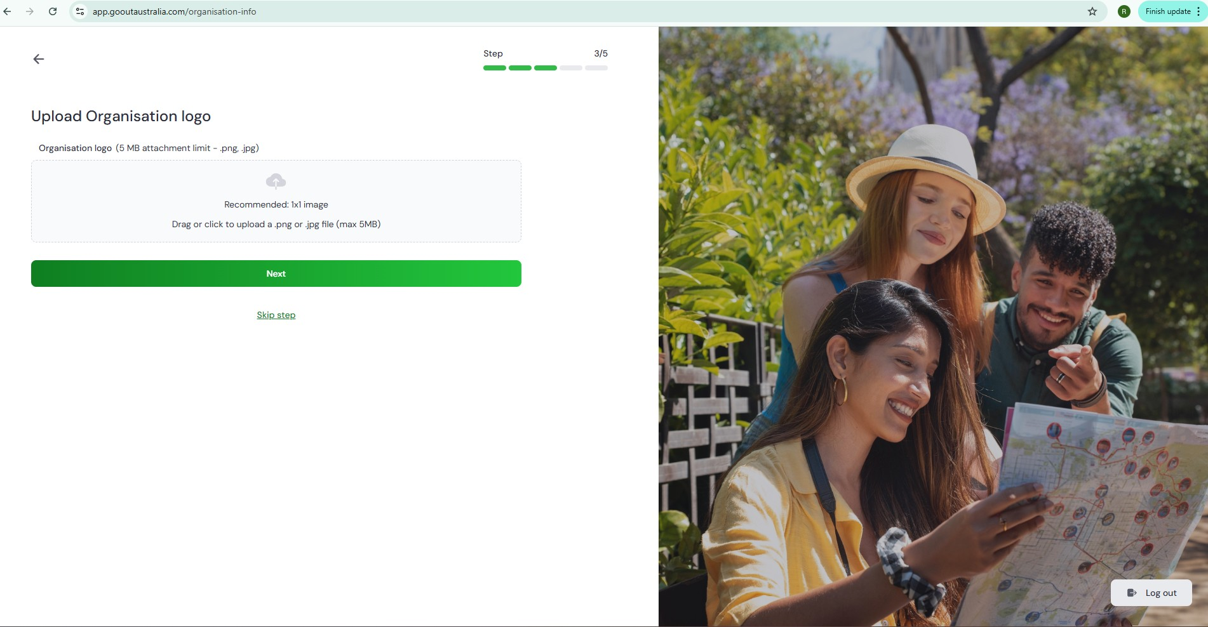
  - Add your Organisation ID verification. Provide your ABN or ACN, select
‘Send for Approval’.
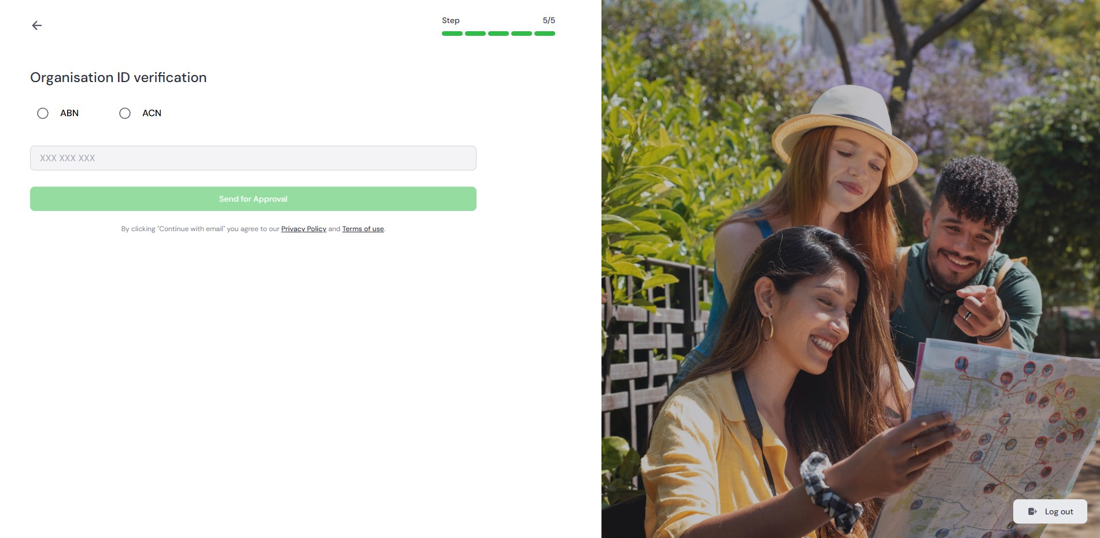
- Once completed, you’ll be taken to your organisation’s Community page, where you can manage your venue and events.
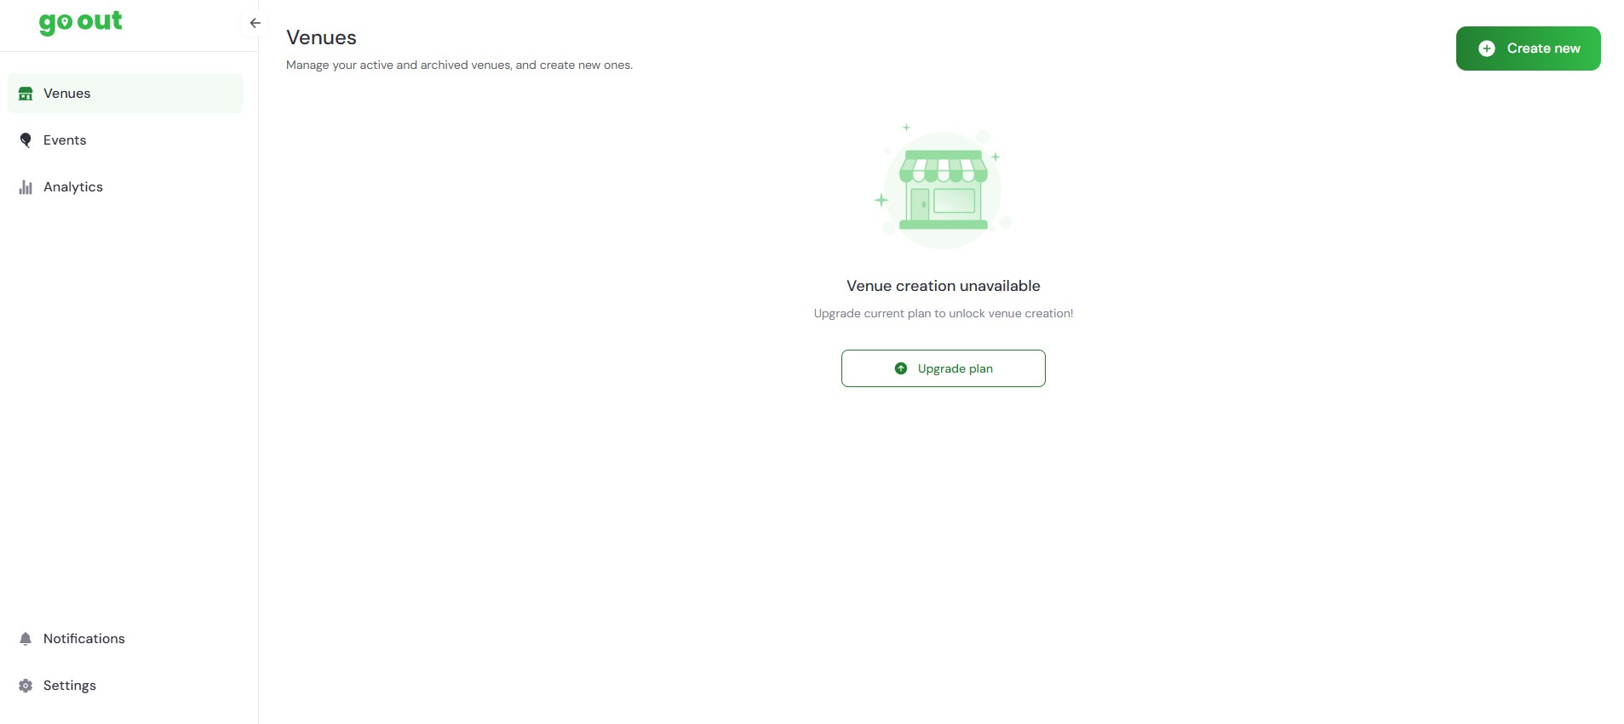

If you need further assistance, The Go Out Australia team is here to help!
Feel free to email us or give us a call anytime.
For more details, visit gooutaustralia.com.

