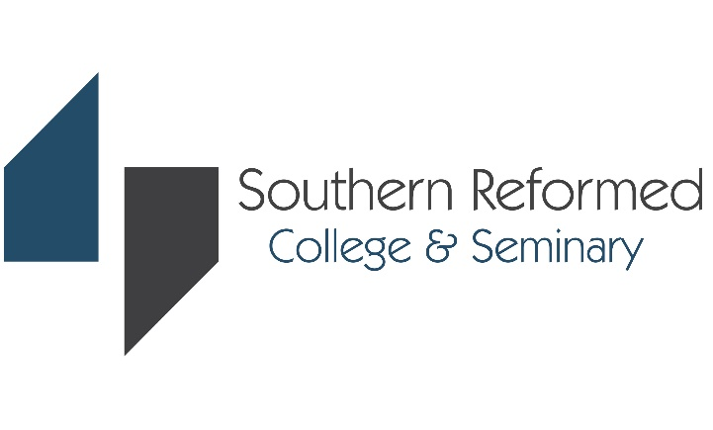

Application & Registration Checklist

Name______________

Greetings from Southern Reformed College and Seminary!

Throughout the college admissions process, there are many steps to complete. We have tried to make that process as simple as possible for you. Our 3 A’s of Admissions are Apply, Accept, and Attend. By following the 3 A’s outlined below, you will be set up for success as you navigate the admissions process.

Use the following chart to keep track of your applications and to make sure you submit all of the required documents.
Applied Program:___________ Checklist Updated:__________
 | Application Item | Important Consideration | Status | Submitted Date
APPLY | Application Deadline | What is the application deadline? | Fall Applications  - Domestic Applicants:  Apply by June 30  - International Applicants:  Apply by May 30  Spring Applications  - Domestic Applicants:  Apply by November 30  - International Applicants:  Apply by October 31
 | Application Form | Did I submit my application form?
 | Application Fee | Did I write a check or pay the application fee online?
 | Photograph | Did I submit a recent photograph (size 2” x 2”)?
 | Passport (International) / Driver’s License (US) | Did I submit a copy of passport or driver’s license?
 | Two Reference Forms | Have I asked the individuals well in advance of my application deadlines to complete the reference forms?  - From Pastor or Leader/Mentor  - One from someone not a family member
 | Personal Statement | Did I write a statement of my faith?
 | Official Transcripts | Did I submit my requests to the guidance/academic office to send my official transcripts to SRCS?  All transcripts must be sent from each respective institution directly to SRCS. Unofficial copies are NOT acceptable.
 | Once all the above documents are submitted, your application folder is considered complete and the review of the application begins. After reviewing the application, additional information or documents maybe requested by the admission committee.
 | Enrollment Item | Important Consideration | Status | Submitted Date
Accept | Once you receive your acceptance decision from Southern Reformed College & Seminary, you may apply for I-20 after signing the Intent to Enroll form and paying the enrollment deposit ($100). The deposit will be credited toward tuition payment upon registration.
 | Intent to Enroll | Did I sign and submit the form?
 | Enrollment Deposit | Did I submit my $100 enrollment deposit?
 | Certificate of Eligibility  (International Students ONLY) | Did I submit a Certificate of Eligibility (Form I-20/DS-2019)?
 | Registration Item | Important Consideration | Status | Submitted Date
 | Student Handbook & Academic Integrity Policy | Did I review and sign the Student Handbook and Academic Integrity Policy?
Attend | Course Registration | Did I register for courses?
 | Registration Fee & Tuition | Did I write a check or pay the tuition and fees with credit card?  *Tuition must be paid before an updated I-20 is issued by the ISO.
 | If you are a transfer student with over 12 credit hours, you will need to speak with one of our professional advisors from the academic office for acceptance of credits and course inventory.

8/2022

