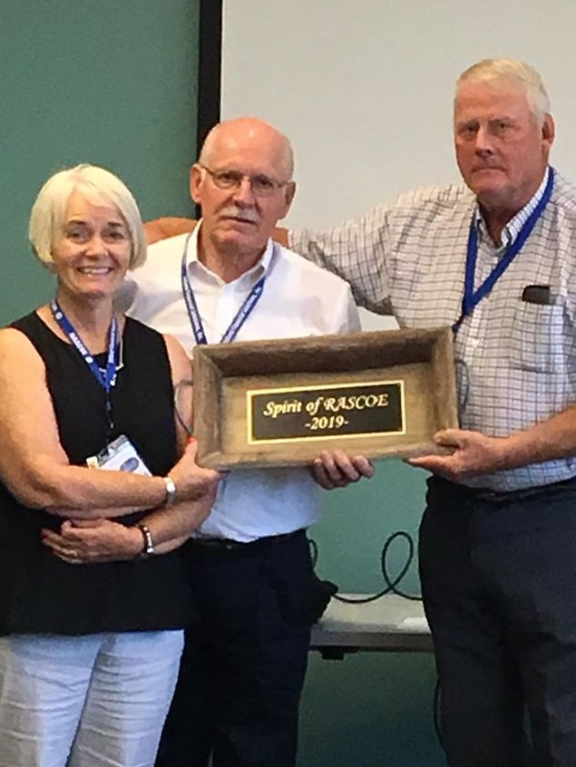

**2019 SPIRIT OF RASCOE WINNER JIM IVERSON, SD**

**AWARDED BY LYNDA STEICHEN AND BEN BOSSHART**