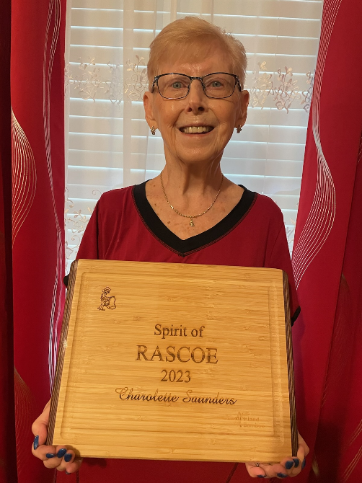

**2023 “SPIRIT OF RASCOE”**

**AWARD WINNER**

**CHAROLOTTE SAUNDERS**