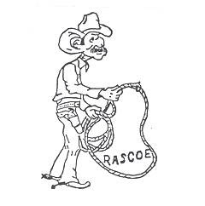

BECKY ZIRPEL, PRESIDENT
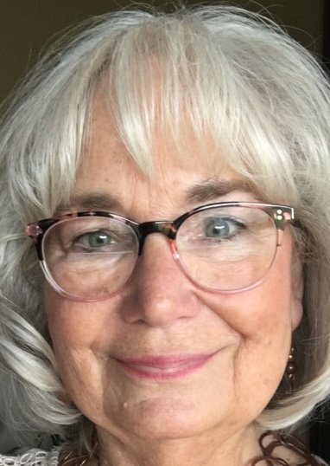

Not sure I need to introduce myself, but I am from South Dakota. I keep busy with crafting and go to several shows to set up and promote my work. Some ask why as it does take a little time, but it also keeps me in shape as it takes about 4 - 6 hours to load up, set up and take down for perhaps a 5-hour show. It is like any other business as some shows you may not sell anything and others it is well worth the effort put into it. I also sell NORWEX and setting up for those are a lot less time and effort.

I continue with the treasurer position for our Church as the Financial Administrator. As a new mission church it has been exciting to have grown in size that this year we purchased land to build and hope to move to the next step soon in building a permanent church facility. I am also the President of the Rose Hill Cemetery Association in my home town.

I have been active in the association in some form or other since the first year I was employed. Active with State, Area and National level. I came from a job with no benefits so I understood the importance to this great organization. I look forward to being your President of RASCOE Association.
I want to just touch base on a few things that I feel are important to all of us. First is
Membership. It is so important as it shows unity to the outside world. It brings teamwork and unity to employees and to the retirees. It shows a close knit family working together toward our future with our benefits, during our employment days and well into retirement. Associate membership is also very important as it shows all the same with unity and support of your co-workers, and retirees fighting to keep and better their retirement. We have led the way and we simply need to show support no matter what level we are in this path. If you have not joined yet please contact our membership chair and treasurer, Cindy Hall.

Retirement is another concern. Retirement is very important to all when it comes to the finish line of a wonderful career. It is one of the perks of our benefits. If your wait time is more than 4 months, please consider filling out the survey and reaching out to us as an organization. We do want this to be more efficient and the only way is to know where the problem is. You can find the survey online at: https://forms.office.com/r/Z8BEXCJ6Ri. The responses are being compiled in an Excel file on NASCOE’s Legislative SharePoint site. Once the survey has been completed, you will have the opportunity to print your responses and you will receive the following message: “Your response was submitted”. As I assume the Presidents role, I and Mary Behm, Vice President are here to encourage and assist if we can.

Lastly is legislative issues. Yes, even as retirees we have legislative issue that arise and we always need your help in supporting for the good of all Retirees. Our Legislative Chair (Mary Behm) will keep you informed.

I want to thank Chuck Land for his guidance as President and now Past President. He has been a great leader of RASCOE and for me to follow in his steps. I also thank the board members for continuing and stepping up to serve RASCOE. Let’s give our thank you Mary Behm VP/Legislative chair, Cindy Hall Treasurer and Membership chair, Micki Linehan Secretary and Publicity Chair and Shelly Odenkirk Benefits and Web chair.

For now, I truly wish you a wonderful, and safe travel, family kind of Christmas and bright beginnings into 2024. Merry Christmas and may God’s Blessing be with each of you.

____________________________________________________________________________________

MARY BEHM, VICE PRESIDENT/LEGISLAIVE CHAIR
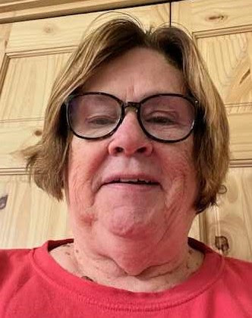
I would like to introduce myself as the newly elected Vice President of RASCOE. I worked for FSA for 38 years and was active in NASCOE/WASCOE in the state of Wisconsin. I served 7 years as state treasurer and 4 years as its president. Since retiring, I have served as your Benefits Chair and also created the RASCOE website, serving as webmaster. I have always felt the organization was an important part of our work experience.

Maintaining membership with the organizations has been a major emphasis for me. With NASCOE membership having a decline in numbers, this translates to a decline for RASCOE. I have worked hard to get retirees to join us. It behooves all of us to invite retirees to join RASCOE. We can all do our part in maintaining our benefits. One never knows what changes are ahead.

As Vice President, I also serve as the legislative chair. RASCOE for as long as I can remember has worked to have the Windfall Elimination Provisions and Government Offset Provisions reversed. A house bill in the last session came close but it never made it to the floor even with approximately 300 sponsors. BUT certain parts of the bill did not die. HR 5342 could, if passed, amend title II of the Social Security Act to replace the windfall elimination provision with a new formula the “equalizes” benefits for individuals with noncovered employment. It would appear that a maximum reduction of $500 could be made to benefits. Ways and Means committee is still working on this…so it is still wait and see the end result.

There has not been a lot of legislative activity. The House was concentrating on electing a new Speaker. I will bring you any issues that are of concern to RASCOE membership as it happens. Do not hesitate to contact me with your concerns. My information is in this newsletter and also on the rascoe.org website. I look forward to working with the board and serving the membership.

Finally, have a great holiday season. Stay safe and healthy. Make the next month or so a memory-filled event for you and your family.

__________________________________________________________________________________________

TREASURER/MEMBERSHIP REPORT
BY CINDY HALL, TREASURER/MEMBERSHIP CHAIR

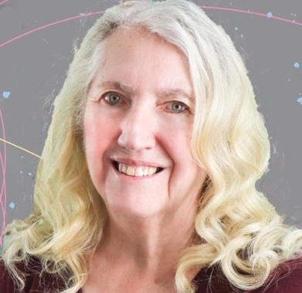
I’m going to take this opportunity to remind members of a few things. Dues year is from July 1 through June 30. Technically, dues are delinquent after July 1, but because this is an easy-going group of retirees, we don’t worry about that. I get (and accept) dues all year long. If you miss a year, we just apply your payments to the current year unless you tell me differently. We’re just happy that you are members! If you have a state organization, dues should go to your state treasurer. If your state does not have a local organization, you can send your payments made payable to RASCOE and mailed to me at 3025 Snead Drive, Fremont, NE 68025-2133.

If you know of new retirees in your state, please tell them about RASCOE! They can complete a membership application which is found on the website rascoe.org and mail it to me. We give a free membership (through the end of the dues year) the first year people retire.
If you know of members who reach their 90th birthday, please let me know. Once they reach that special birthday, their membership becomes lifetime.

As of October 31, 2023 our checkbook balance was $34,409.82.

*********************************************************************************************************************************
A NOTE FROM MILDRED SCARBOROUGH...

Dear Cindy,
Thank you & RASCOE for the RASCOE Life Time Membership. I feel so honored. I myself grew by learning the ins and outs of NASCOE and was very honored to serve for 12 years with the NASCOE Board.
I was ill during the NASCOE Convention in August. My sister did not want me traveling alone. Please send me info on the 2024 NASCOE Convention.
Again thanks to you and RASCOE.
Love,
Mildred E. Scarborough

___________________________________________________________________________________________________

MICKI LINEHAN, SECRETARY/PUBLICITY CHAIR

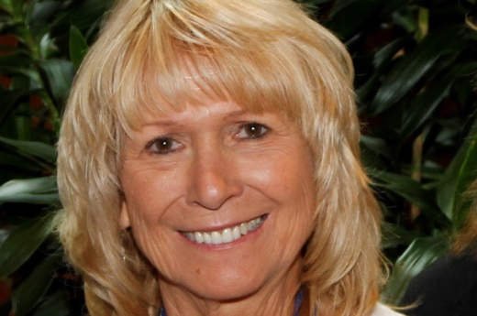
Here we are once again approaching our hustling and bustling Christmas Season. We just finished a glorious Thanksgiving celebration that acknowledged all of the things that we are and will always be thankful for. Family, friends, and our lives and wellbeing. We do the best we can no matter what our situations are.

As I reflect on our second “winter” in Yuma, AZ, I think of how many things that have changed for me personally. I no longer need to bundle up to go outside, I’m socializing with many new (and old) friends in this Yuma sunshine, and I’m a little surprised that I’m feeling content with the seasonal move. Life takes some interesting turns along the way.

Our Annual Meeting in College Station, TX was a great success. Texas, as always, did a fabulous job of making sure our RASCOE Association was well taken care of. And we thank them. 2024 National Convention will be in Davenport, Il. I’m sure it’s going to be a huge success! It’s a Quad Cities event that will provide transportation to and from the Davenport hotels over to Moline for the event. There will be more information on the NASCOE website soon.

Along those same lines, there are a couple of Area Rallies that are currently scheduled. They are:

NEA RALLY
APRIL 11TH – 1TH, 2024
HILTON GARDEN INN
FREEPORT, MAINE

ALL SOUTH RALLY
MAY 2ND – 5TH, 2024
RENAISSANCE MOBILE RIVERVIEW PLAZE HOTEL
MOBILE, ALABAMA

There will be additional Rally information in the future weeks about the Mid-West and Northwest Rally. We will let you know when we know!

************************************************************************************************************************

BENEFITS AND WEBSITE
SHELLY ODENKIRK, BENEFITS CHAIR/WEBMASTER

Hello RASCOE members! I am your new RASCOE benefits chair. I retired from Ohio FSA after 33+ years of service in December of 2017. I moved to The Villages in sunny central Florida in January of 2018 and am loving the retirement life!

A couple reminders:
If you have a Benefits Direct Policy, remember to send in your receipts for your wellness checkup refunds. Policyholders can contact Benefits Direct with questions through any of the following ways: Customer Service toll free 800-330-6223 (press 1 for customer support), email customersupport@AmerilifeBenefits.com or mailing address 4551 W 107th Street, Overland Park, KS 66207. Your receipts and wellness benefits form MUST, however, be sent directly to your insurance carrier due to HIPAA laws. If you are unsure of who your carrier is or need the form, that is when Benefits Direct can help you out. Individual Insurance Carrier numbers/websites/mail address are on the RASCOE Website under Benefits/Amerilife/Benefits/JM Marketing (jpeg).

By now the deadline has passed to opt out of the MPDP (new prescription drug program) and just keep your FEP prescription drug program. You can, however, still opt out by January 1 by calling 888-338-7737. You can also always contact Medicare directly by calling 800-633–4227 or by mail at FEP Medicare Prescription Drug Program, PO Box 3539, Scranton, PA 18505. If you decide to opt out or dis-enroll, you can re-enroll during Open Season in a future year.

I have updated the website with some 2023 Convention pics, and the new travel policies voted on at the convention. If there is anything you all would like to have added to the website, please let me know and I will try to get it added.

I would like to wish a Merry Christmas and Happy New Year to you all! May the joy and love of the season surround you all.
Shelly
____________________________________________________________________________________

2023-24 Winter Report
BY John Lohr
Dillard Financial Solutions, Inc. Marketing Director

I once again hope this report finds all our RASCOE friends safe and well.
It has been a wonderfully mild and dry fall here in southwestern Pennsylvania. Only one day of snow flurries so far. Maybe we’ll continue last winter’s trend when I didn’t once start my snow thrower.

Again, this time of the year for those of us eligible for Medicare, it’s when we can make changes to our coverage in the annual open season. New FEHB Medicare Advantage (MA) plans have become available to federal annuitants over the last few years. For many, these MA plans offer the lowest estimated yearly cost for healthcare coverage in retirement.
All MA plans must offer at least the same level of coverage as Original Medicare, or Parts A & B, but many plans have significant additional benefits.

Federal annuitants can suspend FEHB enrollment and join any MA plan. In this case, you would just pay the Medicare Part B premium and any additional MA premium, which is usually only a few hundred dollars per year and often nothing at all. Because you are only suspending your FEHB coverage, you can switch out of MA during any future Open Season and rejoin FEHB as if you never left.

Be careful never to cancel your FEHB unless absolutely sure you’ll never need to return to it. Suspension on the other hand gives you the opportunity to return to FEHB.

While many MA plans generate substantial premium savings, you’ll face higher out-of-pocket costs than with the FEHB MA options that have no out-of-pocket costs for approved care. That’s because with a non-FEHB MA plan you’ll be subject to copays, coinsurance, and deductibles. On the other hand, FEHB MA plans have zero out-of-pocket costs, can include prescription drug coverage, and a Part B premium reimbursement.

Importantly just like any change of health care plan, be sure your personal preferred providers are participating in the plan you are considering. Although most of us are not affected by the following restriction, another caution is that no FEHB MA plan provides routine medical coverage outside of the USA.

With few participation limitations to consider for many of us, most federal annuitants should research joining an FEHB MA plan. These plans can offer many federal annuitants a significant savings, enhanced benefits, and possibly greater provider choice than their existing FEHB plan coupled with Original Medicare.

Please feel free to call us toll free at 1-(800) 692-7643 or email us at nascoe@dillardfinancial.com to learn more about how you might best utilize a Medicare Advantage (MA) plan. We welcome the opportunity to help.

Wishing everyone a blessed holiday season. Take care.
____________________________________________________________________________________________________

RASCOE AREA REPORTS

Charolette J. Saunders, NE Area Representative

The Northeast has been so colorful this fall season and we are all so blessed to live here where the colors change so beautifully. As the leaves change, we are so thankful for each new day and all of our members.

I was honored to be asked by Becky Zirpel, RASCOE President, to again serve as Northeast Area Representative. I love to work with my RASCOE/NASCOE Friends.
First, I want to Thank RASCOE from the bottom of my heart for the Spirit of RASCOE AWARD. I feel so unworthy but VERY honored.

I continue to be on the Northeast Area Officers/Committee Chairs Conference Calls and am doing everything possible to promote RASCOE Membership. Vermont has sent me a list of their retirees and I hope other states will follow so that I can personally contact our retirees.
The Maine delegation is working hard to have a fantastic Northeast Area Rally at the Hilton Garden Inn in Freeport, Maine April 11 through Sunday, April 14, 2024. Would love to see many of our friends in Maine.

Reminder to everyone: RASCOE has its own webpage – RASCOE.org. If your state does not have an association, go to this page and the Dues Membership application can be found there as well as other important information.

I will continue to promote membership in RASCOE. Each State President was asked to send me a listing of their retirees so that I can do my job better.
*************************************************************************************************************************
SHERYL BLAKELY, SEA REPRESENTATIVE

Music is in the air. It’s beginning to look a lot like Christmas and I love Christmas in the Southeast. Our weather is crisp on most days, and still comfortably warm to be outdoors. The cotton has been harvested and vegetable farms are selling their sweet potatoes and greens. We sure do love to eat down south!

We enjoyed a great deal of delicious foods and great southern hospitality at the 2023 NASCOE convention in College Station, TX. If you weren’t able to attend, we missed you and we are offering you another chance to visit the south in the very near future. Alabama will host the All South Rally in Mobile, AL on May 2-5, 2024. Information will be posted on the SEA NASCOE Facebook page so follow them to know when registration opens and when reservations can be made at the Renaissance Hotel in Mobile for May 2-5, 2024.

I have been watching the Facebook posts of the state rallies being held in the Southeast. Alabama’s “family reunion” is being held in November this year. No matter where you live, stay involved in your state and attend your yearly conventions. Your input is needed to keep everyone aware of our objectives…and your working friends really do want to see you and hear about all the fun you are having in retirement. Your RASCOE Board continues to work hard to protect the benefits we enjoy and to keep you informed about changes and updates. National dues are $25.00 and Associate dues are $15.00, so mail your check to Cindy Hall and tell any new retirees that their first year is free.

I have enjoyed serving with our Executive Board for the past two years and I commend them for the many hours they put in working to promote the welfare of our association and for lobbying to maintain the integrity of our benefits. Thank you to all who serve and to all who support RASCOE. Watch our RASCOE Facebook page for news and follow the work we are doing. Let us know how we can serve you.
+++++++++++++++++++++++++++++++++++++++++++++++++++++++++++++++++++++++++++++++++++++++++++

SPIRIT OF RASCOE AWARD

NOMINATION FORM
NOMINEES SHOULD EXEMPLIFY THE TRUE “SPIRIT OF RASCOE” IN ACTIONS, SUPPORT AND PROMOTION OF THE RASCOE RETIREE ORGANIZATION.

NOMINATIONS MUST BE SUBMITTED TO THE PUBLICITY CHAIRPERSON NO LATER THAN July 15, 2024
Entries received after the deadline will be reviewed and/or saved for the next year.
MAIL NOMINATION TO: Micki Linehan
3743 Swallows Nest Ct
Clarkston ID 99403

NOMINEE NAME:________________________________________________________________________________

NOMINEE’S ADDRESS:____________________________________________________________________________

STATE OF RASCOE MEMBERSHIP:___________________________________________________________________

IN SEVENTY-FIVE WORDS OR LESS, EXPLAIN WHY YOU NOMINATED THIS RETIREE FOR THE SPIRIT OF RASCOE AWARD:
____________________________________________________________________________________________________________________________________________________________________________________________________________________________________________________________________________________________________________________________________________________________________________________________________________________________________________________________________________________________________________________
OTHER COMMENTS:___________________________________________________________________________________

PAST SPIRIT OF RASCOE AWARDS WINNERS:
2005 – ERA JARRARD, GA 2006 – VIRGINIA SHORT, KY (AND ROSE MELICK, SD)
2007 – CONRAD SHEPP, WI 2008 – DORIS STUCKY, SD
2009 – GENE LUTZ, CO 2010 – CLARA RUTH SAINT, LA
2011 – JUNE FAULK, GA 2012 - GENE VOGNILD, SD
2013 – PAUL NEWTON, IL 2014 – Leo Osborne, UT
2015 - Lynda Steichen, SD 2016 – Sandi Rocker, NE
2017 - Mike Schryer, AL 2018 – Joyce Logsdon, KY
2019 – Jim Iverson, SD 2020-2021 – Brenda Boomer, TX – Laura Ann Evans, KY
2022 - Laura Howell, KY 2023 - Charolette Saunders
________________________________________________________________________________________________
_
________________________________________________________________________________________________

ELECTED OFFICERS AND APPOINTED CHAIRS FOR FY 2023-2024

Becky Zirpel Mary Behm Micki Linehan
President Vice President& Secretary &
206 Heritage RD Legislative Chair Publicity Chair
Brandon SD 57005 9097 Thouroughfare RD 3743 Swallows Nest CT
flyingz@alliancecom.net Minocqua WI Clarkston WA 99403
Cell: 605-999-2290 mpbehm9@gmail.com mickilinehan@gmail.com
Cell: 715-797-2407 Cell: 509-595-0156

Cindy Hall Shellly Odenkirk
Treasurer & Benefits Chair &
Membership Chair Webmaster
3025 Snead Drive 4416 Creighton Loop
Fremont NE 68025 2133 The Villages FL
nwanascoe@gmail.com shelly.odenkirk@gmail.com
Cell: 402 210 1814 Cell: 330-64-1475

NATIONAL ASSOCIATION OF FSA/ASCS RETIRED COUNTY EMPLOYEES

