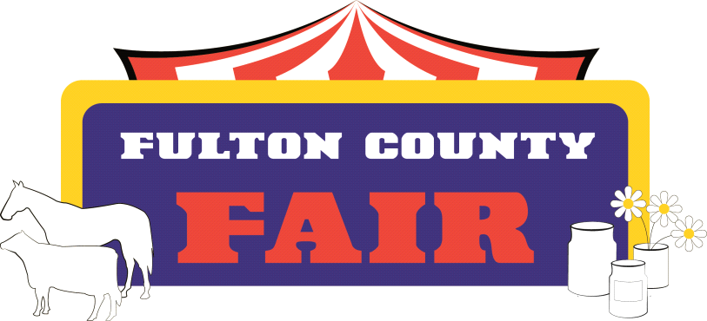
Fulton County Fair Association Mailing Address:
888 Lincoln Way East P.O. Box 246
McConnellsburg, PA 17233 fultoncountypafair.com
2026
To Whom It May Concern:
The Fulton County Fair Association is hosting the Annual Festival of Lights display at the fairgrounds on December 4, 5, 11 and 12, 2026. In addition to driving through the light display, visiting the live nativity, folks will have an opportunity to stop by and visit Santa in the Welcome Center. The Fair Association will be offering free refreshments (coffee, hot chocolate, and a variety of cookies). The Fair Association will also be offering goodie bags to the children who stop by to visit Santa. We are seeking donations to help with this event. Any donation whether monetary or refreshment items such as hot chocolate and cookies is greatly appreciated. The Fair Association would like to wish everyone Happy Holidays! Monetary donations (made payable to Fulton County Fair Association) may be mailed to:
Festival of Lights
Michelle DeShong
480 Cherry Lane Road
McConnellsburg, PA 17233
Donated items may be dropped off at the fairgrounds on Friday, December 4th anytime after 4:30pm.
Sincerely,
Michelle DeShong
Festival of Lights Committee Co-Chair

