6th grade Unit 9
The Rock Cycle

Objectives:
SCI.6.5B Recognize that a limited number of the many known elements comprise the largest portion of solid Earth, living matter, oceans, and the atmosphere.
℗ SCI.6.6C Test the physical properties of minerals including hardness, color, luster, and streak
SCI.6.10B Classify rocks as metamorphic, igneous, or sedimentary by the processes of their formation.

All videos and power point can be found at www.missdoctorbailer.com

Activity 1 Physical Properties of Minerals
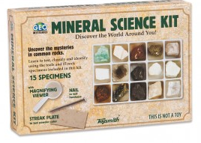
Materials: Mineral Sets, nail, penny, streak plate – gold ring or earing for teacher demo

Mineral kits for this lesson may be ordered from www.amazon.com. The manufacturer is Toysmith from Sumner, WA. A picture of the box is found below.

Focus: I can test the physical property of minerals using the hardness test.
Language Objective: I can listen and follow directions.

Activity 2 More Physical Properties of Minerals
Materials: Mineral Sets, streak plate
If you don’t have access to BrainPop, there is a video on Mineral Identification on the website. It goes a little further than the BrainPop video but its only about 5 minutes long.

Focus: I can test the physical properties of minerals using a streak plate.
Language Objective: I can work with my partner to identify minerals.

Activity 3 Facts about the Earth
Materials: colored pencils
Focus: I can Recognize that a limited number of the many known elements comprise the largest portion of solid Earth.
Language Objective: I can speak with my partner to find the elements listed on the Periodic Table.

Activity 4 Rocks, Rocks, Rocks
Materials: Rock sets, Rocks, Rocks, Rocks! Placemat
Rock Sets used in this lesson may be ordered from www.amazon.com. The manufacturer is Toysmith from Sumner, WA. A picture of the box is found below.
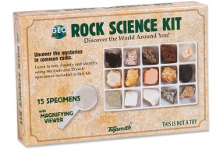

Focus: I can classify rocks by the processes of their formation.
Language Objective: I can use sentence stems to summarize my learning.

Rock 5 is Rhyolite and is not on the placemat.
Rock 7 is Calcareous Tufa and is not on the placemat.
Rock 15 is Schist and is not on the placemat.

The picture below is the inside of the Rock Science Kit.

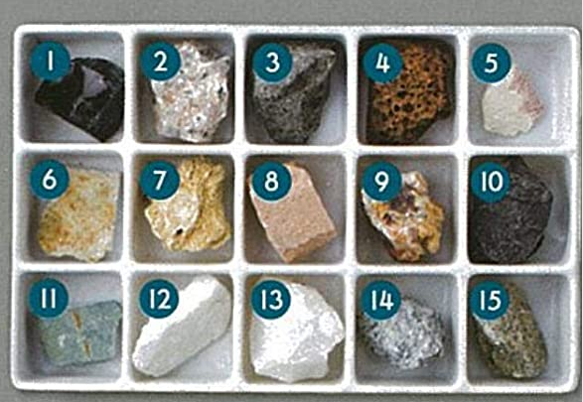

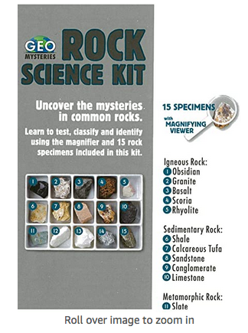

12. Marble
13. Quartzite
14. Granite Gneiss
15. Schist

Activity 5 The Rock Cycle
Materials: hot plate, scissors, 4 different colors of Starburst candy, plastic bag, aluminum foil, hot plate, heavy books
Starburst Rock Cycle video from www.missdoctorbailer.com

Focus: I can classify rocks by the processes of their formation.
Language Objective: I can review information using a flow chart.

Activity 6 Recycling Rocks
Materials: Rock Recycle Wheel, brass fasteners, scissors

Rock Recycle Wheel is found in PDFs for printing file.

Focus: I can classify rocks as metamorphic, igneous or sedimentary.
Language Objective: I can summarize a video using spider maps.

