Ideas about the Solar System

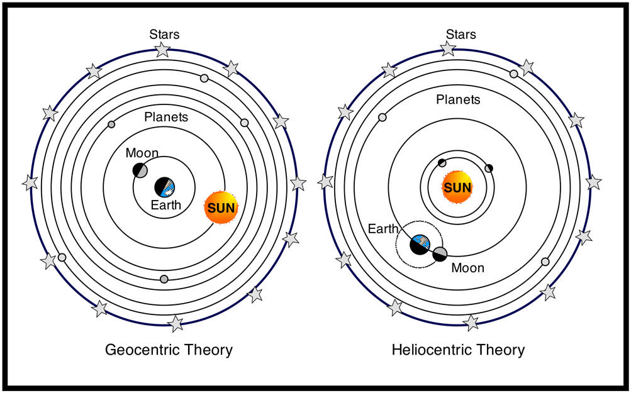
At this time in history everyone knows that the earth orbits around the Sun. But this has not always been true. Early people believed that the solar system was geocentric. Geo means earth and centric means center, so they believed that the earth was the center of the solar system and all the planets and the Sun revolved around it. After many years of studying the skies and the invention of the telescope, astronomers proved that the solar system was heliocentric (helio meaning Sun). There are some important astronomers and mathematicians whose ideas contributed to our knowledge of the solar system. We will see them in the power point your teacher shows you.

Watch and listen to the power point. Place the words from the word bank next to the scientist who worked with these ideas.

WORD BANK
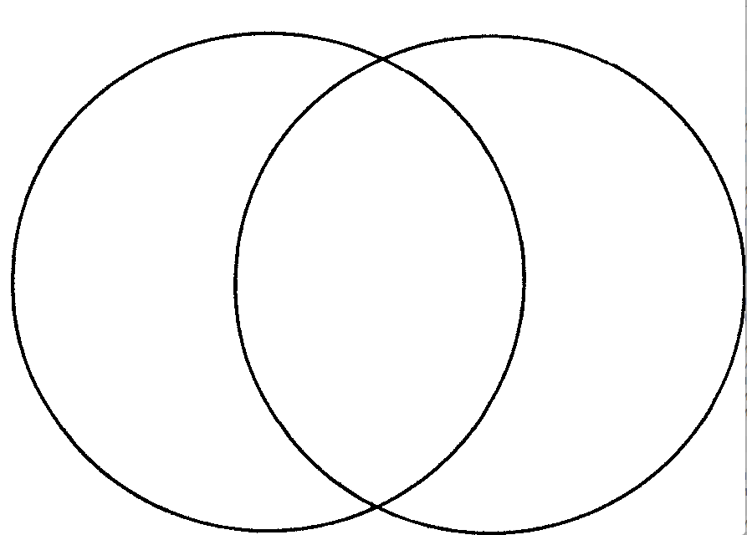
Heliocentric Geocentric Epicycles
Gravity Inertia Invented Telescope
Elliptical Orbits

Scientist | Ideas
Ptolemy
Copernicus
Galileo
Kepler
Newton

1. Observe the image of the Geocentric and Heliocentric
Theories above.
2. Fill in the Venn diagram below comparing the two images.

Geocentric Heliocentric

Systems make up Systems

The word system comes from the Greek meaning a whole made of several parts. Most systems share common characteristics, including
- Systems have structure and are made up of components or parts.
- Systems are interconnected to other systems
- Systems have functions

There are natural and man-made systems and both
are designed for their parts to work together.

What To Do:
1. Look at the lists below and determine which components go together to form the system.
2. Cross out the component that doesn’t fit in the system.

Computer System | Human Body System | Earth System
Mouse | Stomach | Rain
Keyboard | Brain | Clouds
DVD drive | Battery | Land
Hard drive | Eyes | Ocean
Software | Ears | Mars
Fingers | Toes | River
Printer | Heart | Air
Questions:
1. Which of the systems above are natural systems?
__________________________________________
2. Which of the systems above are man-made systems? ___________________________________
3. Name 5 components of your classroom system.
___________________________________________

Everything in space is part of the universe. The solar system consists of the sun and eight known planets that revolve around it. The sun is just one star of the 100 billion or so that make up the Milky Way galaxy. In the universe, there are millions of other galaxies, each containing billions of stars. So each system is part of another system that makes up the entire universe.

- Color the diagram below.
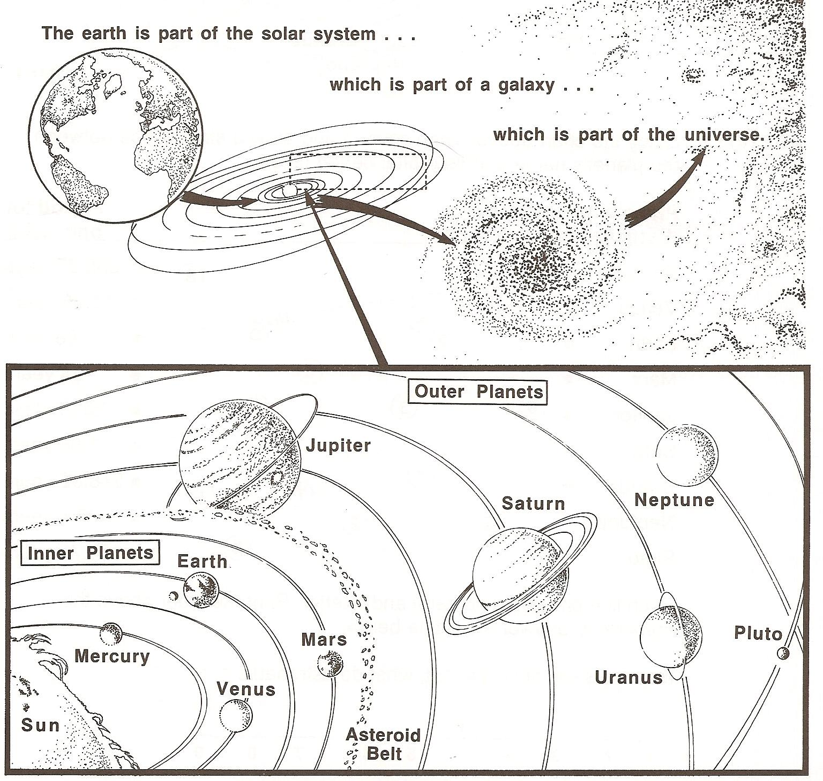

Questions:
1. Name the components of the universe shown in the diagram above. _______________________________
2. Everything we know of is in the universe but the universe doesn’t have a name like the galaxy or the solar system. What would you name the universe?
___________________________________________
Name ________________ period _____

EXIT TICKET
Ideas about the Solar System
1. Which of the following astronomers is known for his work in gravity and inertia?

A. Ptolemy
B. Galileo
C. Newton

2. Which of the following astronomers is known for inventing the telescope?

A. Ptolemy
B. Galileo
C. Newton

3. Which of the following astronomers is known for believing the earth was the center of the solar system?

A. Ptolemy
B. Galileo
C. Newton

4. What does geocentric mean?

A. Earth in the center
B. Sun in the center

5. How is our solar system arranged?

A. Geocentric Model
B. Heliocentric Model

Name ________________ period _____
EXIT TICKET
Ideas about the Solar System
1. Which of the following astronomers is known for his work in gravity and inertia?

A. Ptolemy
B. Galileo
C. Newton

2. Which of the following astronomers is known for inventing the telescope?

A. Ptolemy
B. Galileo
C. Newton

3. Which of the following astronomers is known for believing the earth was the center of the solar system?

A. Ptolemy
B. Galileo
C. Newton

4. What does geocentric mean?

A. Earth in the center
B. Sun in the center

5. How is our solar system arranged?

A. Geocentric Model
B. Heliocentric Model

