Renewable and Nonrenewable

Sources of Energy

You have learned about the different types of energy such as chemical, mechanical, radiant and nuclear. You have also learned that energy can be changed from one form to another. A major energy transformation in our lives is the one that changes various energy sources into electricity. Energy sources can be either renewable or nonrenewable. Renewable energy sources are those that can be replaced in a relatively short period of time. Examples of renewable resources are solar energy, wind energy, biomass and hydropower. Nonrenewable energy sources cannot be replaced as they are used. They take millions of years to form. Examples of nonrenewable energy sources are the metal uranium used as the nuclear energy source and

fossil fuels such as coal, natural gas and oil. A fossil fuel is formed from the buried remains of plants and animals that lived millions of years ago

**Materials:** Packet of Energy Sources cards for each set of partners, Energy Source Posters

**What To Do:**

1. Your teacher will give you and your partner a set of cards that show an energy source.

2. Classify these energy sources on the cards as renewable or nonrenewable.

3. Fill in the graphic organizer on the next page.

**Energy Sources**

are

**Nonrenewable**

**Renewable**

including

including

4. Your teacher will give each table an Energy Sources Poster.

5. Determine under which category it fits.

6. Your teacher will have two columns on the board - Renewable and Nonrenewable. When your table is called place your poster in the correct category.

7. Write the name of each energy source next to the symbol on the next page.

8. Write whether it is renewable or nonrenewable next to the name.

Name the following symbols for each type of energy resource.

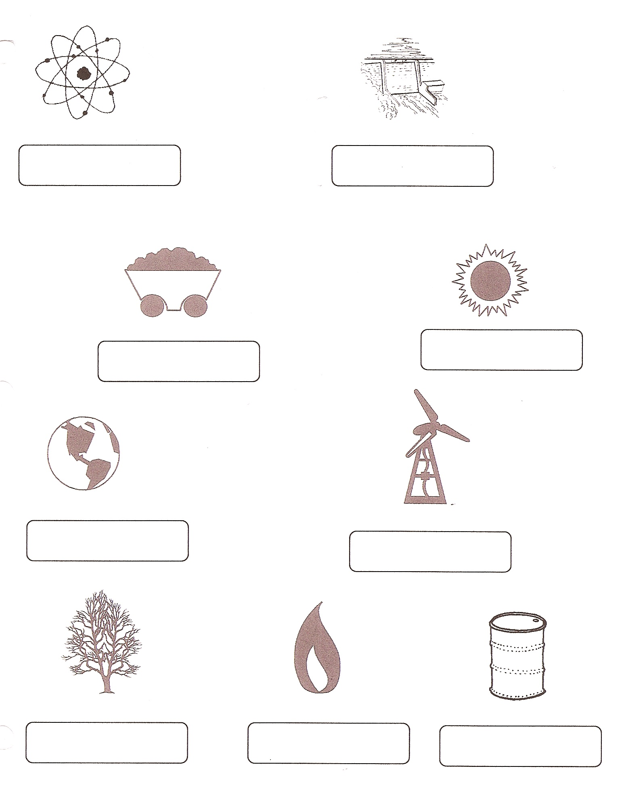Heat can be measured in joules, BTUs and calories. Many appliances such as air conditioners and heaters come with a BTU rating. BTU stands for British Thermal Unit. It is used in the United States and the United Kingdom.

Use the following information to make a bar graph of the Sources of Energy Production in the United States.

|  |  |  |  |  |  |  |  |  |
| --- | --- | --- | --- | --- | --- | --- | --- | --- |
| **Source** | **Nat. Gas** | **Oil** | **Coal** | **Nuclear** | **Bio**  **mass** | **Wind** | **Hydro** | **Solar** |
| **BTUs** | 35 | 25 | 14 | 9 | 5 | 3 | 3 | 2 |

|  |  |  |  |  |  |  |  |
| --- | --- | --- | --- | --- | --- | --- | --- |
|  |  |  |  |  |  |  |  |
|  |  |  |  |  |  |  |  |
|  |  |  |  |  |  |  |  |
|  |  |  |  |  |  |  |  |
|  |  |  |  |  |  |  |  |
|  |  |  |  |  |  |  |  |
|  |  |  |  |  |  |  |  |
|  |  |  |  |  |  |  |  |
|  |  |  |  |  |  |  |  |
|  |  |  |  |  |  |  |  |

Name _____________ period _____

EXIT TICKET

*Renewable and Nonrenewable Sources of Energy*

1. Renewable resources are those that –

A. cannot be replaced after they are used up.

B. can be replaced after 100 years

C. can be replaced after a short amount of time

2. Nonrenewable resources are those that –

A. cannot be replaced after they are used up.

B. can be replaced after 100 years.

C. can be replaced after a short amount of time.

3. Examples of renewable resources are –

A. oil and natural gas

B. wind and solar

C. coal and biomass

4. Examples of nonrenewable resources are -

A. oil and natural gas

B. wind and solar

C. coal and biomass

5. Where do fossil fuels come from?

A. Fossil rocks in the ground

B. Grass and trees that have been rotting in a pond

for about 100 years.

C. Remains plants and animal that lived millions of

years ago.

Name _____________ period _____

EXIT TICKET

*Renewable and Nonrenewable Sources of Energy*

1. Renewable resources are those that –

A. cannot be replaced after they are used up.

B. can be replaced after 100 years

C. can be replaced after a short amount of time

2. Nonrenewable resources are those that –

A. cannot be replaced after they are used up.

B. can be replaced after 100 years.

C. can be replaced after a short amount of time.

3. Examples of renewable resources are –

A. oil and natural gas

B. wind and solar

C. coal and biomass

4. Examples of nonrenewable resources are -

A. oil and natural gas

B. wind and solar

C. coal and biomass

5. Where do fossil fuels come from?

A. Fossil rocks in the ground

B. Grass and trees that have been rotting in a pond

for about 100 years.

C. Remains plants and animal that lived millions of

years ago.