Potential and Kinetic Energy

There are two kinds of energy, potential and kinetic. Whether energy is kinetic or potential depends on whether or not an object is moving. Anything that is moving has kinetic energy. The scientific name for the energy of motion is kinetic energy.
Sometimes when you transfer energy to an object, you change its position or shape. For example, you lift a book up to your desk or you compress a spring to wind up a toy. Unlike kinetic energy potential energy is stored energy. It might be used later when the book falls to the floor and hits your foot or when the toy’s spring unwinds. Energy that is stored and held in readiness is called potential energy.
Gravity has a great deal to do with potential energy. The higher an object is from the surface of the earth, the more potential energy it has. So, a book on the table has more potential energy than a book on the floor.

Materials: marble, ruler with center groove, Styrofoam cup with 1” square cut out, pencil, book, meter stick

What To Do:
1. Set up the ruler and pencil as shown in the picture.
2. Place the cup over the ruler.
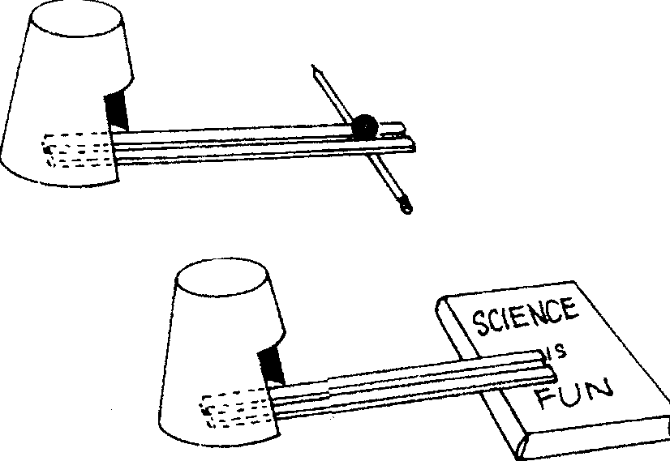
3. The end of the ruler should touch the back of the cup.
4. Place the marble in the center groove of the ruler at the highest point.
5. Release the marble and observe what happens to the cup.
6. Measure how far the cup travels on your table with the meter stick.

7. Record in the table below.

8. Repeat 2 more times.
9. Place the ruler on the edge of the book.
10. Place the cup over the ruler again.
11. Place the marble on the ruler and release it.
12. Measure how far the cup travels on your table.
13. Record in the table below.
14. Repeat 2 more times.
15. Find the average of each set of trials.

Trials | How far the cup traveled when started on the pencil (cm) | How far the cup traveled when started on the book. (cm)
1
2
3
AVG.

Questions:
1. Did the cup move farther when started on the pencil or started on the book? ________________________
2. Why? _____________________________________
3. In what place does the marble have potential energy?
____________________________________________
4. When does it start to have kinetic energy? _______
____________________________________________
5. When does it stop having kinetic energy? ________
____________________________________________
6. A good conclusion for this investigation would be:
The (higher, lower) the marble, the more potential energy it has.

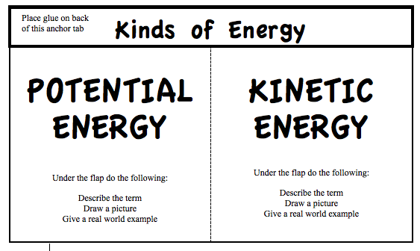
Activity 2
Always ask yourself – is it moving? If moving – it’s kinetic!
1. What type of energy is found at P?  Potential Kinetic  2. What type of energy is found at Q?  Potential Kinetic | 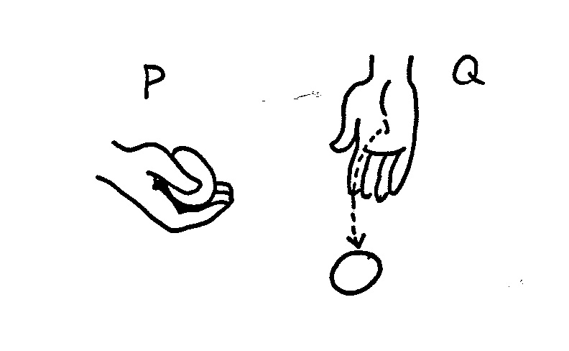
3. What type of energy is found in this picture?  Potential Kinetic  4. What would have to happen to change the type of energy? _________________ | 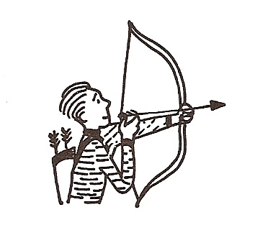
5. What type of energy is found is found in the books on the chair?  Potential Kinetic  6. What type of energy is found in the books falling from the chair?  Potential Kinetic | 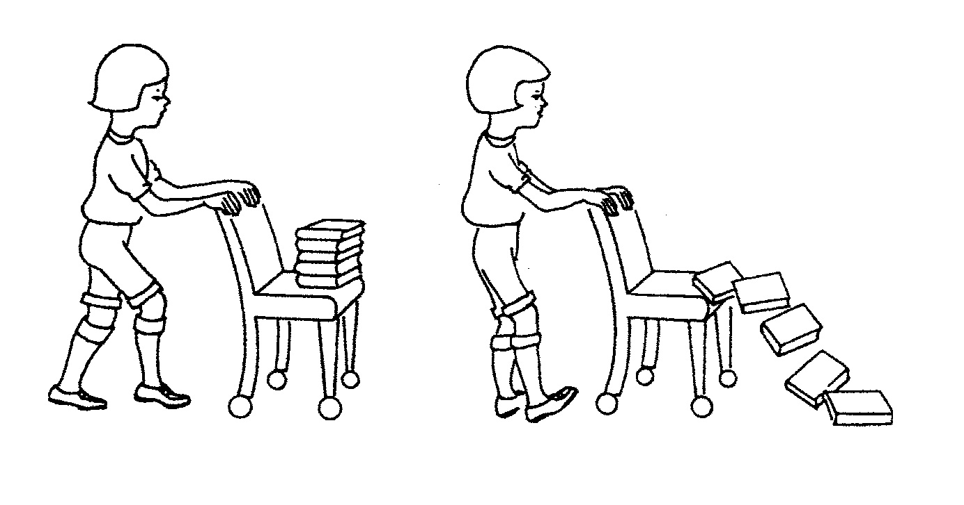
7. The car is speeding down the highway. What type of energy is found in the speeding car?  Potential Kinetic | 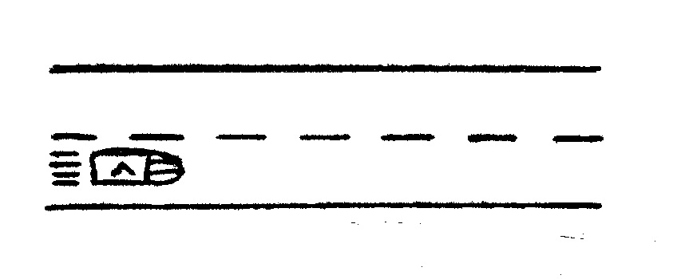
8. The airplane is landing on the runway. What type of energy is found in the plane at this time?  Potential Kinetic | 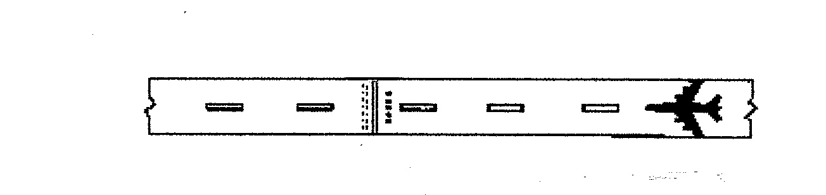

Activity 3 (DO NOT GLUE until teacher says)

Name ________________ period ___
EXIT TICKET
Potential and Kinetic Energy
1. Circle the book in the pictures below that has the most potential energy.
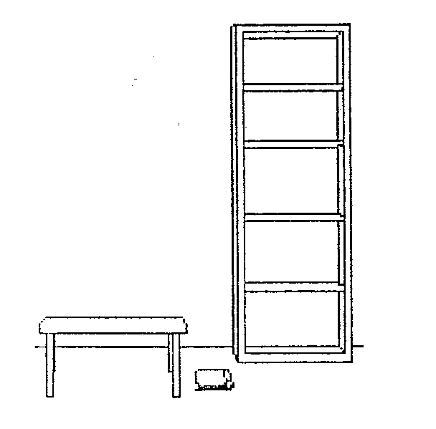
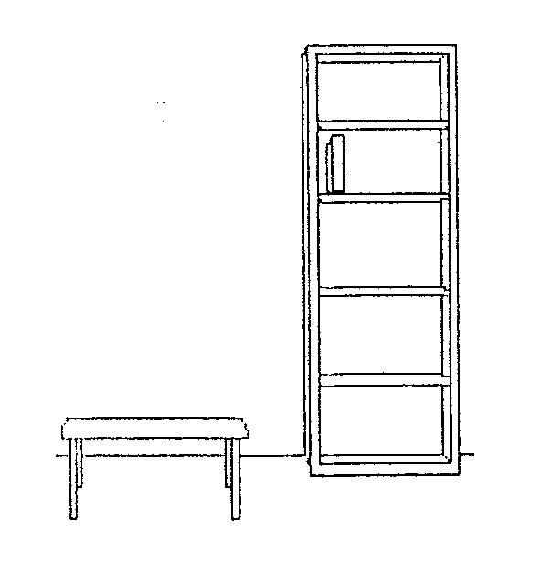

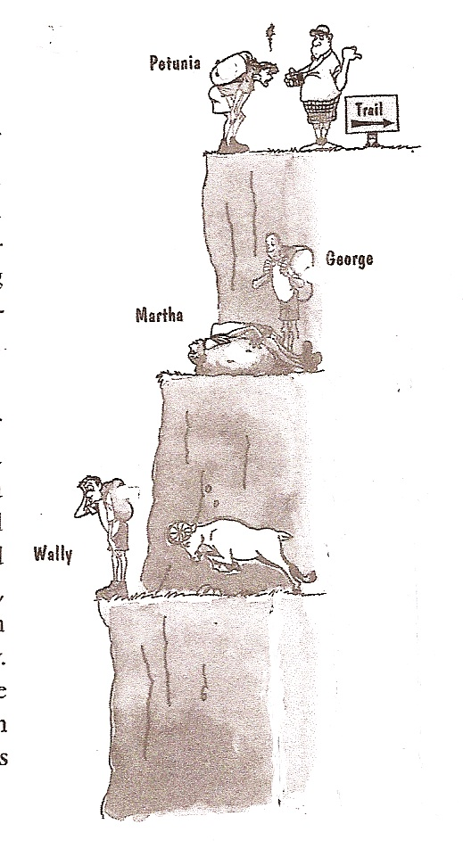

2. Which person on the cliff
has the most potential energy?

______________________

3. Which person on the cliff
has the least potential energy?

______________________

Conclusion: (stored, potential, surface, kinetic, height, motion)
The two kinds of energy are _________ and __________. Energy that is ______or held in readiness is potential energy. The scientific name for the energy of _______ is kinetic energy. The potential energy of an object is influenced by its _________ from the earth’s _______.

Name ________________ period ___

EXIT TICKET
Potential and Kinetic Energy
1. Circle the book in the pictures below that has the most potential energy.

2. Which person on the cliff
has the most potential energy?

_________________

3. Which person on the cliff
has the least potential energy?

______________________

Conclusion: (stored, potential, surface, kinetic, height, motion)
The two kinds of energy are _________ and __________. Energy that is ______or held in readiness is potential energy. The scientific name for the energy of _______ is kinetic energy. The potential energy of an object is influenced by its ______ from the earth’s _________.

