General Goals
The goal of Science 7 is to learn and understand general scientific principles in life science to prepare you to be successful on the Science TAKS test in the 8th grade and other high school science classes.

Academic Honesty

It is expected that any work completed in this class is a product of your own mind and effort. If you give another student answers to a question or take answers from another student, it is cheating. Cheating will result in negative consequences for ALL parties involved.

Make Up Work
One of your partners will place all handouts in our Science Notebook when you are absent. When you return you should glue the pages in and complete the assignments using your partner’s data from any laboratory. If you are absent or have lost your homework you may download and print it from home by going to my website. The address is
www.missdoctorbailer.com

Extra Help
If you need extra help, speak to me as soon as possible, so we can set a time either before or after school.

Conclusion
I want you to be successful in science. I encourage you to participate in class and ask questions when you do not understand. I am looking forward to a very exciting and productive year!

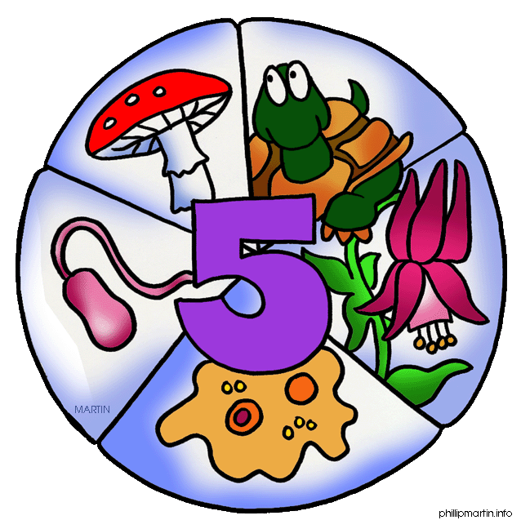

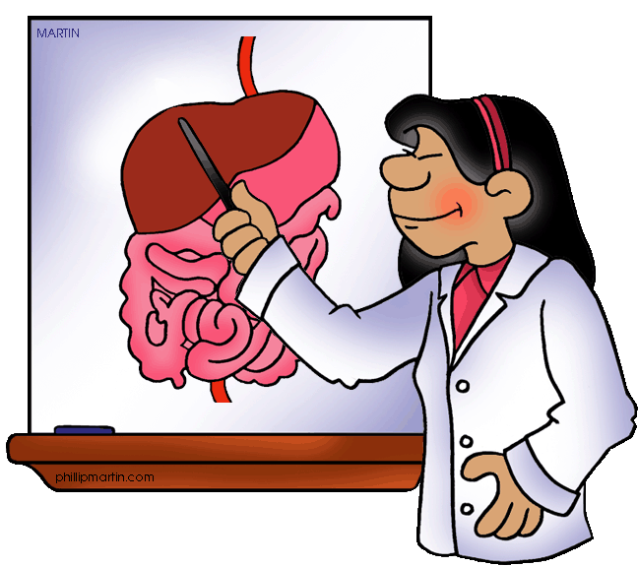

Welcome to
Seventh Grade Science
At
Jane Long Middle School

Teacher: Dr. J. Bailer
E-mail: jbailer@houstonisd.org
School phone: 713-778-3380

I hope you have had an enjoyable and relaxing summer. The following information will help you to survive the year in science.
It will be a fun and exciting journey if you follow the rules and open your mind to the material at hand.
One of the first questions 7th grade students ask is, “Will we dissect frogs this year?” The answer is YES sometime during December as we finish the Human Body unit.
Seventh grade science is an integrated science course, with a focus on Life Science. Major topics of study this year include:

1st 6 weeks - Safety, Force and Motion
2nd 6 weeks - Earth and Space Systems
3rd 6 weeks – Cells and the Human Body
4th 6 weeks – Heredity and Genetic Traits
5th 6 weeks – Classification and Ecosystems
6th 6 weeks - Scientific Inquiry
Philosophy
Science is more than just a discipline; it is a way of knowing, thinking and using that knowledge to explain the world around us. Some of you may think that you don’t like science, or that it is too hard for you. Others already know that science is one of their favorite classes. I believe that everyone learns by doing. The lessons and activities in my classroom are created to provide you with multiple opportunities for learning in a hands-on, minds-on format.

We do not use a textbook during science class but if you would like a copy of the state adopted textbook for science, just let me know and I will get one checked out to you. You will not need it at school but you may use it as a reference at home.


Materials

During the first week of school you are expected to bring the following items:

4 small glue sticks
1 roll of paper towels OR 1 box of tissues

Conference Time

My conference time is 2:00-2:30 pm. Please make an appointment through the school office or through my email address.
Classroom Expectations
You will not do anything that will get in the way of your learning and/or the learning of others. You are expected to participate in laboratories, activities and class projects. You are expected to follow all safety rules during laboratories. You will be given a job each 9 weeks to help the classroom run smoothly.

Our Classroom Rules

1. Be on time to class.
2. Throw gum away as you enter the classroom.
3. Respect My Time and Your Time.
4. Wait until the teacher dismisses the class.
5. Be considerate of other people and their property.

Grading System

60% Daily work – classwork
30% Major grades – tests/projects
10% Homework

Projects
Projects are assigned throughout the year, giving you the opportunity to demonstrate what you have learned in a creative way. Typically, students can expect to complete one project per semester. Most projects are to be completed at home, but occasionally class time may be given.

Class Routine
- Enter the classroom on time, prepared and ready to learn.
- Once in the room, you are expected to begin the Do Now while your Folder Folks teammate retrieves your Science Notebook.
- Class time will consist of independent and group activities, laboratories, vocabulary work and review.
- You are expected to be respectful, responsible and cooperative in the classroom.
- The bell does not dismiss you, I do! You may not pack up until I dismiss the class.


Homework
You will have homework every day. Your homework will consist of an assignment called My Demonstration of Understanding. Completing this assignment will help you internalize the information you have learned in science class. The assignment will be given every Monday and is to be turned in on Friday. Instructions on how to complete the homework will be given during the week. Not completing the homework will result in lunch detention until it is completed.

