Classbook Home Profile Friends Inbox Settings Logout
Draw a profile picture
Latest news…________________________________________(name)
Joined Dr.Bailer’s 8th grade science class!

?? Minutes Ago Clear

Info Wall Photos Links Events Notes
All Info Posts By… Posts by Others
Take the quiz…

Take the quiz…

Take the quiz…

Take the quiz…

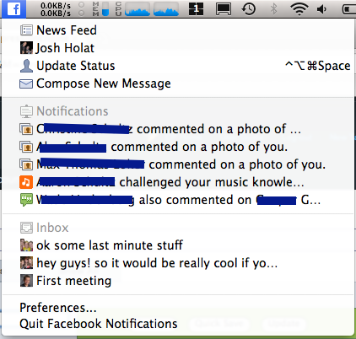

How I get to school now…(circle)
WalkBikeCar School Bus Metro
My dream ride…(draw)

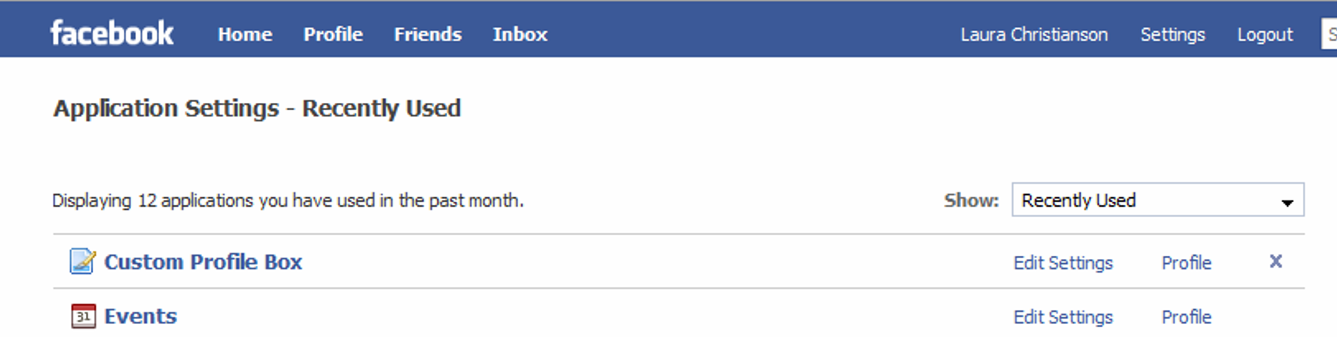

View Photos of Me (1)
Edit My Profile

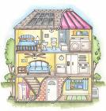
Favorite Saying
Who’s in your house?
I live in a(n)…(circle)
Apartment House Condo


Basic Information

Birthday:_____________________________

Home Phone number: _______________
Draw or name all people & animals that live with you.
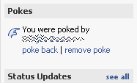
Cell Phone number: ___________________

Email address (if available):

______________________________________

Parent’s name: _______________________
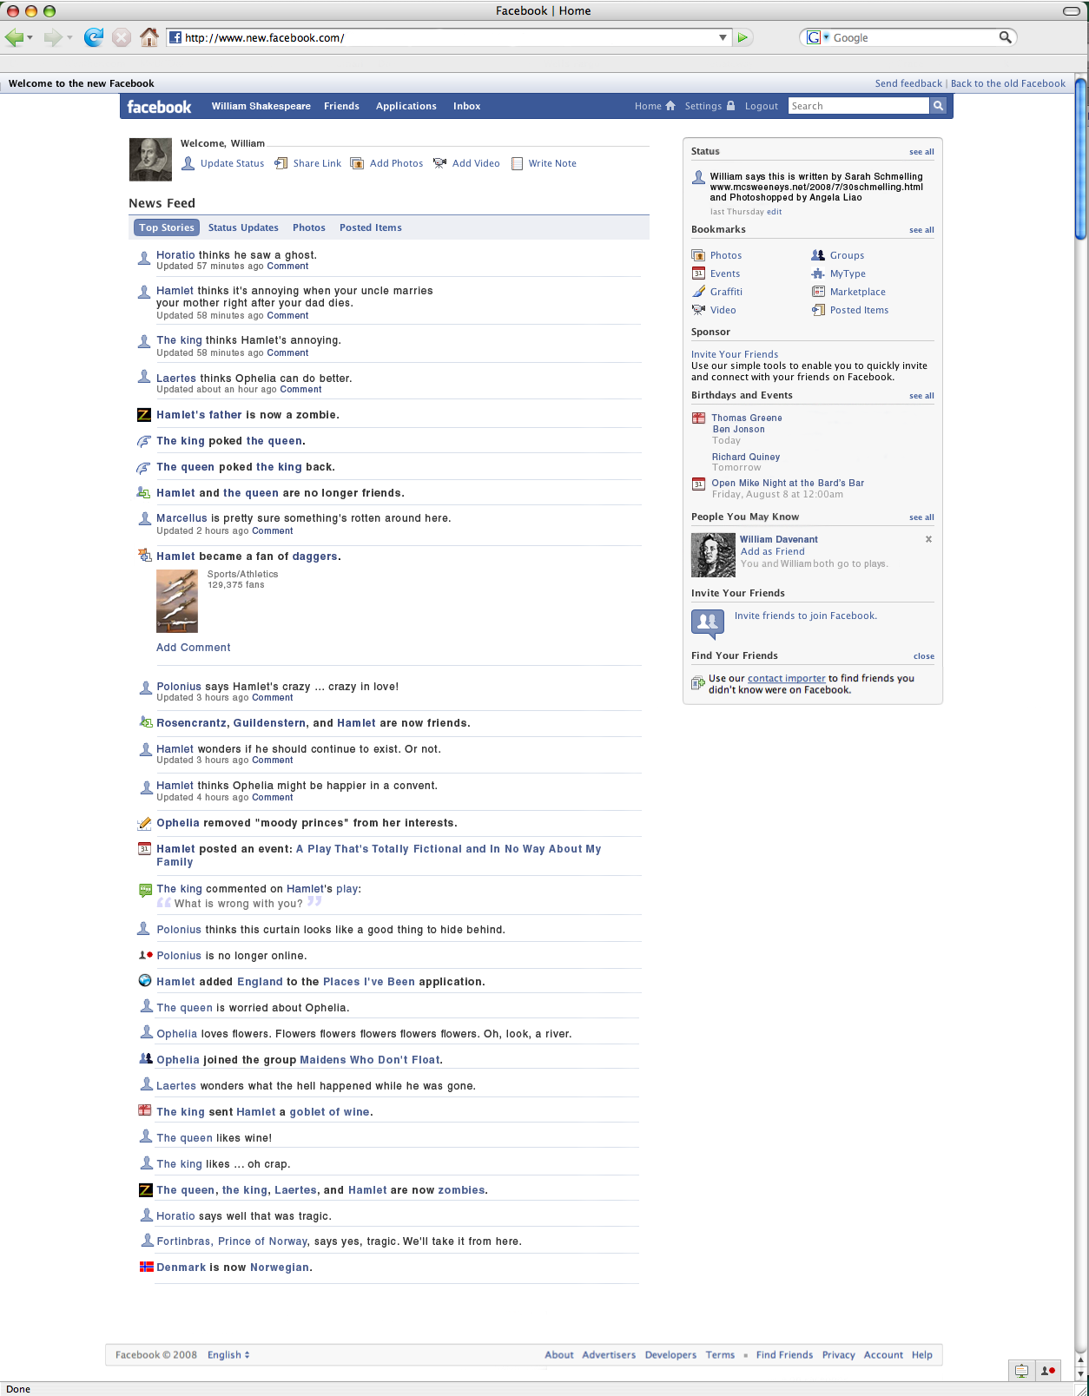

Personal Information
What would you buy if you had…
$1: _________________________________________
$10: ________________________________________
$100: _______________________________________

Activities:

Interests:


About Me: (2-3 words to describe you)
What are you worried about?

What are you proud of?



Friends
Adapted from https://kreftenglish.wikispaces.com/ About Advertising Developers Careers Terms Privacy Mobile Help

