What’s In The Bag?

All human beings share a desire to explore and understand the world around them. Science developed out of this curiosity. Science is a search for knowledge based on experimentation and observation. Sometimes observations are made directly with the human senses. Sometimes technological devices, such as microscopes, are used to help.
Observing means using the senses to get information or data. We have five senses: sight, smell, taste, hearing and touch. We use our eyes to see, our nose to smell, and our tongue to taste, our ears to hear and our fingers for touching. These are called sense organs. When we make an observation it is important to remember that observations are facts not opinions. They must be the truth not a guess.
After we have observed something with our all or
part of our senses we try to explain that observation. An inference is a possible explanation of an observation. We use knowledge we already have along with the observations we make to explain what we have observed. These explanations are called inferences. Inferences do not have to be correct but they must be logical.

Materials: mystery bag with 5 items inside.
What To Do:
1. Your teacher will give your table a bag with 5 items
inside.
2. DO NOT look inside the bag.
3. Reach inside the bag with your hand and touch the objects.
DO NOT TALK to your teammates, yet and DO NOT take
anything out of the bag.
4. Write down some observations you can make about the
objects in the bag in the table.

5. After everyone at your table has had a chance to experience the bag you may talk to each other.
Observations:
10
Object | Hard  Or Soft | Shape | Rough or Smooth | Light or Heavy
1
2
3
4
5

6. Now it is time to make inferences.
7. Talk with your teammates and make a guess identifying each object in the bag in the space below.
Questions:
1. What do you think the first object you felt is? _______________________________________
2. What do you think the second object you felt is? ________________________________________
3. What do you think the third object you felt is? ________________________________________
4. What do you think the fourth object you felt is? ________________________________________
5. What do you think the fifth object you felt is? ________________________________________
After you have all made guesses take out the objects and see if you were correct.

Directions:
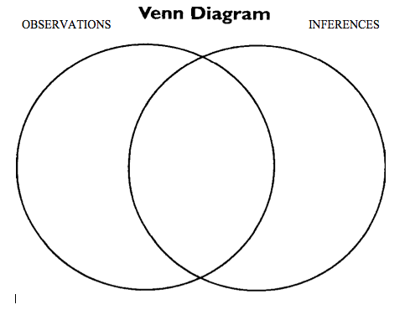
Watch the video “In focus_Otzi” from www.missdoctorbailer.com about a scientific investigation into a mummy that was found on a glacier.

List 3 observations the scientists made in the space below.

List 3 inferences the scientists made in the space below.

Share your observations and inferences with your partners.

Complete the Venn Diagram below
comparing observations and inferences.

Name __________ period _____
EXIT TICKET
What’s in the Bag?
Your teacher will show you an object. Make 3 observations about the object.

Make one inference about how that object could be used.

Conclusion:(logical, observe, hearing, correct, sight, touch, smell, taste, inferences)

When we _____________ we use our senses. Our five senses are sight, _______,touch, _________ and _______. The two senses we used in this lesson were ________ and _______. We made guesses or ________________ based on our observations. Inferences do not have to be ________ but they must be ___________.

Name __________ period _____

EXIT TICKET
What’s in the Bag?
Your teacher will show you an object. Make 3 observations about the object.

Make one inference about how that object could be used.

Conclusion:(logical, observe, hearing, correct, sight,
touch, smell, taste, inferences)

When we _____________ we use our senses. Our five senses are sight, _______,touch, _________ and _______. The two senses we used in this lesson were ________ and _______. We made guesses or ________________ based on our observations. Inferences do not have to be ________ but they must be ___________.

