Common Science Equipment

You probably used some science equipment last year during laboratory activities. You should remember some of their names and uses.

Directions:
1. Look at the list of science equipment below.
2. Find one in each list that doesn’t belong with the rest of
the list.
3. You may not know every piece of equipment in the list
looks like or how it is used.
4. Share what you know with your table partners and make
a guess.
5. Circle the one that doesn’t belong with the rest.
6. At the end of the lesson you will come back to the list
and make any changes you need to.

A. Beaker, graduated cylinder, hot plate, test tube

B. Microscope, dissecting microscope, hand lens, forceps

C. Test tube clamp, tongs, flask, test tube holder

D. Ring stand, thermometer, ruler, temperature probe

E. Slide, balance, coverslip, watch glass

F. Dropper, Pipette, test tube rack, Petri dish

Materials: all equipment pictured below with labels
What To Do:
1. At each table you will find 3-5 pieces of science
equipment that have been labeled.
2. When your teacher directs, look at the equipment
and write the name of each piece in the box under
the picture.
3. You will have about 3 minutes at each table.
4. Move to the next table when time is up.

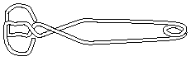 | 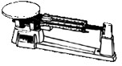 | 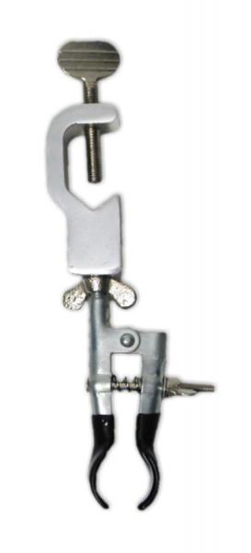
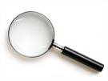 |  | 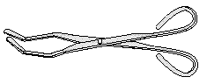
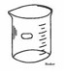 |  | 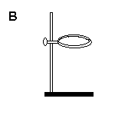
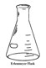 | 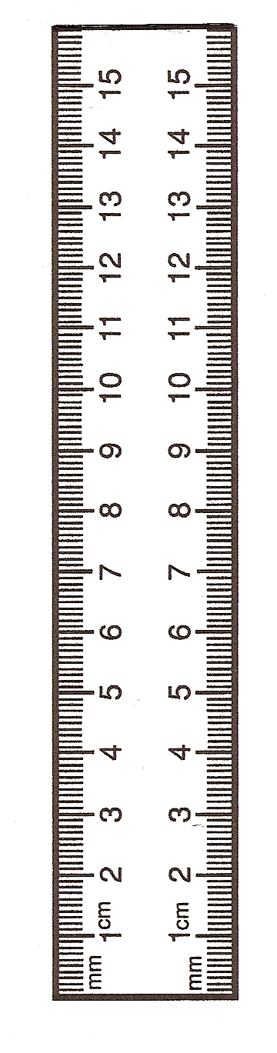 | 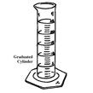

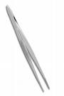  11 | 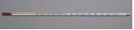 | 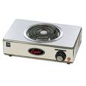
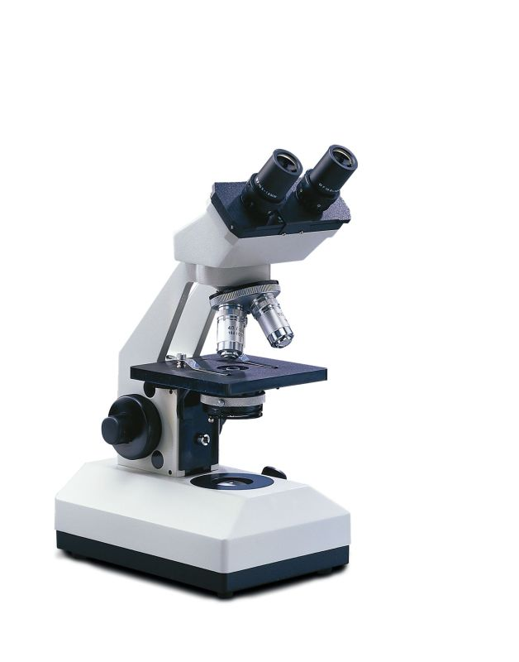 | 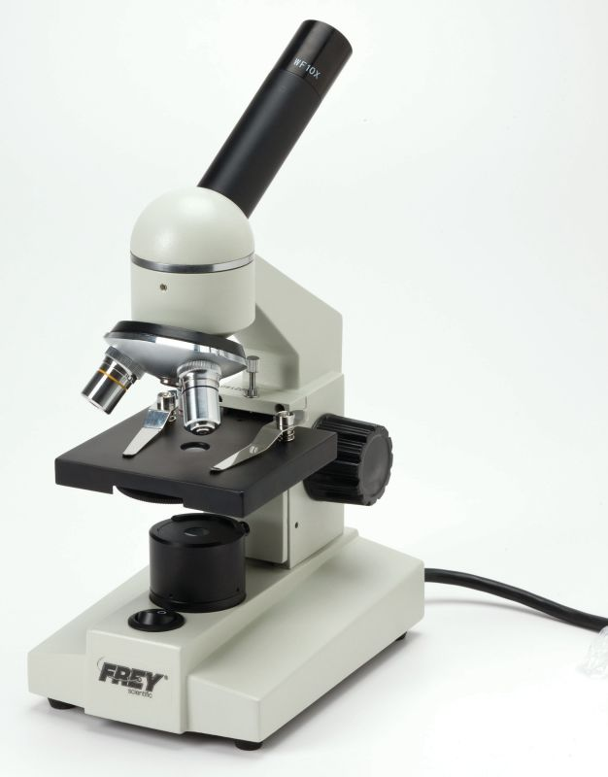 | 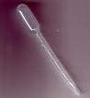
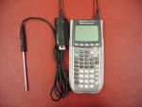 | 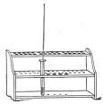 | 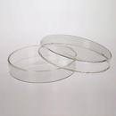
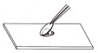 | 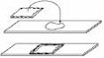 | 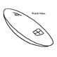

Questions:
1. Name 3 pieces of equipment you already knew. _________________________________________
2. Name 3 pieces of equipment you did not know. ________________________________________
3. Go back to the first activity and make any changes you
think you need to make. Discuss your answers with your partners.
How Are They Used?

1. Which of the equipment measure liquids? There are 5.

______________________________________________

2. Which of the equipment measures temperature? (2)

____________________________________________

3. Which of the equipment allows you to look at small things? (3)

____________________________________________

4. Which of the equipment is used with microscopes? (2)

__________________________________________

5. Which of the equipment measures mass? (1)

__________________________________________

6. Which of the equipment can be used to hold things? (4)
___________________________________________

7. Which of the equipment measures length? (1)

___________________________________________

8. Which of the equipment is used to heat things? (1)

___________________________________________

Name ____________________ period _____
EXIT TICKET
Common Science Equipment
Draw lines to match the picture with the label.

Hand lens
Beaker
Microscope
Flask

Conclusion: (microscope, equipment, beaker, flask, thermometer,
probe, magnifying lens)
Many pieces of science _____________ do the same jobs. A
___________ and __________ hold liquids. A
________ and a temperature __________ both take the
temperature of a substance. A __________ ________ and
a ____________ magnify small objects so we can see them
better.

Name ___________________ period _____
EXIT TICKET
Common Science Equipment
Draw lines to match the picture with the label.

Hand lens
Beaker
Microscope
Flask

Conclusion: (microscope, equipment, beaker, flask,
thermometer, probe, magnifying lens)

Many pieces of science _____________ do the same jobs.
A ___________ and __________ hold liquids. A _______________ and a temperature __________
both take the temperature of a substance. A __________ ________ and a ____________ magnify small objects
so we can see them better.

