Safety First
Materials: injury pictures, equipment labels

What To Do:
1. Look at the pictures your teacher has given your table.
Make some observations about what you see in each
picture. Write them below.

A. ____________________________________________
B. ____________________________________________
C. ____________________________________________
D. ____________________________________________

2. Discuss with your partners why you think these things
happen. Write your thoughts below.

A. ____________________________________________
B. ____________________________________________
C. ____________________________________________
D. ____________________________________________

3. When your teacher tells you to do so, leave your seat and
walk around the classroom.
4. Find where each of the following safety equipment is
stored.

1. Eyewash 4. Safety Glasses
2. Fire Blanket 5. First Aid Kit
3. Fire Extinguisher

5. Be ready to place a label on a piece of safety equipment
you found around the room.

Materials: Teacher Safety Statements
What To Do:
Read the following 10 guidelines about safety in the science classroom. Be ready to listen to the statements made by your teacher. If it is breaking a safety rule write wrong in the blanks below. If it is following a safety rule write correct in the blanks below.

Lab Safety Guidelines

Preparation and Neatness
- Before beginning your investigation, ask your teacher to explain any procedure you do not understand.
- Clean off table of any extra materials before starting.
- Tie back long hair when working with chemicals or fire.
19
- Roll up long sleeves when working with chemicals or fire.
- Eat or drink only when directed to do so by your teacher.

Eye Safety
- Wear safety glasses when handling liquid chemicals, using fire or performing any activity that could harm the eyes.
- If chemicals get in your eyes, wash them for at least 15 minutes with at the eyewash fountain.

Chemicals and other Dangerous Substances
- Wash any chemical spill with plenty of water.
- Never taste chemicals or put chemicals near your eyes.
- When smelling chemicals, wave the fumes toward your nose with your hand with a wafting motion.

Statements
1. ______________
2. ______________
3. ______________
4. ______________

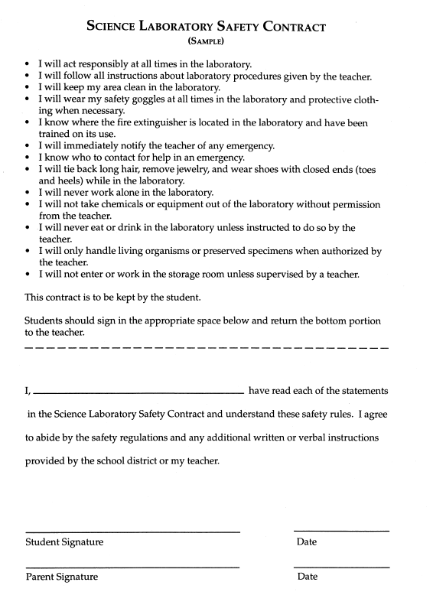

Materials: Safety Statements, part 2, Safety Contract
What To Do:
Read the following 13 guidelines about safety in the science classroom. Be ready to listen to the statements made by your teacher. If it is breaking a safety rule write wrong in the blanks below. If it is following a safety rule write correct in the blanks below.

Safety Equipment
- Know the location of all safety equipment, including fire extinguishers; fire blankets, first-aid kits and eyewash.
- Report all accidents to your teacher immediately.
- Report any cuts you received in the science classroom to the teacher so that first-aid may be given.

Heating and Electricity
- Use a hot plate to heat liquids.
- Do not point a heating test tube toward anyone.
- Do not let loose electrical cords hang over the table edge.

Knives and Glassware
- Be careful when using knives, scalpels and razor blades.
- Never use cracked or chipped glassware.
- Use a broom and dustpan to pick up broken glassware.

Unauthorized Experiments and Clean Up
- Do not perform any experiment that has not been assigned or approved by your teacher.
- Clean up all work areas and put away all equipment.
- Leave your basket and work area neat and clean
- Do not play around during laboratory.

Statements
5. ______________
6. ______________
7. ______________
8. ______________

Read and Sign the safety contract and glue in your notebook.

Name _____________ period _____

Exit Ticket
Safety First
1. Circle students breaking safety rules in green.
2. Circle students following safety rules in blue.

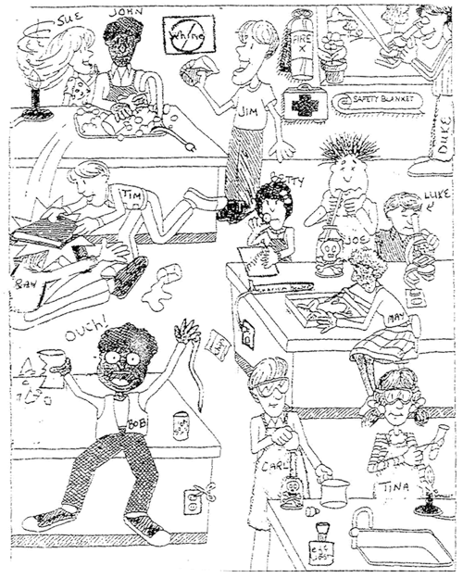

Name _____________ period _____
Exit Ticket
Safety First
1. Circle students breaking safety rules in green.
2. Circle students following safety rules in blue.

Teacher page

Safety statements

First 10

1. I will eat a candy bar during laboratory.

2. I will taste the chemical to see if it is sour.

3. I will wear my safety glasses when working with fire.

4. I will put my nose next to a test tube to smell it.

Second 13

5. I will not tell the teacher if I cut myself.

6. I will use a broom and dustpan to pick up broken glass.

7. I will run and play during laboratory.

8. I will not point a heating test tube toward my classmate.

