Metals and Nonmetals

All matter is made up of atoms. Different kinds of atoms are called elements. An element is considered the simplest form of matter. Elements are considered to be pure substances.
Typically, the properties of metals are a shiny luster, being very malleable, conducting electricity, and some metals are attracted to a magnet. Nonmetal properties are usually a dull luster, being brittle, not conducting electricity and not being attracted to a magnet.

Luster describes whether the substance is shiny or dull.
Brittleness describes whether the substance will break easily.
Malleability is the opposite of brittleness. It describes whether the substance can be pressed out into thin sheets.
Electrical conductivity describes whether electricity can pass through an object.
Magnetism describes whether the substance is attracted to
a magnet. Iron, cobalt and nickel are the only magnetic elements.

Materials: mirror, cookie and clay
What To Do:
1. Your teacher will show you a mirror.
Which property does a mirror have?
Dull luster or Shiny luster (circle one)
2. Your teacher will show you a cookie and break it.
Which property does the cookie have?
Brittleness or Malleability
3. Your teacher will roll out a piece of clay.
Which property does the clay have?
Brittleness or Malleability

Materials: carbon (charcoal briquette), iron washer, lead, sulfur, copper, aluminum, magnet, conductivity tester

What To Do:
1. Use your periodic Table to find the symbol for each element.
2. Use the conductivity tester to test each element. If the bulb lights up then the material conducts electricity. If the bulb does not light up it is an insulator.
3. For luster determine if the element is shiny like a mirror or dull like the material in your shirt.
4. For brittleness or malleability determine if the element will break apart like a cookie or if it has been rolled out to a thin sheet.
5. Use the magnet to test each element.
Observations:
Elements |  | Properties
Name | Symbol | Conductor or Insulator | Luster  (shiny or dull) | Malleable or Brittle | Magnetic  (yes or no)
Aluminum
Carbon
Copper
Iron
Lead
Sulfur

Use your Periodic Table to classify the six elements as metals or nonmetals.
1. Which ones are metals? ___________________________
2. Which ones are nonmetals? ______________________
3. What properties do all metals have? ______________
_____________________________________________

Listen and watch the video “Meet the Elements”
Fill in the elements as they are mentioned in the song.

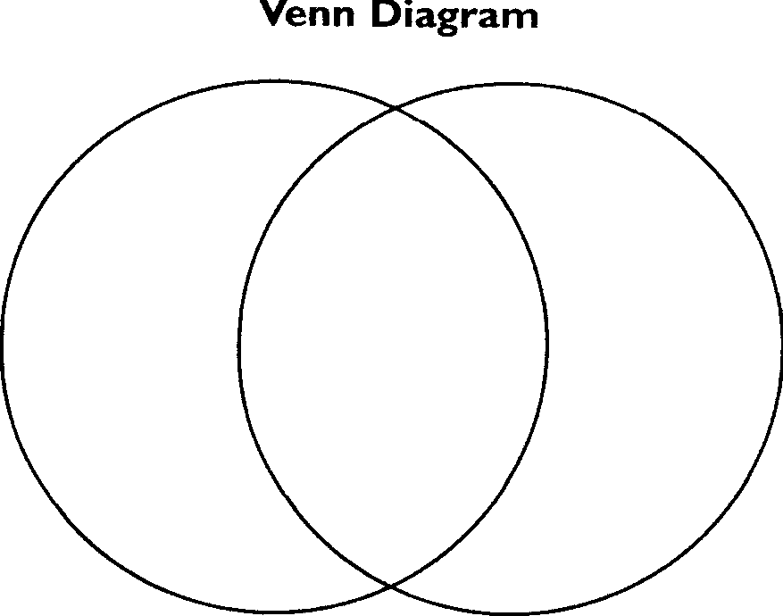
NonMetals
_______ is a metal, you see it every day
__________, eventually, will make it rust away
__________ in its ordinary form is coal
Crush it together and diamonds are born.

Refrain
Come on come on and meet the elements
May I introduce you our friends, the elements?
Like a box of paints that are mixed to make every shade
They either combine to make a chemical compound or stand alone as they are.

________’s a gas that lights up the sign for a pizza place
The coins that you pay with are _______, ______ and ______
___________ and __________ make concrete bricks and glass
Now add some ______ and ______ for some pizza place class.

Refrain
Team up with other elements making compounds when they combine. Or make up a simple element formed out of atoms of the one kind.

Balloons are full of _________ and so is every star
Metals
Stars are mostly _________, which may someday fuel your car.

Hey, who let in all those elephants?
Did you know that elephants are made of elements?
Elephants are mostly made of four elements
And every living thing is mostly made of four elements
Plants, bugs, birds, fish, bacteria and men
Are mostly ______, _______, _______ and ________

Complete the Venn Diagram below comparing Metals and Nonmetals.

Name ____________________ period ______

EXIT TICKET
Metals and Nonmetals
Directions: Place the letter of the answer next to each property. The answers will be used more than once.

 | Conductor | A. metal
 | Insulator
 | Sometimes a conductor
 | Brittle | B. nonmetal
 | Malleable
 | Magnetic | C. metalloid
 | Not Magnetic

Conclusion: (atoms, metals, nonmetals, elements, metalloids)

All matter is made up of ___________. Different kinds of atoms are called _________. ________ conduct electricity, ________ do not conduct electricity and _________ may or may not conduct electricity.

Name ____________________ period ______

EXIT TICKET
Metals and Nonmetals
Directions: Place the letter of the answer next to each property. The answers will be used more than once.

 | Conductor | A. metal
 | Insulator
 | Sometimes a conductor
 | Brittle | B. nonmetal
 | Malleable
 | Magnetic | C. metalloid
 | Not Magnetic

Conclusion: (atoms, metals, nonmetals, elements, metalloids)

All matter is made up of ___________. Different kinds of atoms are called _________. ________ conduct electricity, ________ do not conduct electricity and _________ may or may not conduct electricity.

