Combining Elements

There are close to 120 elements on the Periodic Table. Everything in the universe – you, the table, the earth and all the stars are made up of combinations of these 120 elements. As you know elements are pure substances. When we combine these pure substances with each other they become compounds. A compound by itself is also a pure substance.
You have learned how to write the symbols for the elements. Some elements have one letter for their symbol while other elements have two letters. When we write symbols for a compound it is called a formula. For example, table salt is a compound made up of one part sodium and one part chlorine. Its formula is written as NaCl. The carbon dioxide gas you breathe out is a compound that will always be made of one part carbon to two parts oxygen (CO₂). Scientists use the element symbols to write the chemical formula for compounds.
Notice that if there is only one element in the compound there is no subscript written. If there is more than one element in the compound a subscript number is placed after the element in the formula.

Directions:
Use the numbers 0-9 and make as many 2 number combinations as you can in 30 seconds. Write your combinations below. Your teacher will time you.

As you can see from this there are many combinations with just 10 numbers. Think about how many combinations there are with 120 elements.

Materials: Scissors, glue, elements sheet, periodic table
What To Do:
1. Below you will find 6 compounds listed.
2. Use your periodic table to determine the elements that are found in the listed compounds.
3. Cut out the elements from your elements sheet.
4. Work with your partners to make a model of each compound. Watch those subscripts!

Compound formula | Elements and Symbols | Model
CO₂

H₂O

NO₂

SO₂

HCl

NaCl

Reviewing TAILS

When we make a graph we like to make an excellent graph. To do this we have learned the acronym TAILS.

T stands for Title. Every graph should have a descriptive title.
A stands for axis. You must have an x and a y-axis. The x-axis is the horizontal line and the y-axis is the vertical line.
I stands for interval. Intervals on the y-axis must be equal and the intervals on the x-axis must also be equal.
L stands for labels. Each axis must have a label that tells what the data is.
S stands for scale. You should make your graph as big as possible.

Label the parts of the graph below.
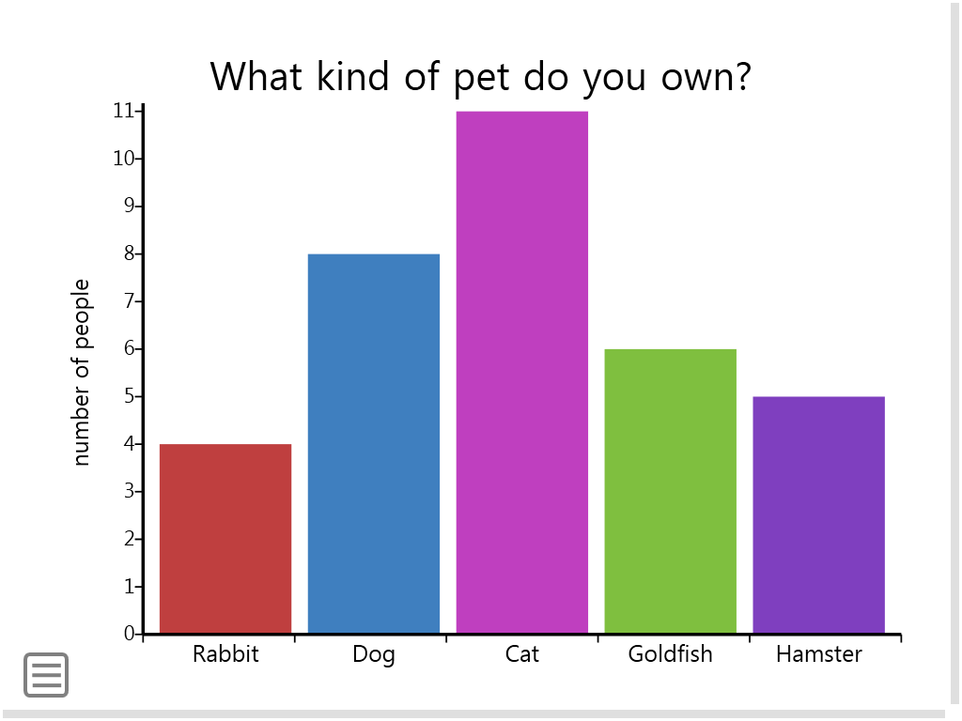

Directions:
1. Use your Periodic Table to complete the data table below.
2. Use TAILS to make an excellent graph of the data.

Elements and Compounds in Your Body

Element | Symbol/  Formula | Amount in pounds
Oxygen |  | 97
Carbon |  | 27
 | H | 15
 | N | 4.5
Water | H₂O | 56
Salt | NaCl | 0.3

Name ____________________ period _____

EXIT TICKET
Combining Elements
Directions: Determine which substance listed below is an element and which is a compound. Write an E for element and a C for compound.

H
CO₂
Co
Ca
CaCO₃
O
N
SiO₂

Conclusion: (formula, atom, elements, molecules, one, subscript, compound)
A ________ is a substance made up of more than _____ type of element. When we write the symbols for a compound we call it a _______. If there is more than one of the same kind of___________ in a compound we use a ________ after the element in the formula.

Name ____________________ period _____

EXIT TICKET
Combining Elements
Directions: Determine which substance listed below is an element and which is a compound. Write an E for element and a C for compound.

H
CO₂
Co
Ca
CaCO₃
O
N
SiO₂

Conclusion: (formula, atom, elements, molecules, one, subscript, compound)
A ________ is a substance made up of more than _____ type of element. When we write the symbols for a compound we call it a _______. If there is more than one of the same kind of___________ in a compound we use a ________ after the element in the formula.

C | O | O | Cl
H | O | O | Cl
H | O | O | N
H | O | S | Na

Make one copy per 4 students.

C | O | O | Cl
H | O | O | Cl
H | O | O | N
H | O | S | Na

C | O | O | Cl
H | O | O | Cl
H | O | O | N
H | O | S | Na

C | O | O | Cl
H | O | O | Cl
H | O | O | N
H | O | S | Na

