6th grade Unit 3 – Chemical Change and Density

Objectives

SCI.6.5D Identify the formation of a new substance by using the evidence of a possible chemical change such as production of a gas, change in temperature, production of a precipitate, or color change.
ⓈSCI.6.6B Calculate density to identify an unknown substance.

Activity 1 Making New Substances
Materials: Demonstration: Beaker, vinegar, 2 pieces of steel wool, tongs, paper towels
Materials each lab table: baking soda, vinegar, Chem-plate, scoop, ammonia, grape
juice, beaker, water, Damp Rid, small spoon, thermometer, graduated cylinder

Focus: I can identify the clues that indicate a new substance was made when compounds are mixed.
SIOP Language Objective: I can read a diagram to collect qualitative data.

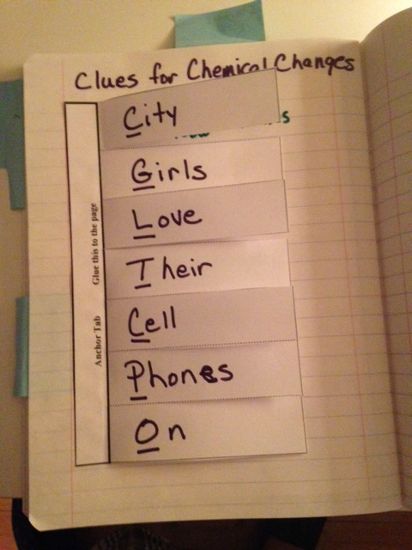
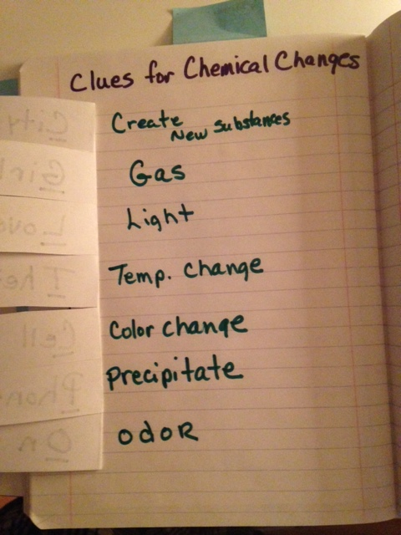

Activity 2 Defining Density
Materials: Demonstration: Large beaker of water, 3 different blocks (wood, plastic,
metal, available from Delta or Wards Scientific)
For each lab table: Ocean in a bottle, beaker, water, graduated cylinder, baking soda,
vinegar, spoon, 10 raisins

To make the Ocean in a Bottle use the small water bottles. Fill half way with colored water and half way with baby oil. Make sure the tops are on tightly and tape to keep students from opening them easily.

Focus: I can determine the relative density of solids, liquids and gases.
SIOP Language Objective: I can predict what will happen during a demonstration by completing
several sentence stems.

Activity 3 Calculating Density
Materials: Demonstration: 1 can Diet Coke, 1 can Coke, large, clear, container filled
with water, triple beam balance, calculator for each student
For each lab table: beaker of water, 3 blocks from Activity 2

Focus: I can calculate the density of various solids.
SIOP Language Objective: I can predict what will happen during a demonstration by completing
several sentence stems

Activity 4 Reviewing Density and the Periodic Table
Materials – Teacher Demo: 1 Density column made of 500mL graduated cylinder or tall jar, light Karo syrup colored red, blue Dawn dishwashing liquid, water colored green, baby oil, and a marble, cork, plastic cube, erasure, paper clip
Materials: Element Cards, Periodic Table

Focus: I can compare and contrast the physical properties of different substances.
SIOP Language Objective: I can work with a partner to categorize various elements by their physical properties.

