Calculating Density

Density is a physical property of matter. Remember that density tells how much mass is in a given unit of volume. So to calculate the density of an object you must know two things – its mass(g) and its volume (mL). We calculate density by dividing the mass by the volume. That makes the unit for density g/mL.
The density of water is 1 g/mL. Any substance that has a density less than 1 g/mL will float on water. Any substance that has a density greater than 1 g/mL will sink in water.
You can use density to predict whether an object will sink or float in water. The density of a substance is constant (it always stays the same). Density does not depend on the amount of the substance you have.

Materials: 1 can Diet Coke, 1 can Coke, large, clear, container filled with water, triple beam balance, calculator

What To Do:
1. Your teacher will show you two cans of soda.
2. What differences do you observe?
________________________________________

3. Your teacher will read the volume in mL of each can.
4. Record below – don’t forget your units!

Regular Coke volume _________
Diet Coke volume ___________

5. Your teacher will use the triple beam balance to determine the mass of each soda can.
6. Record below – don’t forget your units!

Regular Coke mass _________

Diet Coke mass ___________

Density = mass
volume

Mass of Regular Coke = _________
Volume of Regular Coke =

8. Use your calculator to divide the mass by the volume.

Density of Regular Coke = ___________

9. Repeat for Diet Coke.

Density of Diet Coke = ___________

As we learned at the beginning of the lesson the density of water is 1 g/mL. Anything that has a density of less than 1 will float in water and anything that has a density of greater than 1 will sink in water. From your calculations and the information give above, predict what will happen when the cans of soda are placed in a container of water.

Will they sink or float?

The regular Coke will ___________.

The Diet Coke will ___________

Draw what happens.

Materials: 3 blocks from previous lesson, ruler, electronic balance and triple beam balance
What To Do:
1. During the last lesson you observed whether or not 3 different blocks would sink or float in water.
2. Record what happened in the chart below.
3. Use the triple beam balance to determine the mass.
(Double-check your mass with the electronic scale)
4. Volume can also be determined by measuring 3 sides of a regular shaped object and multiplying the numbers together. This unit of measurement is cm³.
5. Use the ruler to measure 3 different sides of each block and multiply them together to get the volume.
6. Divide the mass by the volume to get the density.

 | Block # 1 | Block # 2 | Block # 3
Sinks/Floats
Mass (g)
Volume (cm³)
Density (g/cm³)

Questions:
1. Did the blocks with greater than 1 g/cm³ float or sink?
________________________________
2. Did the blocks with less than 1 g/cm³ float or sink?
_______________________________
3. Why? ____________________________________
____________________________________________

Directions:

1. Calculate the densities for each of the unknown substances in the data table below.

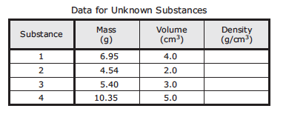
2. Compare them with the table of densities of known substances shown below.
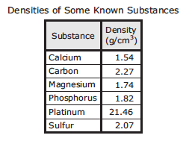
3. Fill in the chart below with the name of the substance according to its density.

Substance Number | Substance Name
1
2
3
4

Name ___________________ period _____
EXIT TICKET
Calculating Density
1. The mass of 10 mL of baby oil is 9.8 g. Determine the density of baby oil in the space below.

2. The density of water is ___________.
3. When placed together in a bottle which liquid would be on top? _________________
4. Which liquid would be on bottom? _____________
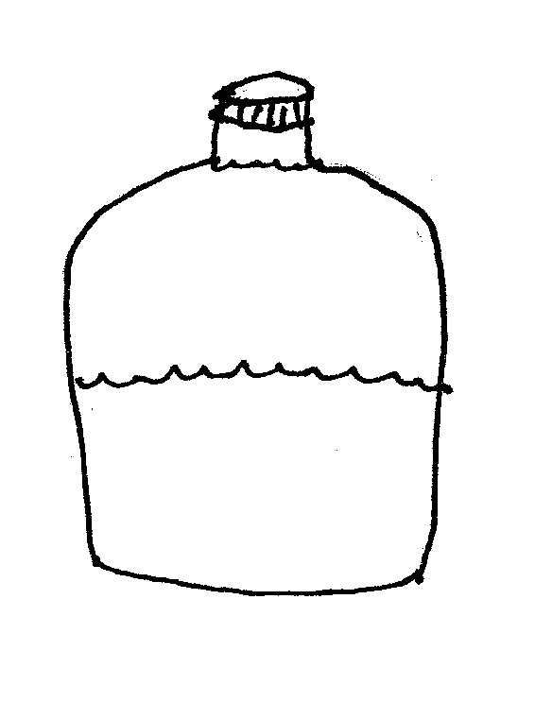
5. Label the liquids in the bottle.

Conclusion: (less, greater, sank, floated, density, matter)
The physical property __________ measures how much ________ is packed into a volume of space. The metal block ______ because its density was ______ than water. The Diet Coke _______ because its density was _______ than water.

Name ___________________ period _____
EXIT TICKET
Calculating Density
1. The mass of 10 mL of baby oil is 9.8 g. Determine the density of baby oil in the space below.

2. The density of water is ___________.
3. When placed together in a bottle which liquid would be on top? _________________
4. Which liquid would be on bottom? _____________
5. Label the liquids in the bottle.

Conclusion: (less, greater, sank, floated, density, matter)
The physical property __________ measures how much ________ is packed into a volume of space. The metal block ______ because its density was ______ than water. The Diet Coke _______ because its density was _______ than water.

