Changing Potential Energy into Kinetic Energy

There are two kinds of energy, potential and kinetic. You should remember that potential energy is stored energy. When an object starts to move its potential energy changes into kinetic energy. A moving object possesses energy because of its motion. When objects speed up and slow down they either gain or lose energy. They may gain potential energy as they slow down and gain kinetic energy as they speed up. This is called a continuous transformation of energy.
Did you know that roller coasters use potential and kinetic energy? When the roller coaster cars are taken up to the top of the hill their height changes. This action gives them more potential energy than at the bottom of the hill because the cars are located farther above the earth’s surface. When the roller coaster starts moving down the hill its potential energy is changed - or transformed into kinetic energy. As the roller coaster goes up and down hills it is constantly gaining more potential energy and transforming it to kinetic energy. This is an example of a continuous transformation of energy.

Activity 1 Roller coasters and Energy
What To Do:
1. Your teacher will show you the following website
http://science.howstuffworks.com/roller-coaster3.htm

2. As you watch the animation pay attention to where the potential energy is the highest and where the kinetic energy is the highest.

3. On the drawing show each place where the potential energy is highest and each place where the kinetic energy is highest.
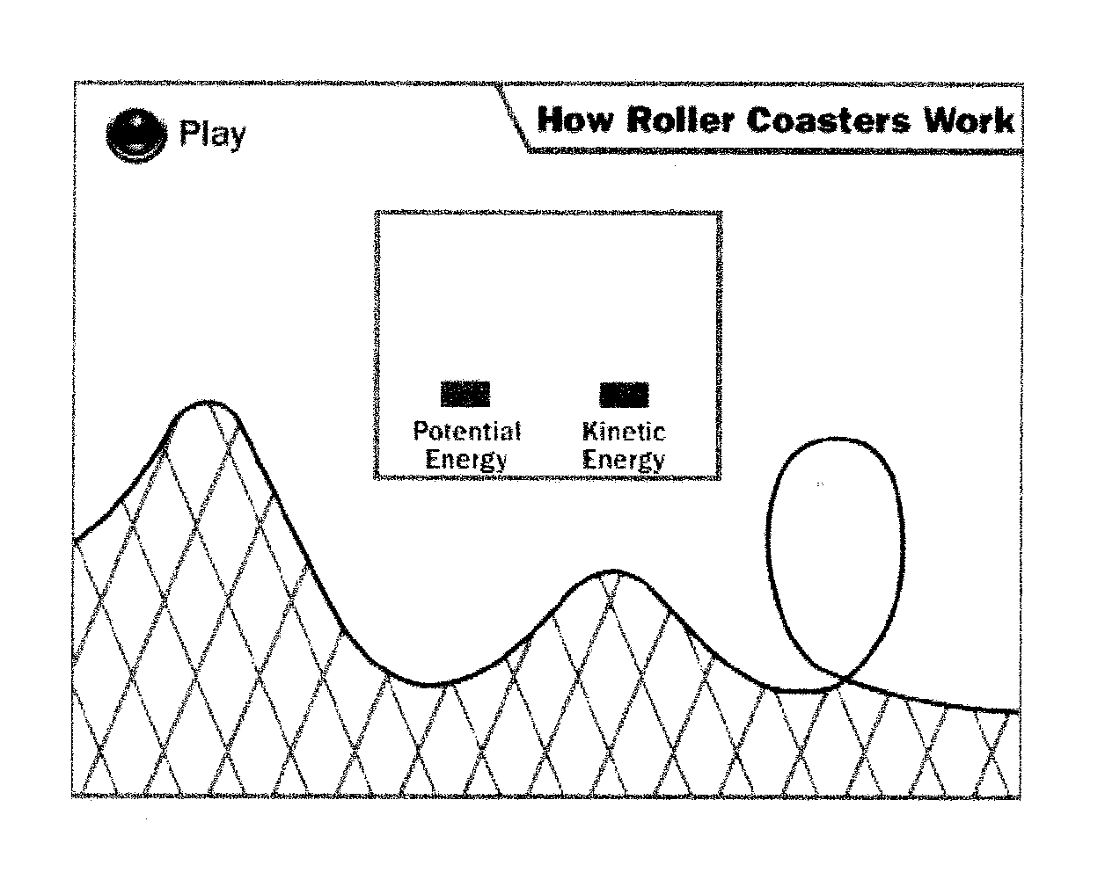

Questions:

1. How does the roller coaster gain potential energy? ________________________________________
2. What happens to potential energy when the object starts moving?__________________________________
3. What happens to the kinetic energy when the roller coaster stops? _________________________________

Activity 2 Designing a Roller Coaster

Use your knowledge of potential and kinetic energy by designing a roller coaster found on the following website:

http://www.funderstanding.com/coaster

You can adjust the settings at Hill 1, Hill 2 and the speed.
Leave the Loop, mass, gravity and friction settings where they are.

Design a roller coaster with the following specifications:

1. High Hill 1, low Hill 2 and medium speed. What happens to the roller coaster?_______________________

2. Medium Hill 1 and a high Hill 2 with medium speed. What happens?_______________________________

3. Highest Hill 1 and low Hill 2 with fast speed.
What happens?_______________________________

4. Low Hill 1 and high Hill 2 with medium speed.
What happens?_______________________________

5. _______ Hill 1 and _______ Hill 2 with ______ speed.
What happens?_______________________________

6. When the roller coaster gets to the end of the track what is the relationship between the Hill 1 and the Hill 2?
_____________________________________________

7. When the roller coaster completes the loop what is the relationship between Hill 2 and the loop?
____________________________________________

Activity 3 What is happening?

Explain what is happening in terms of potential and kinetic energy at each location in the picture below.

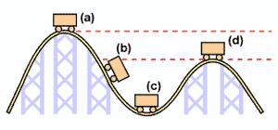

(a)
(b)
(c)
(d)

Name _______________ period ______

EXIT TICKET
Changing Potential Energy into Kinetic Energy
Circle the letter of the roller coaster that will make it to the end of the track.

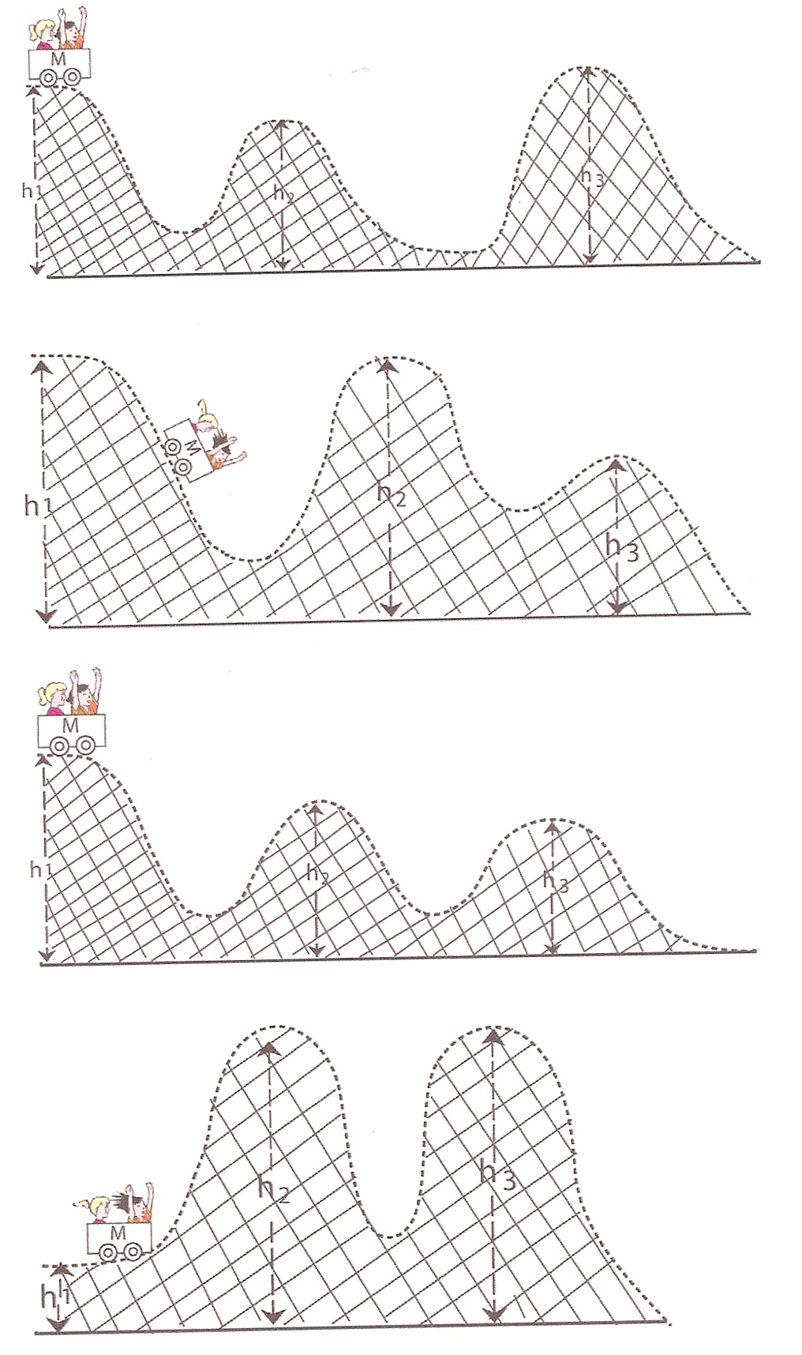

A

B

C

D

Conclusion: (top, stored, moving, bottom,)
Potential energy is _________ energy and a _________ object has kinetic energy. A roller coaster has the highest potential energy at the ______ of the hill. A roller coaster has the highest kinetic energy at the _______ of the hill.

Name _______________ period ______
EXIT TICKET
Changing Potential Energy into Kinetic Energy
Circle the letter of the roller coaster that will make it to the end of the track.

A

B

C

D

Conclusion: (top, stored, moving, bottom,)
Potential energy is _________ energy and a _________ object has kinetic energy. A roller coaster has the highest potential energy at the ______ of the hill. A roller coaster has the highest kinetic energy at the _______ of the hill.

