N. R. G.

Materials: Mystery Cube

What To Do:
1. Look at all the pictures on your Mystery Cube.
2. What does each picture show?

_____________ ______________ _____________
________________ ________________

3. What do these pictures have in common?

____________________________________________

Each of these pictures shows some type of energy. What is energy? It’s simple - energy is the ability to do work. Even though you can’t really see it, energy causes millions of different actions and reactions to occur every single day. In fact, whenever something moves, heats, cools, grows, changes or produces light - energy is involved. There are a number of different types of energy. Did you know that you can easily memorize the different types of energy by remembering the letters that make up the words MRS. CHEN?

Mechanical Chemical
Radiant Heat
Sound Electrical
Nuclear

Let’s find out what each of these types of energy really mean.

Materials: pictures of energy types, scissors, glue
What To Do:
1. In the chart on the next pages all of the types of energy are defined.
2. Match them with the pictures your teacher gives you.
3. Cut out the pictures and arrange them in the Picture Column.
4. Some of the pictures can be classified in more than one category. Find the place that fits for all the pictures then glue them down.
5. In the “What else can it be?” column list other types of energy shown in the pictures.
6. Go back to the Mystery Cube and identify all the different types of energy shown.
Energy Match
Type of Energy | Picture | What else can it be?
Mechanical Energy
Anything that has motion or can move

Radiant Energy
Anything that is giving off light or electromagnetic radiation (sun, magnet)
Sound Energy
Anything that makes noise

Type of Energy | Picture | What else can it be?
Chemical Energy
Anything with stored energy that is released by a chemical reaction

Heat Energy
Also called Thermal Energy - anything that gives off heat

Electrical Energy
Anything that involves electricity

Nuclear Energy
Anything that involves an atomic reaction

Questions:
1. What is energy? ______________________________
2. What is an easy way to remember the first letters of the
types of energy? _____________________________

Do Not Glue until teacher says

Write the name of the energy on the flap and draw an example under it.
M
R
S
C
H
E
N
Name ________________ period ___

EXIT TICKET
NRG
Unscramble the types of energy below. Use the numbered boxes to fill in the words below the puzzle.

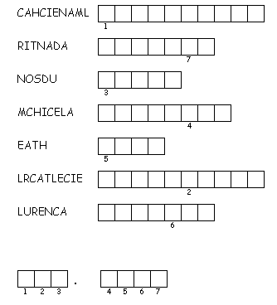

Conclusion: (heat, work, radiant, mechanical)
Energy is the ability to do _______. They type of energy that comes from the sun is known as _______ energy. The type of energy that involves motion is known as _______ energy. The type of energy that can also be called thermal is ____ energy.
Name ________________ period ___

EXIT TICKET
NRG
Unscramble the types of energy below. Use the numbered boxes to fill in the words below the puzzle.

Conclusion: (heat, work, radiant, mechanical)
Energy is the ability to do _______. They type of energy that comes from the sun is known as _______ energy. The type of energy that involves motion is known as _______ energy. The type of energy that can also be called thermal is ____ energy.

