Getting Energy to Change

Energy is neither created or destroyed but only changes form (transforms). All of the energy that goes into a system is constant. In other words, energy may be converted from one form to another, but it doesn’t disappear or multiply. A law of science says that Energy cannot be Created or Destroyed! Think about the energy in your favorite food - this is chemical energy. When you eat the food, your body digests it and gives you energy to move and pick up things - this is mechanical energy. So the chemical energy in food is transformed to mechanical energy in your body. All of the types of energy we have studied can be transformed into other types of energy.

Materials: flashlight, hot plate, carafe of water, radiometer, electromagnet, small paper clips, glow stick, CD player, radio or computer

What To Do:
1. Your teacher will show you a flashlight and the batteries inside.
2. Your teacher will turn the flashlight on.
3. On the next page fill in the chart for the flashlight.

4. Your teacher will plug in and turn on the hot plate.
5. Place a carafe of water on the hot plate.
6. On the next page fill in the chart for the hot plate
and water.

7. Your teacher will give each table a radiometer.
8. Place it on the table and observe.
9. Take it outside and place it in the sun. Observe what
happens.
10. On the next page fill in the chart for the radiometer.

11. Your teacher will show you a battery, nail with

wire wrapped around it and 5 small paper clips.
12. Touch the wires to the top and bottom of the battery and
touch the nail to the paper clips.
13. On the next page fill in the chart for the electromagnet.

14. Your teacher will show you a glow stick.
15. Then your teacher will turn off the classroom lights and break the glow stick.
16. On the next page fill in the chart for the glow stick.

17. Your teacher will plug in a computer, radio or CD player.
18. Then your teacher will play some music.
19. On the next page fill in the chart for the CD player.

Questions:
1. What types of energy did electrical energy transform into? _____________ ______________
2. What types of energy did chemical energy transform into? _____________ ______________
3. A flashlight actually has 2 energy transformations in the process of getting light. The chemical energy in the battery changes to electrical energy in the flashlight, which changes to radiant energy in the light bulb.
Draw and label these 2 energy transformations in the space below.
Chemical Energy Electrical Energy Radiant Energy

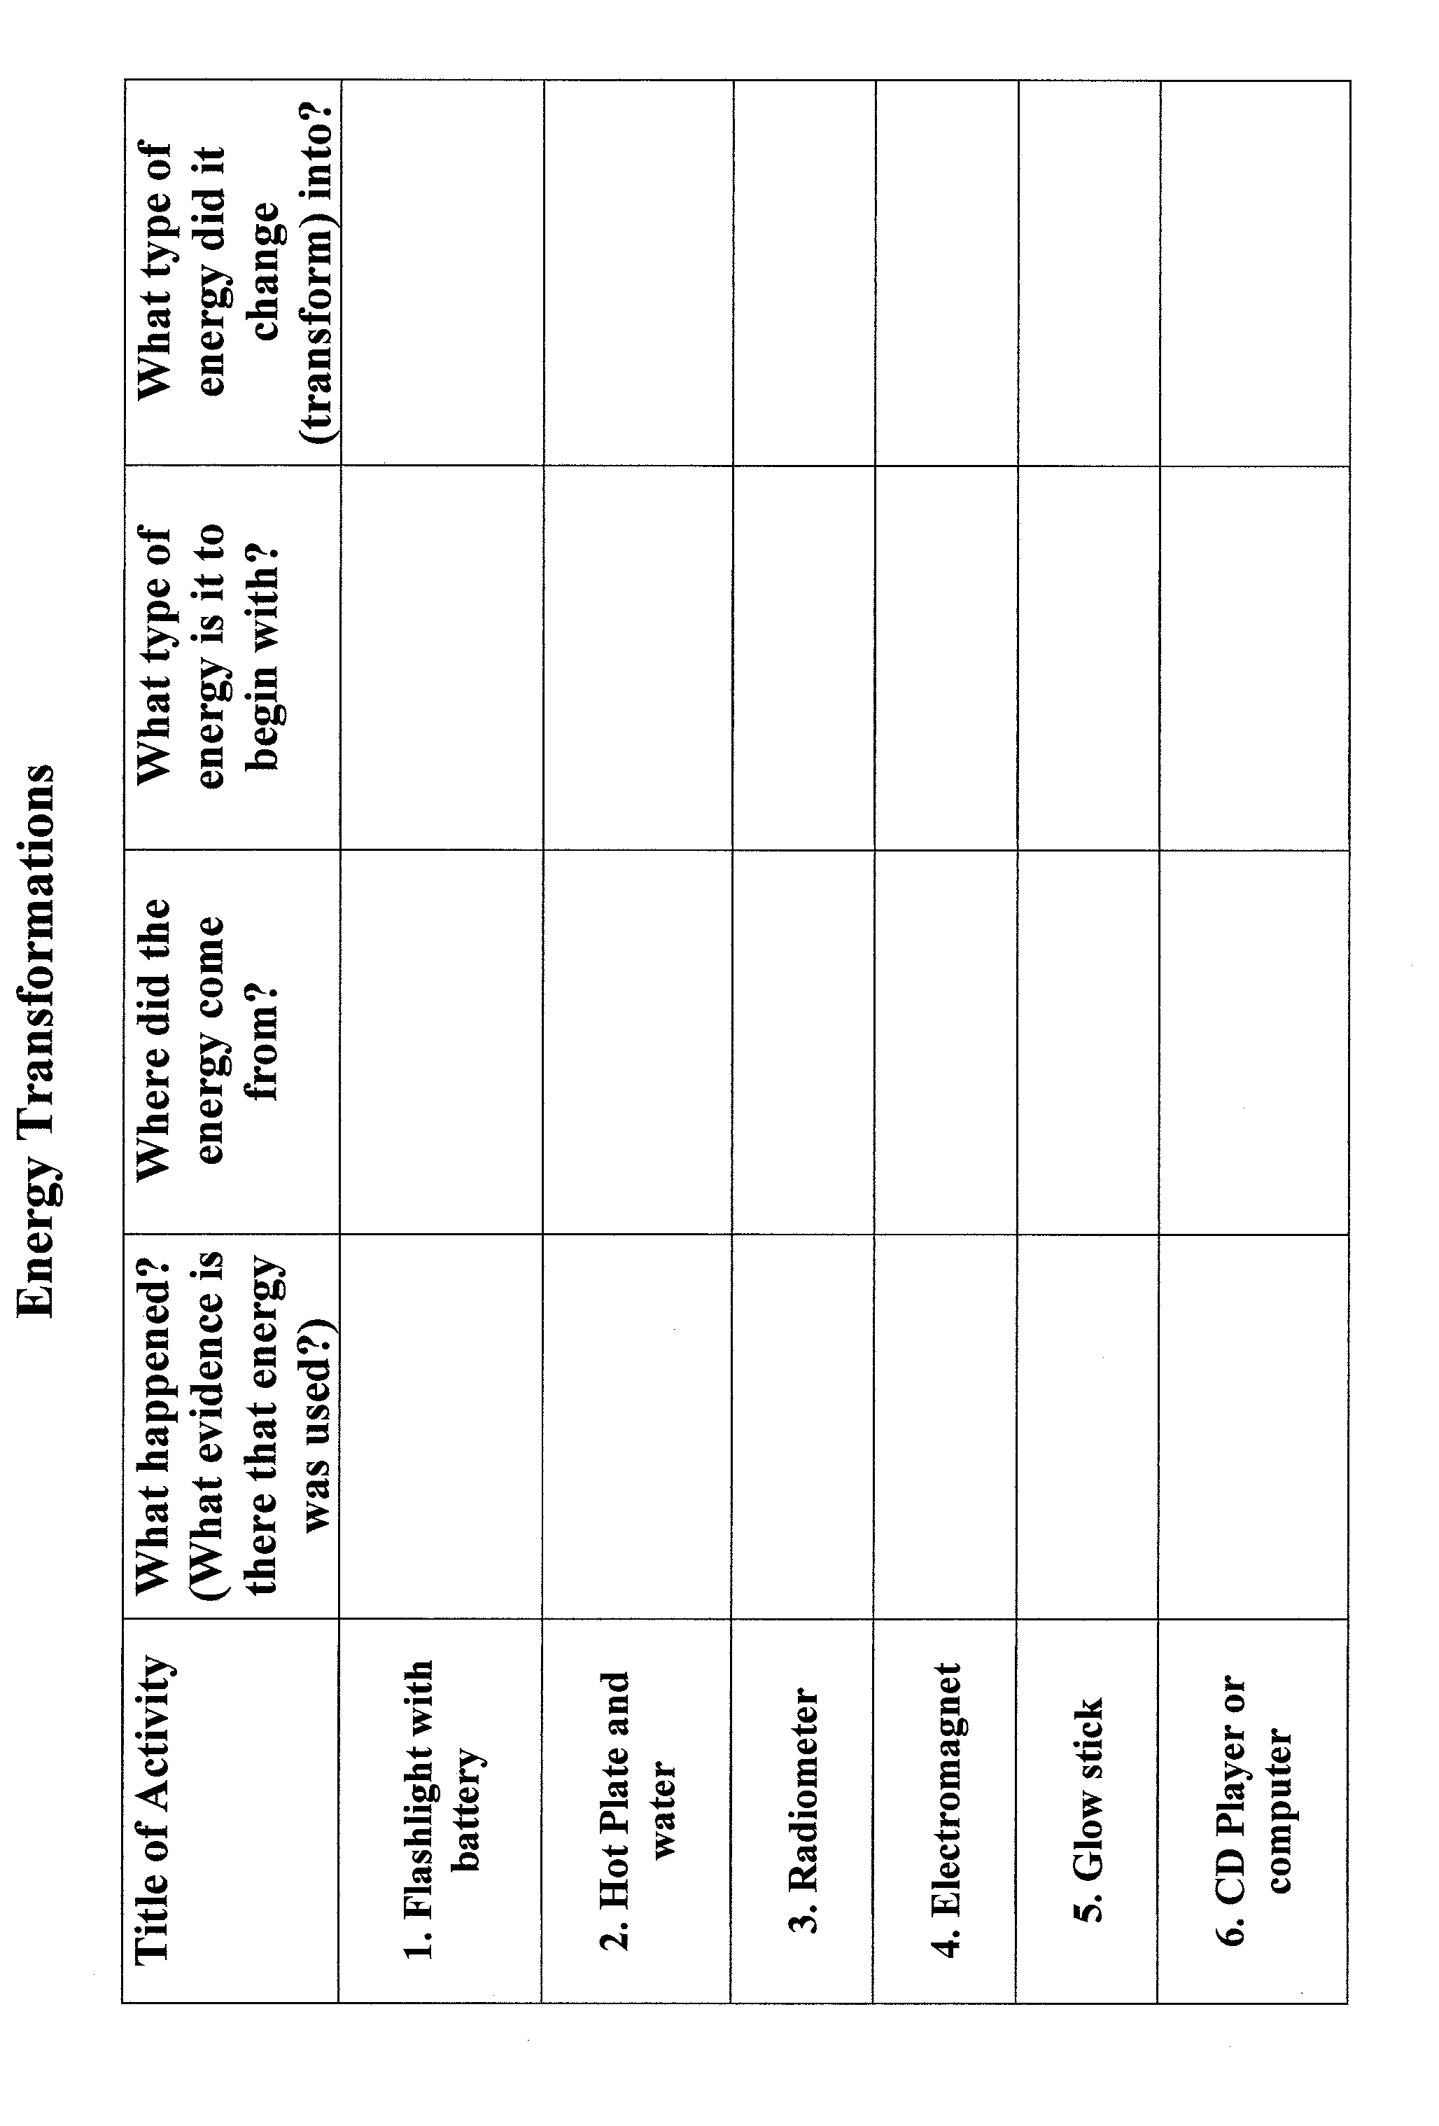
FORMS OF ENERGY
Mechanical
Chemical
Sound
Radiant
Nuclear
Electrical
Heat

Write examples of each type energy on the lines below.

Name _____________ period _____

EXIT TICKET
Making Energy Change
Fill in the blanks below using the following words:
Heat Nuclear Electrical Mechanical

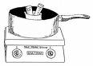
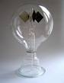
Beginning changes Ending
Energy Type into Energy Type
Beginning changes Ending
Energy Type into Energy Type

Conclusion: (transforms, electrical, flashlight, chemical, radiant,)
When energy changes from one form to another it _____________. Two energy transformations occur when you turn on a ___________. The __________ energy in the battery changes to _________ energy and then to _________ energy.

Name _____________ period _____
EXIT TICKET
Making Energy Change
Fill in the blanks below using the following words:
Heat Nuclear Electrical Mechanical

Beginning changes Ending
Energy Type into Energy Type
Beginning changes Ending
Energy Type into Energy Type

Conclusion: (transforms, electrical, flashlight, chemical, radiant,)
When energy changes from one form to another it _____________. Two energy transformations occur when you turn on a ___________. The __________ energy in the battery changes to _________ energy and then to _________ energy.

