6th grade
Unit 5 Thermal Energy
Objectives:

SCI.6.9A Investigate methods of thermal energy transfer including conduction, convection, and radiation.
SCI.6.9B Verify through investigations that thermal energy moves in a predictable pattern from warmer to cooler until all the substances attain the same temperature such as an ice cube melting.

Activity 1 Introducing Thermal Energy
Materials: Teacher Demo: Clear beaker of hot water, clear beaker of cold water, red food coloring
Student Activity: hot plate, coffee carafe or large coffee maker, ice
water, 3 Styrofoam cups, graduated cylinder, thermometer, funnel

Focus: I can identify temperature as a way of measuring and substances thermal energy.
Language Objective: I can analyze a video for information about the states of matter.

Activity 2 Energy on the Move
Materials:
- Teacher Demo - lamp with incandescent light bulb (40W)
- 2-L bottle, balloon, container of ice and water that bottle will fit in, container of warm tap water that bottle will fit in

Focus: I can investigate thermal energy moving in a predictable pattern from warmer to cooler.
Language Objective: I can work with my partner to fill out a chart and answer questions.

Activity 3 Three Ways to Transfer Heat
Conduction (Can be a Teacher Demo)
Materials: See set up picture below
aluminum foil bridge, timer, metric ruler, 2 small vegetable cans, votive candle, matches, masking tape, 3 chocolate chips

Prepare the aluminum foil “bridge” for each group by cutting a 15cm sheet of aluminum foil from the box and wrapping it around a ruler by folding it so that the bridge is 4 layers thick. Candle needs to be about 2 cm below the foil bridge. Use small vegetable cans or if not available, use tall cans and place something non flammable under the candle to raise it to 2 cm. Note: Cans are 20 cm apart making the bridge about 15cm long.

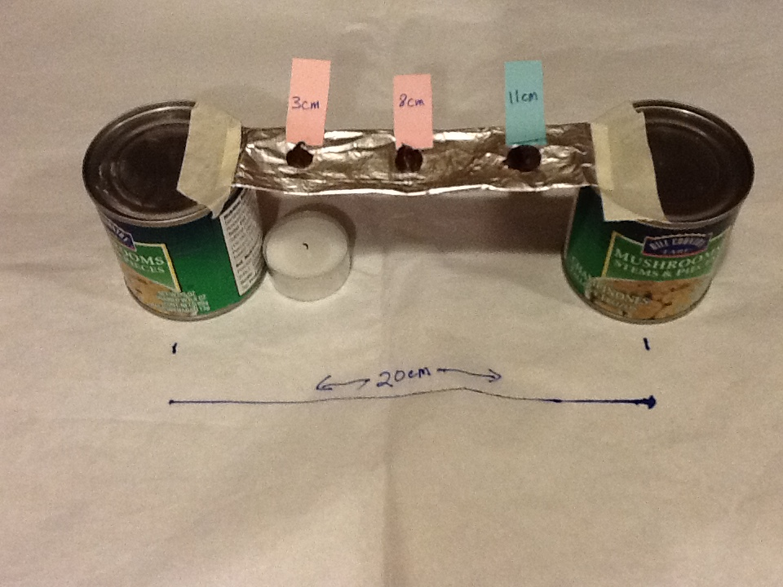
Convection (Teacher Demo)
Materials: Hot plate, paper spiral, straight pin
Cut out the paper spiral - if you live in an area of high humidity you might want to use a paper plate rather than just paper. Place a straight pin through the middle so the head of the pin is against the paper and you can hold the pointed end of the pin. Hold up the spiral so students can see it not moving and then gently move it over the hot plate that has been turned on.

Radiation
Materials: none needed

Focus: I can investigate methods of thermal energy transfer including conduction, convection, and radiation.
Language Objective: I can compare the different types of thermal energy transfer by analyzing a picture.

