Introducing Thermal Energy
All matter is made up of small particles and these particles are always in motion. Particles making up the table (a solid) in motion even though we can’t see movement in the table; particles making up a cold soda (a liquid) are in motion and particles inside a helium balloon (a gas) are in motion. Scientists refer to the collective motion of particles in matter as thermal energy. The amount of thermal energy a substance has depends on its temperature and amount. Anything that has a temperature has thermal energy. The higher the temperature the more kinetic energy they have, too.
Temperature is a way of measuring a substance’s thermal energy. Heat is thermal energy that is on the move. It is moving from one system to another. Thermal energy is transferred when there are temperature differences and always transfers from warmer substances to cooler ones. The faster atoms move, the greater quantity of heat they transfer.

Materials: Teacher Demo: Clear beaker of hot water, clear beaker of cold water, red food coloring
What To Do:
1. Place a beaker of hot water and a beaker of cold water in a place that all students can see it.
2. Predict what will happen when a drop of food coloring
is placed in both beakers?

______________________________________________

3. When the water is very still place one drop of food coloring in each beaker at the same time.

4. Describe what you see happening in the beakers.

______________________________________________

5. Watch the Free BrainPop video on States of Matter.
6. Match the object below to the picture of its particles.

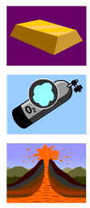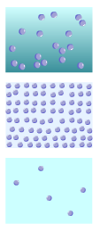

Questions:
1. Why did the food coloring spread out through the water? _____________________________________
2. Why did the food coloring in the hot water spread out faster? ________________________________________
3. Why did the food coloring in the cold water spread out slower? ____________________________________
When equal amount of warm water and cold water are mixed together it stands to reason that the resulting temperature will be somewhere in the middle of the two starting temperatures. Let’s do some math and then test our predictions.

The equation for this prediction would be:

Cold starting temp. + Hot starting temp. = ending temp.
2

Cold temp = 4ºC Hot temp = 56ºC
What would be the ending temp? _________

Cold temp = 3ºC Hot temp = 67ºC
What would be the ending temp? _________

Materials: hot plate, coffee carafe or large coffee maker, ice water, 3 Styrofoam cups, graduated cylinder, thermometer, funnel

What To Do:
1. Get half a cup of each temperature of water.
2. Measure the starting temperature of each cup of water.
3. Record both temperatures in the data table below.
4. Do the math and predict the temperature of the mixed
water. Record your prediction below.
5. Use the funnel and measure out 40 mL of hot water into the graduated cylinder and then pour it into the empty cup.
6. Use the funnel and measure out 40 mL of cold water into the graduated cylinder and then pour it into the empty cup to mix them.
7. Measure the temperature of the 3rd cup of water.

Amount of water  mL | Temp. of warm water | Temp. of cold water | Predicted mixed temp. | Temp. of mixed water
40 warm
40 ice

Questions:
1. How close was your prediction to the real temperature?
______________________________________________

THERMAL ENERGY

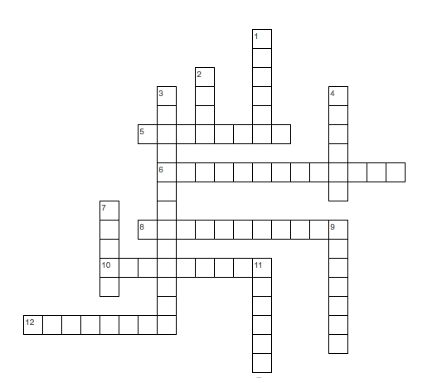
Word Bank
thermal energy
anything
motion
temperature
effects
slower
atoms
molecules
kinetic energy
colder
quantity
heat

Across
5. _______ that has a temperature has Thermal Energy.
6. The collective motion of particles of matter in ______ ______.
8. _______ is a way of measuring a substances thermal energy.
10. Combination of atoms
12. The faster the molecules move the greater _______ of heat they transfer.
Down
1. Atoms and molecules are always in ___________.
2. ________ is thermal energy on the move.
3. The hotter something is, the more ________ _______ the particles have.
4. The slower the molecules move the ______ the temperature is.
7. The basic building blocks of matter are ___________.
9. The motion of thermal energy is usually not visible but we can feel or see its ____________.
11. The colder something is the ______ its particles move and the less kinetic energy it has.

Name __________________ period ______

EXIT TICKET
1. Which of the following pictures show the particles found in a liquid? Circle the correct one.

2. How are the particles in a hot liquid different from the particles in a cold liquid?

A. There would be no difference
B. They would be moving faster
C. They would be moving slower
D. They would be farther apart

Conclusion: (middle, thermal energy, temperature)

Scientists refer to the motion of particles in matter as _________ ________ . ____________ is a way of measuring a substance’s thermal energy. When mixing equal amounts of hot and cold water the resulting temperature should be near the __________.

Name __________________ period ______

EXIT TICKET
1. Which of the following pictures show the particles found in a liquid? Circle the correct one.

2. How are the particles in a hot liquid different from the particles in a cold liquid?

A. There would be no difference
B. They would be moving faster
C. They would be moving slower
D. They would be farther apart

Conclusion: (middle, thermal energy, temperature)

Scientists refer to the motion of particles in matter as _________ ________ . ____________ is a way of measuring a substance’s thermal energy. When mixing equal amounts of hot and cold water the resulting temperature should be near the __________.

