Three Ways to Transfer Heat

Heat is thermal energy on the move. We have learned that heat moves and that it moves from warmer matter to cooler matter. The three ways in which heat moves from one substance to another are called conduction, convection and radiation.

Conduction
Have you ever grabbed the handle of a hot metal pan? Why did it feel hot to you? Heat is transferred from the handle to your body because it is in direct contact with matter than is at a hotter temperature. You are at a cooler temperature and so the heat moves to your hand. This form of heat transfer is called conduction. Conduction is the transfer of thermal energy between matter that is in direct contact.

Materials: aluminum foil bridge, timer, metric ruler, 2 small vegetable cans, votive candle, matches, masking tape, 3 chocolate chips
What To Do:
1. Use the ruler to make sure your cans are spaced about 15 cm apart.
2. Place the aluminum foil bridge over the top of the cans.
3. Use the masking tape to fasten the foil to the inside top of the can. (See picture in teacher information.
4. Place the chocolate chips at 5 cm, 8 cm and 11 cm across the foil.
5. Make sure the candle will be about 2 cm below the foil.
6. Light the votive candle with a match.
7. Slide the candle under the first chip.
8. Start the timer and watch the bottom of each chip.
9. Time how long it takes for each chip to begin melting.
10. Record your data in the data table.

Chip | 1 | 2 | 3
Time to begin melting

Questions:
1. What evidence did you observe that showed heat transfer?
_______________________________________________
2. Where did the heat that melted the chocolate chips come from? ________________________________________
3. Where did it go? _______________________________
4. What direction did it move? ______________________
5. What type of heat transfer is this? __________________
6. How do you know? ______________________________

Convection
Have you noticed that when pasta noodles are placed in boiling water the noodles sink to the bottom and then float to the top and then sink to the bottom again? This is called convection. In convection, heated molecules move away from the heat to the cooler area and cooler molecules take their place. Convection is the transfer of heat by the movement of the warmed matter. This matter must be a liquid or a gas.

Materials: Hot plate, paper spiral, straight pin
What To Do:
1. Observe the paper spiral as your teacher holds it up. It should not be moving.
2. Your teacher will turn on the hot plate and let it begin to warm up.
3. Your teacher will hold the paper spiral over the hot plate with the pin.
4. Draw or describe what you observe.

Before After

Questions:
1. Did you observe anything touching the spiral? ___
2. What caused the spiral to move? ______________
3. Where did the heat come from? ______________
4. Where did it go? __________________________
5. What direction did it move? _________________
6. What type of heat transfer is this? ____________
7. How do you know? _______________________

Radiation
Matter, solid, liquid or gas must be present in order for
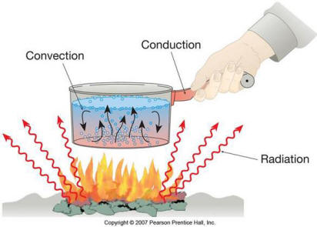
heat to move by conduction or convection. Radiation is
another method of heat transfer. It does not rely on any
contact between the heat source and the heated object.
We feel heat from the Sun but we are not touching it.
Radiation is the transfer of energy by electromagnetic
waves.

What To Do:
1. Your teacher will take you outside.
2. Stand in a sunny spot for 2 minutes.
3. Stand is a shady spot for 2 minutes.

Questions:
1. Where did the heat in the sunny spot come from?_____
2. Were you touching the sun? _____________________
3. How did the heat get to the earth? ________________
4. What type of heat transfer is this? ________________
5. How do you know? ___________________________

Watch the video Conduction, Radiation, Convection from www.missdoctorbailer.com

1. What example of conduction did they use in the video?

_______________________________________________

2. What example of radiation did they use in the video?

_______________________________________________

3. What example of convection did they use in the video?

_______________________________________________

Label each type of heat transfer in the picture below.

Name __________________ period _____

EXIT TICKET
Three ways to transfer
Match the term in column A with description in column B

 | 1. Convection |  | a. way heat moves through  empty space
 | 2. Conduction |  | b. the movement of thermal  energy between substances
 | 3. Radiation |  | c. way heat moves through  solid matter
 | 4. Heat  Transfer |  | d. way of heat moving  through liquids and gases

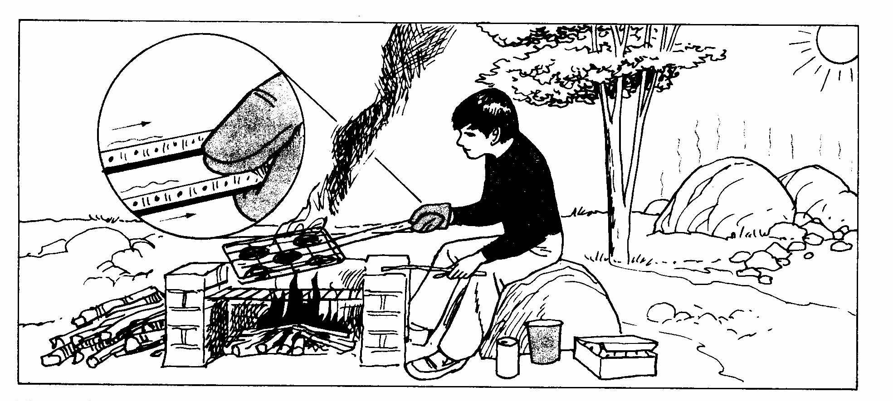

5. What is an example of the transfer of heat by radiation
in the picture?
a. hot handle touching the glove
b. smoke rising in the air
c. heating of the rocks by the sun

6. What is an example of the transfer of heat by
conduction in the picture?
a. hot handle touching the glove
b. smoke rising in the air
c. heating of the rocks by the sun

Name __________________ period _____

EXIT TICKET
Three ways to transfer
Match the term in column A with description in column B

 | 1. Convection |  | a. way heat moves through  empty space
 | 2. Conduction |  | b. the movement of thermal  energy between substances
 | 3. Radiation |  | c. way heat moves through  solid matter
 | 4. Heat  Transfer |  | d. way of heat moving  through liquids and gases

5. What is an example of the transfer of heat by radiation in the picture?
a. hot handle touching the glove
b. smoke rising in the air
c. heating of the rocks by the sun

6. What is an example of the transfer of heat by conduction in the picture?
a. hot handle touching the glove
b. smoke rising in the air
c. heating of the rocks by the sun

