NUCLEAR ENERGY

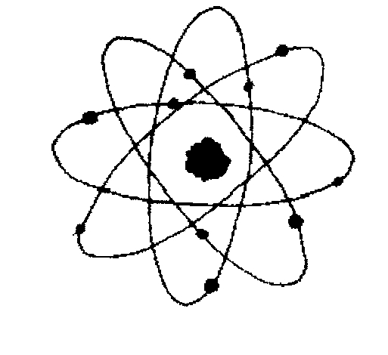

Elements such as uranium with unstable atoms

HYDROPOWER

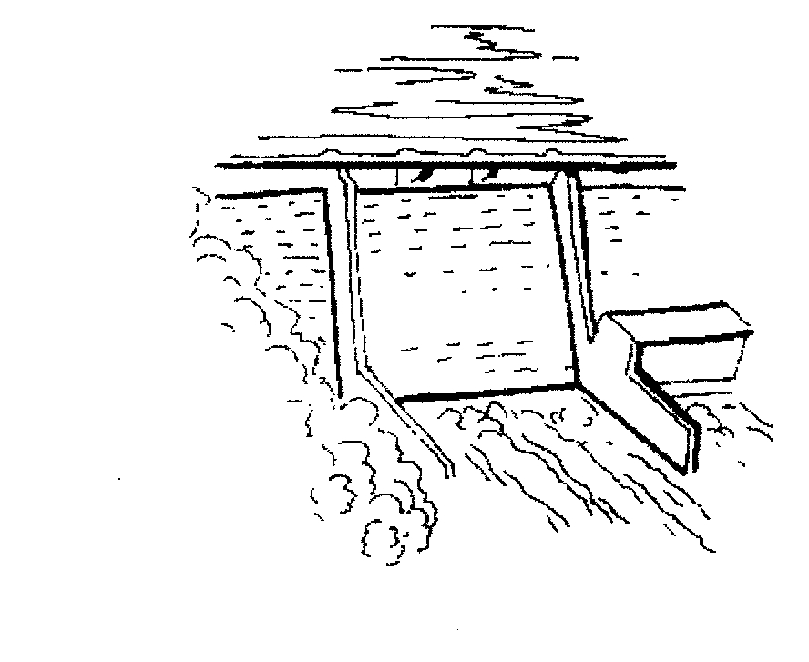

The force of moving water from rivers

COAL

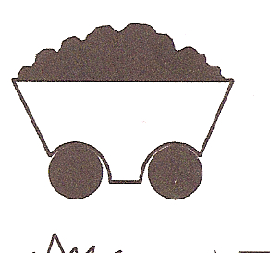

A fossil fuel dug up from the ground

BIOMASS



Plant material such as trees and corn

SOLAR



Radiant energy from the sun

GEOTHERMAL



Natural heat in the earth

NATURAL GAS



A fossil fuel taken from the ground

WIND

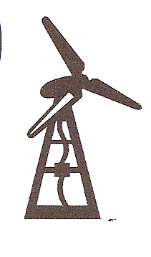

The force of moving air

OIL



A fossil fuel pumped up from the ground

