6th grade Unit 7
Force and Motion

Objectives
SCI.6.1A Demonstrate safe practices during laboratory and field investigations as outlined in the Texas Safety Standards.
SCI.6.2C Collect and record data using the International System of Units (SI) and qualitative means such as labeled drawings, writing, and graphic organizers.
SCI.6.2D Construct tables, using repeated trials and means to organize data and identify patterns.
SCI.6.2E Analyze data to formulate reasonable explanations, communicate valid conclusions supported by the data, and predict trends.
SCI.6.8B Identify and describe the changes in position, direction, and speed of an object when acted upon by unbalanced forces.
SCI.6.8C Calculate average speed using distance and time measurements.
SCI.6.8D Measure and graph changes in motion.

Activities

Activity 1 Interpreting and Making Distance-Time Graphs
Materials: timer, notebook, pen/pencil, colored pencils or markers, Example from Teacher Information page (see below)

Focus: I can measure and graph changes in motion
Language Objective: I can work with a partner to gather data.

Location | Time  (in minutes) | Distance from locker in strides
At locker | 0 | 0
Locker to first class | 3 | 45
First class | 90 | 45
First class back to locker | 93 | 0
Locker to second class | 95 | 23
Second class | 185 | 23
Second class to locker | 188 | 0
Locker to third class | 191 | 53
Third class | 281 | 53

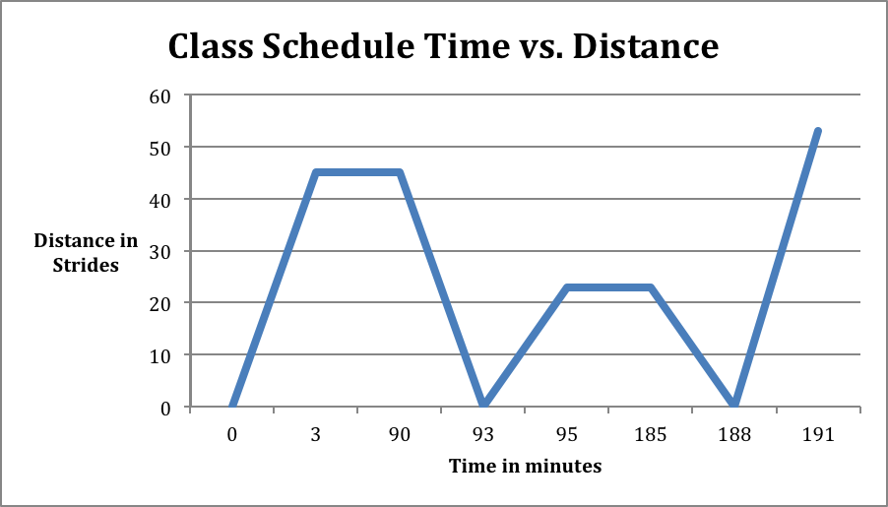

Student’s graphs should look something like this.

Activity 2 Interpreting and Making Speed-Time Graphs
Materials: none

Focus: I can measure and graph changes in motion
Language Objective: I can read a data table and make a graph.

Activity 3 Calculating Average Speed
Materials: toy car, 3 books the same height, board for a ramp, masking tape, meter stick, timer, calculator

Focus: I can calculate average speed using distance and time measurements.
Language Objective: I can work with a partner to design two speed problems for the class to solve.

Activity 4 Force and Motion
Materials: spring scale, various items to measure such as book with string around it, scissors, 200g, 500, or 1000g hooked mass, video downloaded from missdoctorbailer.com

Focus: I can measure force in Newtons by using a spring scale.
Language objective: I can summarize a video by watching and listening

Activity 5 Balanced and Unbalanced Forces
Materials: Net Forces Cards for every 2 students

Focus: I can identify and describe the changes in position, direction, and speed of an object when acted upon by unbalanced forces.
Language Objective: I can speak with my partner using a card sort.

