Making and Interpreting

Distance-Time Graphs

Describing motion is done using both words and graphs. The wording can be confusing but the graphs always give you a picture of what is happening. Remember that motion is a change in position measured by distance and time.

Making a graph showing distance and time can tell you a great deal about the motion of an object. Look at the axes below.
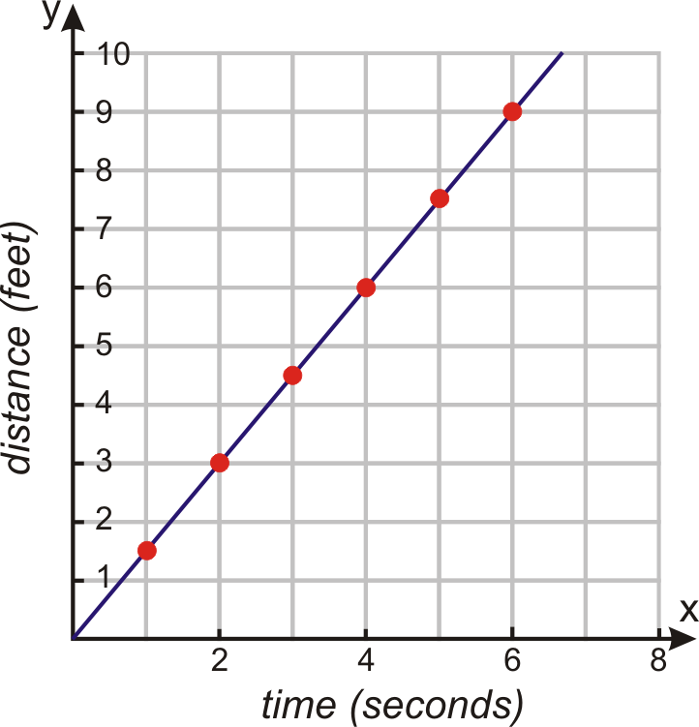

Time is always plotted along the X-axis and Distance is always plotted along the Y-axis. Time is usually in seconds but can also be in minutes or hours. Distance is usually in meters but can be in feet or inches.

Questions:
1. How many seconds are recorded on the graph? ______
2. How many feet are recorded on the graph? _________
3. What distance was traveled after 2 seconds? ________
4. How long did it take the object to travel 9 feet? ______

The shape of the line will tell you what is happening to the motion of the object. Look at the graph below.

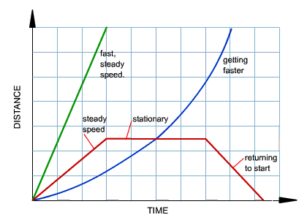
Questions:
1. What is the shape of the line if the object is moving at a steady speed? ____________________
2. What is the difference between the line that shows a steady speed and the one that shows the fast, steady speed? ________________________________
3. What is the shape of the line if the object is stationary? _______________________________
4. What happens to the line if the object is returning to start? __________________________________
5. Is the object speeding up, slowing down or stationary at this time? _______________________
6. If the object is getting faster, how does the shape of the line change? ________________________

Materials: timer, notebook, pen/pencil, colored pencils or markers, Example from Teacher Information page
What To Do:
1. You and a partner will choose whose 1st three classes you will walk in this activity.
2. Both of you will walk the route of the class schedule and count the number of strides you take to get from your locker to the class and back again.
3. While one person is counting, the other will be timing how long it takes to get from one place to another. Don’t zero the time. Keep it going for a running total.
4. Be sure to record the amount of time in each class period.
5. Look at the example from the Teacher Information Page your teacher shows you. Ask questions if you are confused.
6. When you are finished, graph the data you have collected.

Location | Time  (in minutes) | Distance from locker in strides
At Locker
Locker to first class
First class
First class back to locker
Locker to second class
Second class
Second class to locker
Locker to third class
Third class

Use the long side of the next page to place

the time and the short side to place the distance.

7. Trace over the horizontal lines with a red color.
8. Trace over the diagonal lines with a blue color.
9. Put a hatch mark (/) over the diagonal lines that show the time you spent going back to the locker.

Questions:
1. What were you doing during the time of the red horizontal lines? ___________________________
2. What do the red horizontal lines represent on a graph?
____________________________________________
3. What were you doing during the time of the blue horizontal lines? _____________________________
4. What do the blue diagonal lines represent on a graph?
____________________________________________
5. What were you doing during the time of the blue diagonal lines with the hatch marks? _______________________
6.What do the blue diagonal lines with the hatch marks represent on a graph? __________________________
7. Why might some groups’ diagonal lines rise more steeply when compared to other groups? ____________________
____________________________________________
8. Suppose you and your friend have the exact same class schedule. Would your time-distance graphs look identical? ___________ Why or why not? _____________________________________________
_____________________________________________

DO NOT Glue until cut out.
Cut on the solid lines.
Place glue under the anchor tabs
Place in your notebook

 | 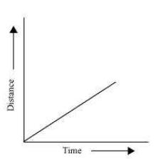  Describe the motion shown by the line below | 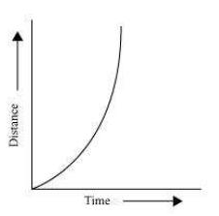  Describe the motion shown by the line below
 | 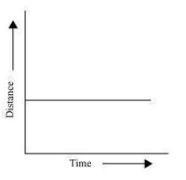  Describe the motion shown by the line below | 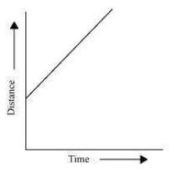  Describe the motion shown by the line below

Name __________________ Period _____
Exit Ticket
Making and Interpreting D-T Graphs
1. What does a horizontal line represent on a distance-time graph?
A. Slow movement
B. Going back to start
C. No movement

2. What does a diagonal line rising steeply represent on a distance-time graph?
A. No movement
B. Fast movement
C. Slow movement

3. What does a diagonal line going back to zero represent on a distance-time graph?
A. Slow movement
B. Going back to start
C. No movement

4. On which axis is time placed on a distance-time graph?
A. X-axis
B. Y-axis
C. Z-axis

5. On which axis is distance placed on a distance-time graph?
A. X-axis
B. Y-axis
C. Z-axis

Name __________________ Period _____
Exit Ticket
Making and Interpreting D-T Graphs
1. What does a horizontal line represent on a distance-time graph?
A. Slow movement
B. Going back to start
C. No movement

2. What does a diagonal line rising steeply represent on a distance-time graph?
A. No movement
B. Fast movement
C. Slow movement

3. What does a diagonal line going back to zero represent on a distance-time graph?
A. Slow movement
B. Going back to start
C. No movement

4. On which axis is time placed on a distance-time graph?
A. X-axis
B. Y-axis
C. Z-axis

5. On which axis is distance placed on a distance-time graph?
A. X-axis
B. Y-axis
C. Z-axis

