Interpreting and Making

Speed-Time Graphs

We have just learned about Distance-Time graphs. Speed-Time graphs look very similar but the lines tell a different story. When analyzing a graph be sure you look at the label on the Y-axis to determine which type of graph you are interpreting.

A Speed-Time graph can also be labeled a Velocity-Time graph. On both of these graphs time is placed on the X-axis while speed or velocity is placed on the Y-axis. Look at the graphs below and compare them to what we learned about distance-time graphs.

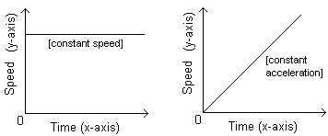

Questions:
1. On a distance-time graph what does the line for an object at rest look like? _______________________________
2. On a speed-time graph what does a horizontal line represent? _____________________________________
3. What does constant speed mean? _________________
______________________________________________
4. On a distance-time graph what does the line for steady speed or constant speed look like? _________________
5. On a speed-time graph was does a diagonal line represent? _____________________________________
6. What does constant acceleration mean? ___________

So, constant speed means the object is going the same speed the entire time, like a car going 60 mph for 2 hours. But constant acceleration means that the object is speeding up at the same rate, like a car going 50 mph at the first minute and then 60 mph at the second minute, then 70 mph the third minute. The acceleration would be 10 mph each minute.
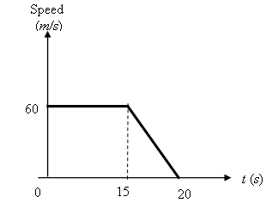
In the graph shown to the right
we see an object traveling at
constant speed and then doing
the opposite of acceleration - deceleration or slowing down to a stop.

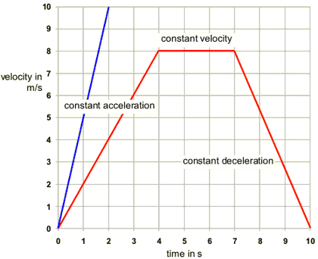
In our distance-time graphs this type of diagonal line shows us returning to start - or going back to our locker. In a speed-time graph the diagonal line slanting downward shows the object in constant deceleration.

What To Do:
Place the following descriptions in this graph:

- Slowing down to a stop
- Speeding up at the same rate
- Going the same speed

Look at the Speed-Time graph below and determine what is happening to an object in each segment. You may use the following terms:

accelerating decelerating
constant speed at rest
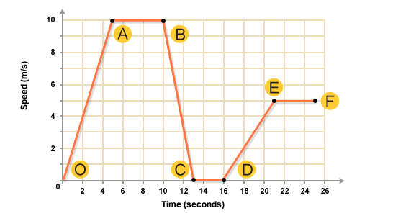
On the Road

1. Segment O-A __________________________
2. Segment A-B __________________________
3. Segment B-C __________________________
4. Segment C-D __________________________
5. Segment D-E __________________________
6. Segment E-F __________________________
There were three rockets launched from Cape Kennedy last week. Make a triple line Speed-Time graph of the data and answer the questions about the graph.

Time in sec. | Speed of Rocket 1 in km/s | Speed of Rocket 2 in km/s | Speed of Rocket 3 in km/s
0 | 0 | 0 | 0
10 | 5 | 10 | 15
20 | 10 | 20 | 30
30 | 15 | 30 | 45
40 | 20 | 40 | 60
50 | 25 | 50 | 75
60 | 30 | 60 | 90

Questions:
1. Do the rockets show constant speed or constant acceleration? _____________________________
2. How do you know this from looking at the graph? __________________________________________
3. Which rocket is accelerating the fastest? _________
4. How do you know this from looking at the graph?
____________________________________________

Name __________________ period _____

EXIT TICKET
Interpreting and Making Speed-Time Graphs

1. Which of the graphs below show that a car is
stopped? _______

2. Which of the graphs below show that a car is
traveling at constant speed? ______

3. Which of the graphs below show that a car is accelerating? ______

4. Which of the graphs below show a car slowing
down? ______

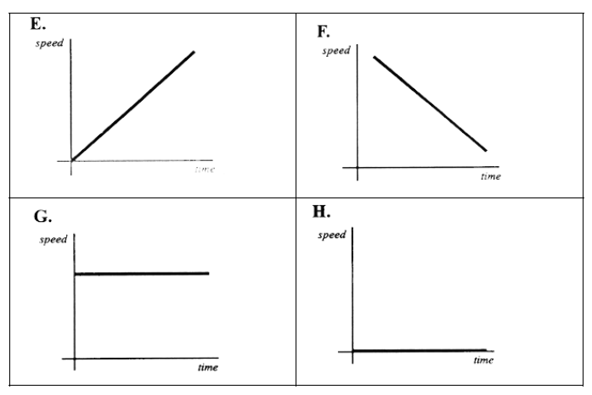

Name __________________ period _____

EXIT TICKET
Interpreting and Making Speed-Time Graphs

1. Which of the graphs below show that a car is stopped? _______

2. Which of the graphs below show that a car is traveling at constant speed? ______

3. Which of the graphs below show that a car is accelerating? ______

4. Which of the graphs below show a car slowing down? ______

