Calculating Speed

You have encountered speed when you were in a car. The speedometer read 25 miles per hour (mph). This is how speed is written. The average speed of an object is determined by the amount of time it takes that object to move over a distance. So, to have a speed you must have a distance, in this case miles, and a time, hour. In science we typically use the metric system for the distances either meters or kilometers and we use seconds for the time. The abbreviation we use in science is usually m/s – meters per second. Now we will learn to calculate the speed of a toy car along a 50-centimeter racetrack.

Materials: toy car, 3 books the same height, board for a ramp, masking tape, meter stick, timer, calculator
What To Do:
1. Place one book at the edge of your table then place the board at the edge of the book.
2. Place a piece of masking tape at the end of the ramp for the Start Line.
3. Measure 50 cm from the end of the ramp down the table and place another piece of masking tape there as the Finish Line.
4. Place the car at the top of the ramp. (See picture below)
Book
car
ramp

Start 50 cm Finish

5. Set your timer at zero and let the car go down the ramp.
6. Start the timer when the car gets to the Start Line

and stop the timer when it gets to the Finish line.
7. Record the seconds in the data table below.
8. Repeat 2 more times and record the seconds below.
9. Add another book and repeat the 3 time trials.
10. Add the third book and repeat the 3 time trials.
11. Use the calculator to find the total and the average time.

Number of Books | Trial 1 | Trial 2 | Trial 3 | Total | Average
1
2
3
Questions:
1. What was the distance the car traveled each time? ____
2. What were the average times? ______ ______ _____
3. Why did we find the average? _____________________

To calculate speed we must divide the distance by the time. Use the data from the data table to determine the speed of your car. Don’t forget the units.

Speed = distance traveled ÷ time

Speed for 1 book = ___ cm ÷ ____ seconds = ____

Speed for 2 books = ___ cm ÷ ____ seconds = ____

Speed for 3 books = ___ cm ÷ ____ seconds = ____

3. What unit did you use for speed? ________________

4. Which number of books gave the car the greatest speed? ____________

5. Why do you think this might be true? ____________
Use a calculator to find the following speeds.

Don’t forget your units.
Place your answer in the grey box
A toy train went around a 6 m track
in 3 minutes.

A student ran the 200 m track in
2 minutes.

An airplane flew for 500 km in
20 minutes.

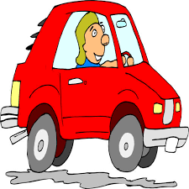
A car traveled for 10 km in 5 minutes.

A school bus traveled 100 km in 2 hours.

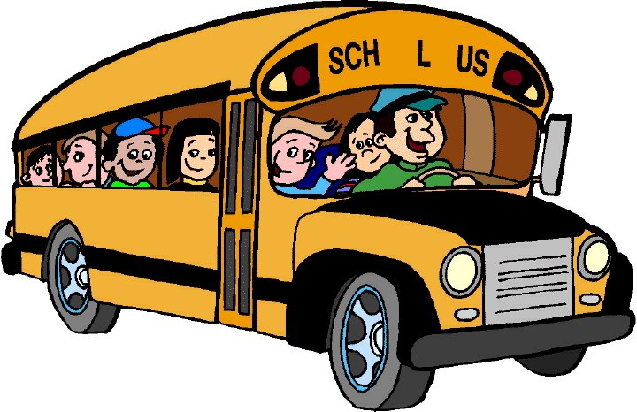

Work with your partner to write 2 problems that find the speed of an object such as a train, car or skateboarder. Be ready to share your problems with the class.

Name _________________ period _____

EXIT TICKET
Calculating Speed
Calculate the following speeds. Don’t forget your units!

1. A skateboard went around a 10m track in 2 minutes.

2. A motorcycle sped down the 500 m track in 2 minutes.

3. A rocket flew 1000 km in 2 minutes.

Conclusion: (seconds, distance, minutes, time, faster, kilometers, meters, greater)
Speed can be calculated by dividing the ___________ by the ___________. Distances can be measured in __________ or ___________ while in science. For time we usually use ________ but can use _________. We found during this lab that the ___________ the height the ___________ the speed.

Name ___________________ period _____

EXIT TICKET
Calculating Speed
Calculate the following speeds. Don’t forget your units!

1. A skateboard went around a 10m track in 2 minutes.

2. A motorcycle sped down the 500 m track in 2 minutes.

3. A rocket flew 1000 km in 2 minutes.

Conclusion: (seconds, distance, minutes, time, faster, kilometers, meters, greater)
Speed can be calculated by dividing the ___________ by the ___________. Distances can be measured in __________ or ___________ while in science. For time we usually use ________ but can use _________. We found during this lab that the ___________ the height the ___________ the speed.

