Force and Motion

When you ride a bike, your foot pushes against the pedal. The push makes the wheels of the bike move. When you drop something, it is pulled to the ground by the force of gravity. In science a force is defined as a push or a pull. Forces affect how objects move.
The simplest forces are pushes and pulls. A force can start an object that is at rest into motion, or it can slow down, speed up or change the direction of an object that is already moving. At other times, a force can have no effect at all. In this case, the force may be canceling out the effect of another force.
The size of a force can be measured using a spring scale and is recorded in the unit of Newtons (N). The abbreviation is written with a capital letter because it is named after Sir Isaac Newton.

Watch the Push and Pull song from www.missdoctorbailer.com.

1. List 3 examples of pushes shown in the video.

2. List 3 examples of pulls shown in the video.

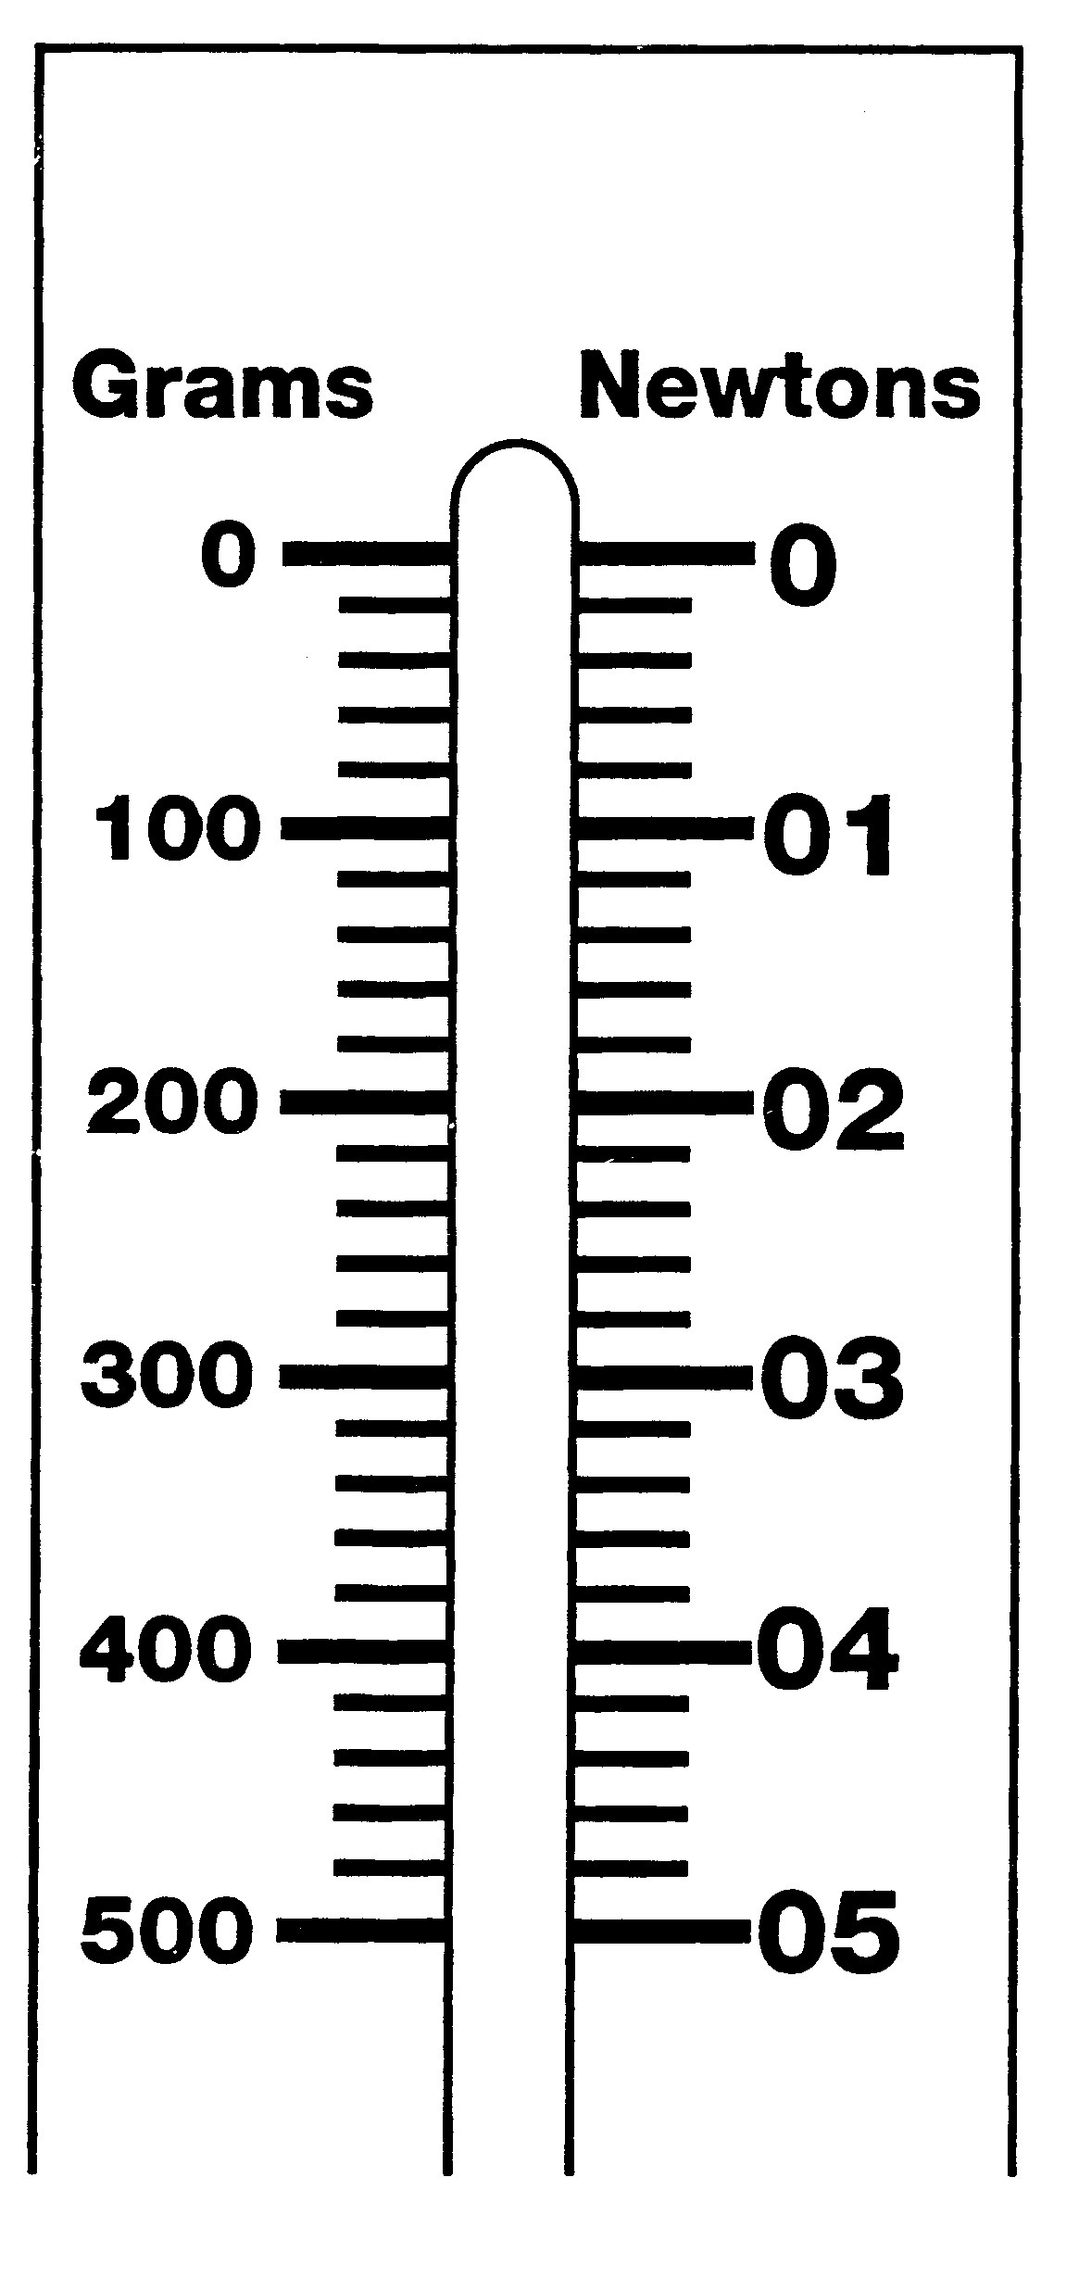
Activity 1: Using the Spring Scale
What To Do:
1. Observe the diagram of the spring scale.
2. Notice on one side it measures grams and on the other side it measures Newtons.
3. What relationship do you observe between grams and Newtons?
____________________________
4. Observe the Newton side of the spring scale. With your teacher determine what each line between the numbers represents. _________________
5. Use a colored pencil and mark the following amounts on the diagram above.

0.6 N | 1.4 N | 2.8 N | 4.6 N

Activity 2 Measuring Forces
Materials: spring scale, various objects to measure

What To Do:
1. Observe the spring scale. Make sure you know how to read it on the Newtons side.
2. Hook your spring scale into one of the objects and pick it up.
3. Read the scale. Record your observation below.
4. Repeat with the other objects.
5. Don’t forget your units!

Object  15 | Size of Force (N)

Questions:
1. Which object required the greatest amount of force to lift? ___________________________
2. Which object required the least amount of force to lift? ____________________
We can show forces by using arrows (they are easy to draw and give lots of information about the force).
Look below at some examples.
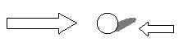
Here is a ball. There are 2 forces acting on the ball.

1. Just by looking at the arrows tell if it is moving or still.
______________________

2. If you think it is moving, in which direction would you say?___________________________

3. If you wanted to show that the ball was at rest, what do you think the arrows would look like? Draw the ball and two arrows below.

DO NOT Glue until complete
Cut apart the boxes and match the word with the definition
Motion | A push or  a pull
Newton | Using force to move an object away from you
Force | Using force to move an object toward you
Pull | A change in position
Push | The unit of force

Name _______________ period ____
EXIT TICKET
Force and Motion
1. In what unit do we measure force?
a. meters
b. liters
c. Newtons

2. What type of equipment is used to measure force?
a. spring scale
b. balance
c. graduated cylinder

3. What can you tell about the forces from the arrows below?
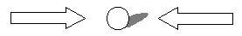
a. The forces are equal
b. The force on the left is larger
c. The force on the right is larger

4. In which direction is the car moving in the picture below?

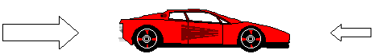
a. to the right
b. to the left
c. it is not moving

Name _______________ period ____
EXIT TICKET
Force and Motion
1. In what unit do we measure force?
a. meters
b. liters
c. Newtons

2. What type of equipment is used to measure force?
a. spring scale
b. balance
c. graduated cylinder

3. What can you tell about the forces from the arrows below?
a. The forces are equal
b. The force on the left is larger
c. The force on the right is larger

4. In which direction is the car moving in the picture below?

a. to the right
b. to the left
c. it is not moving

