Moves up | Moves down | Moves left
Moves right | Stays still | A
B | C | D
E | F | G
H | 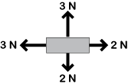  I | 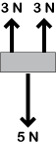  J
K | L | M

