Force and Inclined Planes

Simple machines help us do work by reducing the force needed to do a job. An inclined plane is a simple machine that is sometimes called a ramp. It makes our work easier by reducing the force needed to move a heavy object from one level to another. We have to go a longer distance but our force is less. Think about the ramp at the clinic. You go a longer distance to get to the door than you would if you used the stairs.

The object we are trying to move is called the load. The force we put into moving the object with the simple machine is called the effort/force.

**Materials:** block of wood, inclined plane, 4 books, spring scale

**What to Do:**

1. In the picture below label the load and the effort.

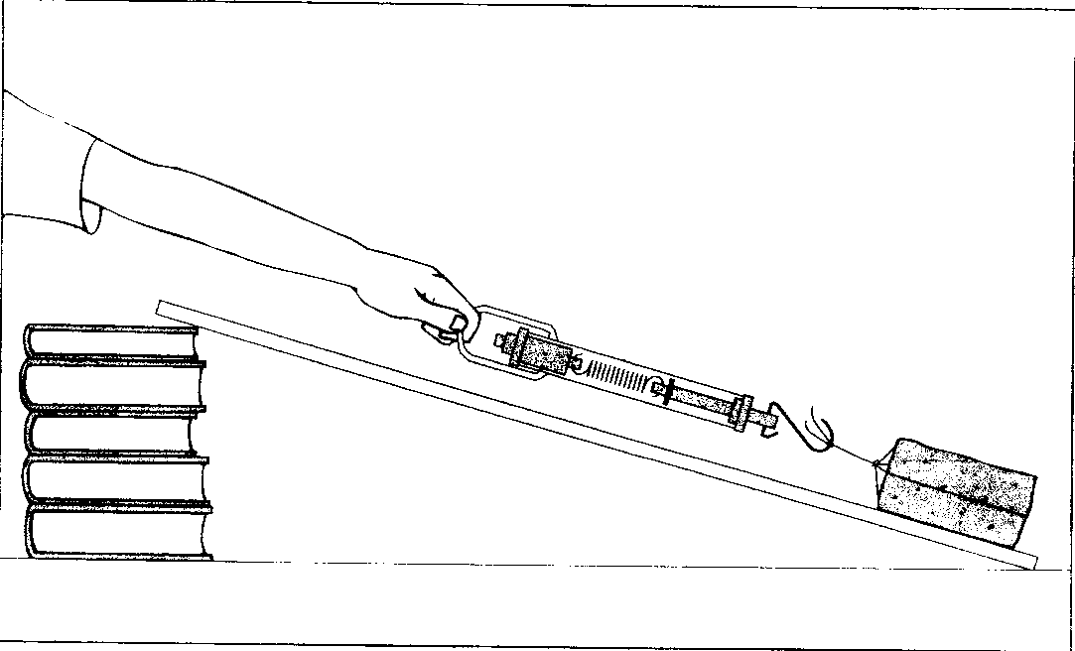

2. Using the spring scale measure the force

needed to lift the block of wood.

3. Record it in the table.

4. Place the ramp (inclined plane) on the books.

5. Slowly drag the block of wood up the inclined plane

with the spring scale as shown in the picture.

6. As you are dragging the block, have a partner read

the spring scale. **This is your effort/force.**

7. Record your information in the chart.

8. Repeat three more times.

|  |  |  |
| --- | --- | --- |
| **Trials** | **Force need to lift the block 20 cm**  **(N)** | **Force Needed to Lift the block 20 cm using a ramp (N)** |
| **1** |  |  |
| **2** |  |  |
| **3** |  |  |
| **4** |  |  |

**Questions:**

1. The hypothesis tested in this investigation was:

If you slide a block up a ramp, then, (more less) force will be needed than to lift the block.

2. The conclusion that can be drawn from this

investigation is:

A simple machine allows us to (reduce increase) force when doing work.

3. You were asked to repeat the same test four different times. Did you get the same measurement each time?

_____________ Why? _______________________

4. Why do you think scientists conduct the same experiments over and over? ____________________

______________________________________________

How Inclined Planes help us.

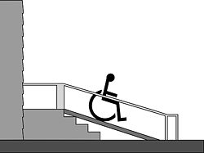1. Which has the longer distance- the steps or the inclined plane? ______________________

2. Which would take less force – pushing the chair up the inclined plane or up the steps?

__________________________

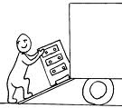3. Which has the longer distance – from the ground to the back of the truck or the inclined plane?

___________________________

4. Which would take less force –picking up the dresser or pushing it

up the inclined plane? _________________________

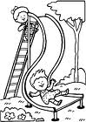

5. Which has the longer distance – the

ladder or the slide? _____________

6. Which would take less force-climbing down the ladder or sliding down the inclined plane? _________

Look at the picture of Lombard Street in San Francisco, California and watch the video of the skateboarder.

http://www.maniacworld.com/Skateboarder-vs-Lombard-Street.html

7. From what you have observed which of the following is true:

_____1. Inclined planes help us by increasing the force

but cause the distance to increase.

_____2. Inclined planes help us by reducing the force

but cause the distance to increase.

Another Simple Machine Related to

the Inclined Plane

Inclined planes can wrap around an object, such as a mountain. When a road gently slopes up around a mountain, the driving distance increases, but less power from the engine is needed to get the car to the top of the mountain. Just as the inclined plane can surround a mountain, it can wrap around a central cylinder, as in a screw. This increases the distance the screw must turn to be put into the wood, but it requires less force than hammering a nail straight into the wood.

**Materials:** pencil, scissors, sheet of paper

**What To Do:**

1. Take a piece of paper and cut out an right-angled triangle from it.

2. Darken the edge of the hypotenuse of the triangle so that you can really see it.

3. Place one of the other edges of the triangle along the pencil and wrap it around the triangle.

4. Draw what you see in the box below.

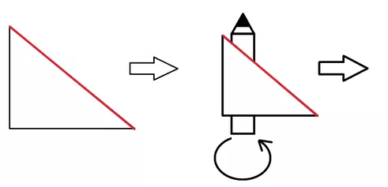

Name ____________________ period _____

**EXIT TICKET**

Force and Inclined Planes

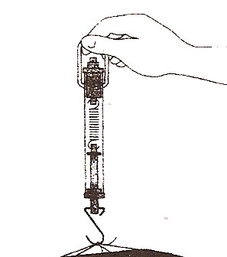

1. What is measured using the

tool pictured?

A. inclined plane

B. force

C. ramp

D. load

2. What units are measured with the tool pictured?

A. pounds

B. milliliters

C. Newtons

D. degrees Celsius

3. Which simple machine is pictured?

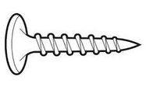A. screw

B. wedge

C. inclined plane

D. pulley

**Conclusion:**(Newton, increase spring scale, reducing,

simple machine)

To measure forces we use an instrument called a _______ ________. The unit of measure that we use to show forces is called the ________. An inclined plane is one type of _______ ________. Simple machines help us do work by ________ the force needed to do a job but _______ the distance.

Name ____________________ period _____

**EXIT TICKET**

*Force and Inclined Planes*

1. Which simple machine is pictured?

A. screw

B. wedge

C. inclined plane

D. pulley

2. What is measured using the



tool pictured?

A. inclined plane

B. force

C. ramp

D. load

3. What units are measured with the tool pictured?

A. pounds

B. milliliters

C. Newtons

D. degrees Celsius

**Conclusion:**(Newton, increase, spring scale, reducing,

simple machine)

To measure forces we use an instrument called a _______ ________. The unit of measure that we use to show forces is called the ________. An inclined plane is one type of _______ ________. Simple machines help us do work by ________ the force needed to do a job but _________ the distance.