Using a Pulley System

We have learned that a pulley is a grooved wheel with a rope or chain wrapped around it. We have learned that a fixed pulley helps us by changing the direction of the force. Now we will investigate how a pulley system helps us. A pulley system includes a fixed pulley and a moveable pulley. The fixed pulley is attached to the ceiling while the moveable pulley hangs free from the rope and that is where the load is attached. The advantage of a pulley system is that it decreases the amount of force needed to pick up heavy objects.

Materials: 1 set up used for demonstration and testing - 2 ring stands, 2 rings, 2 clamps, a 30” piece of wood, 1 pulley attached to the wood, 1 pulley hanging free, string
What To Do:
1. Observe the pulley system your teacher has set up.
2. Draw what you observe in the box below.
3. Label the fixed pulley and the moveable pulley.
4. Indicate the direction of the effort with an arrow.
5. Label the load.

Materials: pulley system, 2 hooked masses of different weights, block of wood, pair of scissors, ring from ring stand, book with string around it, 5 large washers with string, small bottle of water, 1 spring scale per table
What To Do:
1. Each table will be given an object and a spring scale.
2. Find the force needed to pick up the object with the spring scale.
3. Share your measurement with the class.
4. Two people from each group will go up to the pulley system and determine the force needed to pick up the object.
5. Share the measurement with the class.

Object | Picking up with spring scale | Picking up with pulley system
Book
Block of wood
Pair of scissors
Ring from ring stand
Hooked mass 1
Hooked mass 2
5 washers
Bottle of water

Question:
1. How did the pulley system help you do work?
____________________________________________
2. Compare how the pulley system and the fixed
pulley by how they help us do work. ____________________________________________

Who in the world was Rube Goldberg?

What to do:
1.View the PowerPoint from www.missdoctorbailer.com
2. Answer the following questions.

Questions:
1. When did Rube Goldberg live?___________________
2. What prize did he win?_________________________
3. What professions did he have?
__________________________________________
4. What was he best known for?
__________________________________________
5. What did his “inventions” do?
__________________________________________
__________________________________________
__________________________________________
6. Describe at least one of the tasks on the videos.
______________________________________________

______________________________________________
7. In the cartoon Self Wiping Napkin what does the man have to do to get his face wiped?

________________________________________________
8. If time allows design your own Rube Goldberg contraption as shown in the PowerPoint.

Rube Goldberg Contraption

Rube Goldberg was a famous cartoonist in the 1930’s. He was famous for drawing very complicated contraptions to do very simple tasks.
Directions:
1. Look at the picture below.
2. Find the pulleys that are used in the picture and color them green. (There are 4)
3. Use a blue pencil or marker to trace any ramps or inclined planes you see in the picture. (There are 2)
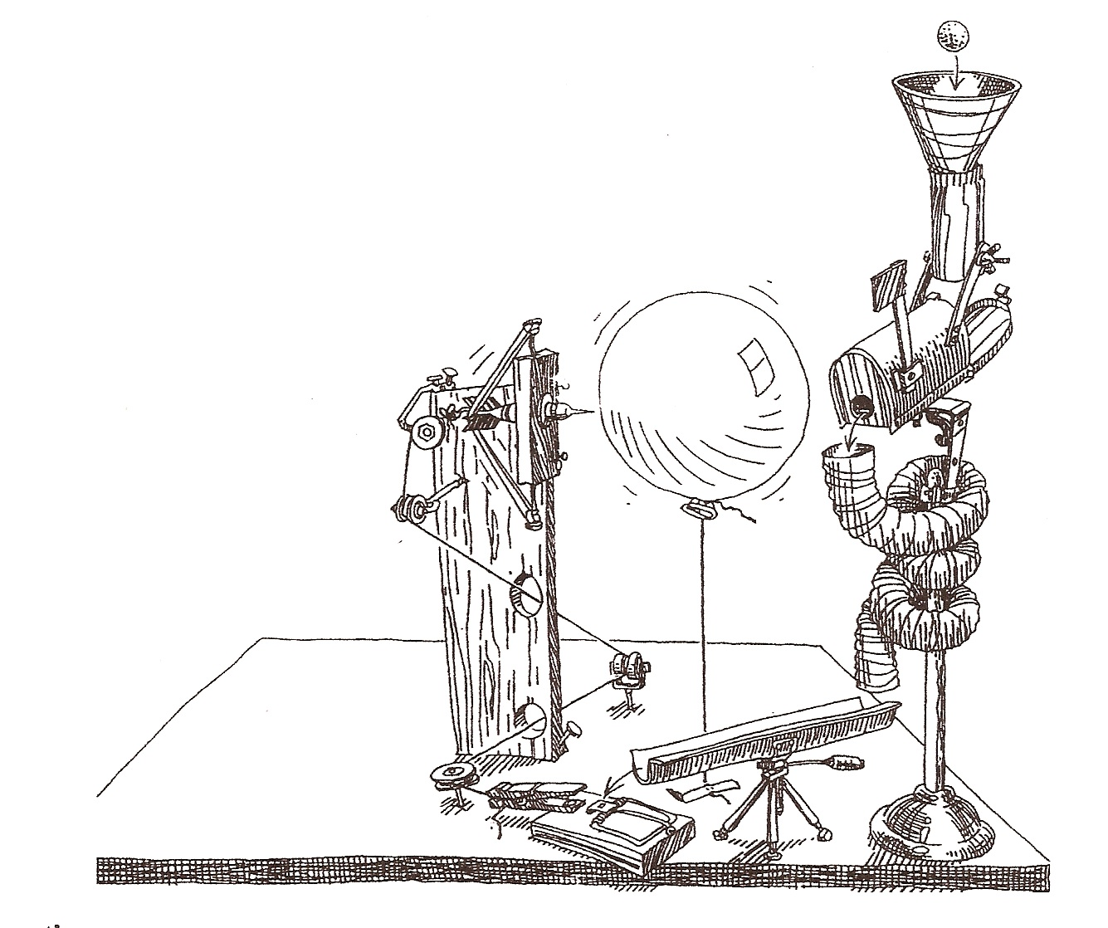

Questions:
1. What type of pulley is in this contraption? _______
2. What is the task of this contraption? ____________

Name ___________________ period _____

EXIT TICKET
Using a Pulley System
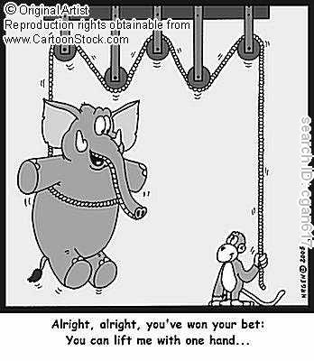

1. Use the following words and label the picture.
Load 1 Pulley Effort

2. What type of pulley is seen in this cartoon?
____________________________________

3. The cartoon is wrong. The monkey cannot pick up the elephant with this arrangement of pulleys. What type of pulley would have to be added for this to be true?
________________________________________
4. How does a pulley system help you do work?
Changes the direction Decreases the amount of force

Name ___________________ period _____

EXIT TICKET
Using a Pulley System

1. Use the following words and label the picture.
Load 1 Pulley Effort

2. What type of pulley is seen in this cartoon?
____________________________________

3. The cartoon is wrong. The monkey cannot pick up the elephant with this arrangement of pulleys. What type of pulley would have to be added for this to be true?
________________________________________
4. How does a pulley system help you do work?
Changes the direction Decreases the amount of force

